Exporting a Clean Starting File

Create a TPQA ticket:
When you have a TMTT ticket requesting an export (whether it be a clean export, redline, or galley) you need to create a TPQA ticket to track your time/work. Follow the below steps when creating said ticket:
- Clone ++
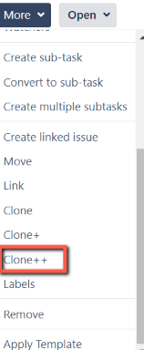
- Tax Production and QA, and leave the default of ‘Task’ selected. Click Next.
- Edit the name of the ticket at the top by adding the terminology “Export Starting File for ---” in front of the already established name.
- In the description, you will type out the following:
  - “Prepare Author Starting file for the portfolio (needs redline), attach them to this ticket, tag Larry Frank and Pete Burt in this ticket, and close this ticket when finished.” This is when there is a Federal or FNC
  - “Prepare Author Starting file for the portfolio (no redline), tag <Practice Lead> in TMTT-####, attach it to the TMTT, and close this ticket when finished. This is going to be for international portfolios
- Change the assignee to your name
- Due date depends on the scenario.
- Component(s) Technical Tax Support (add on Navigator Interim Review if it is a CITN or EXTN)
- Epic Link Portfolio Production (If it is CITN or EXTN, this will be State -- Navigator IR production)
- Tax Production Task Types Data Conversion
- Tax Content Data Swim Lane Production – Manuscripts
- Service Code You will need to pull up the portfolio in BTax and look at the BDAT info. Look at the ‘imported_from_file’ section, and the service code is within this information (see screenshot below)
- Complexity Level Simple
- Sprint Planning Work Category 1 – Plan ahead
- Tools Word
- Sprint Choose the appropriate sprint for the ticket
- Story Points Between a 1 and 2
- Tax Practice Area This will vary depending on the type of portfolio you are working on
- Click on Create

Search BWIP for Portfolio and download
You will need to gather the current portfolio in BWIP. It will come in 3 parts (Front Matter, Detailed Analysis, and Working Papers.) When you download the front matter, use the Export as RTF/Word option. The rest can be downloaded via “Export to BPub Prep Word.” You can also save the separate sections in your work folder or personal folder in Sharepoint (whatever is easier to do, but you may want to leave it accessible to others in case you get stuck.)
- Go to BWIP https://bwip.bindg.com/wip and click on TOC/Browse on the left.
- Clear all values at the top of the screen.
- Type in the service code you are looking for and click on ‘Browse BDMS’
- Click on the plus sign next to the portfolio to expand
- Click on the plus sign next to Front Matter (Portfolio Description), Detailed Analysis, and Working Papers.
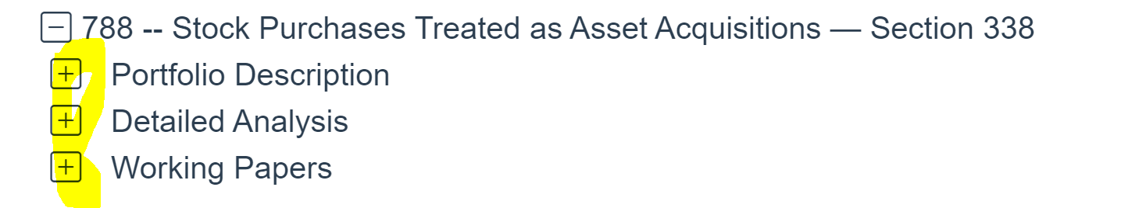
- Check to see if any of the chapters are checked out. If there chapters are checked out, rest the mouse on the checked out chapter to see who is working on it. Message said person to see when the chapter(s) will be released so you can complete export. When a chapter is checked out, it will show up as light grey.

- If the chapters are available, you will start with the Front Matter . Click on the down arrow next to Group Actions and choose ‘Export as RTF/Word’
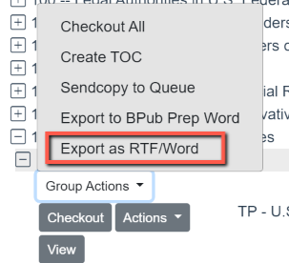
- Open this in the downloads folder and click on ‘Enable Editing’ at the top of the screen. Be sure to have the “Show Paragraph” tool running.
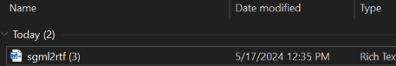
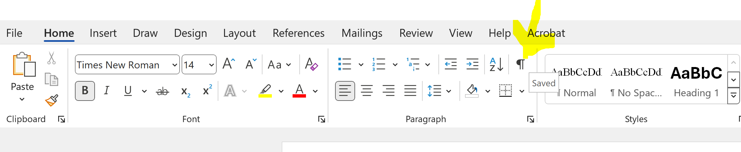

- The very first line will be red. Change that to black.
FROM this:
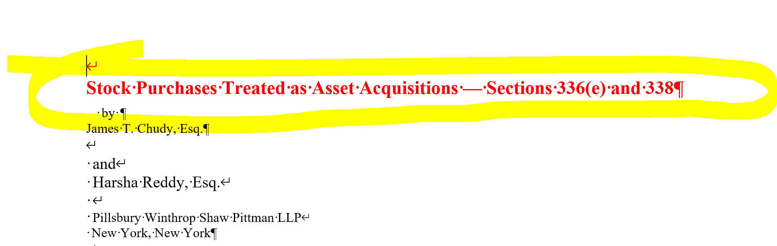
TO this:
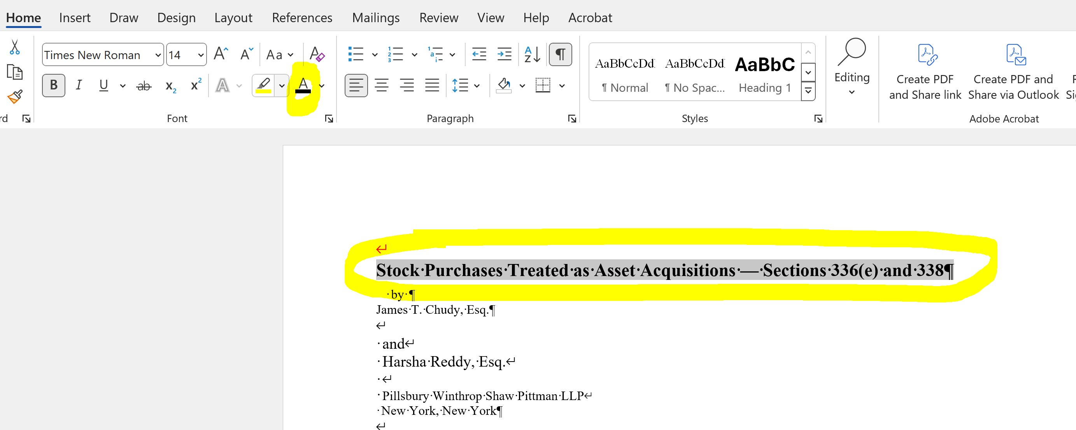

- Scroll down to the table of contents. The column with A-# will need to be removed. Click on the column and delete column. 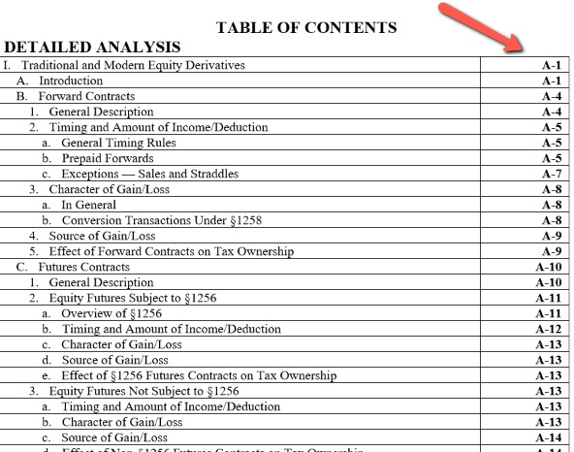

- Scroll to the bottom of the page and remove the copyright line.
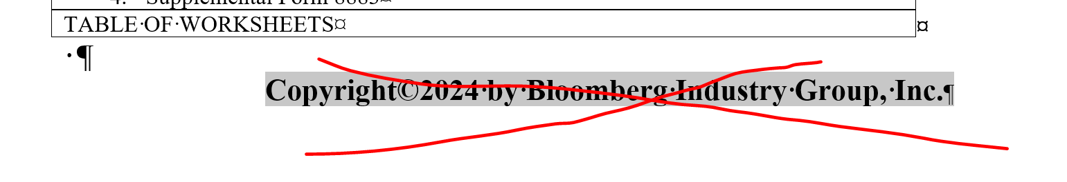

- Save this as a Word Document and name it “01 Portfolio number Front” ie: 01 188 Front.

- Go back to BWIP, click on group actions for the Detailed Analysis, and click on “Export to BPub Word Prep.” It will populate a lot of tabs at first, and then shrink down. If this does not happen, you will need to click on the pop-up tab icon and allow pop-ups.
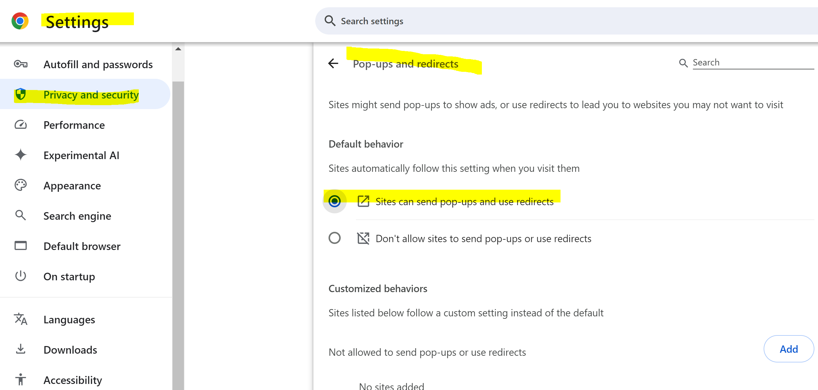

Go to Downloads folder and rename the files

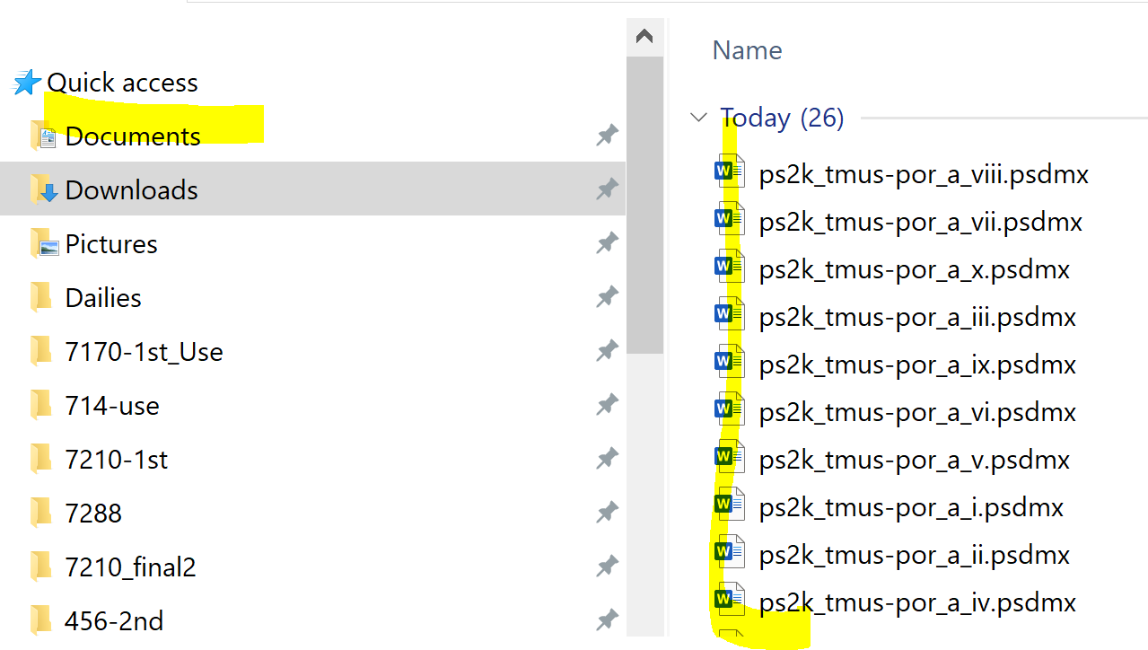

- Rename the chapters so they are in the correct numerical order. **Pro tip: Change chapter 9 to “viiii” so it will flow and save you time. It will look strange, but it will save you time so you don’t have to relabel all chapters.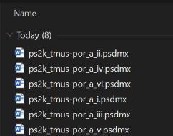
- Open the first chapter and click on “Enable Editing.” Then click on the X when you see the window below. Then click on the X to the right of Enable Content bar(screenshot below.)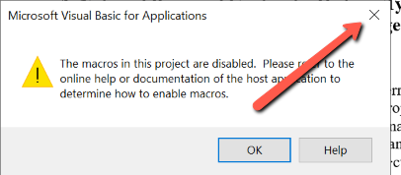

- Scroll to the bottom of the last page.
(MAKE SURE THAT YOUR CURSOR IS AT THE BOTTOM OF THE LAST PAGE BEFORE CLICKING ON INSERT !)
Click on Insert > click on the down arrow next to 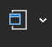 (Object), and choose “Text from File.”
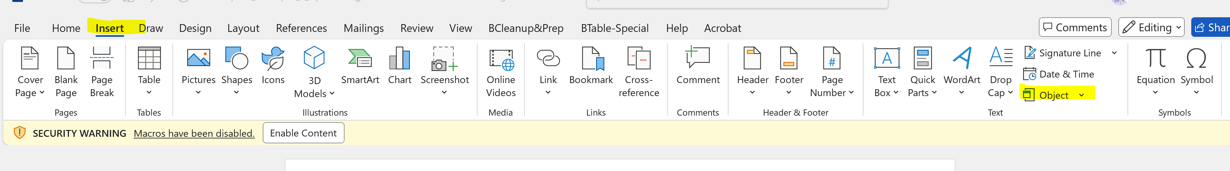
- Select from Chapter 2 to the last chapter and choose ‘Insert.”
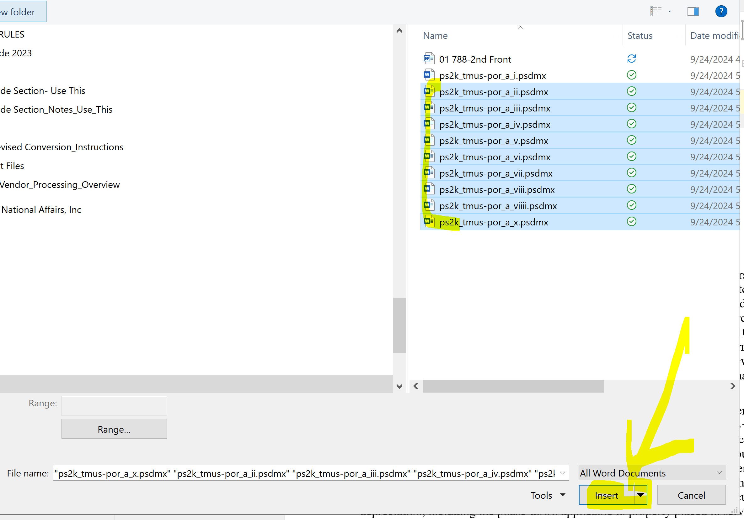
- Save the file as a word document and call it 02 <Port number> DA
Check if you have the all the chapters and if they are in order in the Navigation pane:
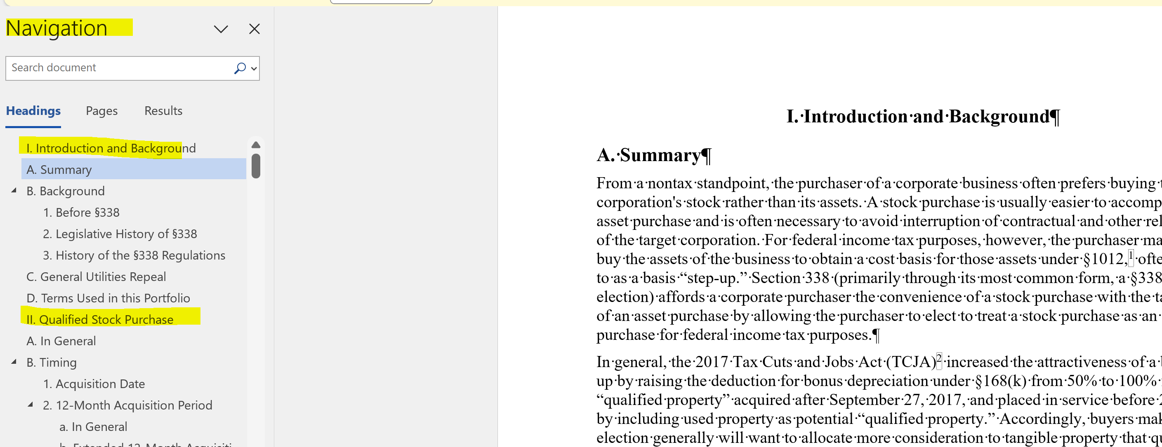

- Follow the same steps for Working Papers but save as 03 <Port number> Back.
- Your folder will look something like this 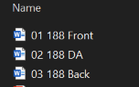

Run clean up steps for the export
- Open the “01” file and remove the extra column in the TOC (it will have black highlights). Scroll to the bottom of the last page and insert the 02 and 03 docs (as mentioned in step 17 above.) Scroll to the bottom of the document once everything loads and add TABLE OF WORKSHEETS above the worksheets table and center it. Make sure it is Bold and centered.

- Collapse the chapters and make sure they are all there.
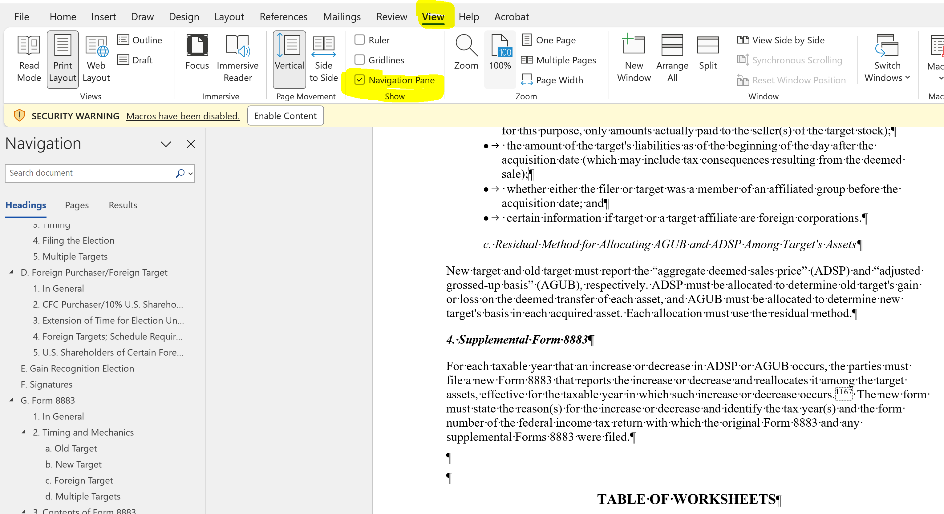

- At the very top, place your cursor at the end of the title and hit the space bar once. In parenthesis, type out the portfolio number followed by ‘T.M.” For CITNs, add the state name in front of the title.

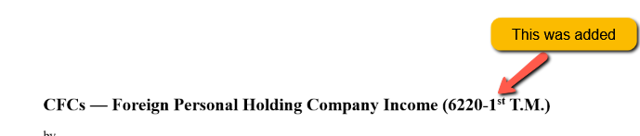
- Add a footer. Double click at the bottom of any page. Click on the arrow next to Page Number (top left of the screen.) Bottom of Page > Plain Number 2. 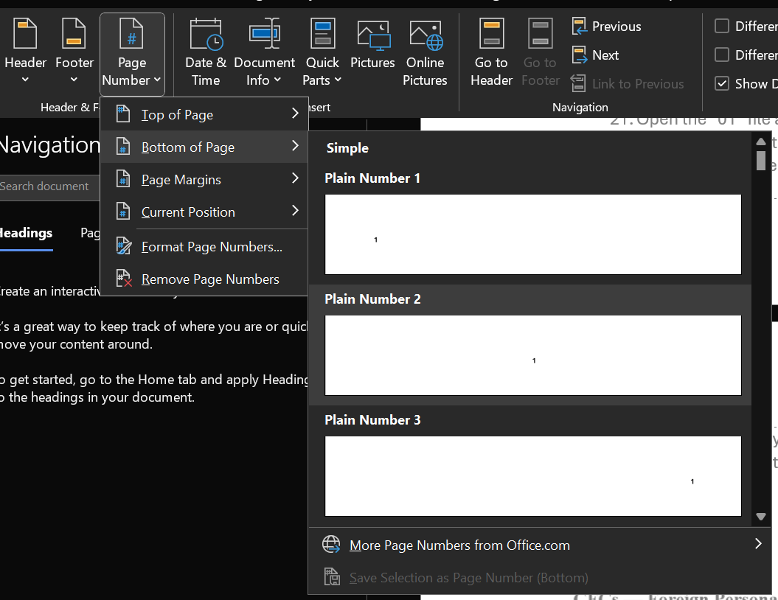
OR
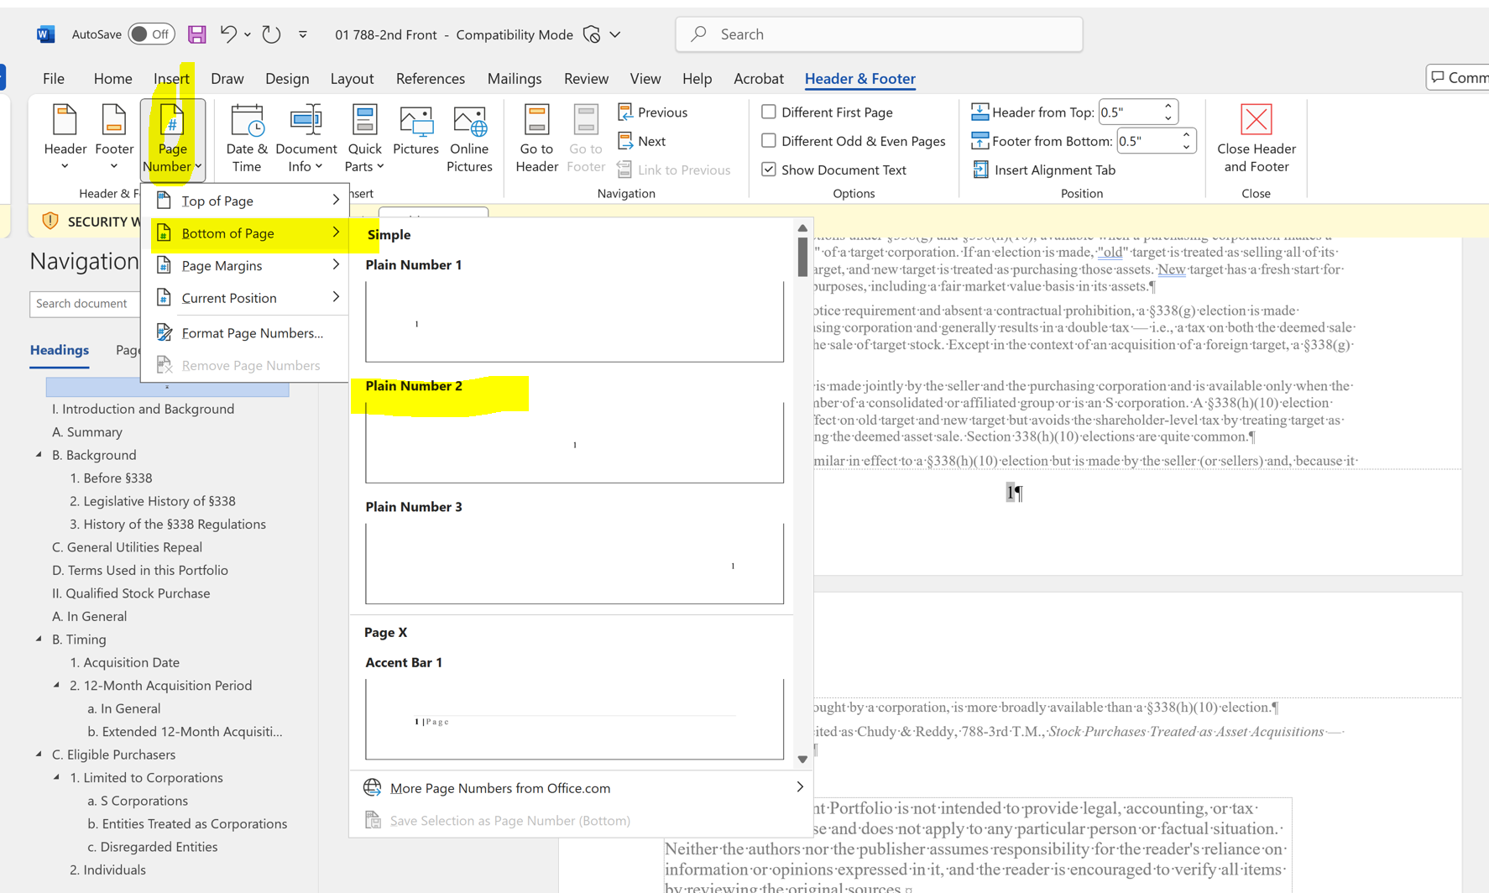

- Go back to the top and place the cursor in front of the title. Click on Home, and break out the styles. Click on BChapter_Name. This will allow the title to show up on the navigation bar. Hit the backspace twice to line it back up properly. You will repeat this for the Table of Worksheets as well, but you will not need to backspace with that one. 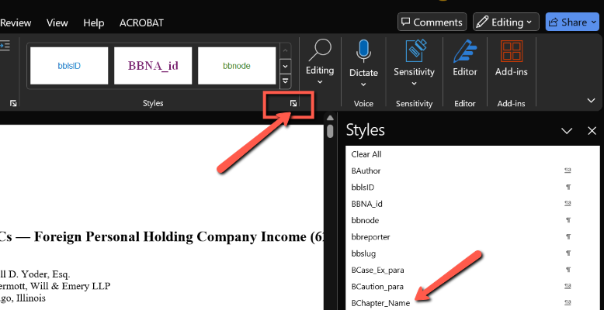

- 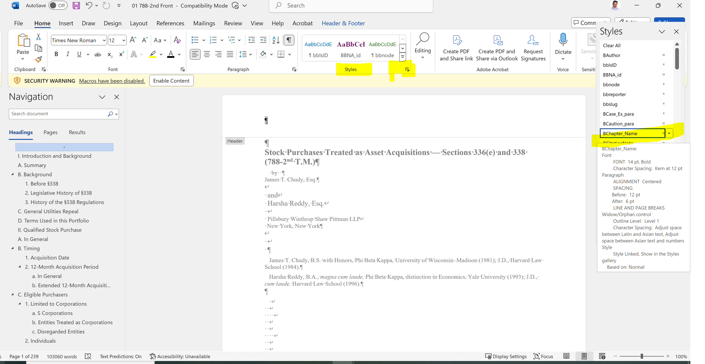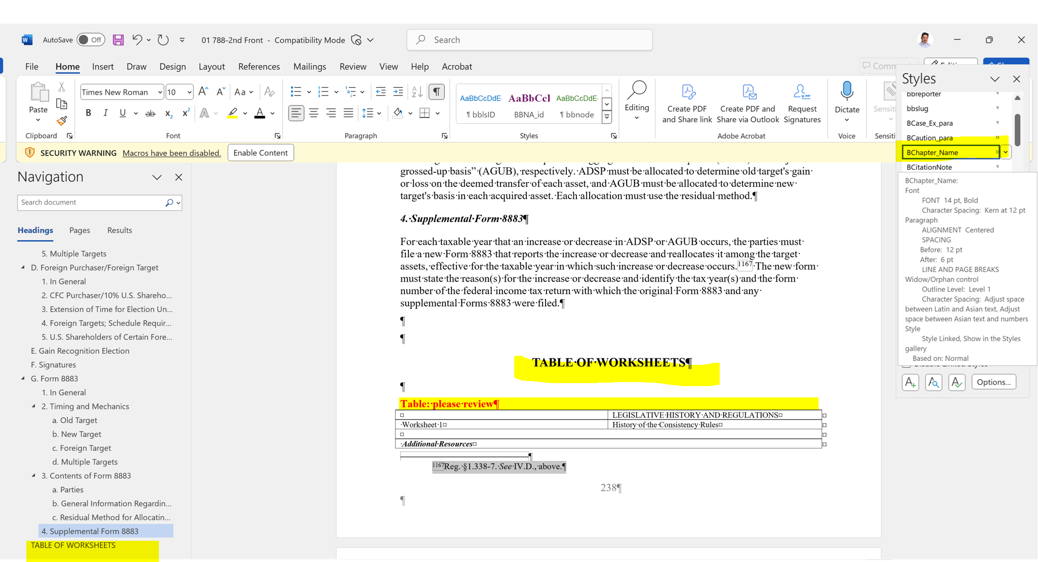

- Scroll back to the top and place the cursor in front of the title.
- Click the down arrow on the navigation bar and select ‘Replace.’ Click on More > >. For the “Find what” field, click on “Special” down below and select Manual Line Break. For “Replace With” click on “Special” and “Paragraph Mark.” Then click on “Replace all.” Click “Replace all” until there are 0 occurrences. You will repeat this with “Find What” being “Manual Page Break.” “Replace With” will always be “Paragraph Mark.”
Next, you will have “find what” look for “Paragraph Mark Paragraph Mark” (^p^p). Keep preplacing until this reaches 0. If you have continued numerous times without reaching 0, that may be as far as it will go. You also want to have “find what” look for “^p ^p” (^p space ^p), “ ^p^p”( space^p^p), and “ ^p ^p”( space^p space^p). **NOTE: There is a space in some of these filters.**

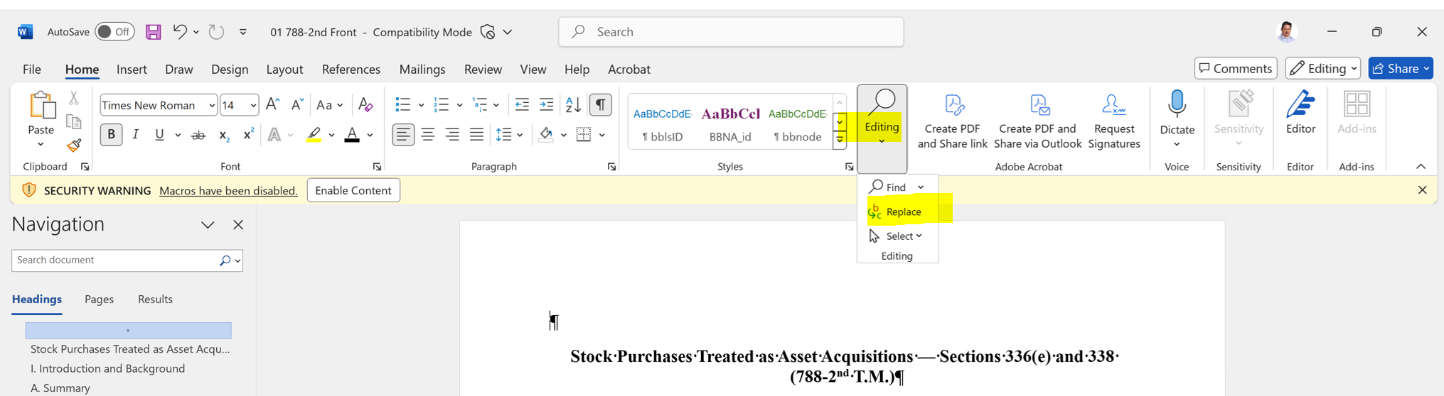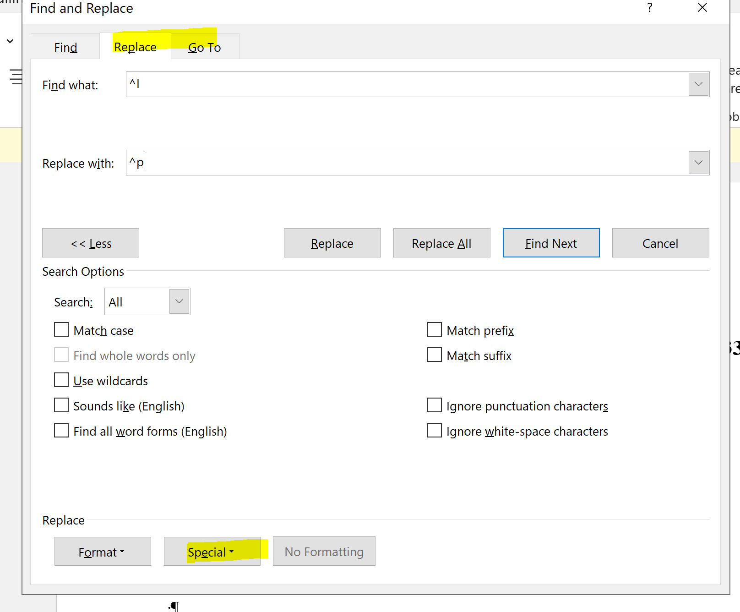

- Line up (align to left margin) the authors just under the title on page 1.

- Insert page breaks (CTRL + Enter) between each element (title page, portfolio description sheet, Author Profiles (where applicable), TOC, DA, table of worksheets, and each worksheet). The chapters do not need to have page breaks. NOTE: Do not remove the yellow highlighted image place holder.

- Place the cursor back at the top (in front of the title) and click the down arrow for navigation. Select “Tables.” The TOC and Table of Worksheets tables need to be 9pt font. The rest of the tables can stay the same.
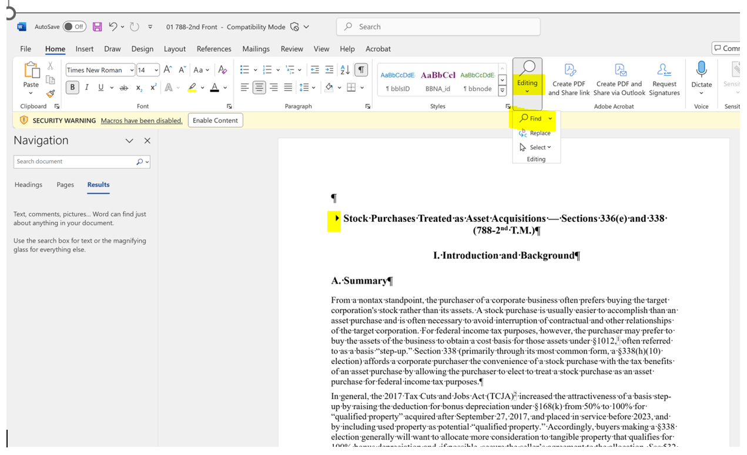

Click the arrow (image below) to navigate to the next table. Unless specified in the ticket, leave the tables as is. You will remove the yellow highlighted portion at the top of each table that says “Table: Please Review.” I find that hitting backspace rather than delete works best. You will then hit enter to bring a space back after deleting the highlighted bar. If there is a table that is extremely discombobulated, you can look up the portfolio in BTAX, highlight the table, and replace in the export you are working on. Same goes for times where the practice lead mentions all tables are going to be reviewed. Click the ‘X’ above the arrows when you are finished going through all tables.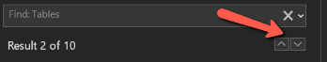
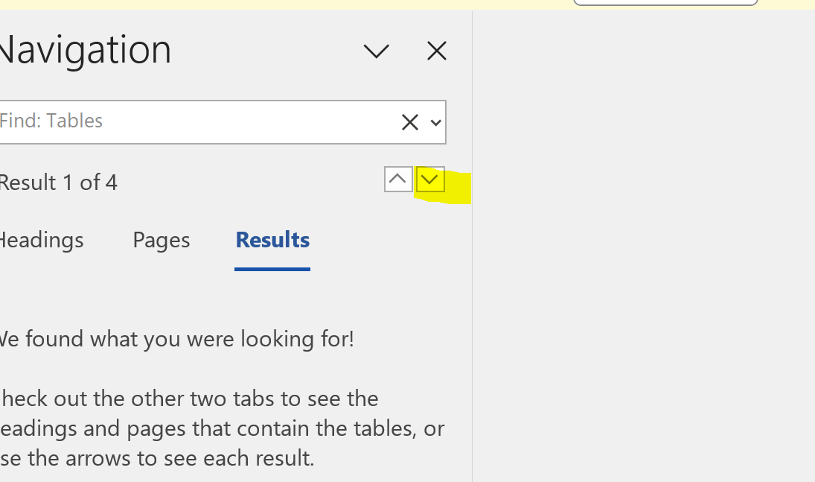

- Now go to the navigation bar and search for “&nbsp” , “&frac” , and “&cir”. If you find any, they need to be backspaced and then hit the spacebar once. There are some circumstances the spacebar is not needed. Be sure to look at each occurrence to decipher.

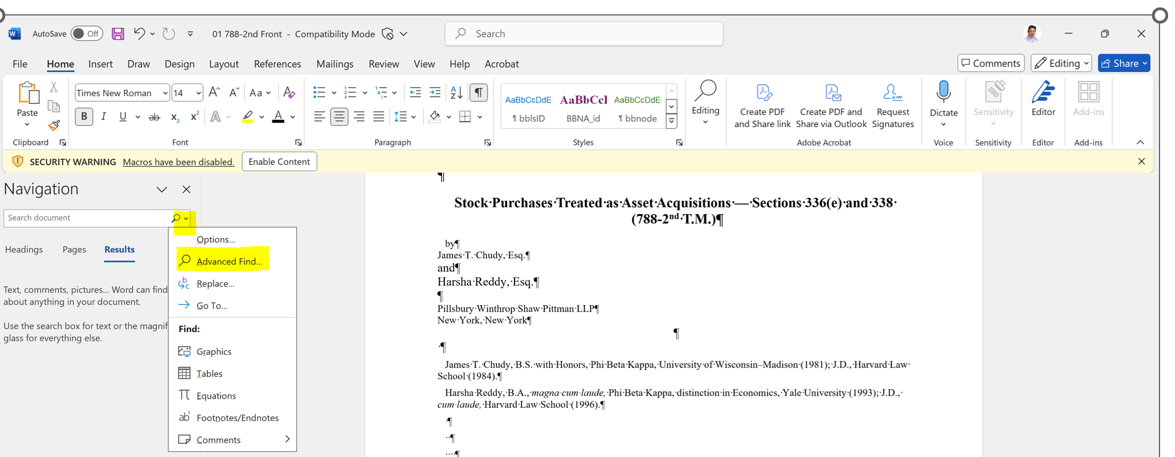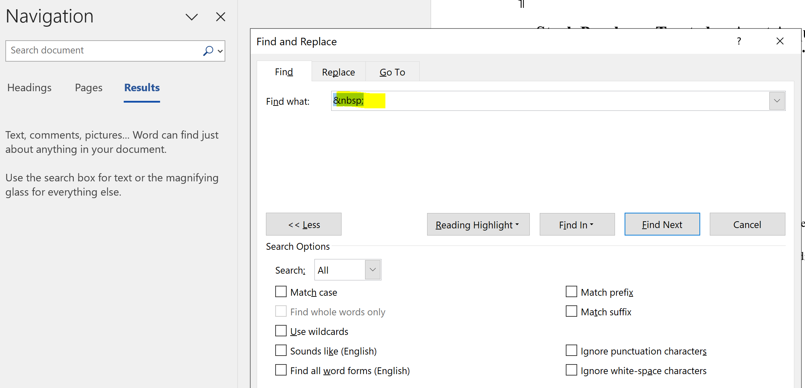

- Browse through the document to see if there are any misspelled words. If something is blatantly misspelled, then correct it.
- Finally, you want to make sure the margins are set to 1 inch. In most cases, the margins are already set this way. Go to Layout > Margins > Make sure the 1” option is chosen.

- Save the export as “Author Starting File for [port #] DDMMMYYYY. IE: Author starting file for 1234-5 IR2 20MAY2024

Place file in ticket and sharepoint
- Go back to your TMTT or TPQA ticket.
- Attach the ticket to TMTT or TPAQ by dragging it in.
- Notate that the attachment was added with a comment. (tag applicable practice lead as well)
- Place a backup copy in sharepoint either in Full Revisions, CITN, EXTN, or Interim Reviews

Place the proper label(s)
Click on Edit and check the “Starting File Attached” once you have attached the file to the ticket. Then click ‘Update.’

Close out the TPQA
- Go back to the TPQA and log your work time. If this is a Federal or FNC, tag Larry Frank and Pete Burt in the comments letting them know the starting file is attached (and redline).
- Close the ticket.
These are the federal tax groups that will help when making TPQAs.
Federal Tax Group | Practice Lead | Redline needed?
BETA | Lindsay Bartholomew | Yes
CP (Compensation Planning) | Seyi Tuyo | Yes
EGT (Estates, Gifts and Trusts) | Annabelle Gibson | Yes
US (US Income) | Steven Grodnitzky | Yes
FNC (Foreign Non-Country) | John McManus | Yes (Unless otherwise specified)
SDT (State Domestic Taxes??) | Annabelle Gibson | Yes and no (if this is a new CITN, then no. If this is an IR, then a redline is needed)
CA (Competent Authority) | Peter Rho | No
FC (Foreign Country) | Maria Menezes | No
TP (Transfer Pricing) | Peter Rho | No

NOTES:
There will be some exports that are chapters of a larger portfolio/manuscript. Pay attention to the request. You will need to remove any chapters that don’t relate to the subject. Those chapters removed will all be in the Front Matter. This includes part of the TOC. You will also add that it is a chapter in the title line (ie: ####-# T.M. Chapter ##)
Pay attention to twin portfolios as well. Sometimes there will be duplicates when you download from BWIP and will need to make some adjustments.

