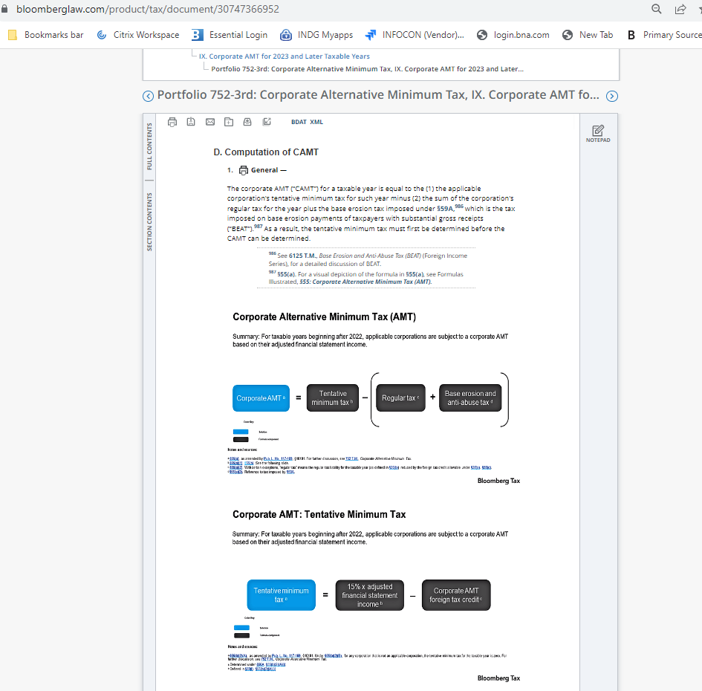

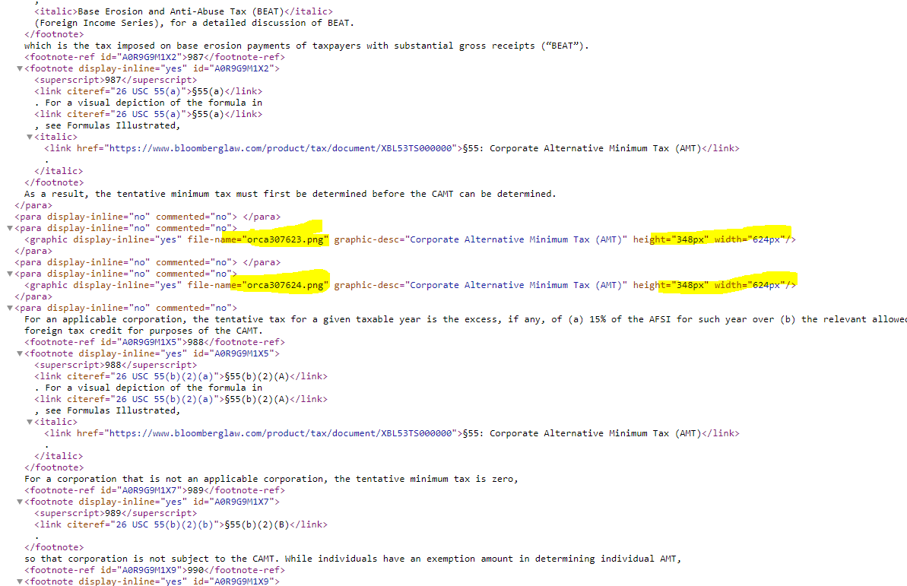

If original file is png you can open it and enlarge in Paint directly

Open file in PDF
Export file as Microsoft Powerpoint (.pptx) (try export to png and see if it can be opened in Paint, if not export to powerpoint. If it doesn’t open in Paint it means the resizing will not work even if it is a .png
ex. Saving as png from Acrobat, error will say not a bitmp file))

Open pdf file in Acrobat
Click on File>Export To>Microsoft Powerpoint Presentation
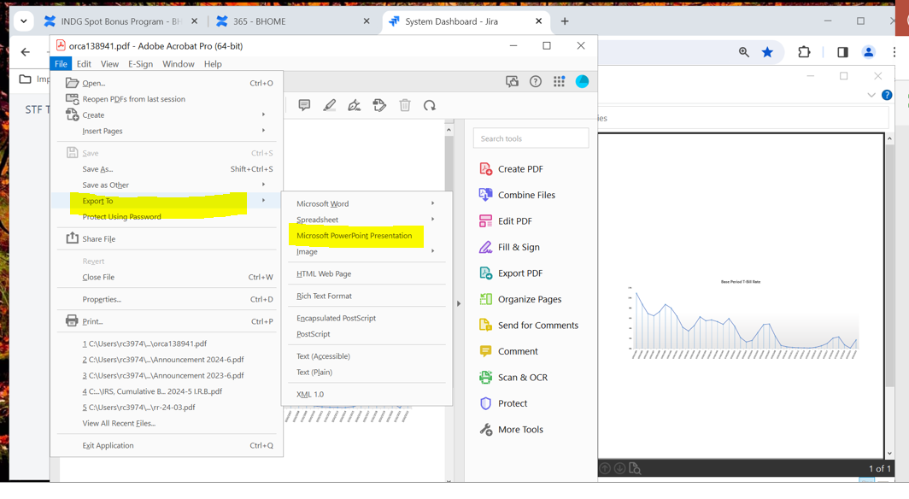

Open file in Powerpoint and Export as different file (.PNG)

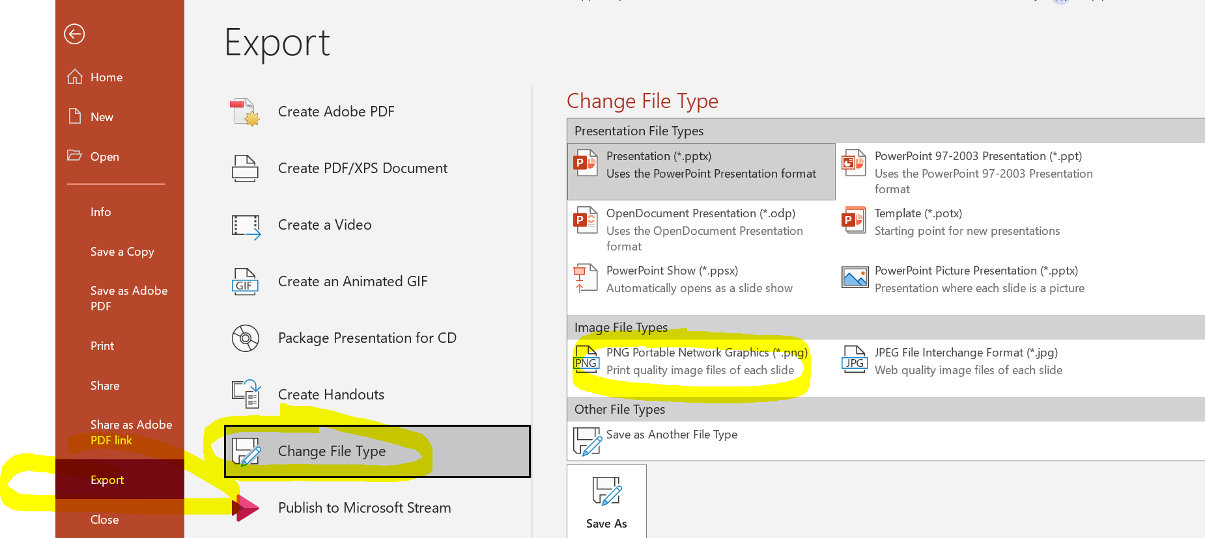
Open png file in Paint
Resize in Percentage (200%) or 2x Pixels and save as another png

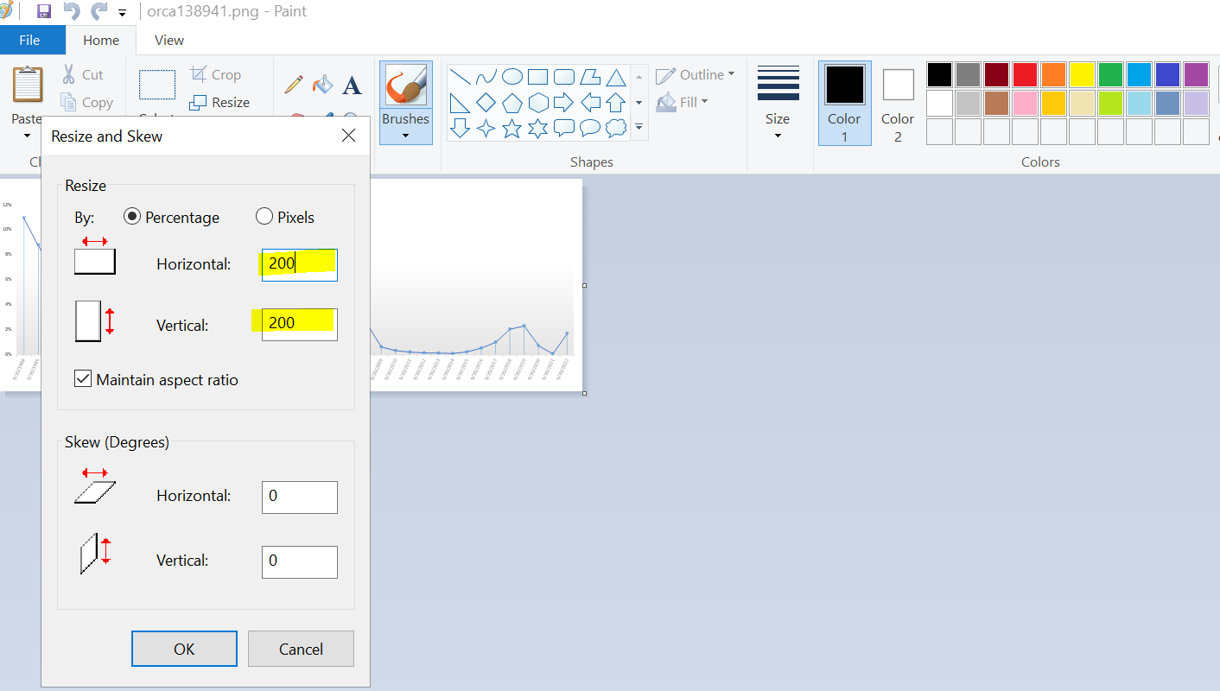

Load resized file to Orca

USE THE Dimensions below or else change will not show in Prince
Retain image width & depth, make changes to print depth & print width
For 2 column use print width 23 & print depth =15

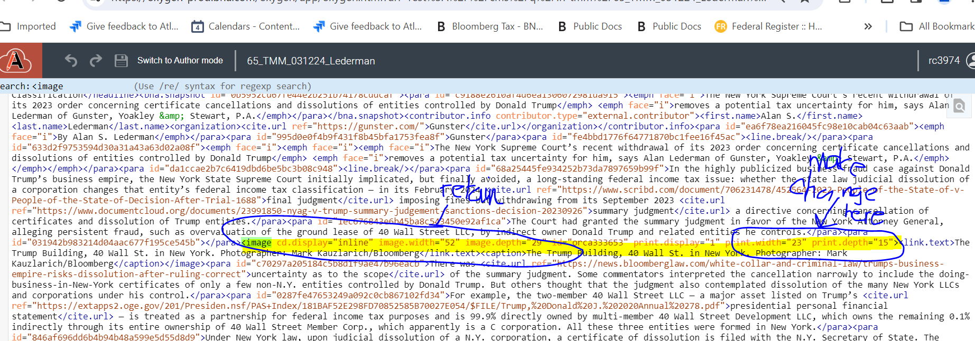

Portfolio images with footnotes Sample:

Sample file in WEBQ:

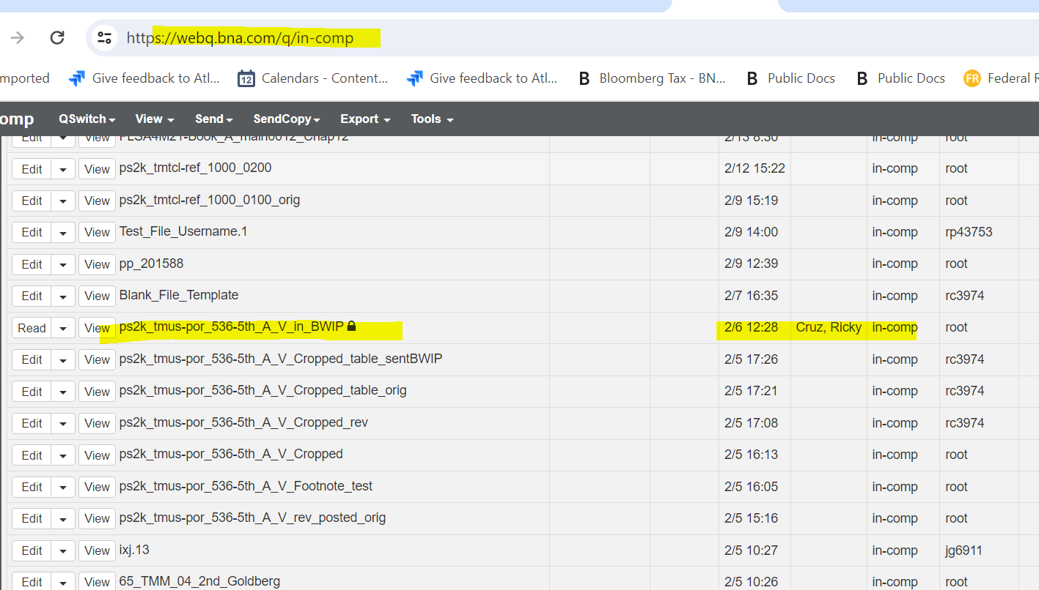




Insert only in tag for Online only or Print only Images

Place cursor after para tag (make sure the line(cursor) only appears and para tag is not highlighted) then right click to insert element –include then edit attribute type only in
Then move image tag inside the include/only in tag.

For examples use:
Portfolios 742 V.A. near ftnt 699, 539 VI.A. ftnt 1638, 758 VII.B. ftnt 869.

