1. Update BPUB plug in if needed (go to Menu and then Help>Check for add on updates)
2. Checkout file
4. Setup transformation scenario (save xsl somewhere it can be referenced in Oxygen)
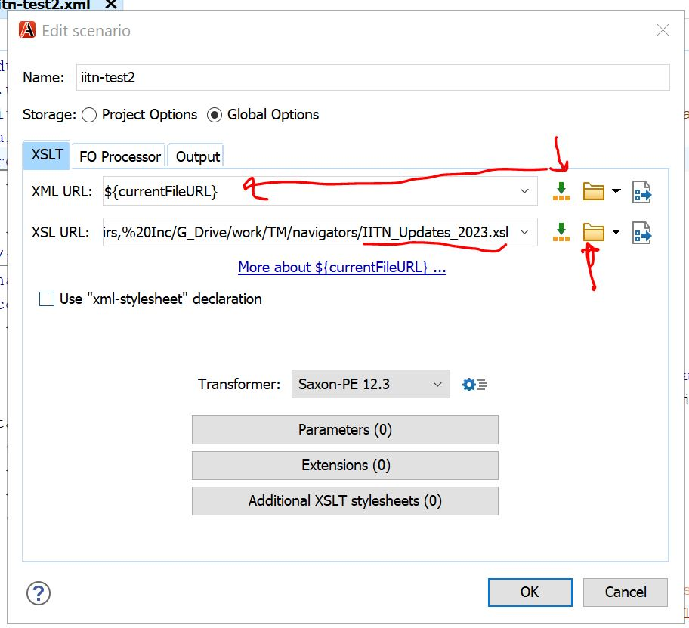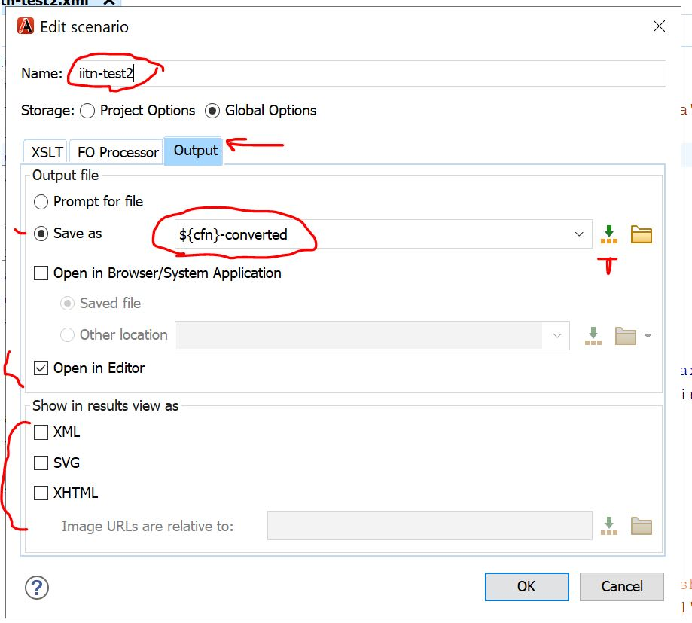

5. Open files one at a time, as many as you feel comfortable juggling
6. Run transform
7. Check ouput
8. Copy and paste data from converted file into BPUB version
9. Save and close the BWIP file
10. Check wip to see if there are any validation errors

