Electronic and Software Patents Law and Practice
Please process the chapter allocated to you using the guidelines provided in Bloomberg Book Tagging Instructions (Rev1.0).docx
- Remove TOC at the beginning of the Chapter.
- If the chapter titles are in all caps, please change them to title case. for example,
Chapter 10. FEES AND EXPENSES LITIGATION IN DEFINED CONTRIBUTION PLANS
convert it to as shown below.
Chapter 10. Fees and Expenses Litigation in Defined Contribution Plans
- If the string “Chapter” is not availabe at the beginning of the Title add it
2
RELATIONSHIP TO OTHER INTELLECTUAL PROPERTY AREAS
convert it to as shown below:
Chapter 2. Relationship To Other Intellectual Property Areas
- Please look for broken paragraphs and fix them
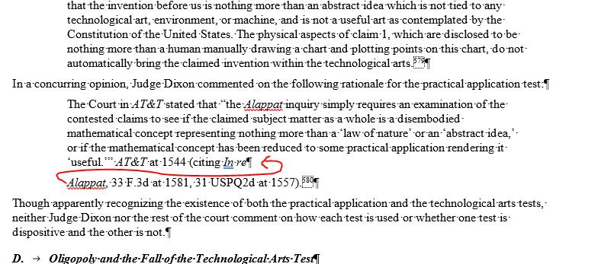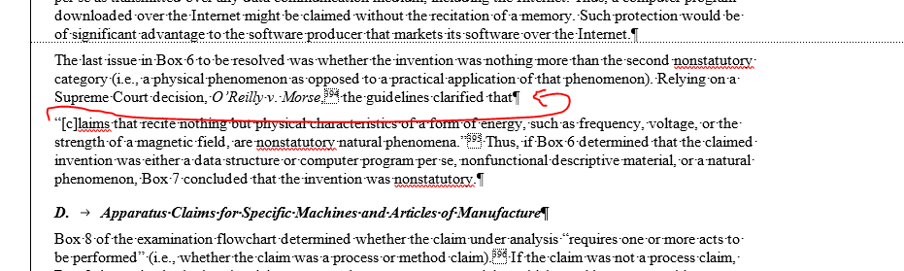
- Look for Footnotes with chapter titles or section heading and move them to the next available paragraph
- This book has a slightly different format of section heads, where you can see § (section symbol), make sure it is added to the BNA.ID as shown below:
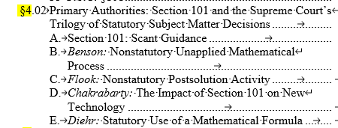
<bna.id bna.id="02">§4.02. </bna.id<name>Primary Authorities</name>
<bna.id bna.id="A">§4.02.A. </bna.id><name>Section 101: Scant Guidance</name>
- Please look for line.break between URLs, remove them before we tag them with cite.url tagging.
- Run autocite with following option while running Autocite in two instalments:
1st Instalment
  - All BNA Services
  - All Federal Rules of Procedure
  - All Federal Agency Documents (NOT Federal Agency Documents - Tax Services only)
  - All Federal Laws
  - All Federal Laws by Acronym (NOT either of the EHS Federal Laws)
  - Federal Laws by Name
  - Federal Regulations
  - Model Acts
  - State Agency Documents
  - State Constitutions
  - State Laws (NOT State Tax Laws)
  - Web
  - TM State Regulations

2nd Installment
  - All Cases.
Note: Fix the cites that are not picked by Autocite manually.
- Pull file to BWIP Queue INFOBOOKS-PSP
- Please use JIRA for all your queries.

