Editing Metadata Manually in BDMS
Go to BDMS ID and insert required fields: bdms id, Realm, Workflow then click on refresh
After selecting XML Manual on the drop down menu click on Land then Launch

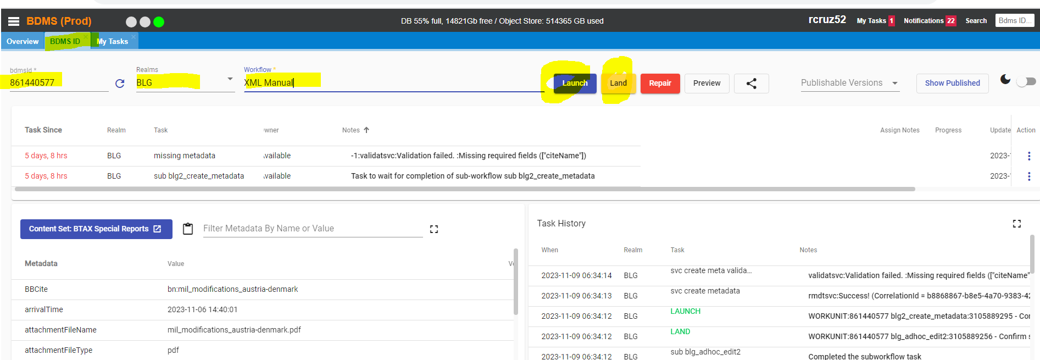

Then click on refresh until the previous entries in the Task Since field changes to:
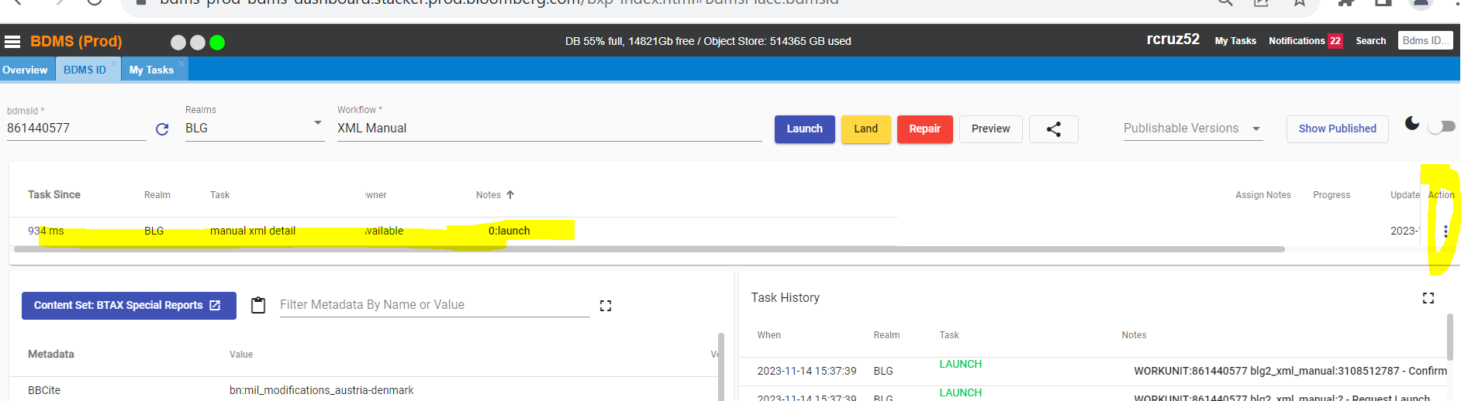

Then click on the 3 dots below Action then Assign to Self:
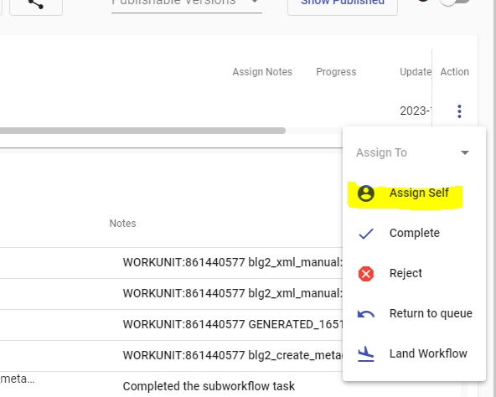

Then click on My Tasks then refresh then work:

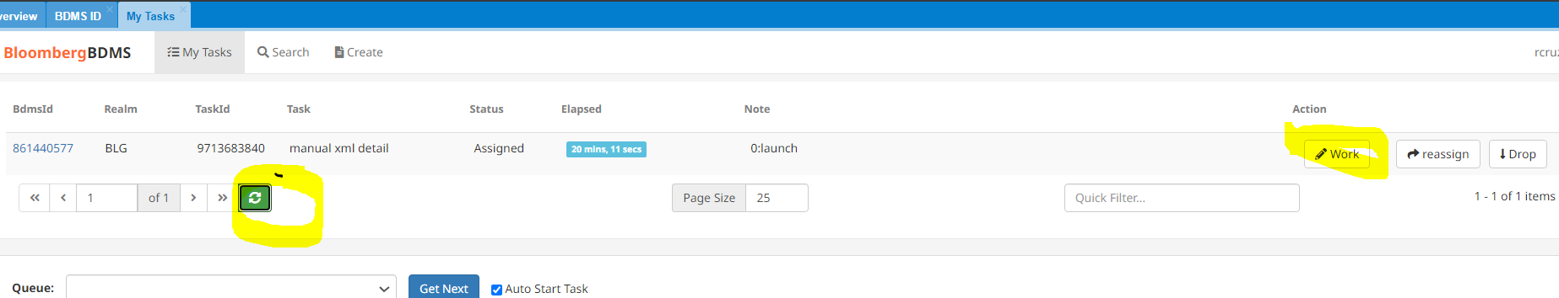

Then click on Edit tab :
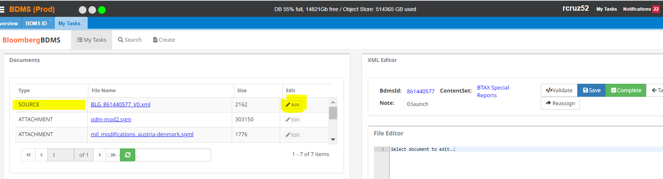

The xml file will appear, then insert the cite name:

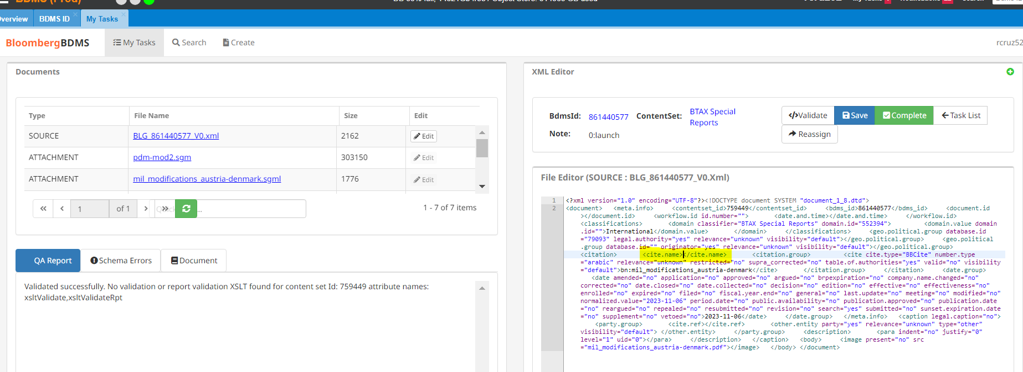

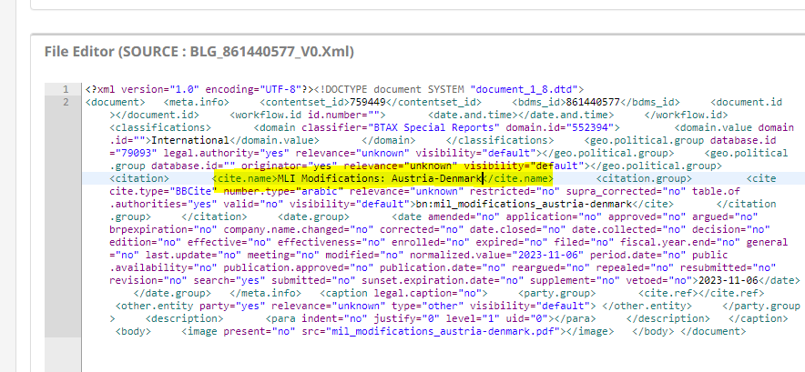

Then click on complete:

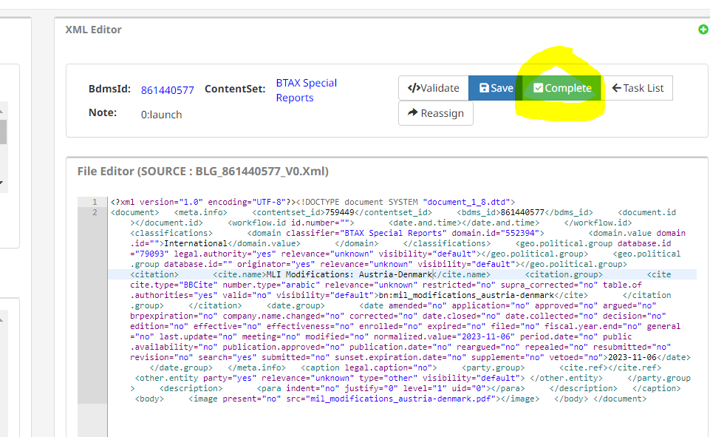

Then click on yes (it will not allow you if there is a validation error. Also check the cite.name tagging if it won’t publish e.g. missing <.

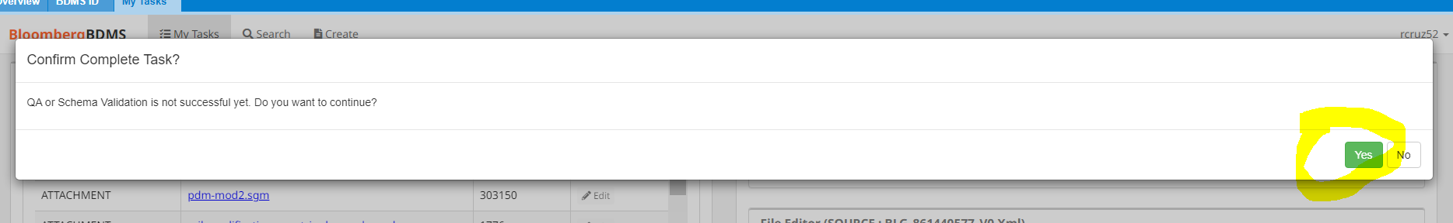

Go back to BDMS ID:
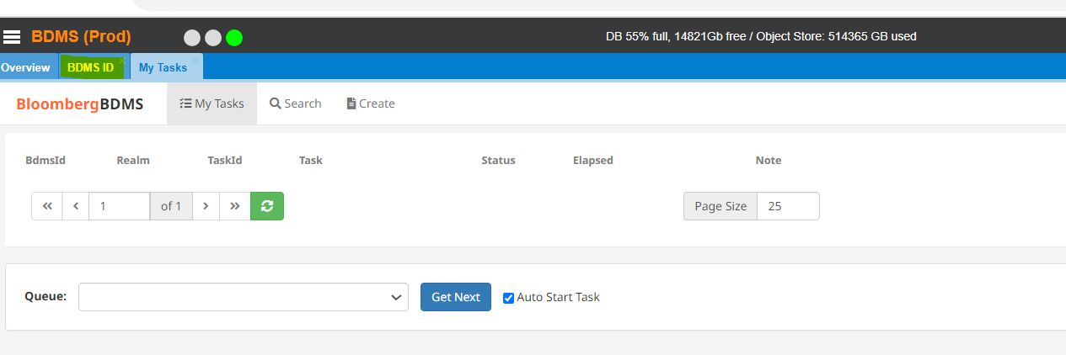

Change workflow to Publish then Launch:
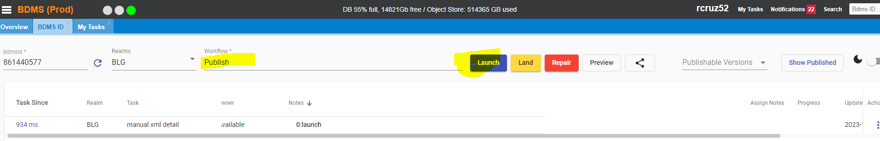

Click on refresh to see if the BBLS ID & BDMS ID appears( it means the file has been published!):
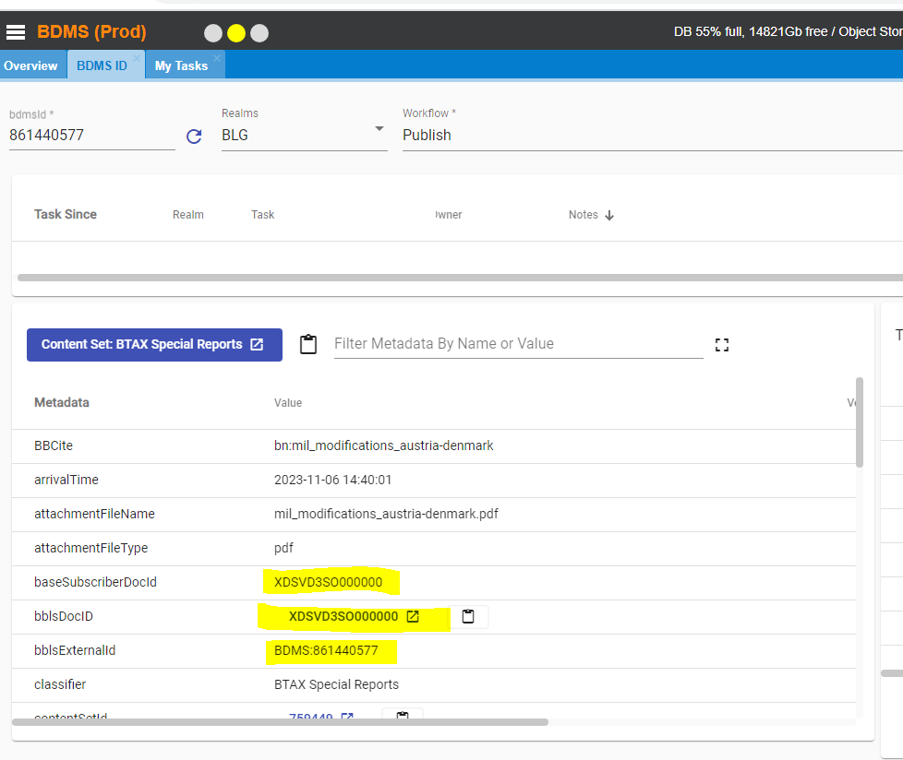

Click on the bblsDocID to check the file in BTAX:

