Forms – EPICS

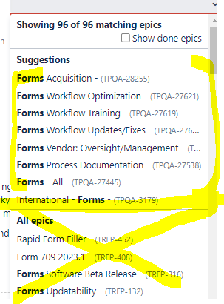

Dataflow Training Stages
TASKS EPIC
Meetings/Discussions --Forms Workflow Training
Prepare Documentation - Forms Process Documentation
Conduct Training - Forms Workflow Training
Evaluate Participants- Forms Workflow Training

Required Fields
- Summary
- Description – give details
- Type -Task
- Status - In Progress, On Hold
- Priority - High
- Epic Link – see above
- Tax Production Task Types ---BLANK
- Tax Content Data Swim - Forms
- Sprint Planning Category – Plan Ahead, Ongoing
- Sprint - Current
- Story Points
- Assignee

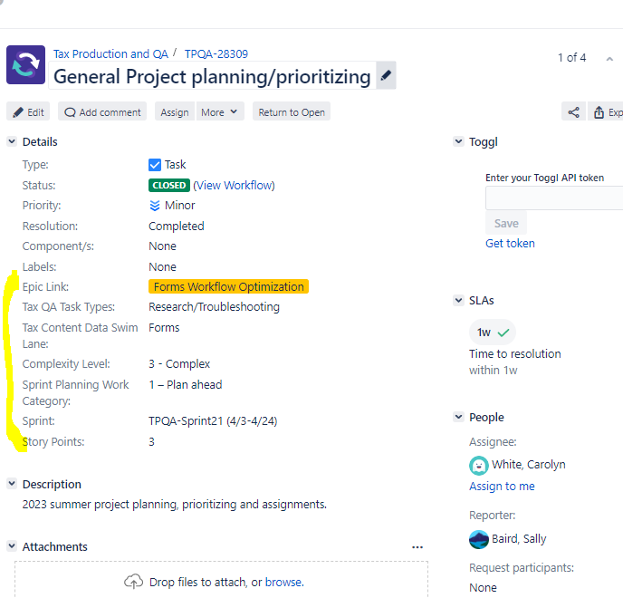

Assist in STF team in creating JIRA tickets for Dataflow training
Schedule meeting with Ammanuel & Kevin of STF to determine steps in the Dataflow Training workflow to be used in JIRA.
Determine values to be inserted in the required fields.
Create Template tickets to be used by the STF Team.

