Overall Process:
- Production team amends 26 USC files in BWIP (USC-REF)
- Use Code Section Affected List spreadsheet to track file progression and alert QA when file is ready.
- Don’t publish Code files to BTAX until I give the word.
- When file is ready, James and I will QA.
- QA makes small edits to the file if needed. (note in spreadsheet.)
- QA will send back to Production if more extensive edits are required. (note in spreadsheet.)
- When approved, QA will note in spreadsheet.
- PL numbers added when available.

Anatomy of Code section: 4 parts
- Language: Amend language according to the provision in the Act language PDF. (I’ll send a link to everyone when we have language)
- History: Add the History at the end of the language example: (…..; Pub. L. 117-___, Div. X, title X, Sec. XXX, Aug. ___, 2022.)
- BNOTE: Add the amendment portion and don’t forget the 2022 heading:
example: 2022 - Subsec. (e)(1)(C). Pub. L. 117-___, Div. X, title X, Sec. XXX(x)(x) amended subpar. (C) by substituting “sections 23 and 25D” for “sections 23, 25D, and 1400C”.
- BNOTE: Add Effective date and don’t forget the heading, “Effective Date of 2022 Amendment” or “Amendents”
example: EFFECTIVE DATE OF 2022 AMENDMENT
“Amendment by Sec. 104(c) of Pub. L. 117-___, effective for taxable years beginning after December 31, 2022.”

Delayed Effective Date Protocol: Sample, Sec. 4672(a)(2)(B), by PL 117-58

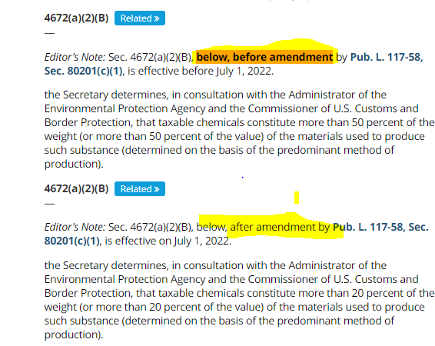
****
BACKGROUND NOTES
AMENDMENTS
2021—Subsec. (a)(2)(B). Pub. L. 117-58, Sec. 80201(c)(1), amended subpar. (B) by substituting “20 percent” for “50 percent” each place it appeared.

EFFECTIVE DATE OF 2021 AMENDMENT
Amendment by Pub. L. 117-58, Sec. 80201 is effective on July 1, 2022.

****

Redesignated Example: Sec. 5002(b), by PL 103-465

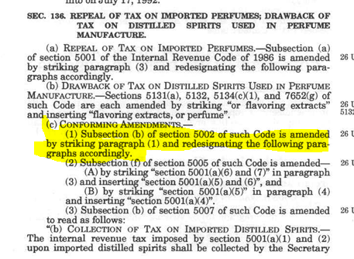

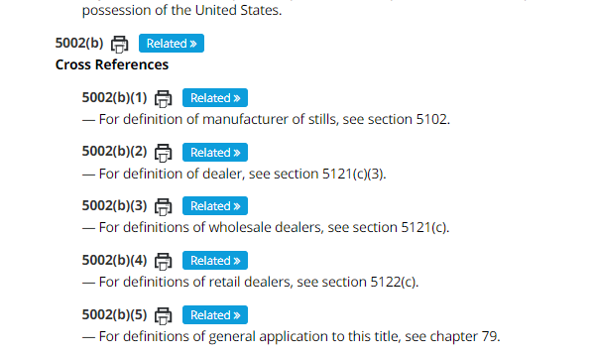

1994--Subsec. (b). Pub. L. 103-465, Sec, 136(c), struck par. (1) and redesignated pars. (2) - (6) as pars. (1) - (5), respectively. Before it was struck, par. (1) read as follows:
“(1) For definition of wine gallon, see section 5041(c).”

EFFECTIVE DATE OF 1994 AMENDMENT
Amendment by Pub. L. 103-465 effective January 1, 1995.

****

