CODE SECTION UPDATE
Link to Modules
https://bna.sharepoint.com/sites/Pride4_Bna4_Data_TaxAccounting/Shared%20Documents/Forms/AllItems.aspx?id=%2Fsites%2FPride4%5FBna4%5FData%5FTaxAccounting%2FShared%20Documents%2FGROUPS%2FTax%26Accounting%2FOperations%2FContent%20Oversight%2FIRC%20Code%20Update%2FIRC%20Training%20Module%20%2D%20Paula&viewid=5955958b%2D7c95%2D45af%2Dbb4b%2Da8e995ab6ab7

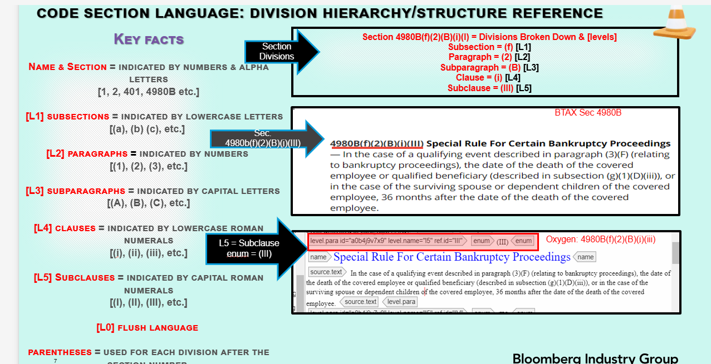

SUMMARY
The Act Section of the Bill shows what changes needs to be made to the affected Code Section
1. Search for Act section in Bill pdf (Act Section is from Bill pdf) MODULE 1
2. After determining the affected code section, checkout the file in BWIP (Code Section is from BWIP) ) MODULE 1
https://bna.sharepoint.com/:p:/r/sites/Pride4_Bna4_Data_TaxAccounting/_layouts/15/Doc.aspx?sourcedoc=%7BE76AEFED-45A8-411F-9391-725153AC0E2E%7D&file=IRC%20Training%20Module%201%20Oct%205%202023.pptx&action=edit&mobileredirect=true

3. Add History Source cite MODULE 2
https://bna.sharepoint.com/:p:/r/sites/Pride4_Bna4_Data_TaxAccounting/_layouts/15/Doc.aspx?sourcedoc=%7B6216B887-EE11-4242-9555-B7633EA7C7A8%7D&file=IRC%20Training%20Module%202%20Oct%2012%2C%202023.pptx&action=edit&mobileredirect=true

4. Add Background Note: Effective Date ) MODULE 3
https://bna.sharepoint.com/:p:/r/sites/Pride4_Bna4_Data_TaxAccounting/_layouts/15/Doc.aspx?sourcedoc=%7BFDE74C20-6BCA-46A2-AC4C-C0843D5496F1%7D&file=IRC%20Training%20Module%203%20October%2019%2C%202023.pptx&action=edit&mobileredirect=true

5.Add Background Note: Amendment for Code section ) MODULE 4
https://bna.sharepoint.com/:p:/r/sites/Pride4_Bna4_Data_TaxAccounting/_layouts/15/Doc.aspx?sourcedoc=%7BFDE74C20-6BCA-46A2-AC4C-C0843D5496F1%7D&file=IRC%20Training%20Module%203%20October%2019%2C%202023.pptx&action=edit&mobileredirect=true

6.IF REQUIRED: Add Editor’s Notes ) MODULE 5
7. Add Act Language ) MODULE 5
https://bna.sharepoint.com/:p:/r/sites/Pride4_Bna4_Data_TaxAccounting/_layouts/15/Doc.aspx?sourcedoc=%7B4647D08B-EE84-47B8-A234-27E390F5F1CB%7D&file=IRC%20Training%20Module_%205%20Nov%209%2C%202023%20Session%20A.pptx&action=edit&mobileredirect=true

TRAINING INDEX
https://bna.sharepoint.com/:w:/r/sites/Pride4_Bna4_Data_TaxAccounting/_layouts/15/Doc.aspx?sourcedoc=%7BA44D52E7-8E65-48BD-B154-E203BDB8126C%7D&file=IRC%20TRAINING%20INDEX%20Nov%2021%202023.docx&action=default&mobileredirect=true

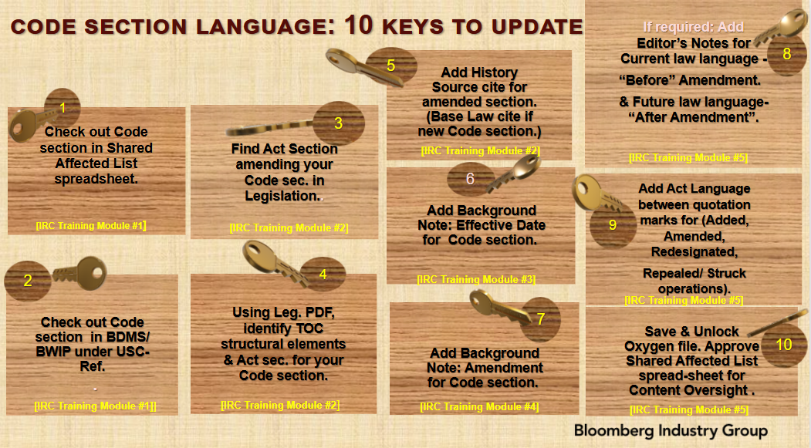

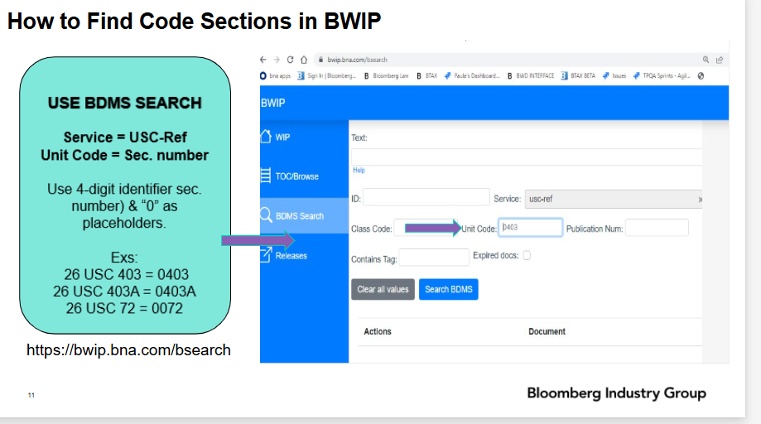

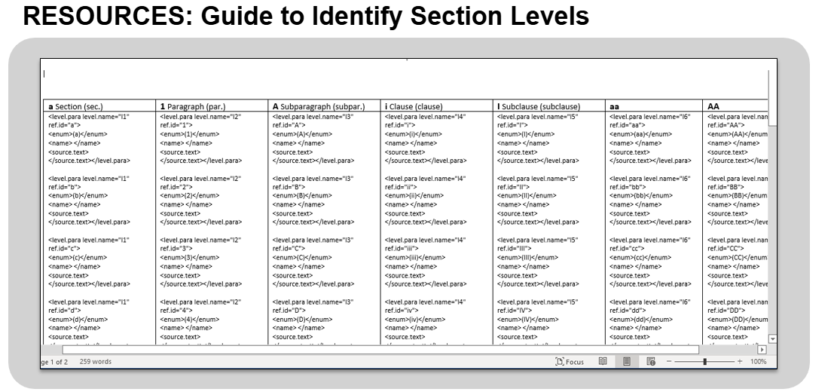

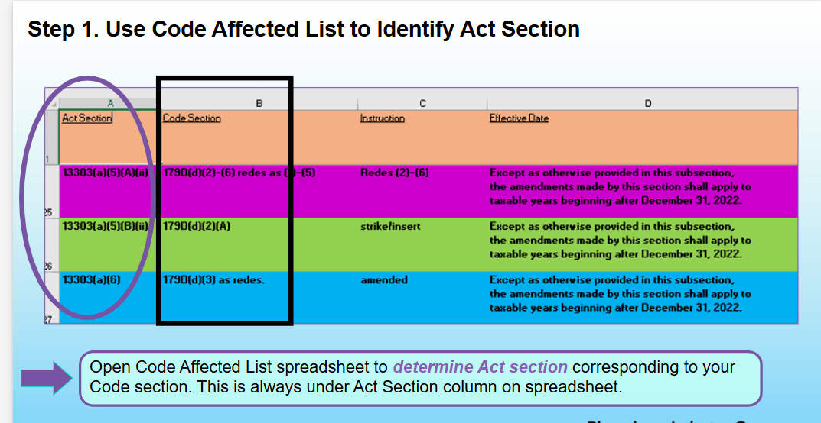

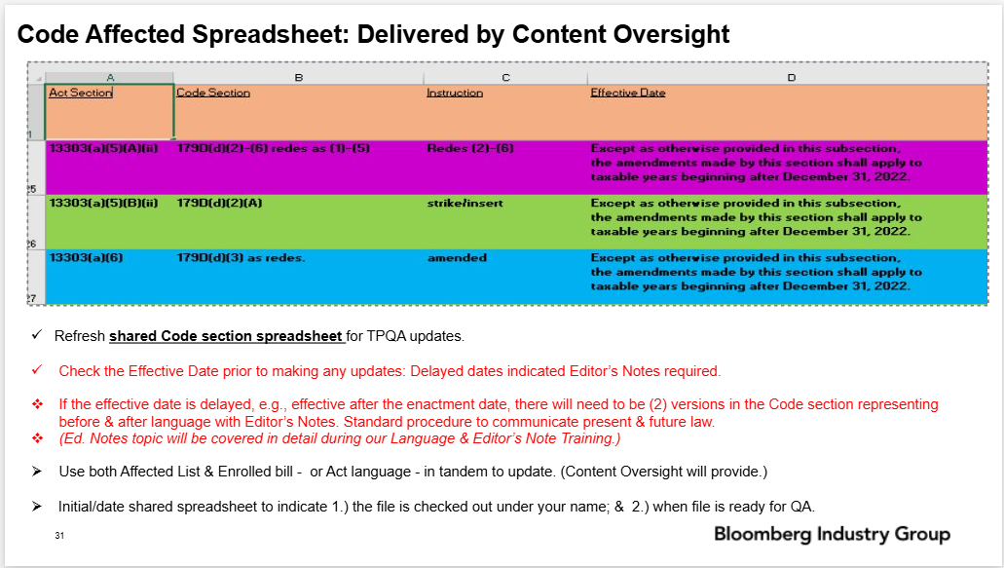

- HISTORY
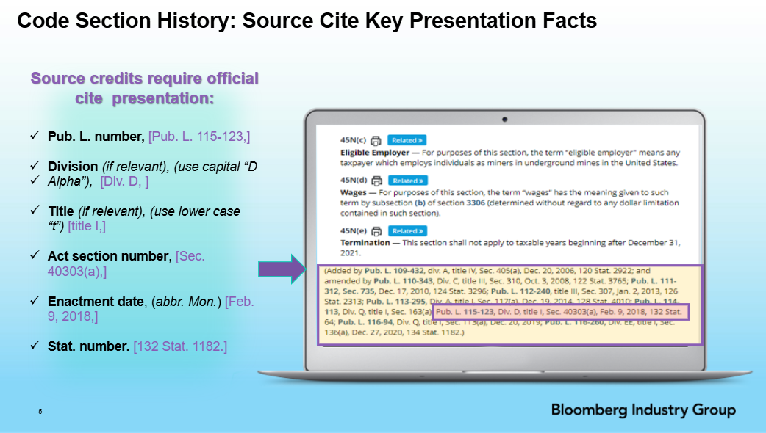

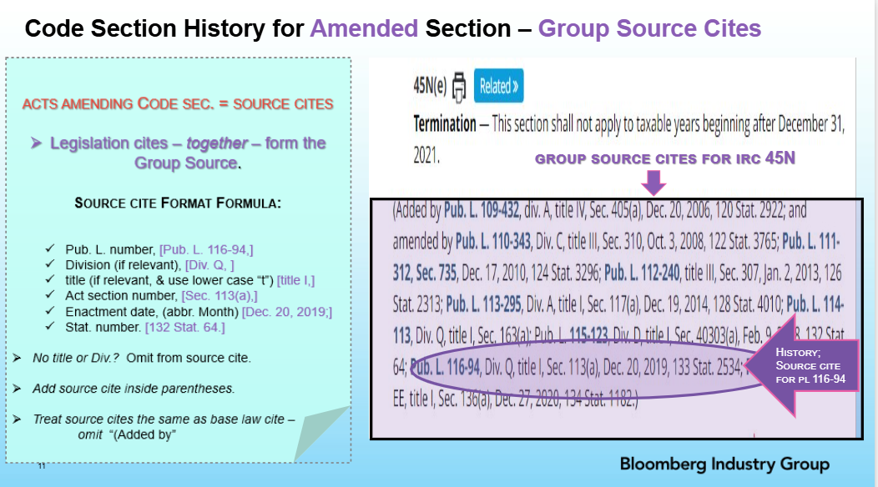

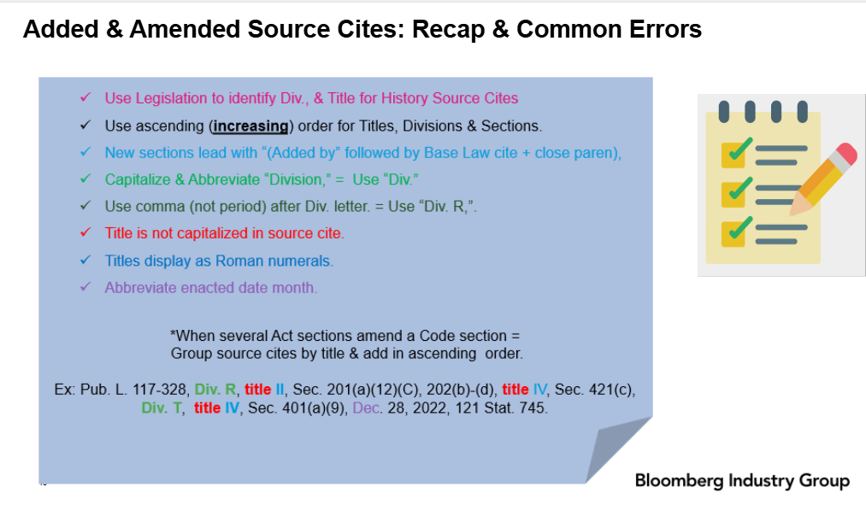

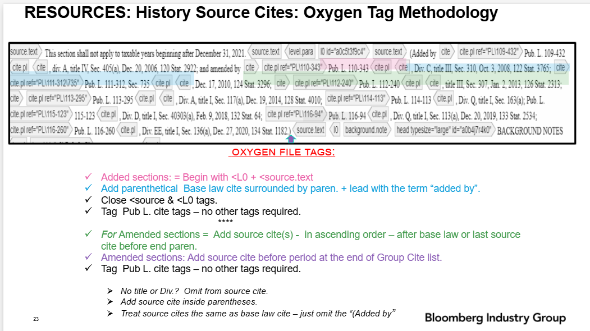

BACKGROUND NOTES
