CODE SECTION UPDATE JULY10, 2025 NOTES

FOR ADDED/NEW CODE SECTIONS

History:
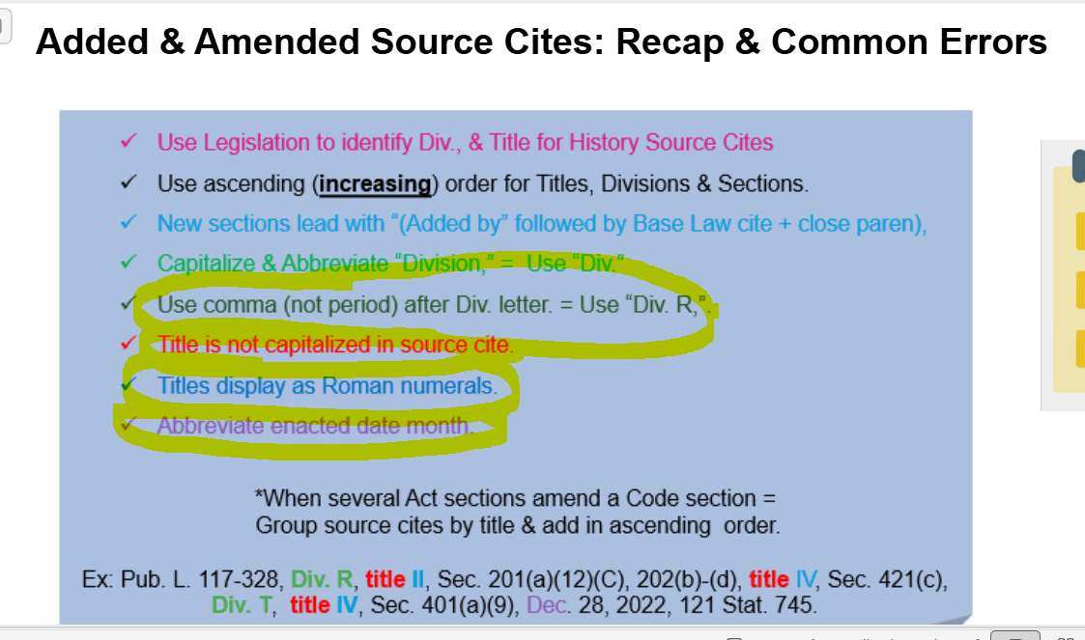

NOTE: THERE ARE NO AMENDMENTS IN THE BACKGROUND NOTES IN NEW CODE SECTIONS

Effective Dates:
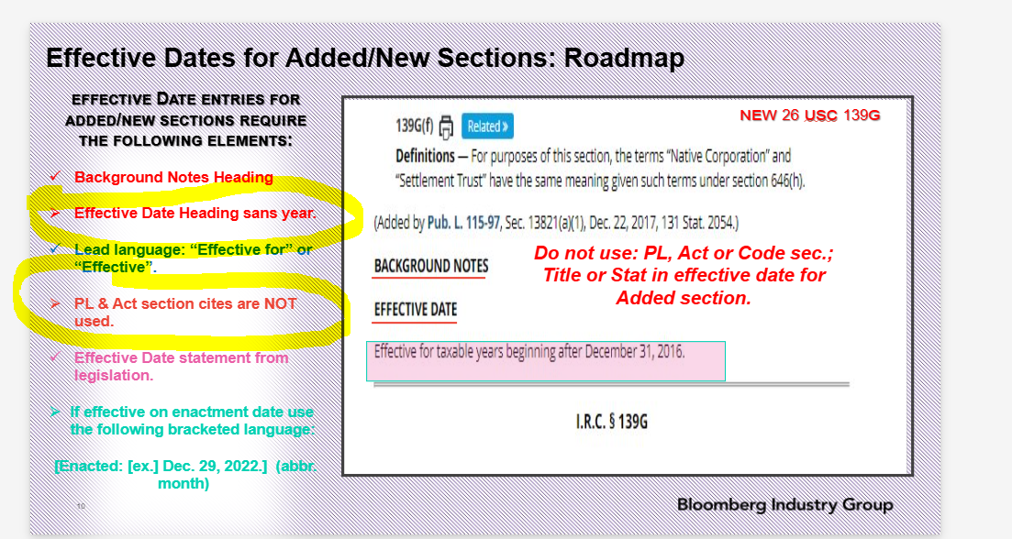

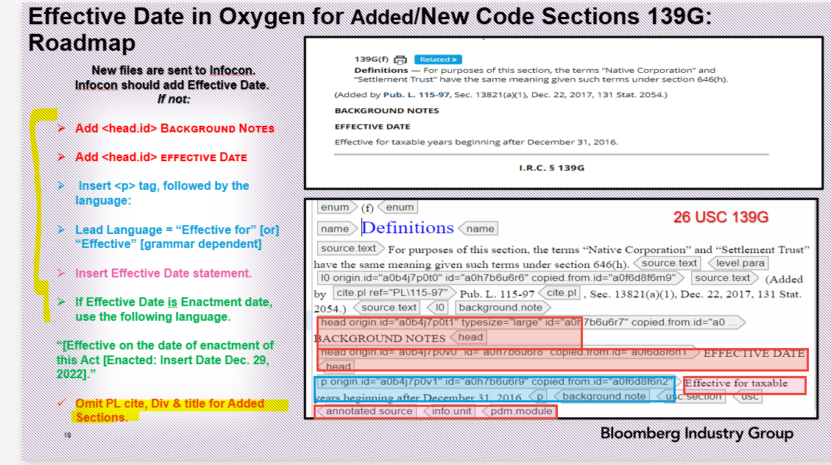

NOTE: If the Effective date is not available use Enactment date.

EDITOR’S NOTE

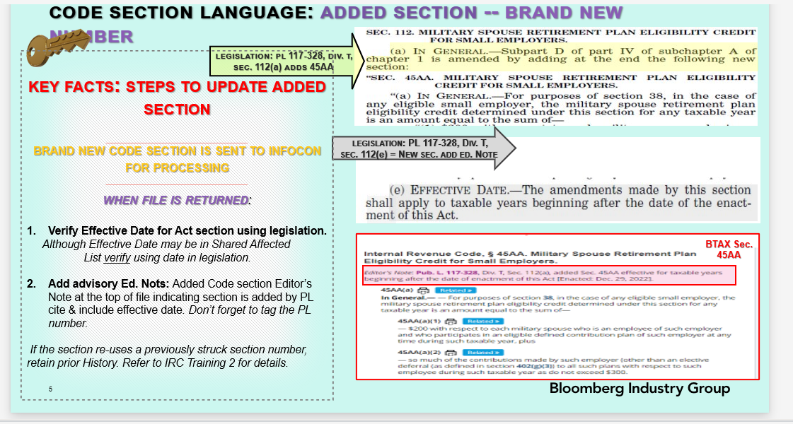

NOTE: IF DATE IS DELAYED –ADD EDITOR’S NOTE or taxable years before enactment date
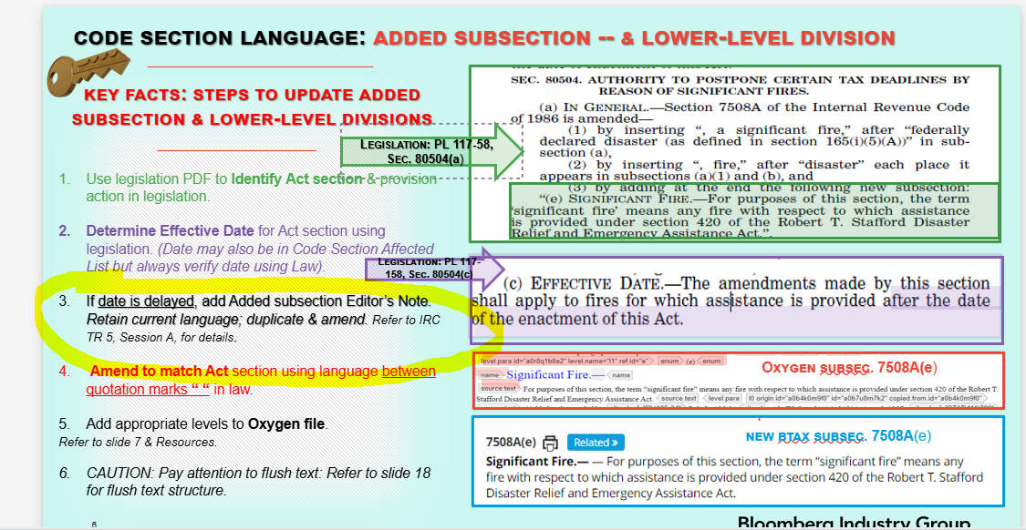

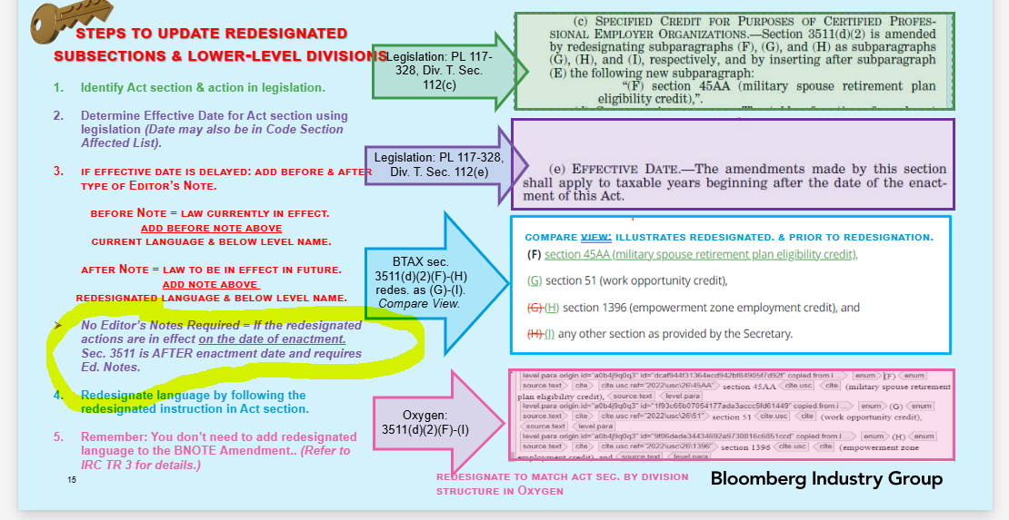

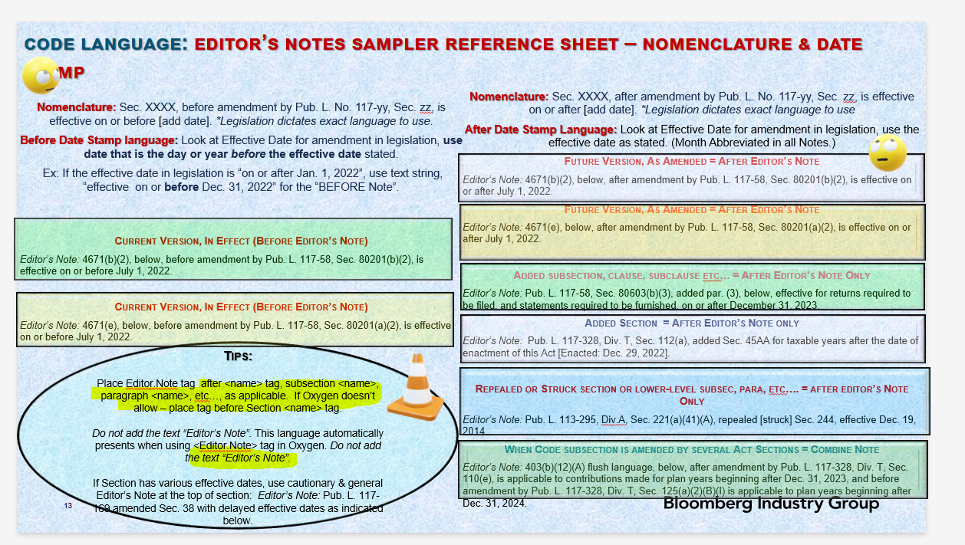

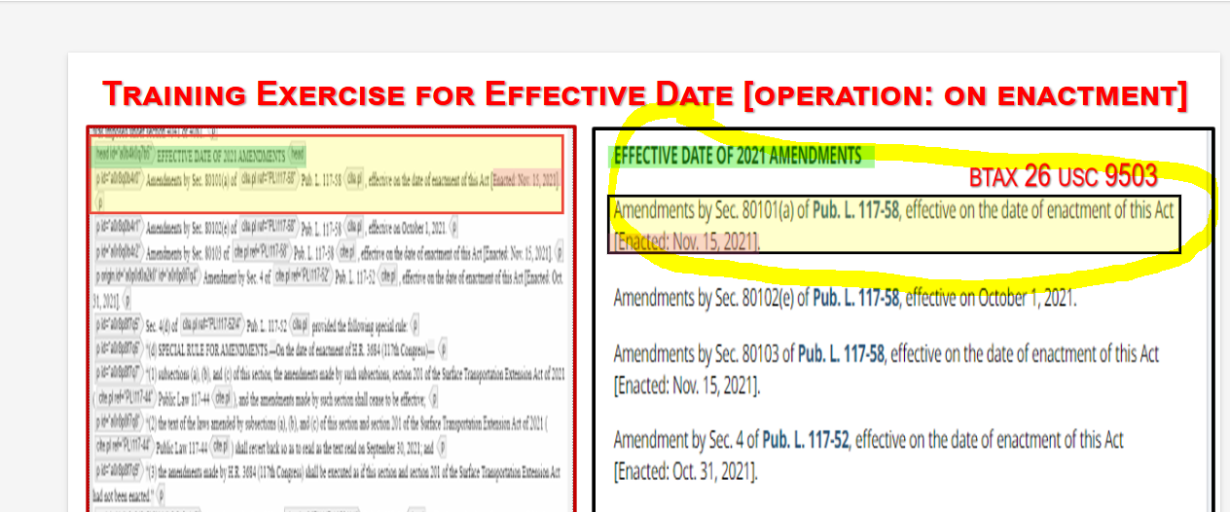

**********************************************************************************
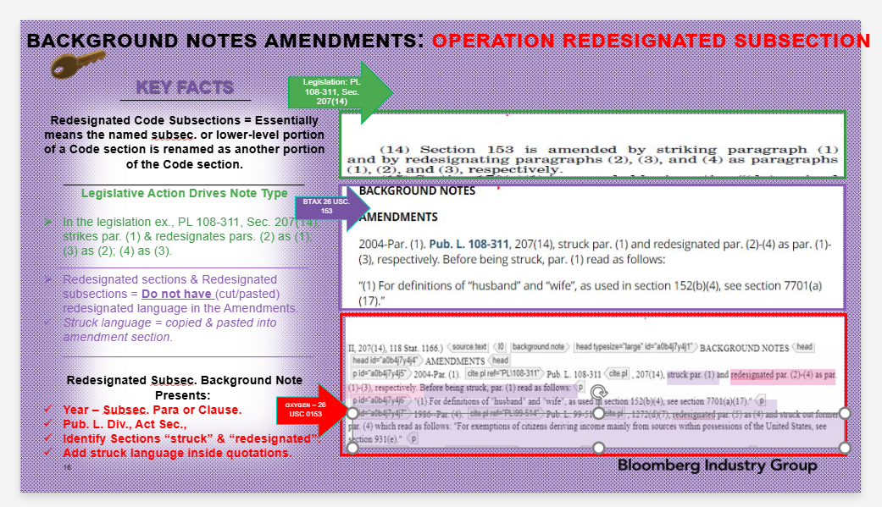

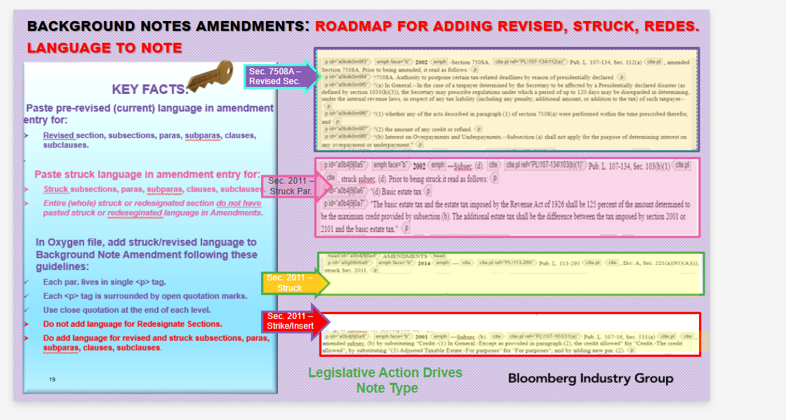

ADDITIONAL EDITOR’S NOTES:
Editor’s Notes
- While we don’t need Editor’s Notes for provisions effective “after the date of enactment”, we need notes for “taxable years after the date of enactment”. There’s a key difference between these (2) statements.

- No Editor’s Notes for these scenarios. Background Note Effective Date will read. .
- Effective after the date of enactment of this Act [Enacted: July 4, 2025].
- Effective to obligations issued after the date of enactment of this Act [Enacted: July 4, 2025].
- Effective on the date of enactment of this Act [Enacted: July 4, 2025].
- Effective to property the construction of which begins after December 31, 2024.
- Effective to facilities or equipment placed in service after the date of enactment of this Act [Enacted: July 4, 2025].

- Editor’s Note are required for these scenarios. You can use these as a guide, by finding a close match and tweaking . . .
- Editor’s Note: Sec. XXX, below, before amendment by Pub. L. 119-XXX, Sec. XXX, is applicable to taxable years beginning on or before Dec. 31, 2024.

- Editor’s Note: Sec. XXX, below, after amendment by Pub. L. 119-XXX, Sec. XXX, is applicable to taxable years beginning after Dec. 31, 2024.

***
- Editor’s Note: Sec. XXX, below, before amendment by Pub. L. 119-XXX, Sec. XXX, is applicable to taxable years beginning on or before Dec. 31, 2025.

- Editor’s Note: Sec. XXX, below, after amendment by Pub. L. 119-XXX, Sec. XXX, is applicable to taxable years beginning after Dec. 31, 2025.

****

- Editor’s Note: Sec. XXX, below, before amendment by Pub. L. 119-XXX, Sec. XXX, is applicable to property acquired on or before Jan.18, 2025

- Editor’s Note: Sec. XXX, below, after amendment by Pub. L. 119-XXX, Sec. XXX, is applicable toshall apply to property acquired after Jan. 18, 2025.

****
- Editor’s Note: Sec. XXX, below, before amendment by Pub. L. 119-XXX, Sec. XXX, is effective for productions commencing in taxable years ending on or before the date of the enactment of this Act [Enacted: July 4, 2025].

- Editor’s Note: Sec. XXX, below, after amendment by Pub. L. 119-XXX, Sec. XXX, is effective for productions commencing in taxable years ending after the enactment of this Act [Enacted: July 4, 2025].

***
- Editor’s Note: Sec. XXX, below, before amendment by Pub. L. 119-XXX, Sec. XXX, is effective for estates of decedents dying and gifts made on or before Dec. 31, 2025.

- Editor’s Note: Sec. XXX, below, after amendment by Pub. L. 119-XXX, Sec. XXX, is effective for estates of decedents dying and gifts made after Dec. 31, 2015.

