MLI Notes: Next Steps
I have just finished moving the final drafts that are ready to be uploaded onto BWIP to a TPQA folder. They are located here:
I:\GROUPS\Tax&Accounting\Analysis & Content\International\Withholding\Withholding Updates\MLI WHT Project notes\For TPQA
Currently, there are 394 of the 443 total final drafts available in that folder. Each draft contains analysis from the point of view of both treaty-partner countries as the “source” country. So, each draft contains updates for 2 BWIP files (for example, the draft titled “Albania-Belgium MLI Notes Final” is technically 2 files – one where Albania is the source country and Belgium as the source country – meaning there are 886 BWIP files to update in total. The remaining 49 drafts (98 files) will be added to the “For TPQA” folder on a rolling basis, as they are finalized. I have attached a spreadsheet listing all the drafts. It has columns to track the date added to BWIP and whether it is live on product. Hopefully it is helpful in keeping track of the progress and ensuring we don’t miss uploading the outstanding drafts.
In BWIP, I typically use the BDMS Search function to locate and check out the files. Here is the necessary coding:
- Service Code: tmiwt2-ref
- Class Code: 200
- Country codes (Unit Code) can be found here: https://www.nationsonline.org/oneworld/country_code_list.htm#C
For example, to upload the “Albania-Belgium MLI Notes Final” draft, you will need to checkout two files: (1) using Unit Code: al-be (Albania as “source” country) and (2) using Unit Code: be-al (Belgium as “source” country).
Albania-Belgium:
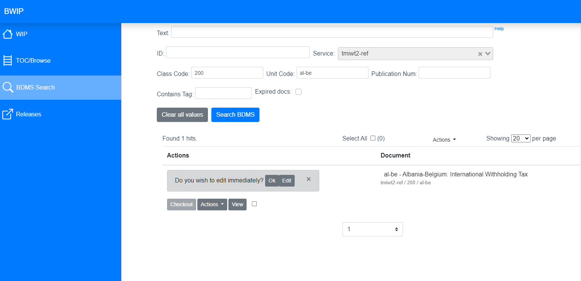
Belgium-Albania:
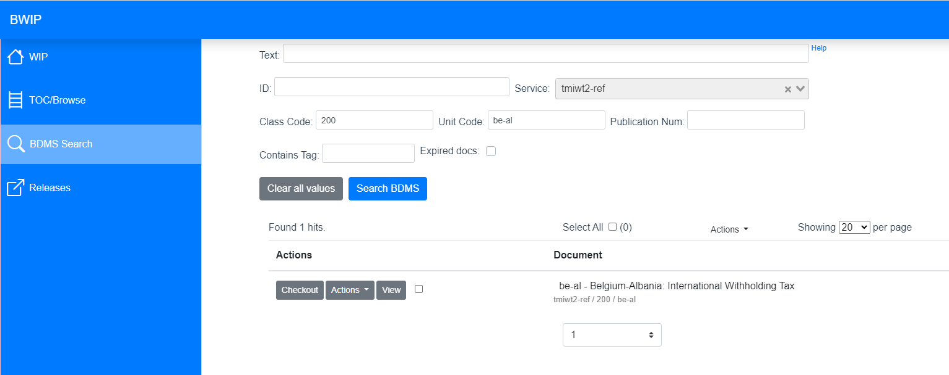

A few things that will be helpful to know about the Withholding Chart when uploading the documents:
- There are 5 main categories covered: Dividends, Interest, Royalties, Services, and Capital Gains. Within those main categories are 16 subcategories (aka, “boxes”). The boxes are where the analysis in the drafts will be uploaded in BWIP.
- Each analysis box contains 3 primary headings:
  - The Headline Rate (highlighted below) – this is the applicable rate from the treaty. It will either be a percentage (i.e., 20%, 10%, 0%, etc.) or will say something like, “Domestic rate not modified.” The Headline Rate should always have a BOLD emphasis. If the BWIP rate differs from the draft, it will need to be changed to the draft’s rate.
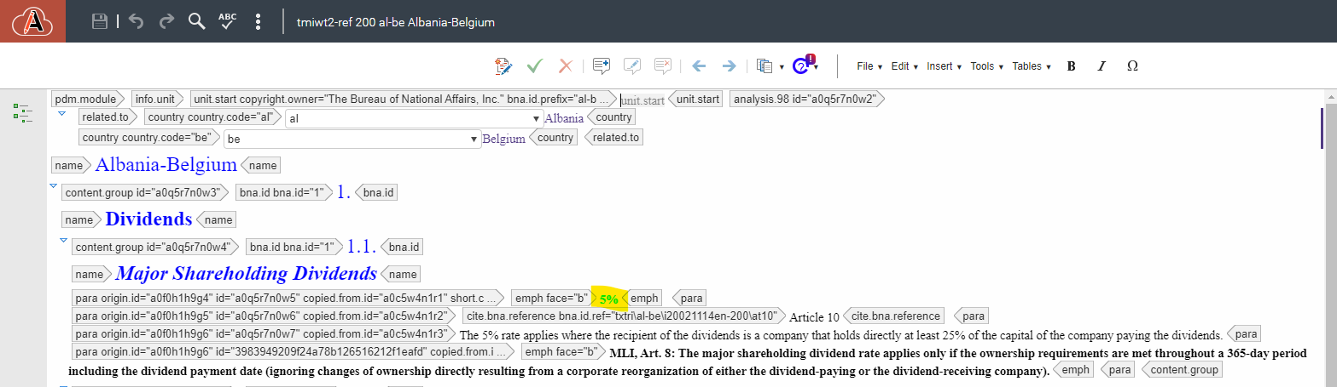
    - Tip: where rate changes are necessary, it is usually in box 4.1 – General Business Services (usually from “0%” to “10%” or some other percentage between 5 and 25%); 5.1 – Capital Gains: Immovable Property (usually from “0%” to “Domestic rate not modified” or vice versa); or 5.2 – Capital Gains: Company Shares (usually from “0%” to “Domestic rate not modified” or vice versa).

  - The relevant treaty article – this heading provides a link to the treaty between the 2 countries and cites the relevant treaty article. It should have a cite.url. reference, but some have cite.bna or other reference. Changing those references is beyond the scope of this project. You will only need to worry about changing the text of the Article Number within the cite reference.
    - Tip: this will typically happen in box 4.1 – General Business Services (usually from “Article 7” to “Article 14” or “Article 12”), but any box may require updating.
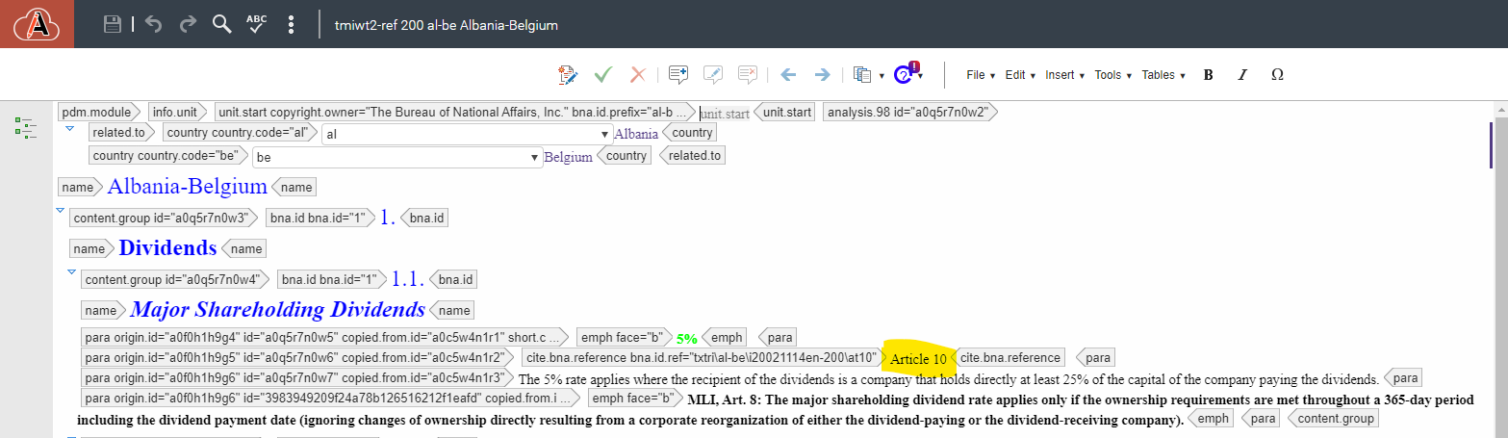
  - The relevant analysis – after giving the prevailing rate and the treaty article it pertains to, each box contains analysis on conditions of, or exceptions to, the prevailing rate under the treaty and the source country’s domestic law. This will be the bulk of the content changed in BWIP and where you will insert the MLI Notes. The analysis section is the only section that will require the insertion of multiple paragraph element tags in BWIP. All paragraph or list items in the drafts will need their own paragraph tag.
    - Tip: in this project we are updating more boxes than just those impacted by the MLI Notes. Any box in the draft containing text will need to be updated in BWIP. So, if the draft document contains analysis in any of the 16 boxes, I typically delete all the box’s analysis paragraphs on BWIP before adding the text contained in the drafts – even if it appears that the draft language is the same as what is currently in the box on BWIP.
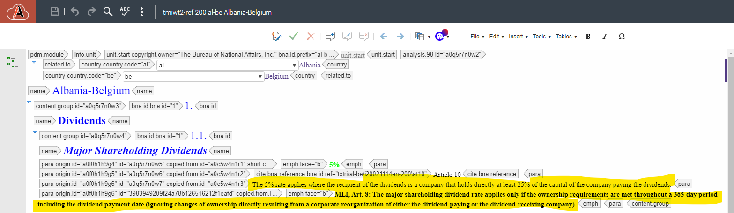
- The MLI Notes will be added to some, or all, of the following 3 boxes:
  - 1.1 – Major Shareholding Dividends – if there is a MLI Note, it will start “MLI, Art. 8:…”
  - 4.1 – Payments for General Business Services – if there is a MLI Note, it will start “MLI, Art. 14 (and 15):…”
  - 5.3 – Company Shares – if there is a MLI Note, it will start “MLI, Art. 9:…”
- All MLI Notes should be added with BOLD emphasis.
- If the draft contains text in any of the 16 boxes, those boxes will also need to be updated in BWIP.
  - Tip: In addition to the 3 boxes containing the MLI Notes analysis, almost every draft contains updated analysis in box 5.1 – Immovable property.
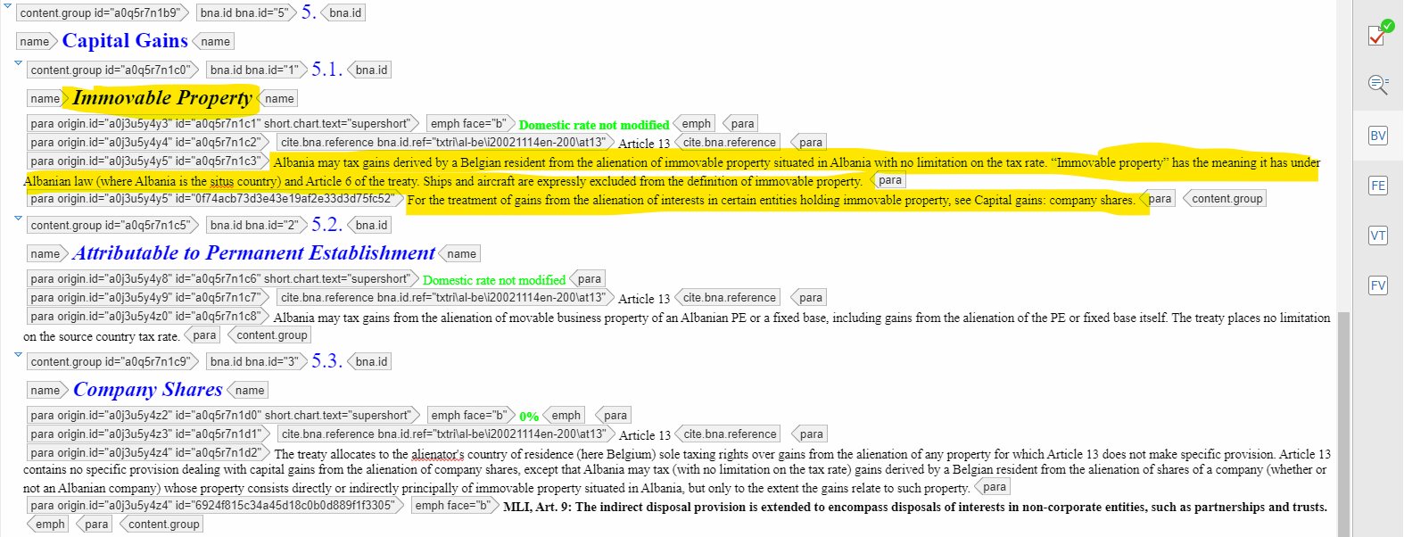

Steps for changing analysis:
- Checkout files in BWIP. Use the Country Codes if needed.
- Open the files in Oxygen by clicking edit in BWIP. Use the outline on the left-hand side to navigate the file.
- Highlight the analysis as it’s shown in the image above. Replace that with the new analysis from the Word doc.
- If there are any MLI notes they must be bolded when adding.
- Save your work then release it back to the product.

