BTAX User Guide (Draft)
Contents
Section 1 – Tools Overview 3
Primary audience 3
Tools ecosystem 3
What is BWIP? 4
What is Oxygen? 4
What is BDMS? 4
What is Anthology? 4
What is Autocat? 4
What is Bwrite? 4
Section 2 – BWIP 4
Login & Permissions 5
Dashboard overview (WIP) 5
File check-out 6
Locate and Edit a Checked-Out Document in WIP 8
Updating a file status in BWIP 8
Unlocking Files in BWIP 9
Queues 10
Re-numbering footnotes 10
Section editing 10
Publishing (Releasing) 10
Exporting a file from BWIP 12
Send to Autocat 13
Check Out History and Redlines | Restore a Version in WIP 13
Section 3 – Oxygen 15
Login & Permissions 15
Navigation / menu overview 15
Tagging & editing 15
Attributes 15
Copying/moving 15
Inserting special characters/symbols 15
Adding an image 15
Editing Portfolios 15
Editing Navigators 16
Editing State Refs 16
Desktop vs web versions 16
Section 4 – Troubleshooting (Errors) 16
Error types 16
Resolving tag validation errors 16
Resolving BPUB validation errors 16
Section 5 – FAQ's 16

Section 1 – Tools Overview

Primary audience
This guide was created primarily to help Bloomberg Tax Analysis & Content Analysts and Authors use the tools necessary for publishing content on the Bloomberg Research platform. However, his guide will be useful for anyone using these tools.

Tools ecosystem
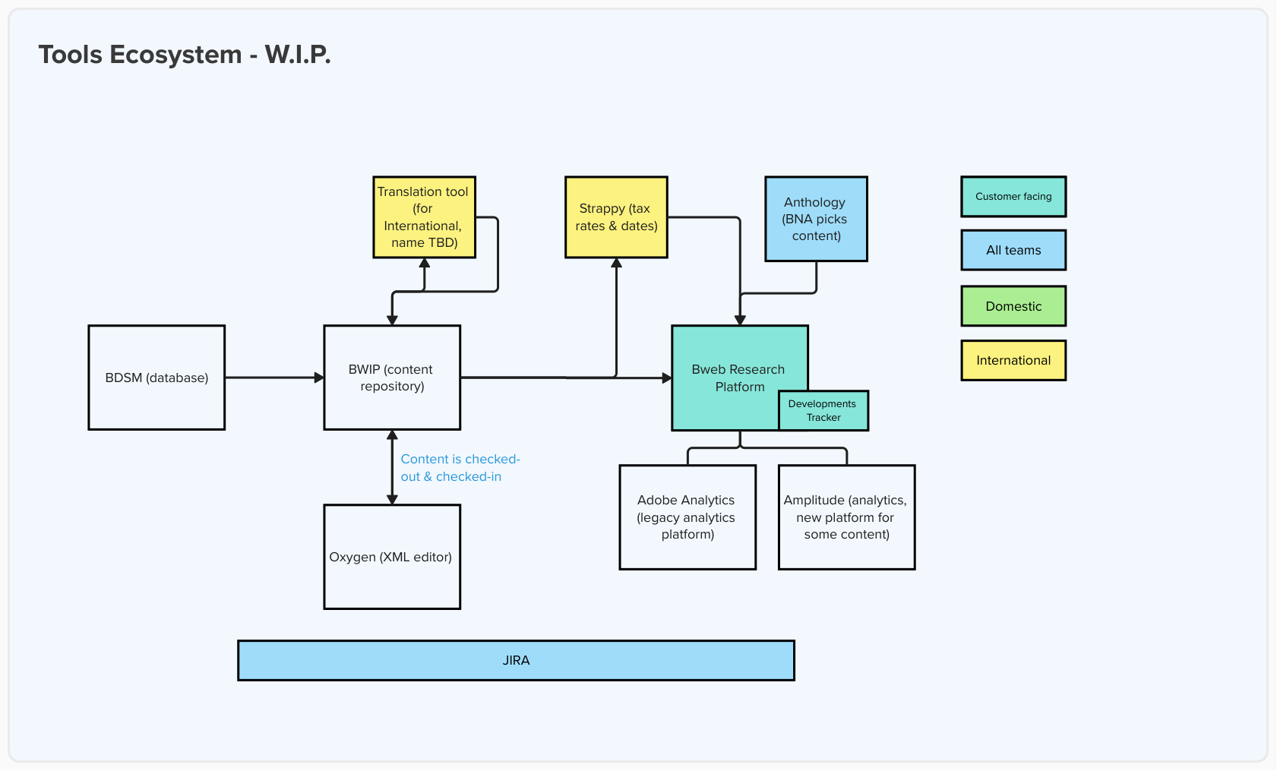
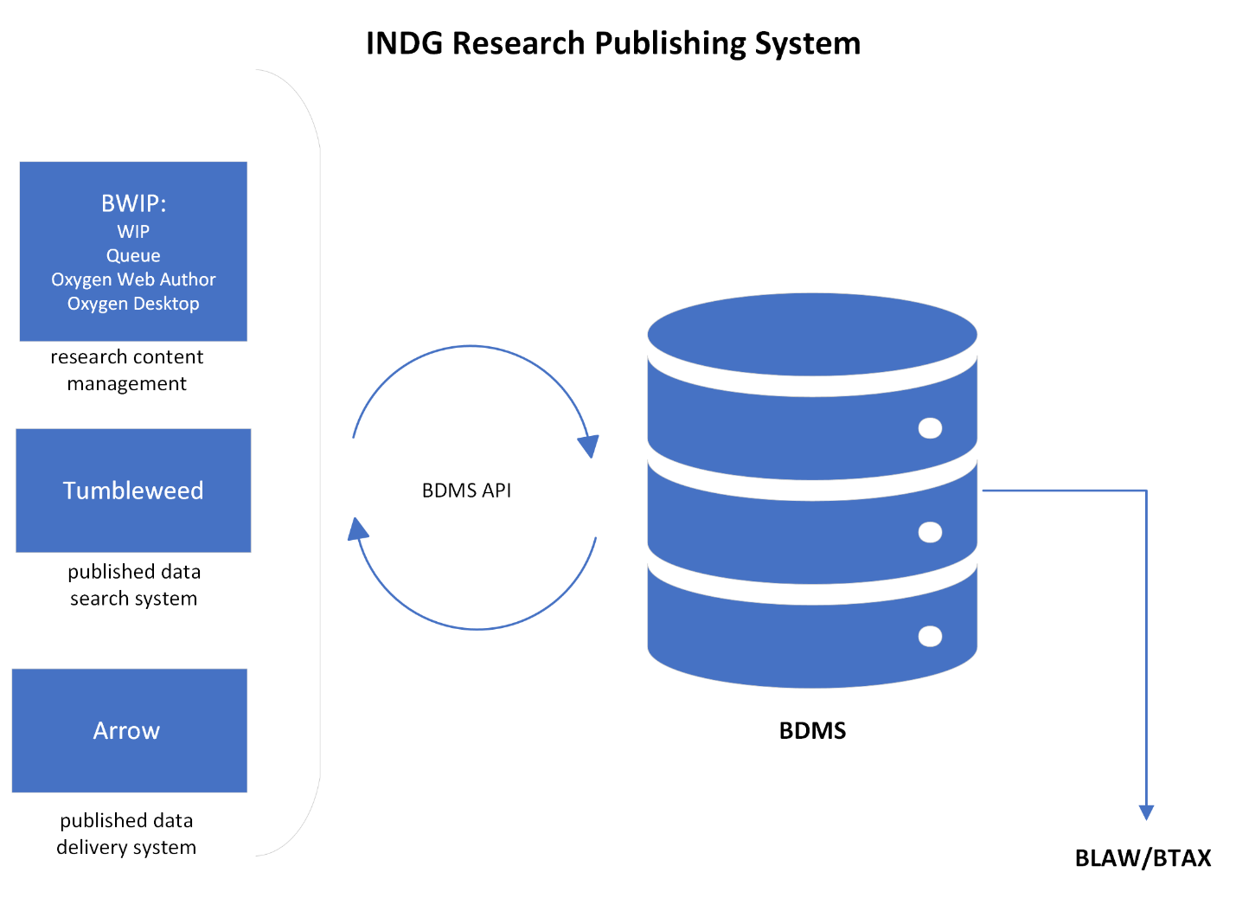

What is BWIP?
BWIP is Bloomberg’s custom file management system, used as a file repository for draft content allowing users to check file out and in to edit before publishing to the customer-accessible Bloomberg Research Tool.

What is Oxygen?
Oxygen is an XML editor used to create and edit the Bloomberg Research Tool content that is stored in the BWIP publishing tool.

What is BDMS?
BDMS is Bloomberg’s central database that stores data and content that is used throughout the organization, such as what is published on the Bloomberg Research platform.

What is Anthology?

What is Autocat?

What is Bwrite?

Section 2 – BWIP
For a video overview of BWIP, click here.

Login & Permissions
- Use Bloomberg Okta login to sign-in to https://bwip.bindg.com/wip
- If you’re not able to access via the link above, log-in to https://bna.okta.com/ and select the BWIP app
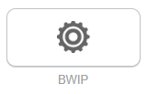

Dashboard overview (WIP)
- Left rail includes the various BWIP views available (always defaults to WIP – Work In Progress)

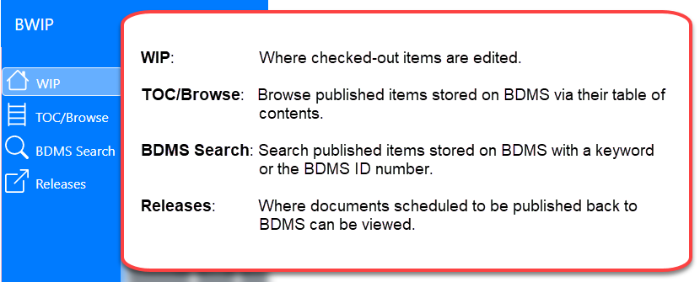
    - WIP – main section within BWIP where files are displayed. Use this tab to select a file to edit.
    - TOC(Table Of Contents)/Browse - use this tab to find files by entire collections (service)
      - Select a service code from the ‘Service’ dropdown menu and then click the ‘Browse BDMS’ button (BDMS – Bloomberg Document Management System)
Note this page only works for those services that have a table of contents. Otherwise use the BDMS Search option.
    - BDMS Search – a way to search for a specific file or collections directly from the central BDMS database
    - Releases - this tab provides history and status of files that have been released (published) or are scheduled to be released from the WIP. Files are listed by those released most recently. Users can search for a specific file using the filters at the top of this page.
    - The left rail can be expanded or collapsed using the arrows (<< / >>) at the bottom.
- Right rail shows specific information about the file that has been selected
    - This is collapsed by default. Click the blue icon at the bottom right of the screen to expand 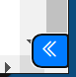
    - The right rail incudes information about the document history (i.e. last edits, checkouts, and auto-saves), displays the BDMS ID, and footnote information. To restore a previous version of the file, view the steps in the Check Out History and Redlines | Restore a Version in WIP section of this document.
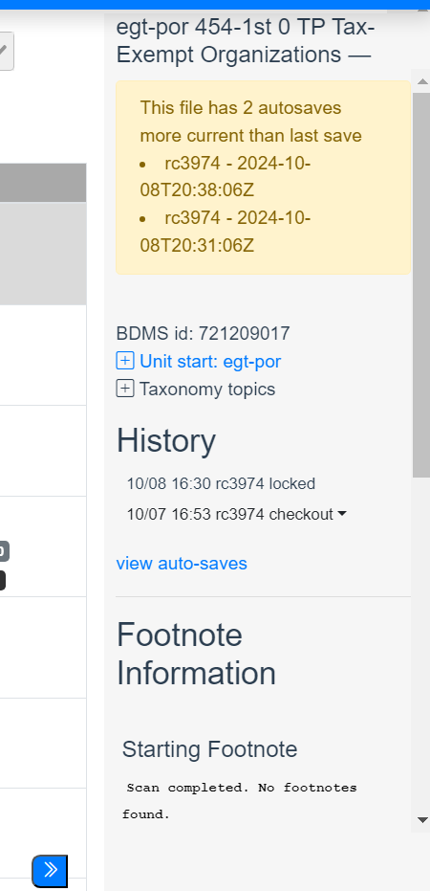

File check-out
- Locate and Check Out a Document with TOC/Browse
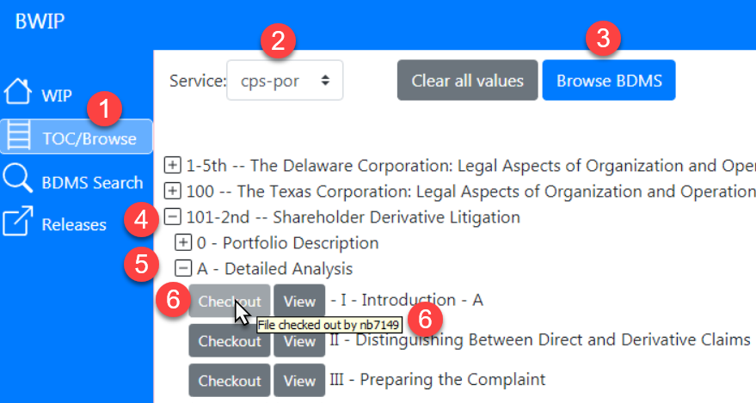
Note: To start over at any time, click Clear all values.
- Click TOC/Browse on the left navigation panel.
- Click the arrow beside Service to select the appropriate service.
- Click Browse BDMS. All documents for the selected service are displayed.
- Click the plus beside a document to open its table of contents.
- Click the plus beside subsequent levels to reach the document needed for check out.
- Click Checkout beside the required document. The button turns light gray when the document is successfully checked out. Note: If Checkout is already a light gray, the document has already been checked out. Hover over the Checkout button to see who has the document checked out.

- Locate and Check Out a Document with BDMS Search
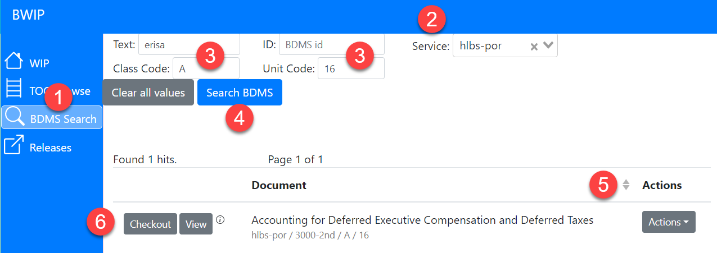Note: To start over at any time, click Clear all values.

- Click BDMS Search on the navigation panel.
- Click the arrow beside Service to select the appropriate service.
- (Optional) Enter keyword(s) in the Text field, a BDMS ID in the ID field, or unit.start tag information into the Class Code or Unit Code fields.
- Click Search BDMS. Notes: 1) If you click Search BDMS when there is no data in the Text or ID field, all documents for that service are displayed. 2) Documents are displayed in the XML file name format, but the service and file information appears beneath the file name.
- (Optional) Click the drop-down arrow beside the column title Document to sort the file names alphabetically.
- Click Checkout beside the required document. The button turns light gray when the document is successfully checked out. Note: If Checkout is already a light gray, file has already been checked out. Hover over the Checkout button to see who has the document checked out.

Locate and Edit a Checked-Out Document in WIP
After checking out a document, locate it on the WIP page to edit it.
Note: To refresh only the WIP page, click the refresh icon beside the service filter instead of the browser refresh icon (or F5) which will refresh all the pages.
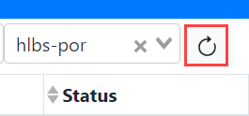

Updating a file status in BWIP
Documents checked out on the WIP page are labeled with statuses, which are displayed in the far right column. To filter the documents by a status, click the drop-down arrow beside the Status field and make a selection.
Generally, a document’s status is assigned when a BWIP tool is run. A few of the statuses that are set automatically are:
- Edit when a document is checked out of BDMS.
- Pending Release when a user has chosen the Release file tool to post updates to BDMS. If a future date is entered, the document’s status will change to Pending Release until the update has been recorded in BDMS.
- Deleted when a new (unpublished) document is deleted from BWIP.
- Abandoned when a user selects the Unreserve in BDMS – Abandon Edits tool.
Two optional statuses are Ready for Approval and Ready to Release.
To change the status of a document:
- Click on a document name to select it. Note: A 1 appears to the left of the document name.
- Click Actions to the left of the document name.
- On the drop-down menu, make one of the following selections:
- Mark For Edit changes the status back to Edit.
- Mark For Approval changes the status to Ready for Approval.
- Mark For Release changes the status to Ready for Release.
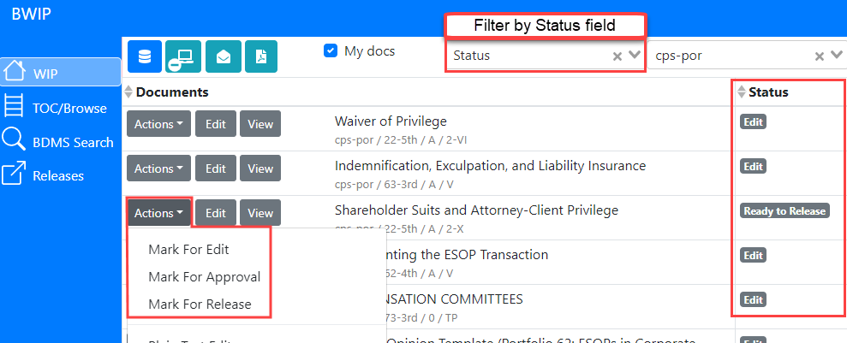
New Actions drop down menu:
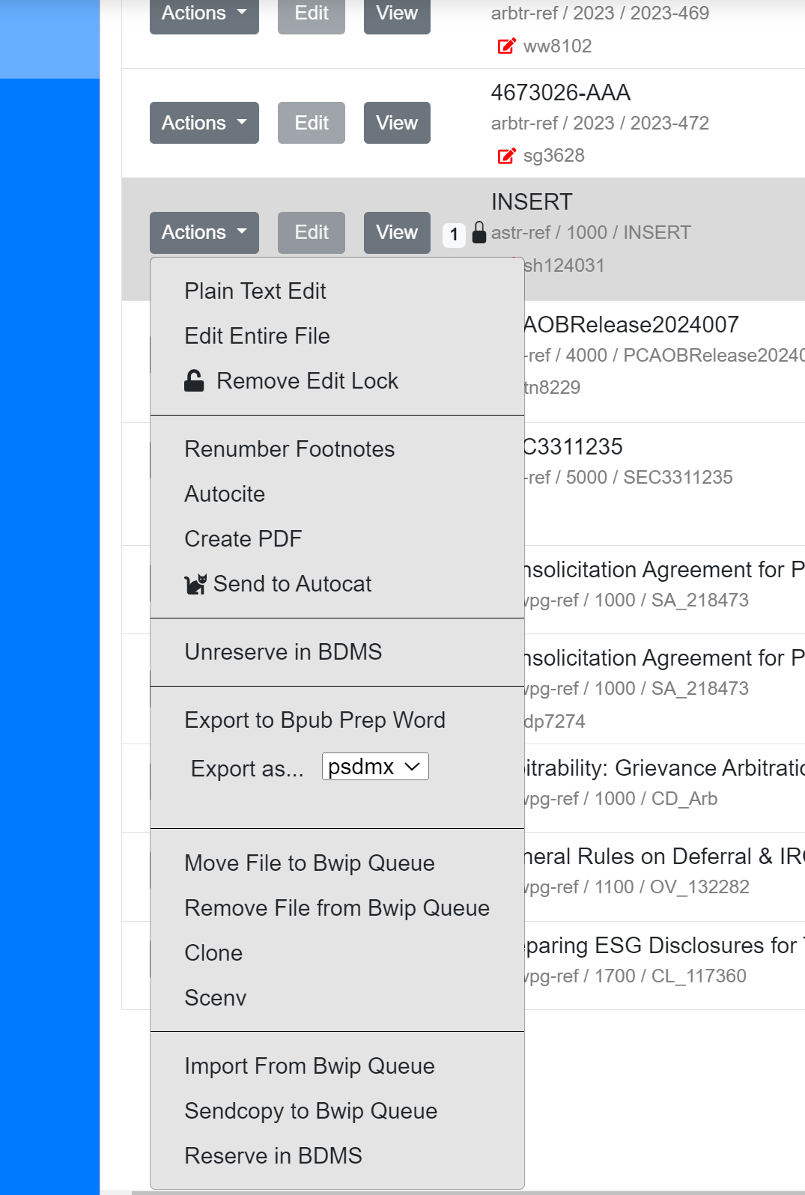

Unlocking Files in BWIP
- If the Edit button says Read instead, BWIP believes the file is currently being edited. A lock icon also appears beside the document name and the user ID of the one editing the file is found under the status.
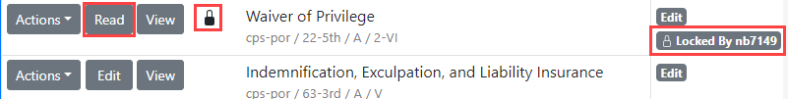If another user is editing the document, please contact that person to discuss storing the file so you edit it. If BWIP shows that you are editing the document, and you are not, you can remove the edit lock with the following steps:

- Verify you do not have the document open in a hidden tab or window.
- Click Actions to the left of the document name.
- Select Remove Edit Lock.
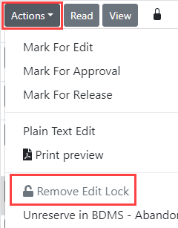

Queues
Explanation of what queues are and how to use them

Re-numbering footnotes
This can be done directly in BWIP or in Oxygen. For large files, this must be completed in BWIP.
- From the WIP, select the desired file and click Actions.
- Select Renumber Footnotes. A prompt will display on the screen with the following options:
- Starting Number field – the first footnote to be renumbered
- Renumber in Tables? - option to renumber table footnotes if desired
- Renumber non-numeric footnotes?

Section editing
Selecting which section(s) you want to edit and opening it up in Oxygen

Publishing (Releasing)
Finished documents are released to BDMS, which then loads them to the BLAW and BTAX websites.
For a video on the BWIP release process, click here.
Once edits to a document have been completed and approved:
- Navigate to the WIP page.
- Click on the document to be released. The number "1" appears next to the selected document. Note: To select more than one document to be released at the same time, hold down the Ctrl key and click to select additional documents or hold down the Shift key to select contiguous documents. A number appears next to each selected document.
- Click the Release file(s) icon on the top icon bar.
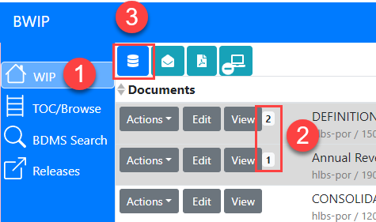
- The list of files to be released appears in the pop-up. Select when the files should be released:
  - To release now:
    - Click the radio button beside Now.
    - Click Release Now at the bottom. Note: Multiple documents that are released Now will create individual Release Groups. This prevents one failure from stopping other documents from releasing.
  - To schedule the release for later:
    - Click the radio button beside Later.
    - Select the required date and time.
    - (Optional) Give the release group a Release Name.
    - Click the Release on date at time button at the bottom.
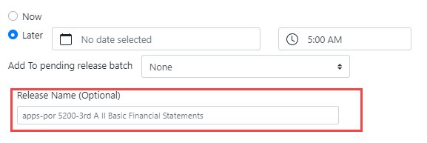
  - To add the document to an existing Release Group:
    - Click the radio button beside Later.
    - Click the dropdown arrow beside Add to pending release batch.
    - Select the existing Release Group to which this document should be added. Note: Information on that Release Group, such as its date and time and other documents in the group, displays at the top of the popup.
    - Click the Release on date at time button at the bottom.
    - The documents are released as scheduled.
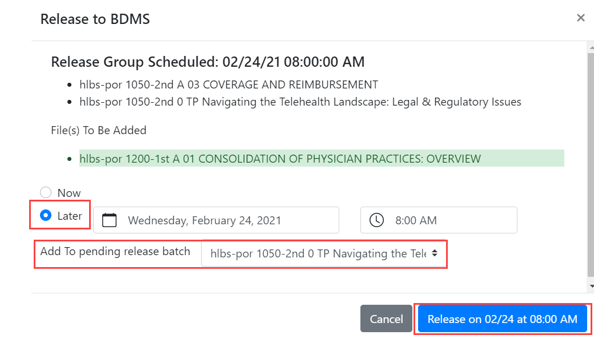
Note: On the WIP page, the status of documents scheduled to be released later is changed to pending release.

Exporting a file from BWIP
In BWIP, select the document from the WIP section.
Note: You can select and convert/email more than one document at a time. Hold the Ctrl key and click to select individual files. Hold the Shift key and click to select contiguous files.
- Click the Actions icon for that document. If multiple files are selected, click on the Action icon for any of them.
- Locate the Export as… option
- Select the desired format (i.e. PDF, Word) from the dropdown
- Click “Export as”
The file will be downloaded via your browser and can be access through your browser’s downloads.
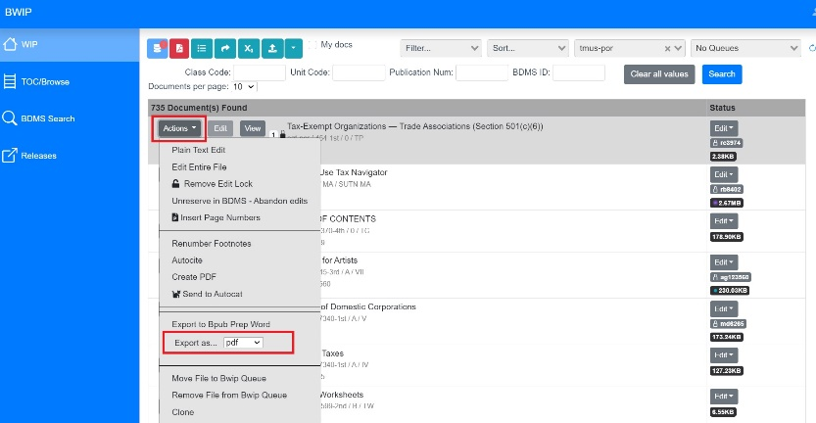

Send to Autocat
https://confluence.bna.com/pages/viewpage.action?spaceKey=BL&title=Creating+and+Editing+Practical+Guidance+Documents#CreatingandEditingPracticalGuidanceDocuments-3.SendtoAutocat

Check Out History and Redlines | Restore a Version in WIP
The details pane in WIP shows the history of a file since it was checked out. View what edits occurred in each version and the cumulative edits since the file was checked out. Select an earlier version to restore.
Open the Details View to See the History
- On the WIP page, select a file.
- Click the expand arrows on the bottom right to open the Details View, which shows information about this file.
- The History shows what events have occurred to this file since checkout.
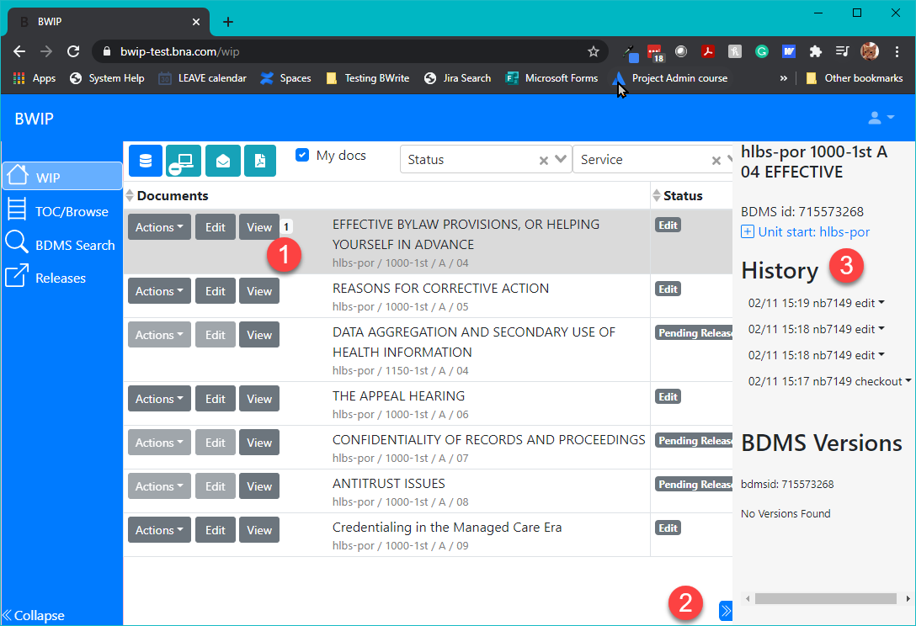
View Redline Changes or Restore a File
- On the Details View, click edit beside an event under History.
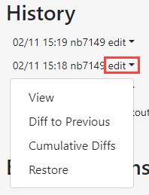
- Select Diff to Previous to view changes made during this editing session.
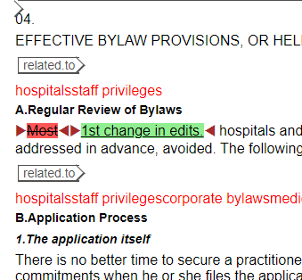
- Select Cumulative Diffs to view all the changes made since this file was checked out.
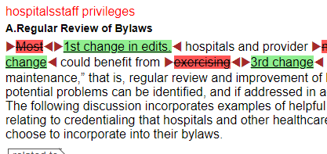
- To make an earlier set of edits the current version, click the arrow and select Restore to make it the current version.
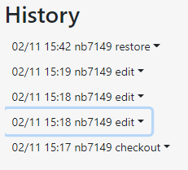

Section 3 – Oxygen

Login & Permissions

Navigation / menu overview

Tagging & editing
  - Inserting tags
Right click to bring up drop down menu: 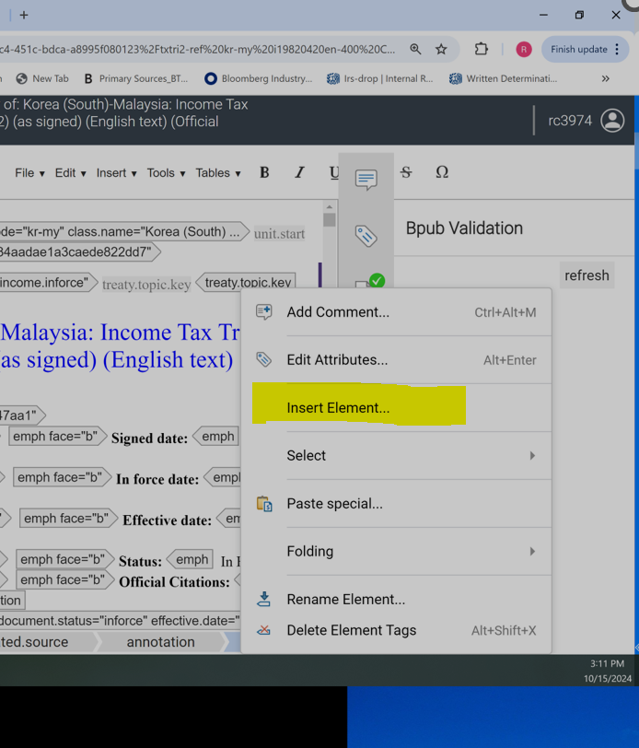

  - Modifying tags:
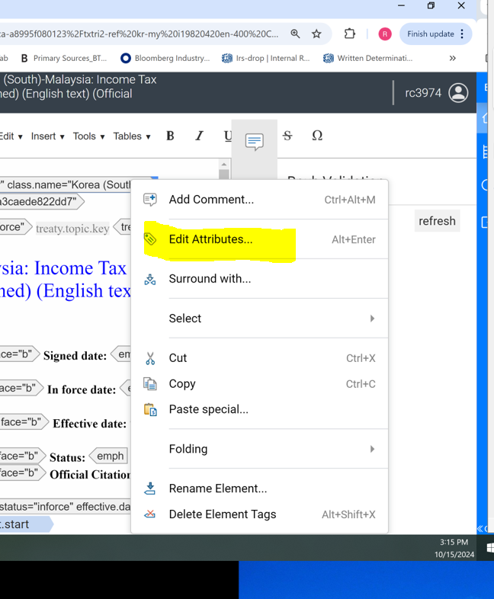
Click on edit attributes
Right click on tag to bring up drop down menu

  - Removing <content.group> tagging (needed?) https://confluence.bna.com/pages/viewpage.action?spaceKey=BL&title=Creating+and+Editing+Practical+Guidance+Documents#CreatingandEditingPracticalGuidanceDocuments-IV.Removing%3Ccontent.group%3Etagging
  - Types of tags
    - P tags vs paratags

Attributes
  - Inserting attributes
  - 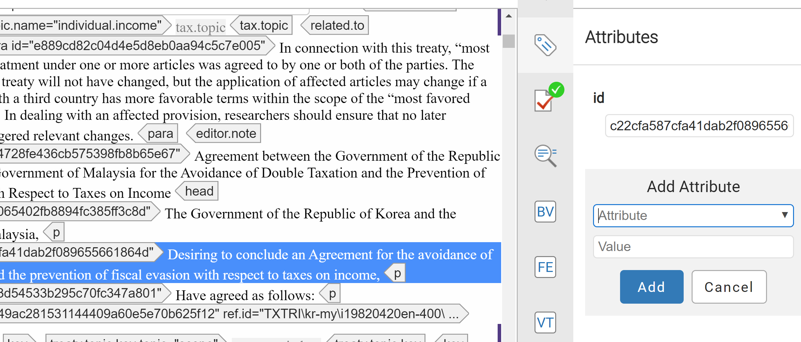
Select Attribute to be inserted on the drop down menu
Right click on tag then select edit Attributes

  - Modifying attributes

Copying/moving
  - Within a document
  - To another document

Inserting special characters/symbols
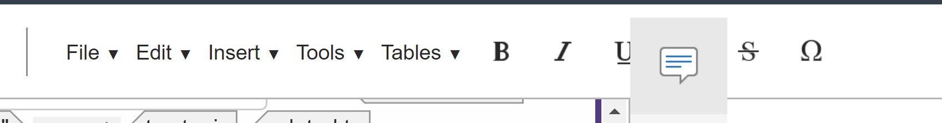
Click on the Special Character Icon

Adding an image
https://confluence.bna.com/pages/viewpage.action?spaceKey=BL&title=Creating+and+Editing+Practical+Guidance+Documents#CreatingandEditingPracticalGuidanceDocuments-III.AddinganImage
Editing Portfolios
- Creating or inserting new content groups
https://confluence.bna.com/display/BL/Editing+Portfolios+in+BWIP

Editing Navigators
- Chart tagging

Editing State Refs

Desktop vs web versions

Section 4 – Troubleshooting (Errors)

Error types

Resolving tag validation errors

Resolving BPUB validation errors
  - https://confluence.bna.com/bpdoc/bwip-documentation/troubleshoot-release-failed-or-edits-don-t-appear

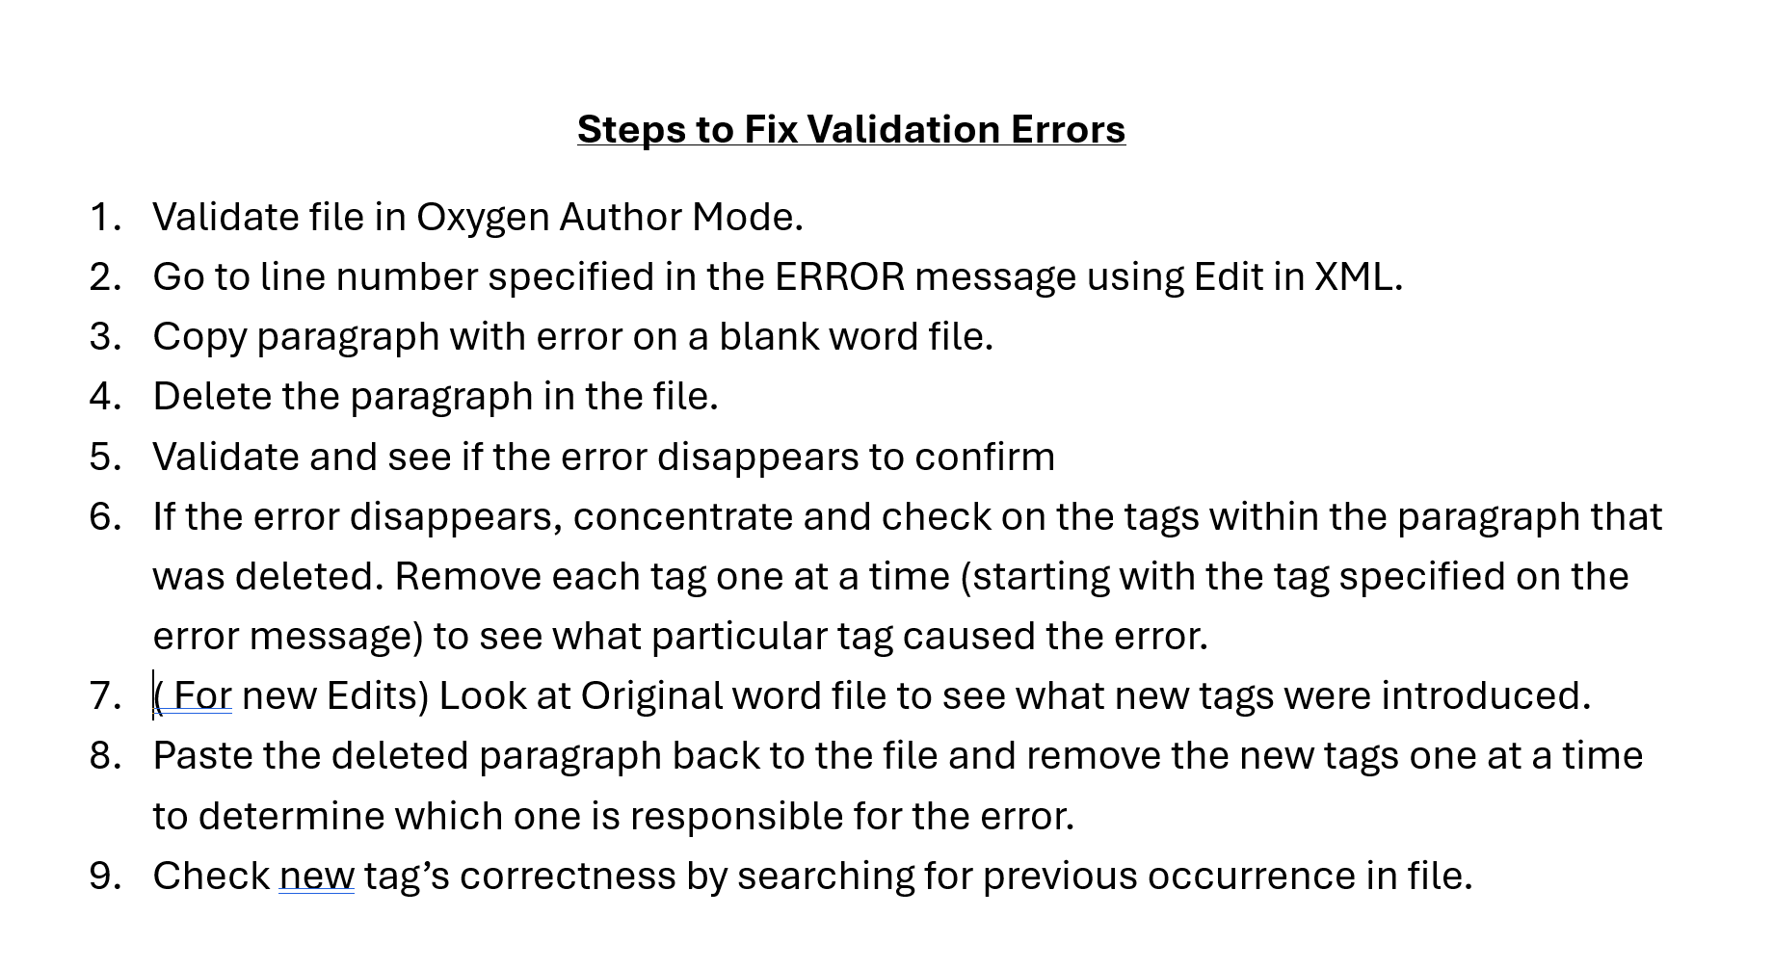

Section 5 – FAQ's
https://confluence.bna.com/bpdoc/bwip-documentation/faq-for-bwip

