Introduction & General Instructions
The Books are converted from PDF/DOCX to the PSDM DTD utilizing the <analysis.98> document type. Most Bloomberg books are published at least once a year.
The book information to be converted consists of the following:
Front Matter | Data included in this section are the Board of Editors pages, author pages, Prefaces and Acknowledgement pages. The table of contents in the book is not converted.
Book Body | The chapters of the book. Chapter table of contents that may be included in the book are not converted.
Appendix | Appendix documents
Table of Cases | Table of cases documents, if requested
Back Matter | Indexes, digests, etc., if requested.
With every book that is to be converted, Bloomberg will provide a spreadsheet indicating which sections of the book are to be converted and the required <book.unit.start> attribute values for those sections. Additionally, Bloomberg will provide an image spreadsheet indicating the images that should be tagged along with the required image ids.
If special instructions are needed for a particular book beyond this specification, Bloomberg will provide.

File Delivery Specification
The delivery will consist of one PSDMX file for each section indicated in the spreadsheet provided. The files will be named as follows:

[service code]_[class.code]_[unit.code]_[pdm.name]
For example:
CLE-BOOK_A_main0003_CH3
File will be left in the INFOBOOKS-PSP queue and status will be flagged as “Ready for Approval”.

Tagging Instructions

Basic Structural Tagging for Bloomberg Books

Tagging | Instructions
<info.unit>
<book.unit.start> | Attribute values should be added from the spreadsheet provided. See Section 1.3.2 for descriptions of each valid attribute.
<analysis.98> | Standard book container element for the nested <content.group> elements.
<name> | The name of the document; e.g. <name>Preface</name>, or <name>Chapter 1. Overview Of The Canadian Environment</name>. Note that for chapters of the book, “Chapter [book chapter #].[space] “ should be added to the chapter title if not present in the source.
<content.group> | Container element for the content sections of the book. This element can be nested.
<bna.id bna.id=”[value]”> | The value of @bna.id is the value of the chapter number or section of the chapter that is contained in the <content.group>; e.g. <bna.id bna.id=”A”>. The value of <bna.id> will be in the form of [value of chapter identifier].[value of section identifier if avail.].[value of subsection if avail.].[space]. For example: <bna.id bna.id=”A”>1.I.A. </bna.id>. See Section 1.4 for more details on <bna.id>.
</analysis.98>
</info.unit>

Book Unit Start Details
Each book chapter carries information about itself in the <book.unit.start> element. In order for the book data to process properly for product publication, the following attributes on this element must be filled in as supplied. This information that is required for each book will be provided by Bloomberg in spreadsheet format.
- acct.code—Required—The value for this attribute is the code assigned to the book. This value uniquely identifies the book within the book service code. An example of an account code is EB2D, which identifies the 2023 update to the Employee Benefits Law book.
- bna.id.prefix—Necessary— Although not required for an PSDMX-valid file, this attribute must be filled in so that correct link targets can be built for the electronic versions of the books. It provides a chapter number for a book document that, when concatenated with the bna.id values assigned to the content groups within the chapter, create unique link targets for electronic presentations of the book.
- class.code —Required—This attribute contains numeric or alpha characters that classify the book document.
- class.name —Required—The value of this attribute is the name of the class in which the document belongs, e.g., “Book Body,” “Front Matter.”
- date —Necessary— This attribute should be applied to all book units, even though the DTD does not require it. The value should be the publication date of the book provided in the Unit Start Spreadsheet. For example “2023-01-01.”
- folio—Necessary— This attribute contains the beginning page number of the book document/chapter. The folio must be filled in for all book units that have been or will be published in print, even though this attribute is not required by the DTD.
- part.name –Optional-- Some books are divided into parts (this is clearly shown in the book table of contents). When this is true, the part name and part number need to be included in the book unit start.
- part.num–Optional-- This attribute should contain just the part number, e.g., "1'" "2," etc.
- pdm.name —Necessary— For internal use as provided by the book.unit.start spreadsheet.
- publication.name—Necessary— The full name of the book should be entered as the value of this attribute.
- service.code —Required—This attribute contains the overall service code under which the books is found. An example of a book service code is EBL-BOOK for the Employee Benefits Law book.
- subpart.name —Optional— This attribute is optional and will only be used if the book is divided into parts and then subparts.
- supplement —This attribute is used to indicate whether or not a given information unit is part of a book supplement. The legal values for this attribute are “0” (no) or “1” (yes). The default value for this attribute is “0.” Therefore, this attribute only needs to be filled in if the unit start spreadsheet provide this information.
- unit.code—Required—This attribute represents a unique alpha/numeric value assigned to a book document. All book documents must have a unique code assigned to them.
- unit.name—Required—This attribute contains the name of the document being prepared. For text chapters, it is the chapter title. A general rule for books is that, regardless of how the chapter title is formulated in the book table of contents, the value for this attribute must contain the word "Chapter" followed by the chapter number, a period, and the title text.
- volume.num—Optional— Indicates which volume an Information Unit belongs to in a multi-volume work. This attribute is used rarely.

<content.group> Details
The <content.group> elements are nested heading and paragraphs that make up the main body of the chapters. The content group has both a <bna.id> and a <name> that together serve as its heading. The hierarchy of these content groups is achieved by properly nesting subordinate groups inside higher-level groups. The <bna.id> element has an attribute @bna.id which must contain the enumerator (letter or number) assigned to the level. The data content of <bna.id> should contain whatever needs to display to the reader.
For example, see Example Source Image 1 below. The content groups would be tagged as follows:
<content.group>
<bna.id bna.id="I">1.I. </bna.id>
<name>POLITICAL AND ECONOMIC FRAMEWORK </name>
<content.group>
<bna.id bna.id="A">1.I.A. </bna.id>
<name>Canada&apos;s Place in the International Community </name>
<para>Canada is the second largest country in the world in territory.
Canada&apos;s population of just over 34 million is, however, only
one-eleventh that of the United
States.<footnote><footnote.marker><superior>1</superior></footnote.marker><footnote.text><para>Online:
Statistics Canada
&#60;http://www.statcan.gc.ca&#62;.</para></footnote.text></footnote>
Much of Canada&apos;s territory is uninhabited because of harsh landforms
and a climate unconducive to settlement. About 60 percent of Canada&apos;s
population lives in the Great Lakes and St. Lawrence River regions
immediately to the north of the U.S. border states of Michigan, Ohio and New
York.
</para>
……..
</content.group>
</content.group>
Note the nesting of the content groups to create the hierarchy and the construction of the <bna.id> element.

Source Image 1

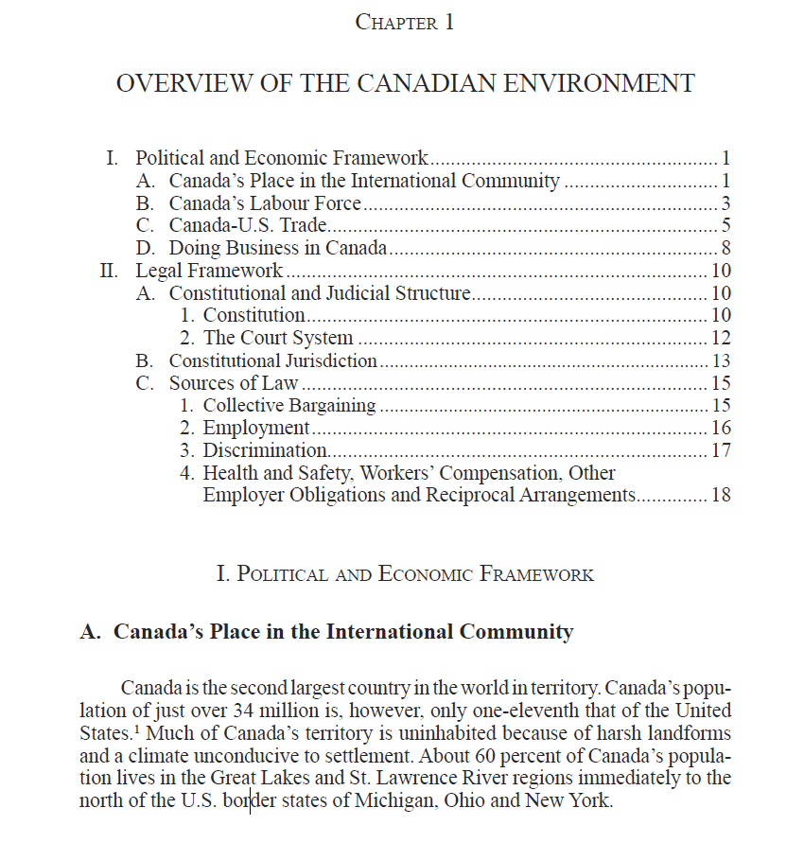

Image Tagging
Standard image tagging will be encoded. Bloomberg will provide an image spreadsheet indicating all necessary image element attributes.

Table Tagging
Standard table tagging will be used to tag tables.

Autocite
All the Chapters need have linking to the reference content like state law, federal laws, web pages etc. Specific Book instructions will have all the options to be used while running Autocite.

