PDF Upload Tool documentation
Updating a PDF that has already been uploaded

Log into the tool: https://bdms.bloomberglaw.com/bdms-www using your Terminal login credentials. You’ll need your BUNIT to generate an access code.

Step 1: Find the document you want to update

- Click on Search, in the menu bar, left corner (IF THE DOCUMENT DOESN’T SHOW WHEN YOU SEARCH WITH THE CORRECT BDMS ID – DO NOT INCLUDE THE REALM TAX OR BLG)

CLICK ON MY TASK TO BE ABLE TO ASSIGN TASK TO YOURSELF

SEND COPY OF PDF FILE VIA EMAIL BY LOADING OUTLOOK AND USING rcruz@bna.com to load.
Get the document using the download directory in Explore.

- 

- In the Saved Query selection menu, select the “Documents: Special Reports” query, and click the blue Search button. You will see a display of all the PDFs that have been uploaded in this collection. You can adjust the width of the table columns in the results to make it easier to read document titles.

Saved query box

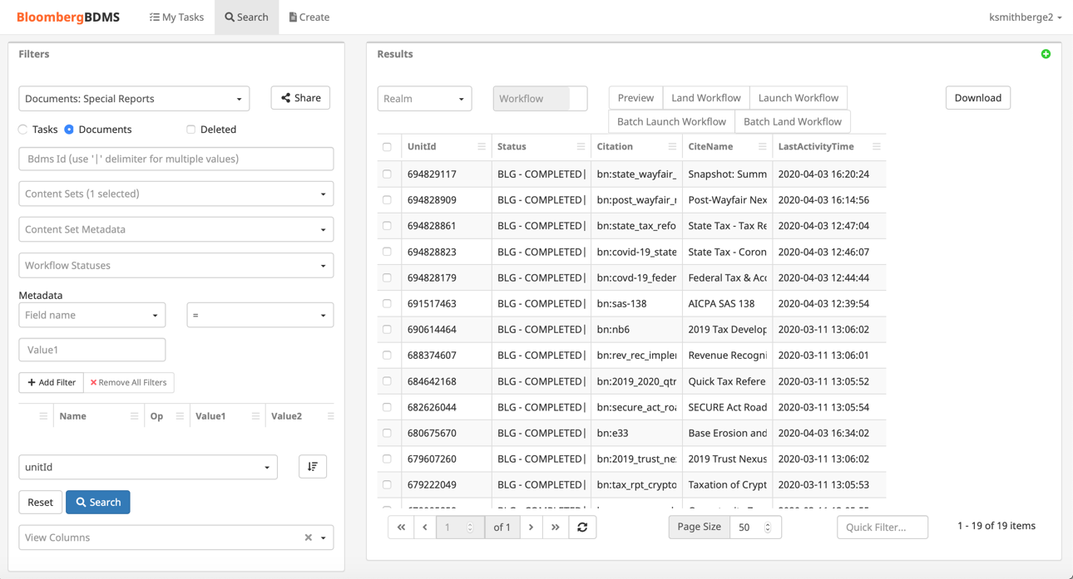
Query Results
Click Search to run query

Step 2: Create the first task, uploading the PDF

- Select your document by clicking in the check box beside the unitId
- In the Realm selection box, select TAX. In the Workflow selection box, select Replace Form. Then click the Launch Workflow button
Click on Launch Workflow

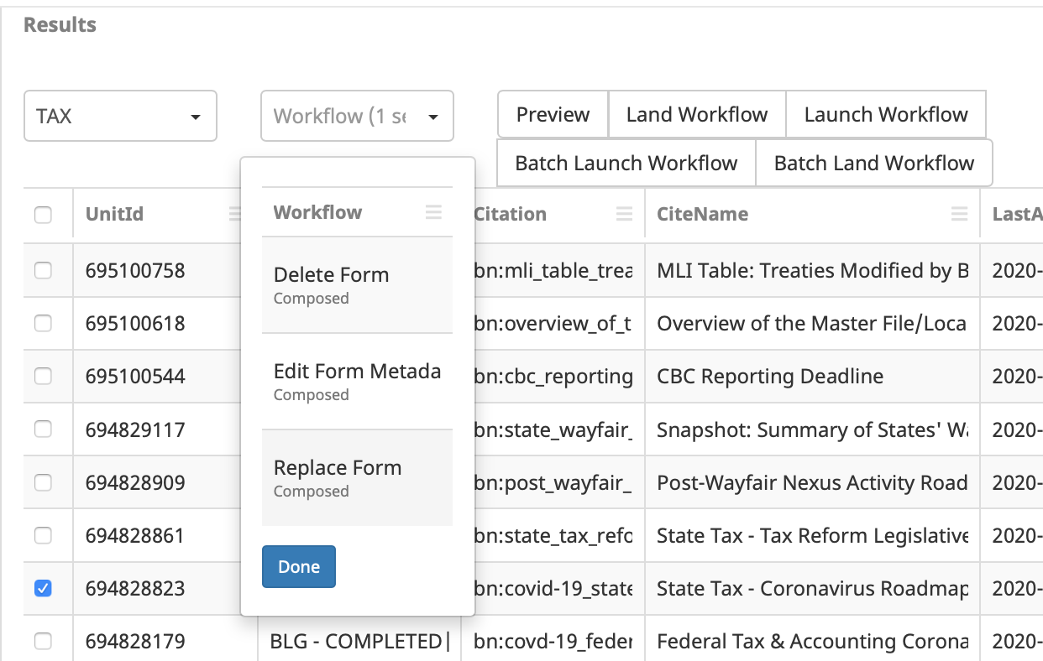

A green bar that says Success should appear at the top of the page. You have created your first task in this process.

Step 3: Find the task you just created and assign it to yourself

- Click into the Saved Query selection box and change the query to Tasks: Special Reports.

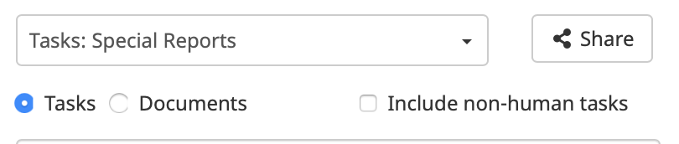

- Click the blue Search button to see the task you just created. The results screen will show all tasks that have not been completed. Yours should be the only task that appears, but if not, chose carefully.

- Select your task by clicking the check box and then click on Assign Task

Click Assign Task

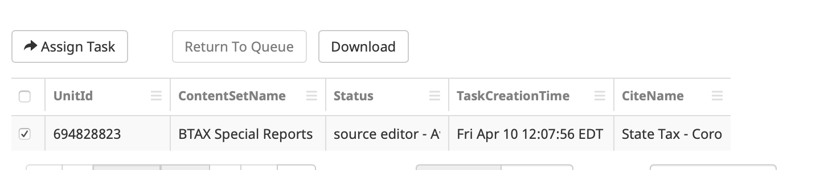

- Another modal will appear with your name in it. Click the Submit button to complete the task assignment

Step 4: Work on your assigned task

- Click on My Tasks in the menu bar

- The task you just assigned yourself now appears. Click on the Work button to open the PDF replacement page

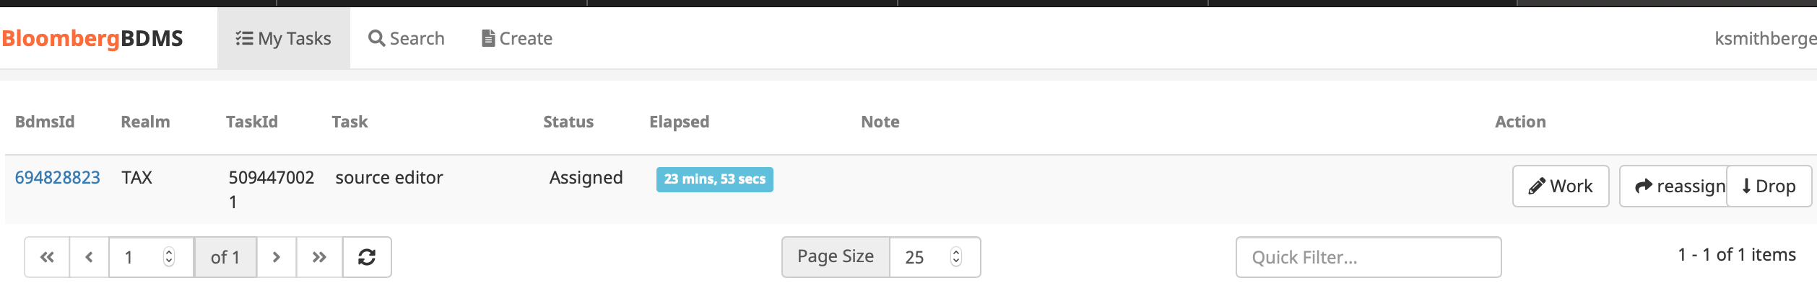

- In the upload tool, drag the updated PDF to the Select Files box or use the green Choose Files box to select the file from a directory on your computer. Once the file is uploaded, you have to add a in the Note text window. Click Upload all to upload the PDF
PDF file name
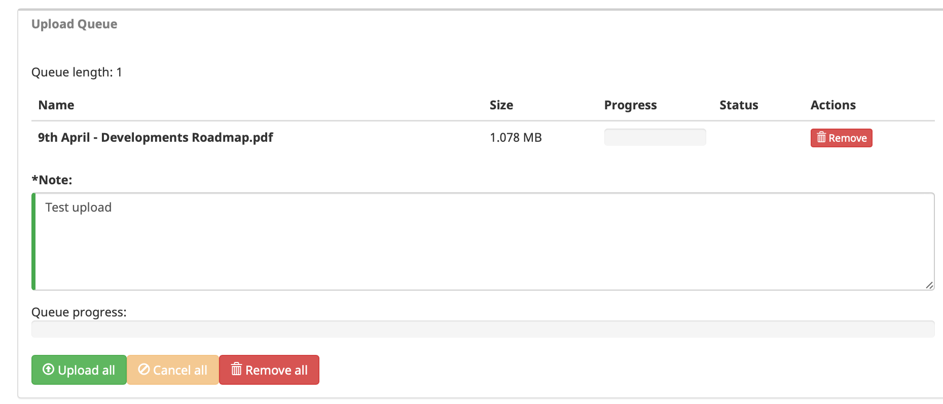
Click Upload all
Add your comment

- You’ll see a message in the Queue progress bar telling you that the upload was successful
- Click on <- Task List button to exit the upload PDF page

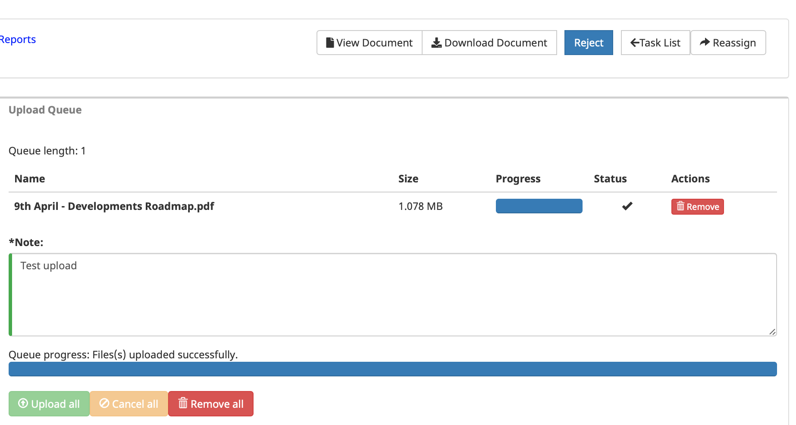
Click Task List to exit page
Success message

Step 5: Find the metadata edit task, assign to yourself and complete the process

Uploading the PDF successfully creates one more metadata task that needs to be completed before your PDF appears on product:

- Click on Search on the page menu bar

- Go to the Saved Search selection box and select the Tasks search again. Click on the blue Search button

- You’ll see a new task appear in search results. You can tell it’s a different task because the status column will say ‘meta edit – Available’

- Once again, select the task by clicking the check box and assign it to yourself

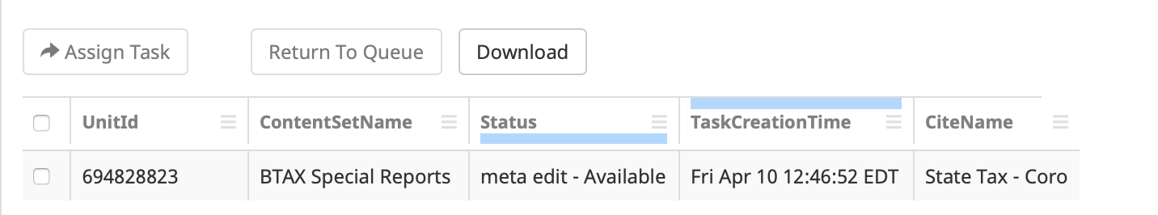

- Now it’s back to My Tasks

- The task you just assigned yourself now appears. Click on the Work button to open the metadata edit/confirmation page

- In this screen you can add/remove various metadata fields if you chose to. It’s not required.

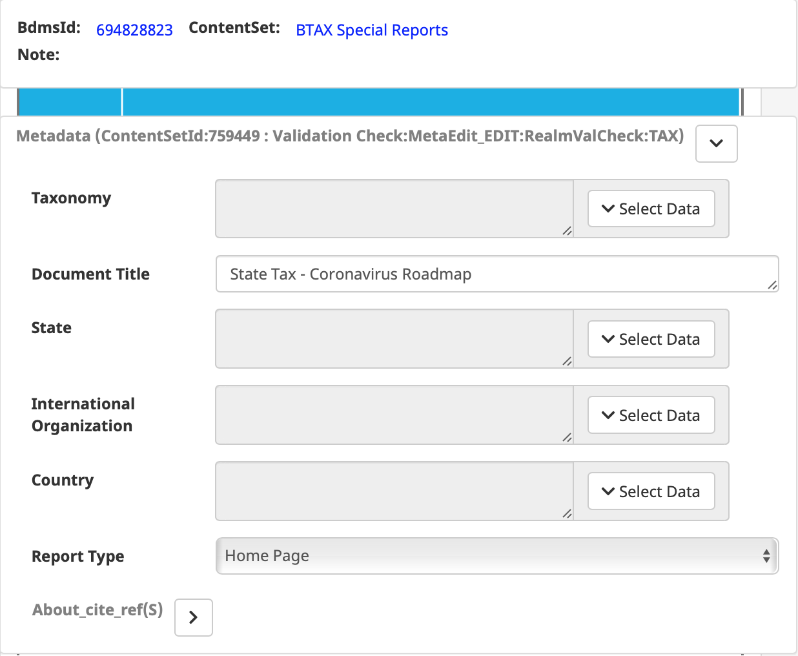

- When you are finished reviewing and updating metadata, click on Submit Document. If you wish to save your changes but upload later, click the Save button. You do not have to click Save before Submit Document.

Save changes but do not publish
Save changes and publish

