MLI BOXES – NEW WORKFLOW 12/07/2022

Where to get files that are to be sent to Infocon
MLI Boxes Directory I:\Analysis & Content\International\MLI\MLI Treaty Notes for CTAs\2022 CTA Boxes\MLI in force date June 1, 2022\Final

Where to put files that are returned from Infocon

MLI Boxes path to returned from infocon folder I:\Operations\Production\Projects\Analysis Content\Current\International\MLI\MLI Boxes\Returned from Infocon

Retuned files will in 1. SGML & 2. Formatted Word .

1.

- 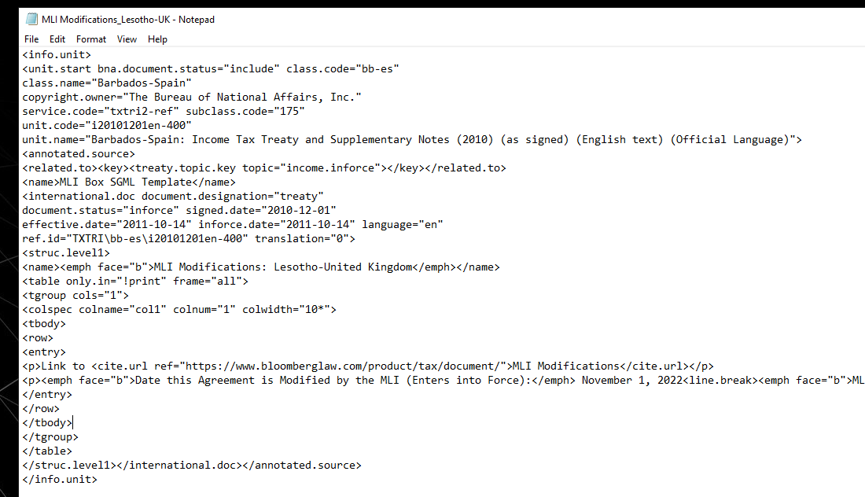

2.

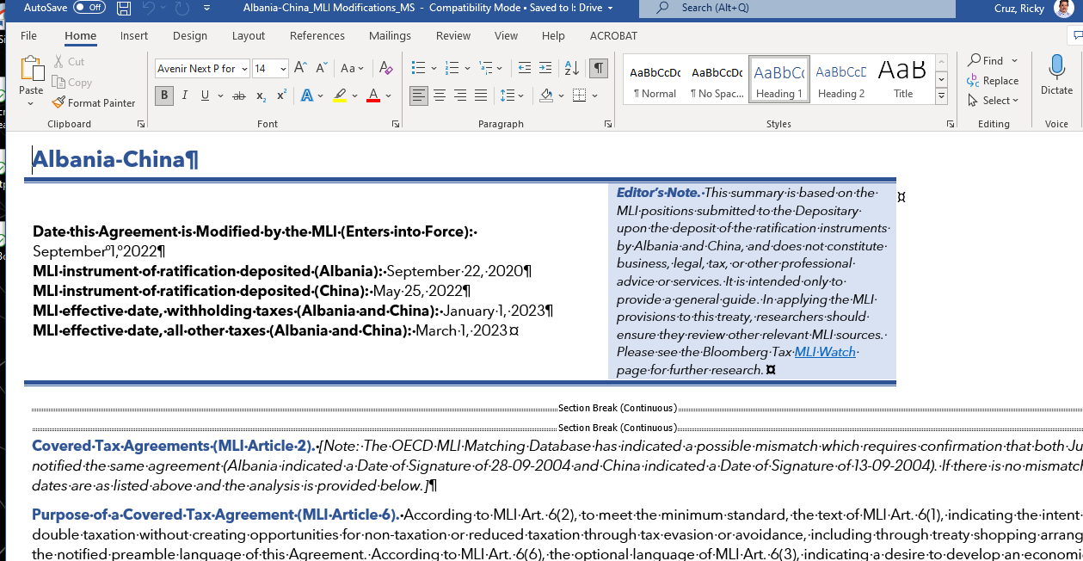

Naming convention for files to be loaded to BDMS (make sure order is the same as the pdf and file where the sgml text was inserted):
ex. MLI Modifications: Austria-South Africa

link: https://www.bloomberglaw.com/product/tax/document/X9LLG2QC000000

Link to <cite.url ref="https://www.bloomberglaw.com/product/tax/document/__________">MLI
Modifications</cite.url>

Note when loading files to BDMS you can crash the files that are stuck or loaded by mistake to free up traffic. 1. Click on box icon in front of file (be sure to click on BLG on the REALM before clicking on the icon in front of the file)
- In workflow- click on delete form
- Click on land workflow
- Click on Launch workflow.

- Make sure the country names are the same in this view in arbortext (although order can be different in arbortext and in the link:
- 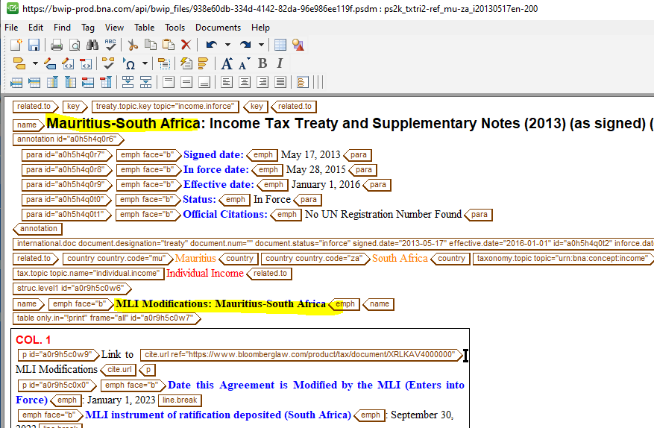
And here in the link (The document names used when loading is what will show as the title in BTAX ex. MLI Modifications: Austria-South Africa):

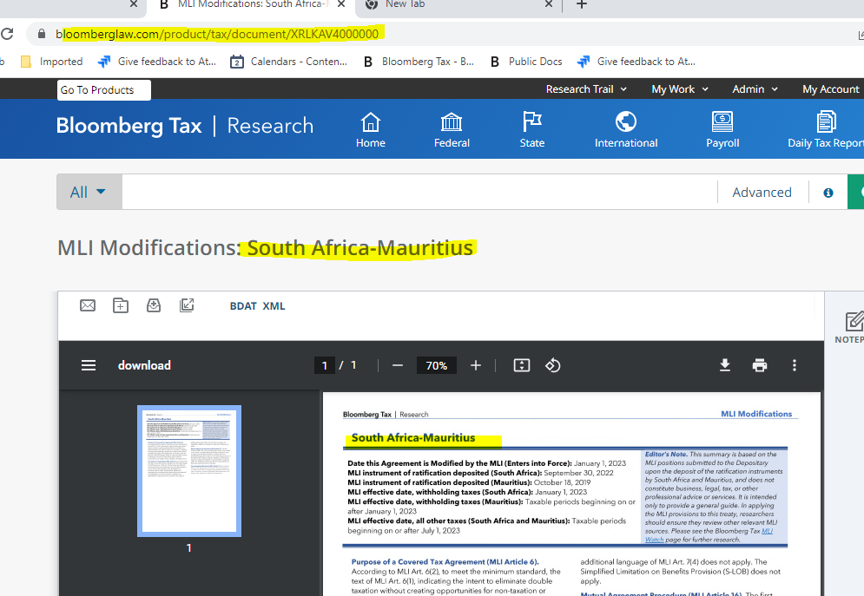

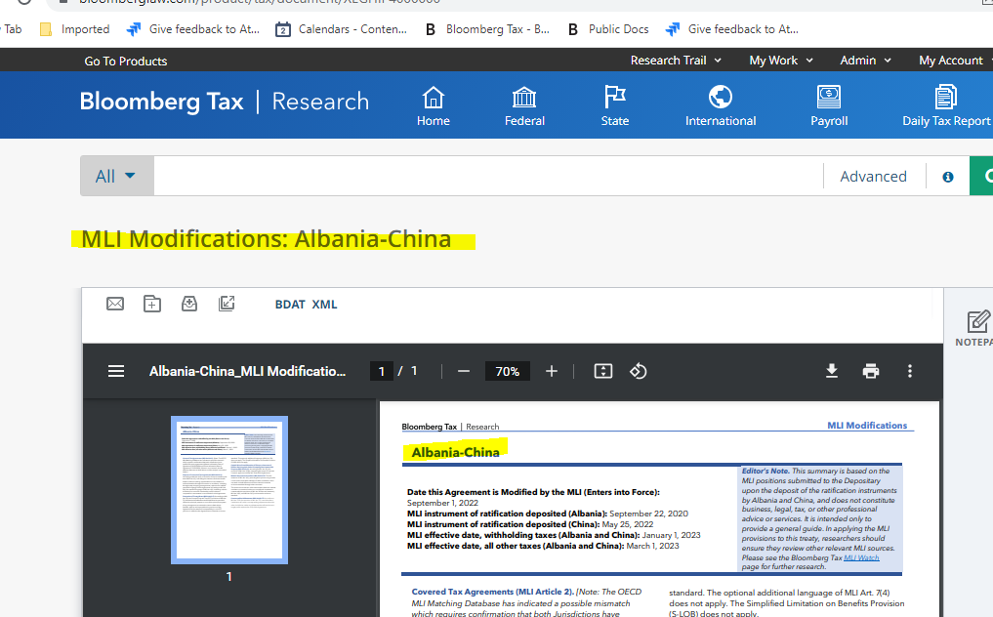

To Load files to BDMS:

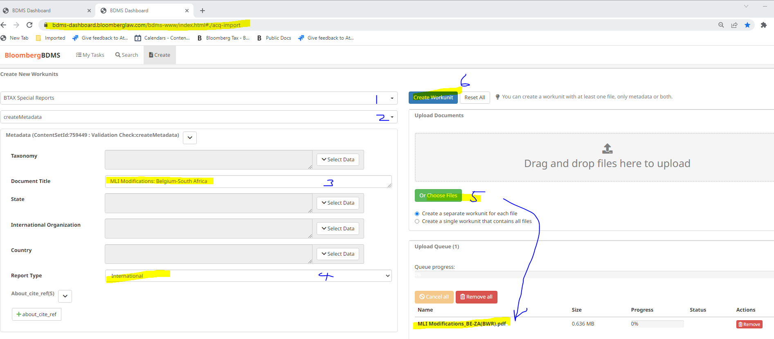

To search for files:
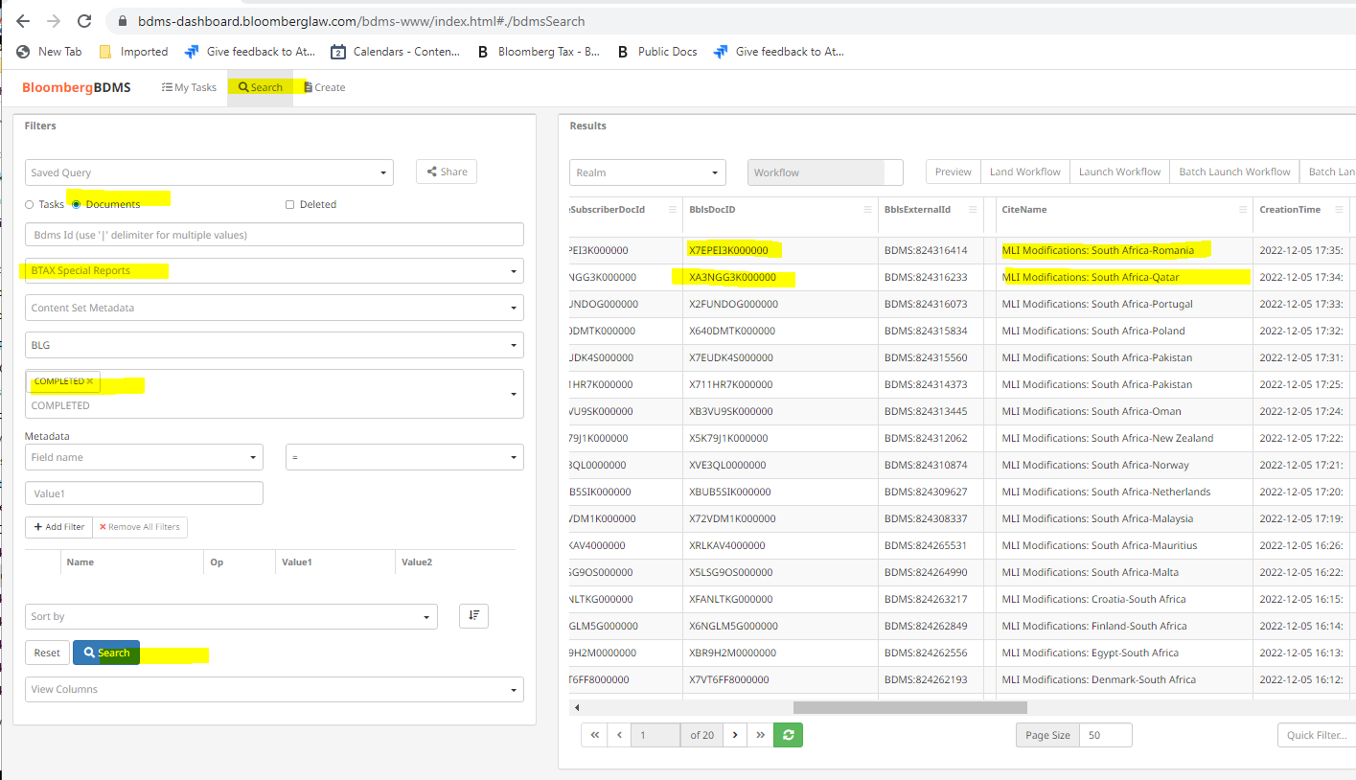

From the files that were returned from Infocon create pdf files and save to Ready to upload folder

- Send Word files to Infocon to convert to formatted Word & SGML files.

- Copy returned documents from Infocon to respective folders in the I drive

- Insert SGML file to checked out file from BWIP

- Create a pdf from the Formatted Word file

- Load pdf to BDMS to obtain Task ID and BDMS ID

- Post to BTAX by loading again in BDMS.

- Insert the BDMS iD to the link in BWIP

- Post in BWIP.

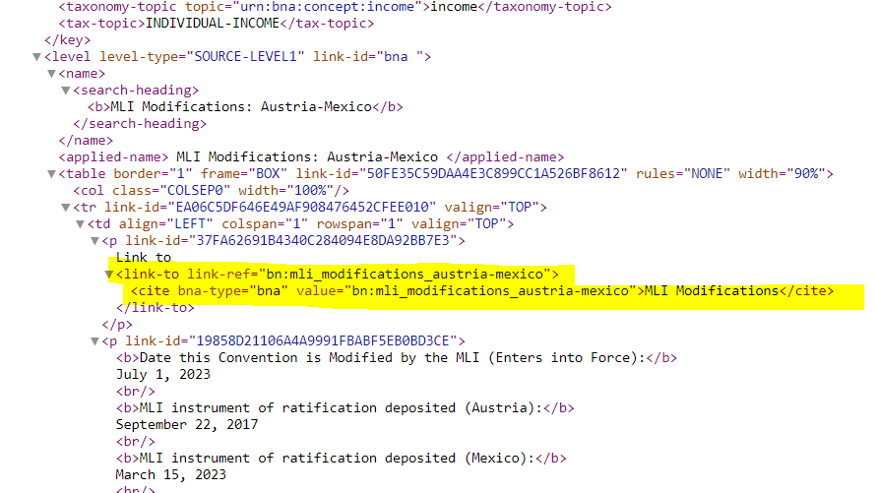

Thanks for the fine job your team did on Batch 2. Attached to this email is a Zip folder that contains the 48 files that compose the 3rd batch of DC_MLI documents that need to be processed using the new workflow. We’re requesting that the 3rd batch be returned by Wednesday (May 18th).
Reminder: Please make sure that the necessary styles are applied to the text.

MLI Boxes Email Template

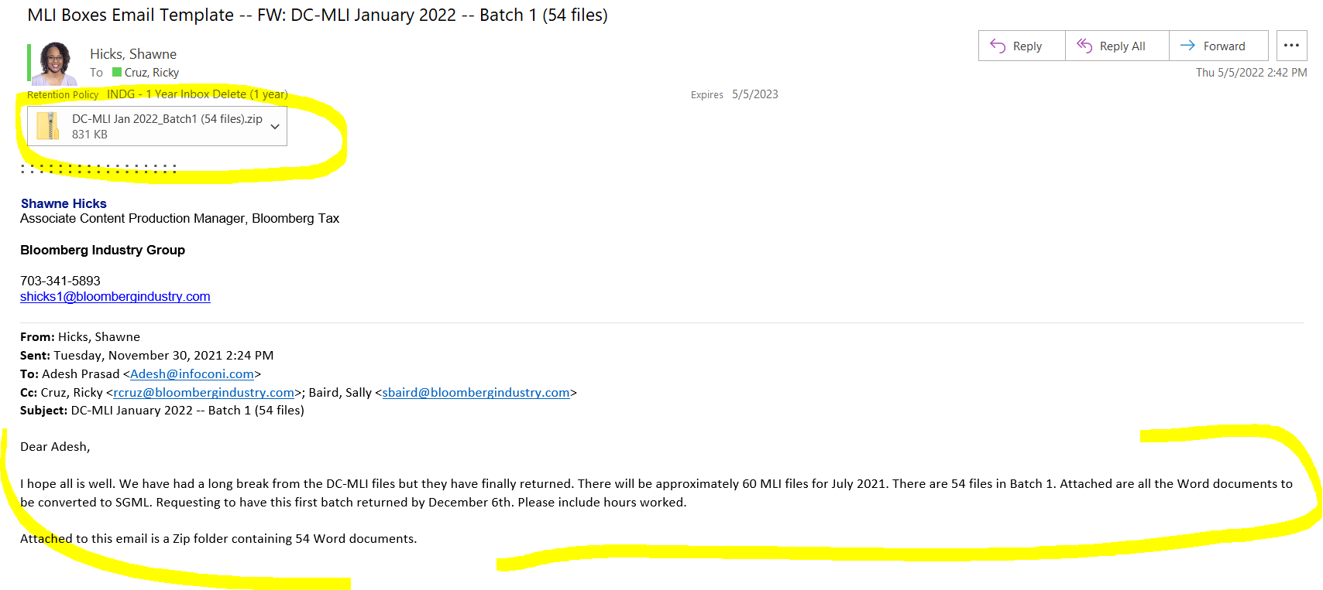

- Get sgml files from:

MLI Boxes path to returned from infocon folder I:\Operations\Production\Projects\Analysis Content\Current\International\MLI\MLI Boxes\Returned from Infocon

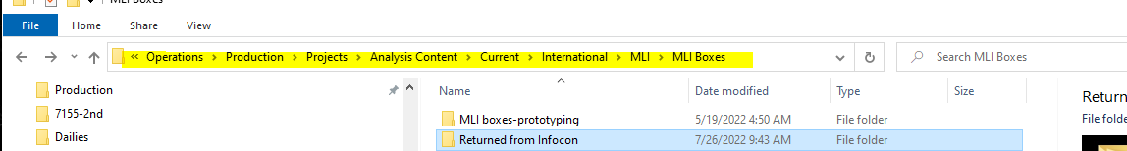

- 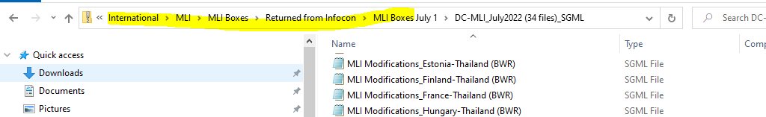

- Open the sgml file and copy the MLI box (text within the struct level 1 tags)
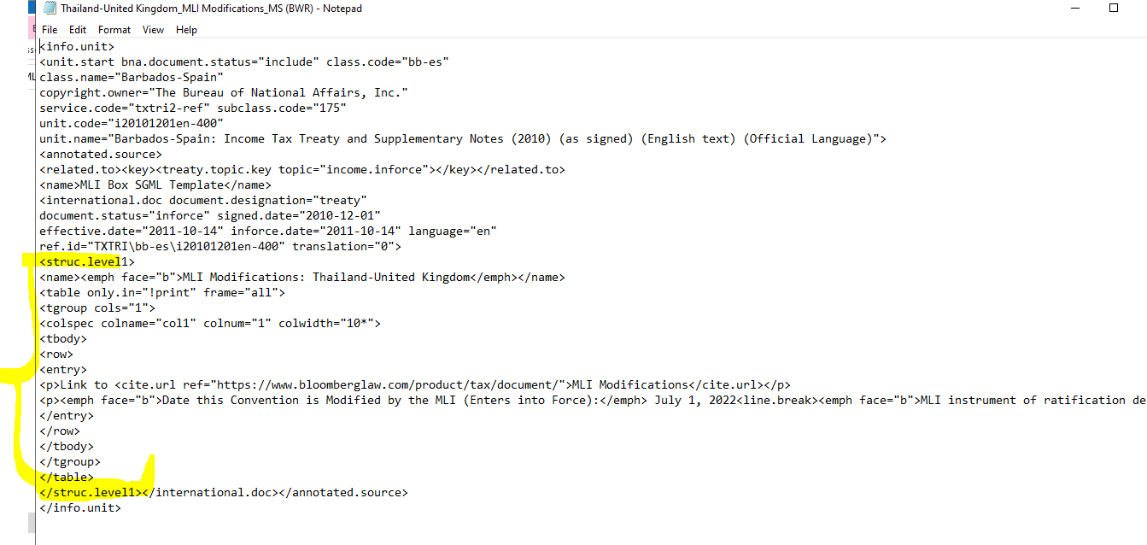
- Open country files in BWIP (txtri2) – Files are usually checked out by Kristina and are located in WIP.
- Insert MLI box copied from the sgml files in the I: drive.

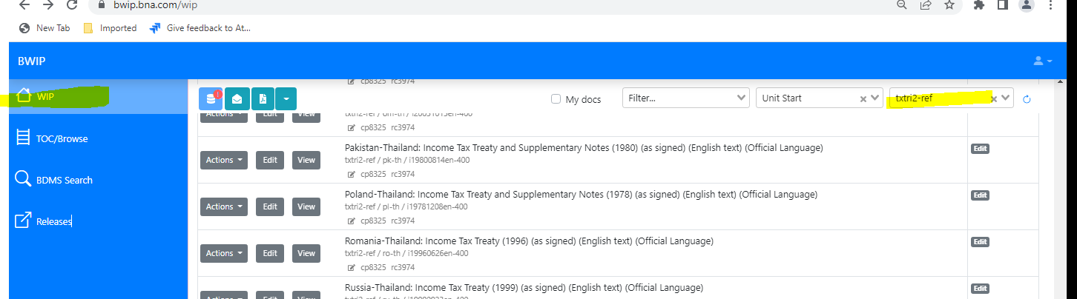

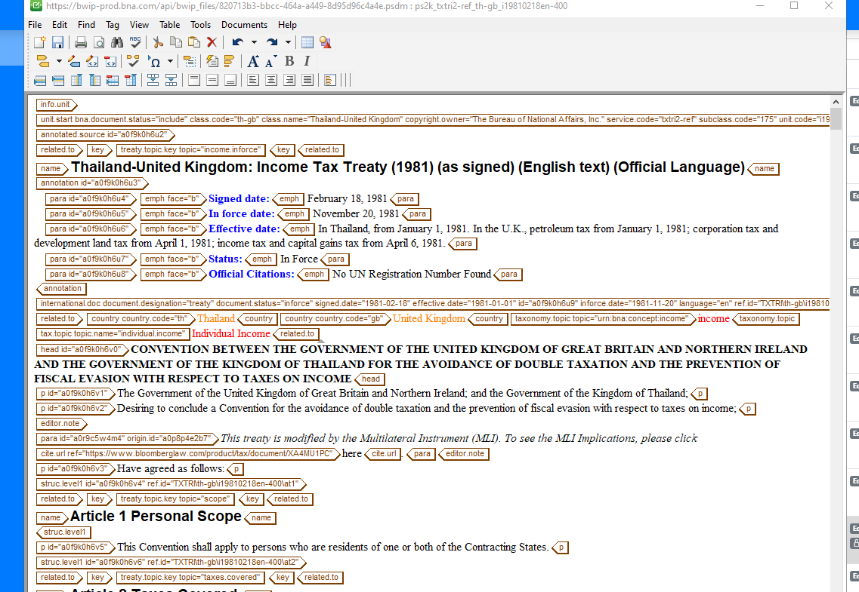
INSERT MLI BOX HERE

Create PDF files
Load Files to BDMS
Copy URLs from the list of files loaded to BDMS to the link in the files in BWIP
