To Log in to Internal BDMS

- Make sure you log in outside of Cetrix

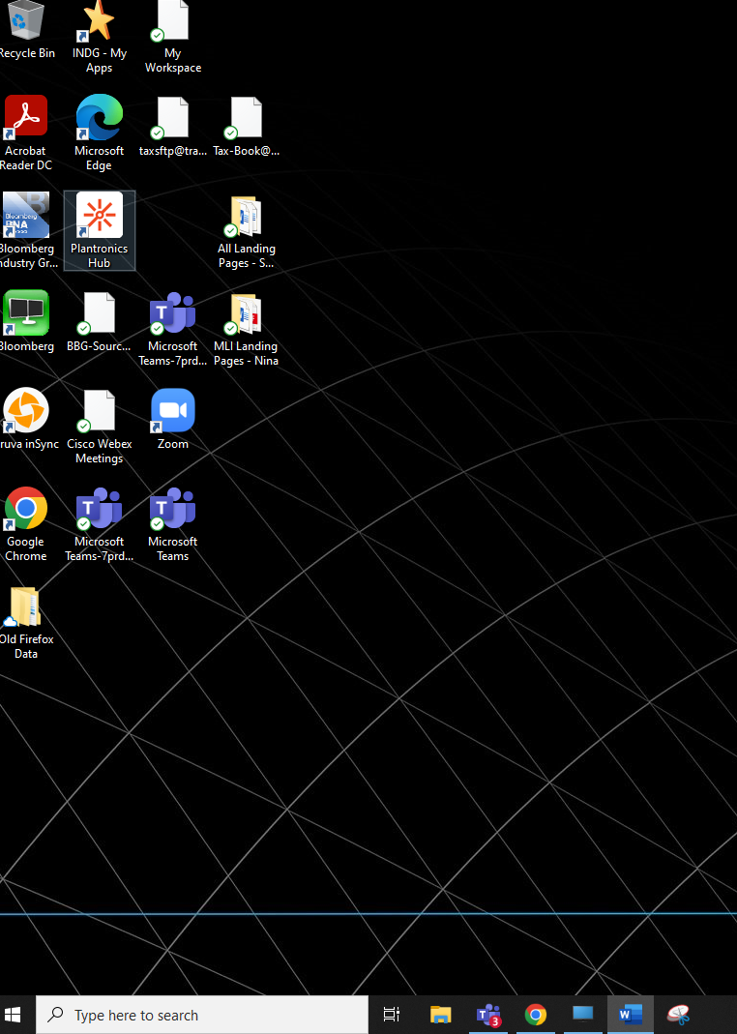

- Use chrome and use this link to sign in:
https://bbe.bloomberg.com/Auth/Logout?reason=Timeout

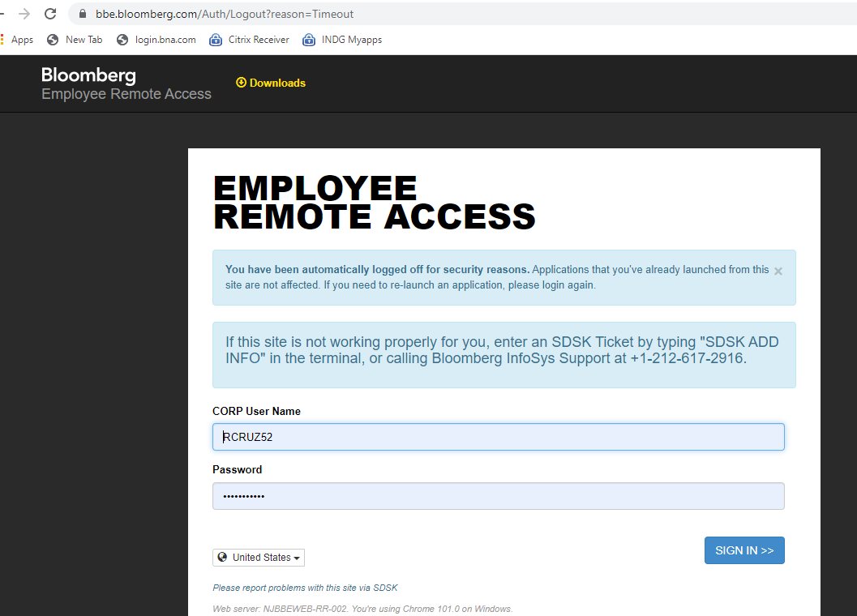

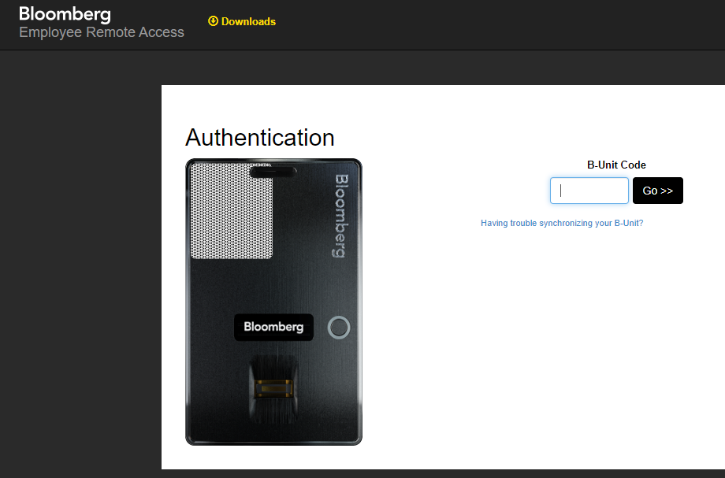

- Click on Generic Desktop
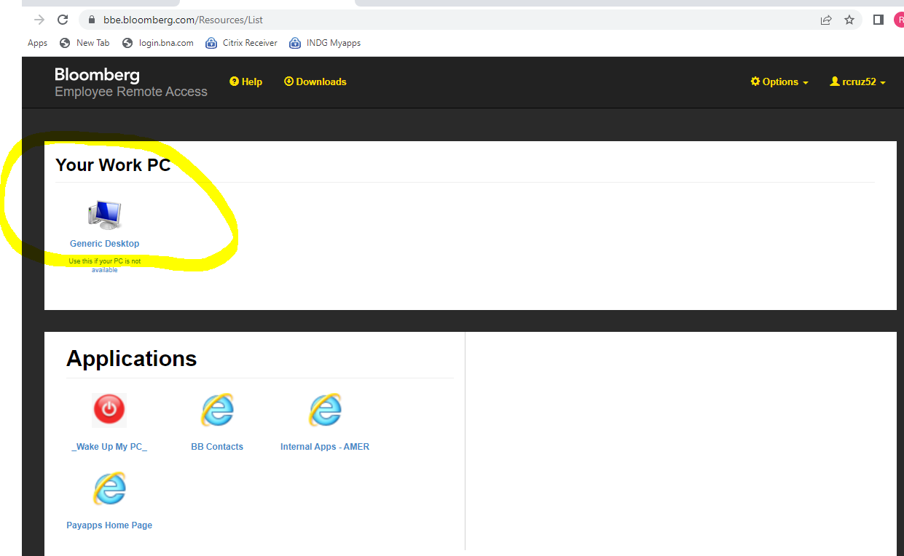

4.Launch Generic Desktop
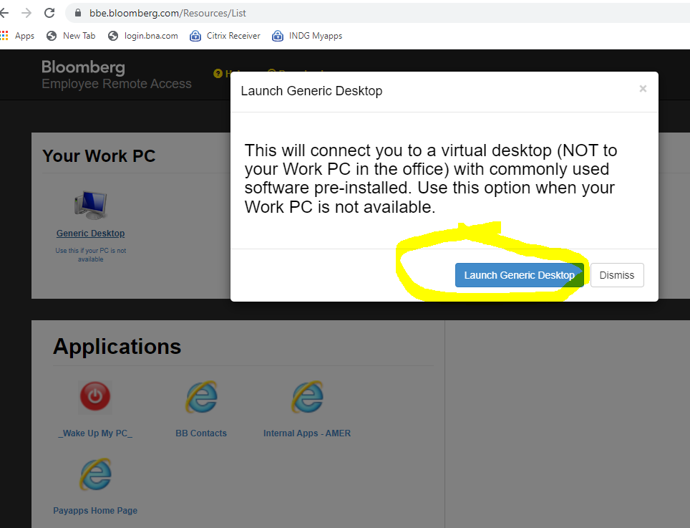

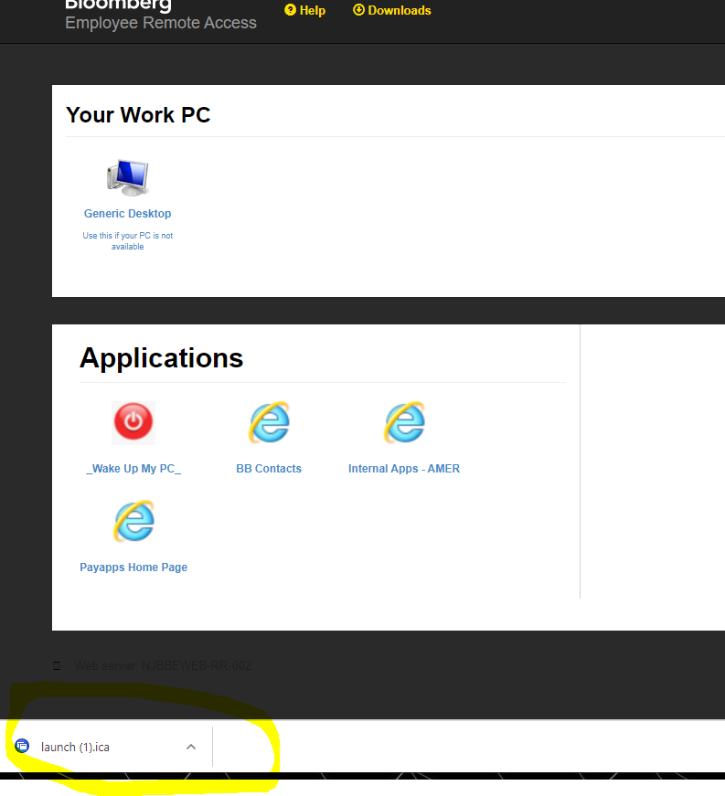

Launch chrome
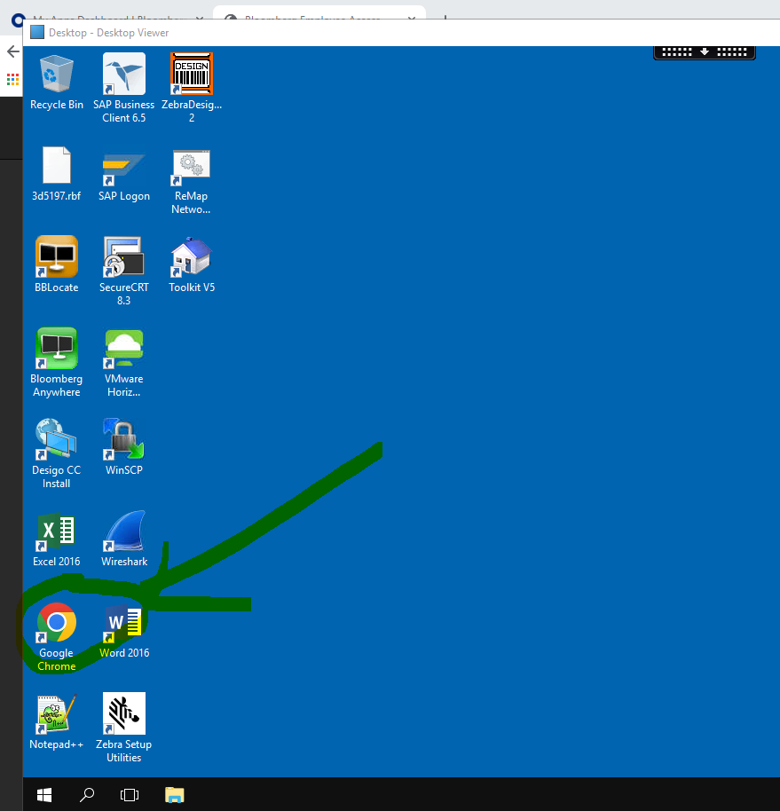

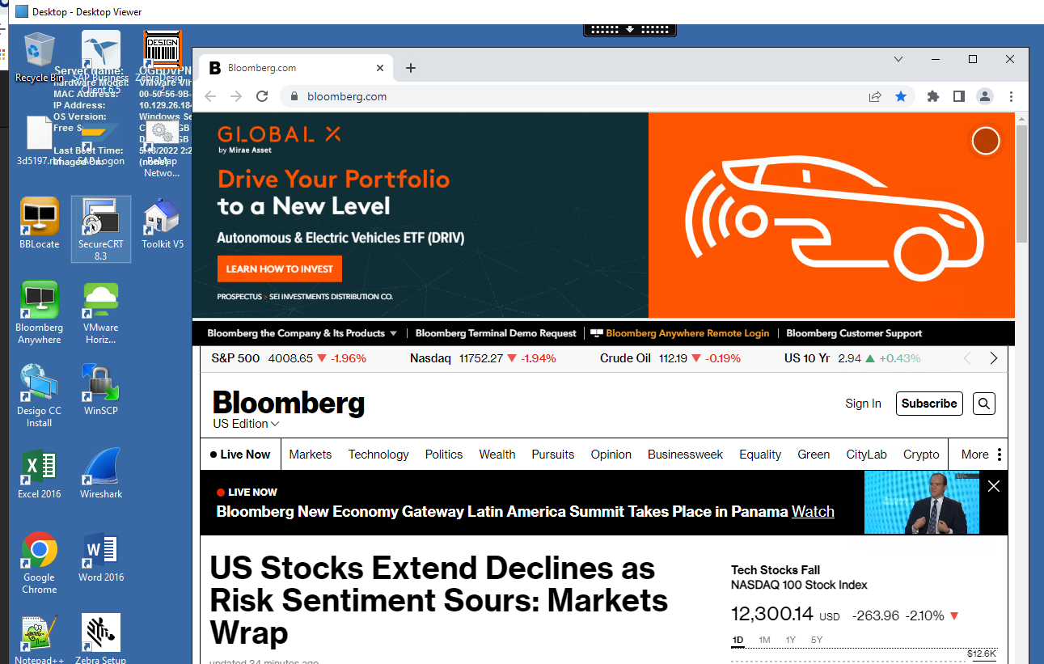

Copy and paste this link :
https://bdms-prod-bdms-dashboard.stacker.prod.bloomberg.com/bxp-index.html

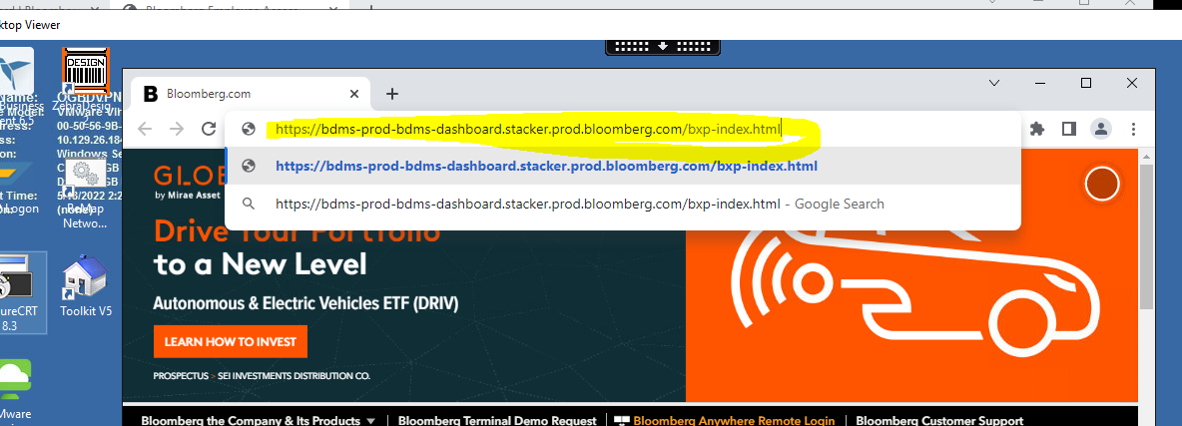

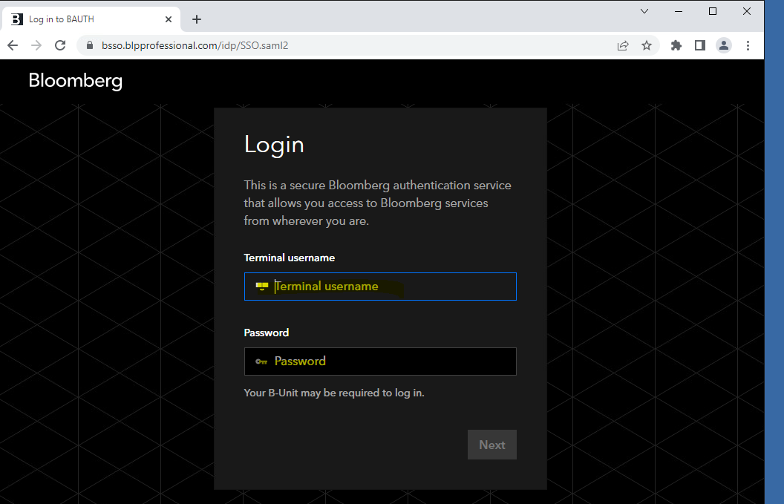

Terminal Username- RCRUZ52
Password – Bianca05$$ (note- only 2 $$)

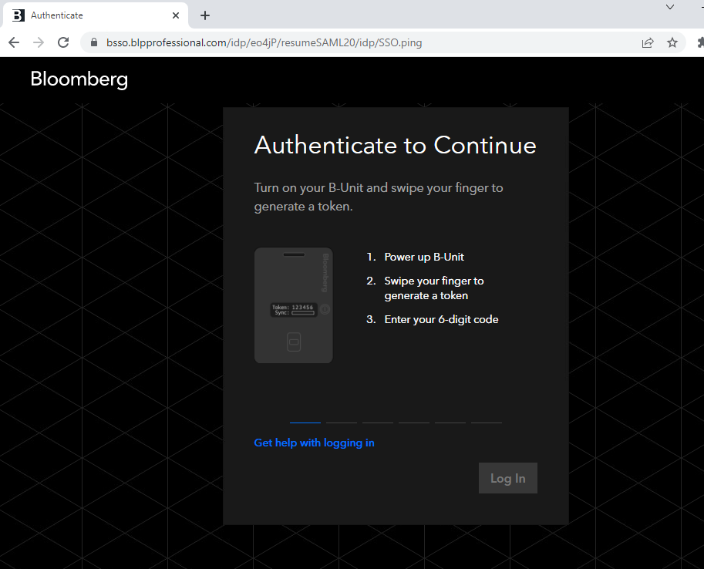

4. Click on Search

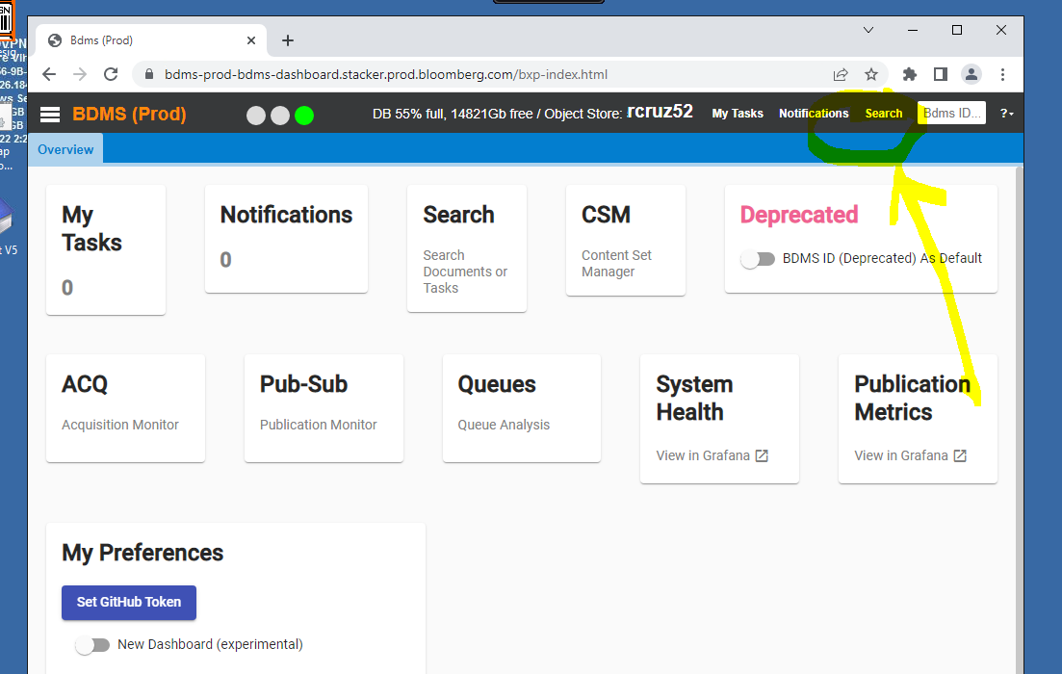

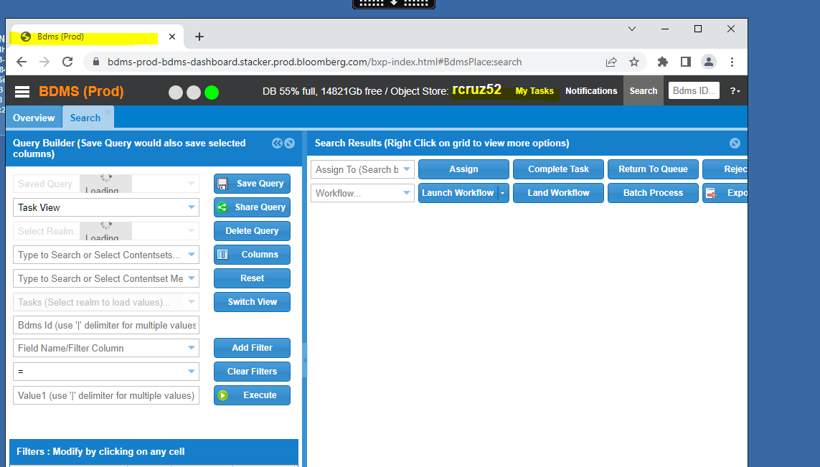

To log off click on WIndow then the globe on the bottom left corner

