BDMS Replacing/Updating Pdfs

Search for Document using Document View, BDMS id
On Realm choose TAX on drop down menu & Replace Form on Workflow menu
Click on Launch Workflow

Search using Task view then Assign
Click on My Tasks and upload pdf file

Search again on Task view and after seeing metaedit available in Status assign again to self

Click on work, when Metadata field shows click on Submit

NOTE: If the link doesn’t work check in BDMS if the BBCITE is the same with what is in the link in the BOX file
The cite ref should be exactly the same as the one indicated in the bbcite column in BDMS. Most of th error is because the bbcite in BDMS has bracketed numbers e.g., [1] and the one in the box sgml doesn’t.

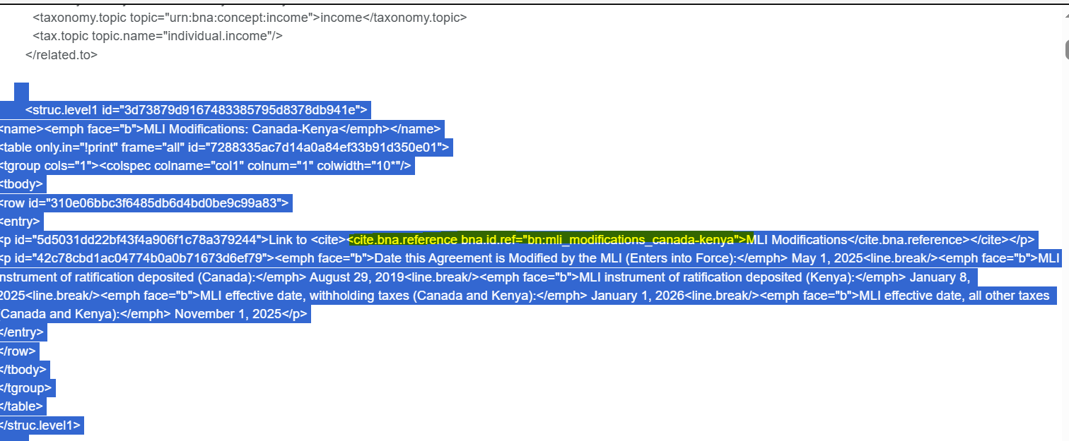
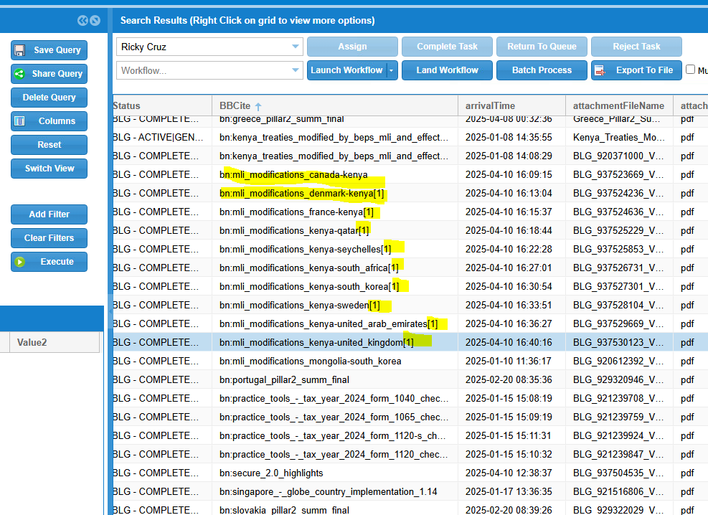
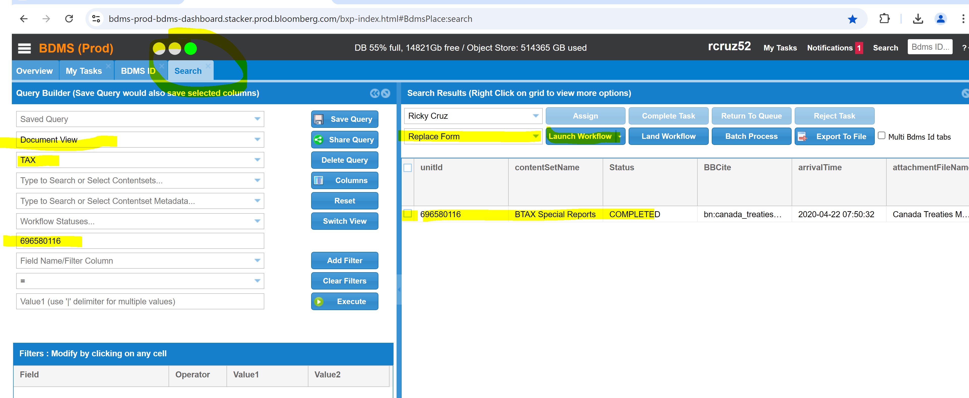

Click on Search fill up Document View, TAX, & BDMS Id.
Click on id & Unit id box
Choose Replace form then Launch Workflow, After the successful window pops up
Click on Task View then Assign

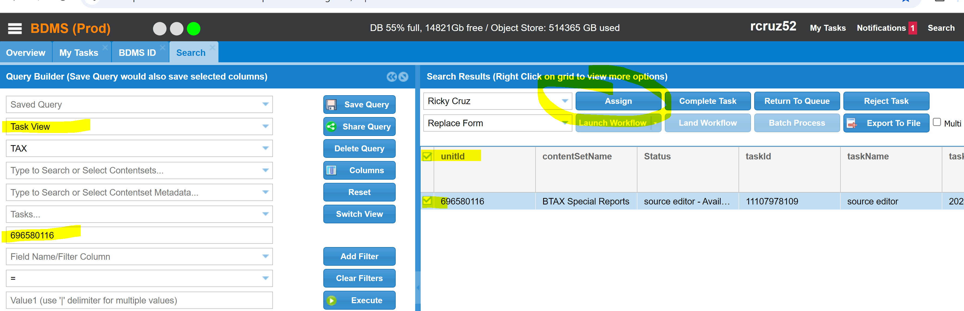

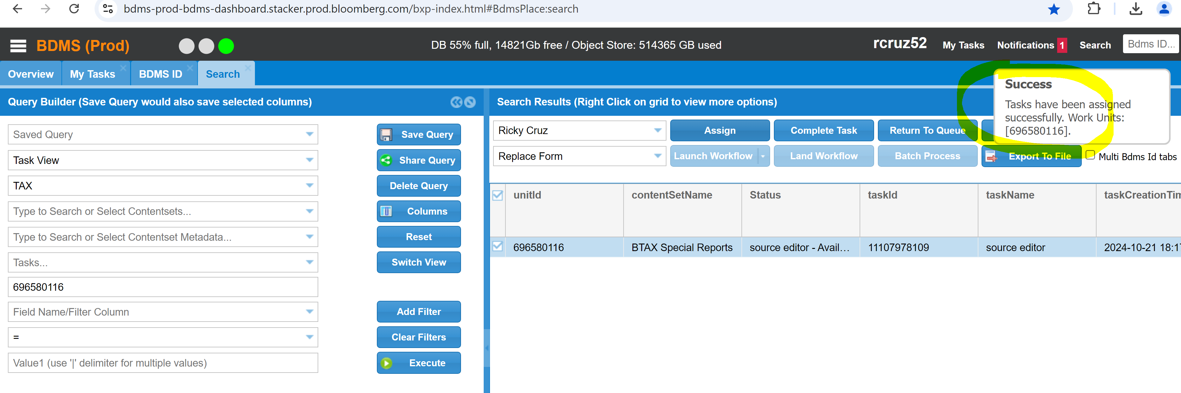

Click on Tasks then Work: 