BDMS Replacing/Updating Pdfs

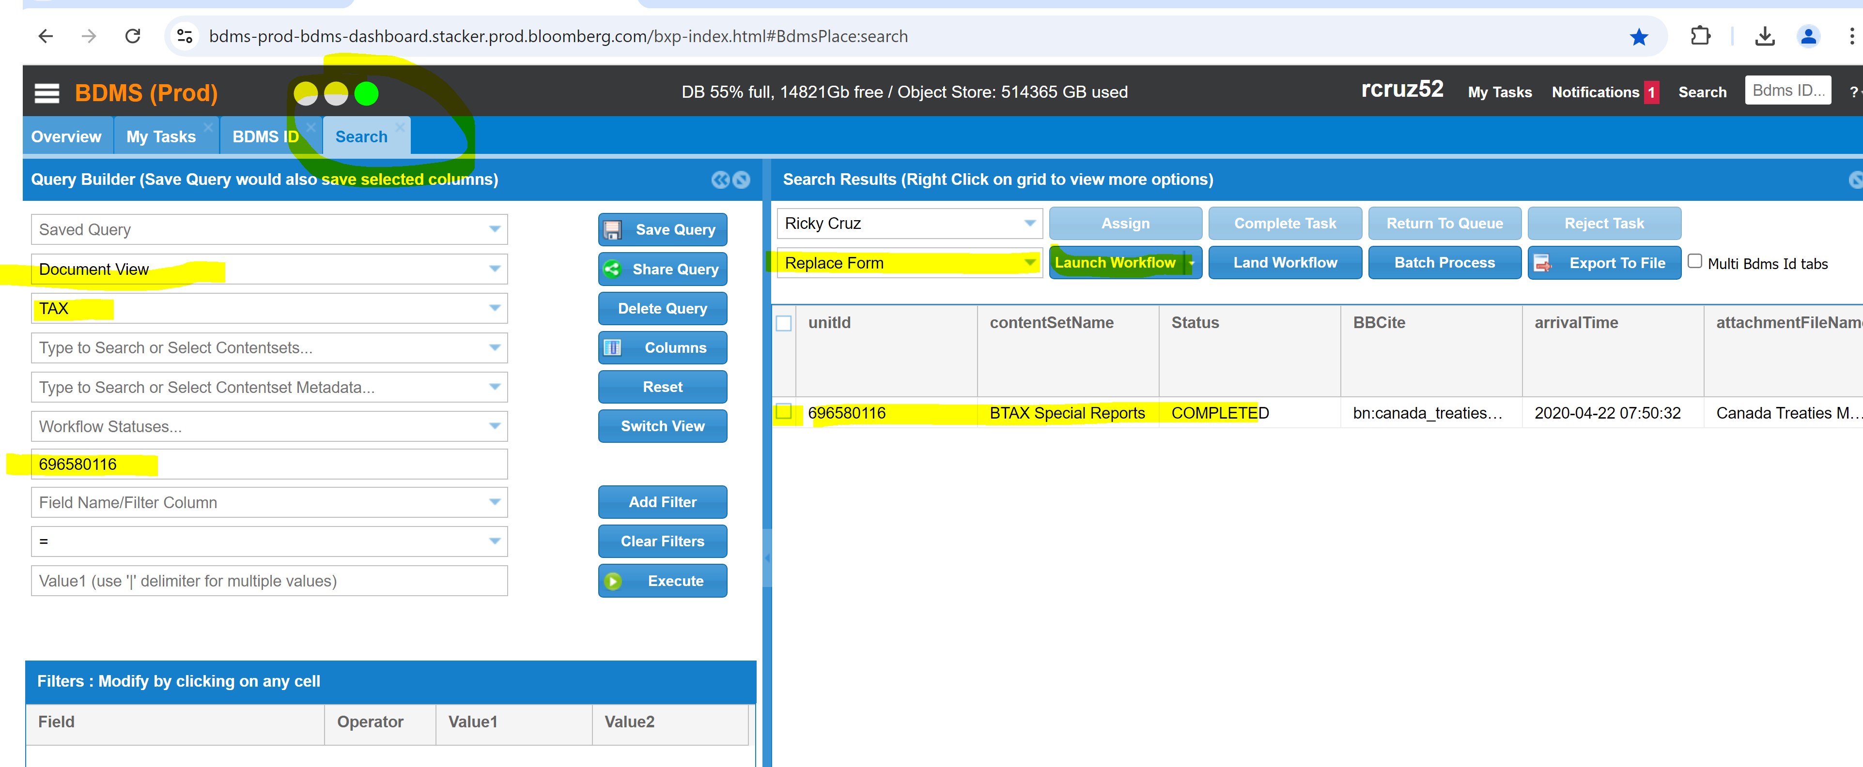

Click on Search fill up Document View, TAX, & BDMS Id.
Click on id & Unit id box
Choose Replace form then Launch Workflow, After the successful window pops up
Click on Task View then Assign

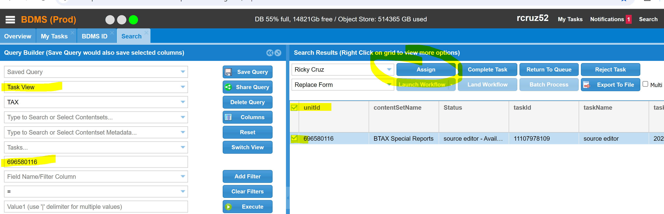

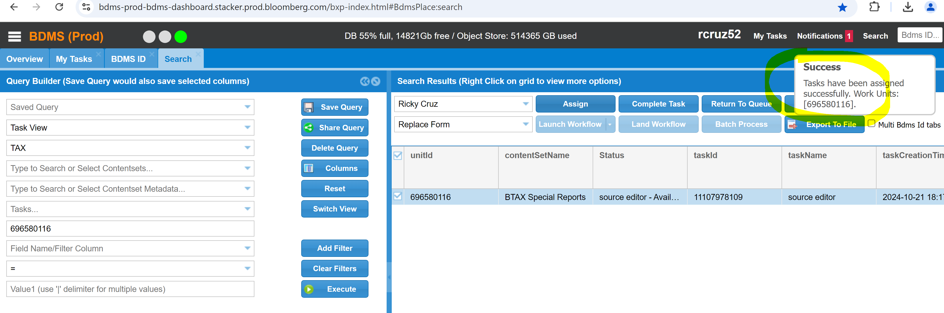

Click on Tasks then Work: 