BDMS- Modifying /Changing Metadata

- Search for the file in the BDMS dashboard using the document’s BDMS ID.
https://bdms-dashboard.bloomberglaw.com/bdms-www/index.html#./bdmsSearch

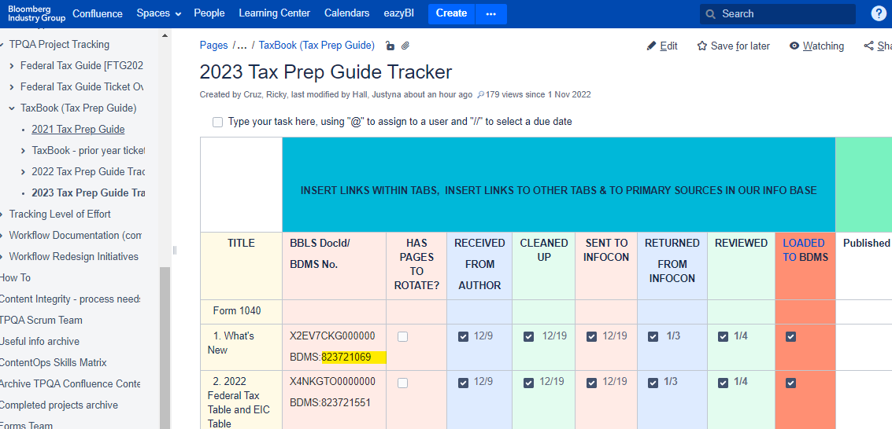

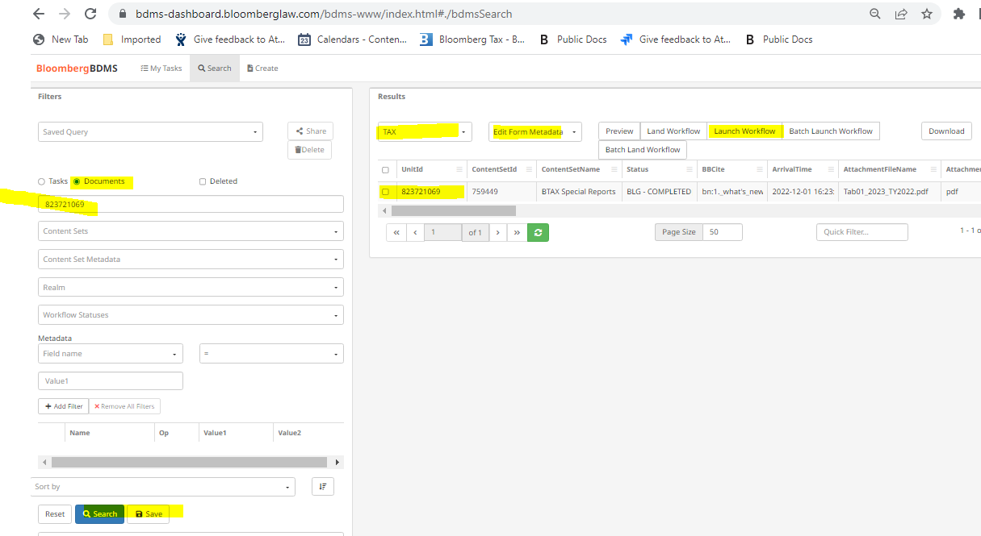

Then click on launch workflow after that Assign Task to yourself
Then go to my Task
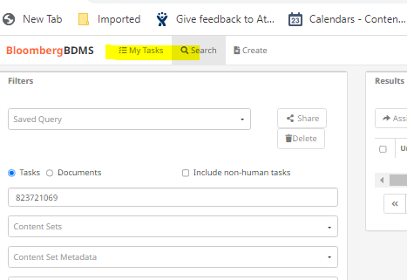

A window will pop up click on Work on.

A window will pop up showing the Metadata fields. Make the necessary corrections then click on Submit document.

After making the correction on the metadata, search for the document again and this time replace the form and upload the original pdf. After that when the status says metadata available assign it to yourself again then re-post(just submit the document without making any changes – this will push the updated file with the revised metadata.)

It seems that you have to replace the document with itself for the change in the metadata to appear in BTAX.

