Annual Rev Proc Update

1.Login to Oxygen
2. Click on BUP>Open MY files>Highlight Filname
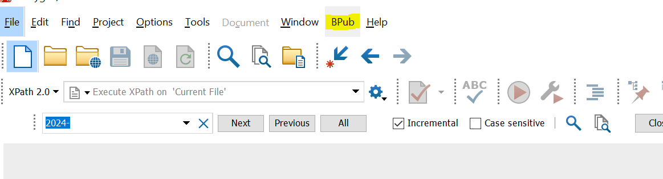

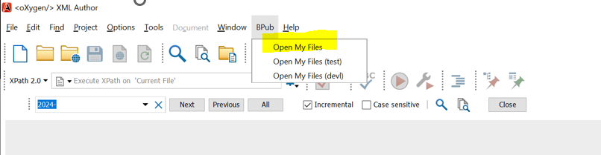

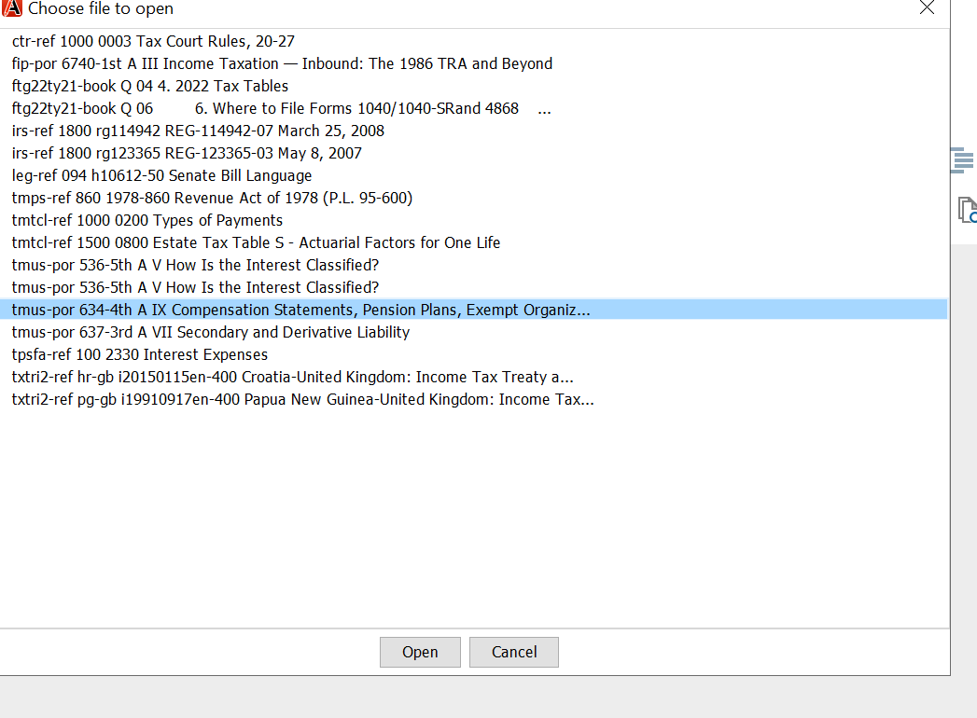

3. in Search Key 2023-

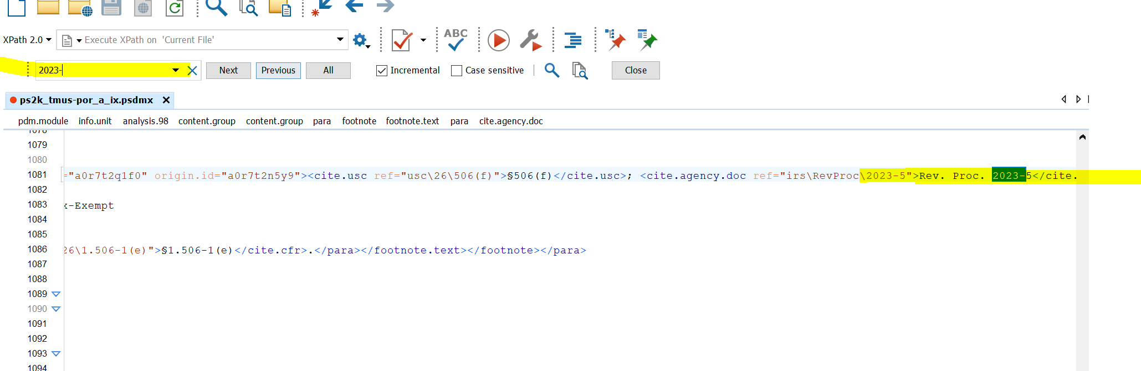

Click on revproc fix box:

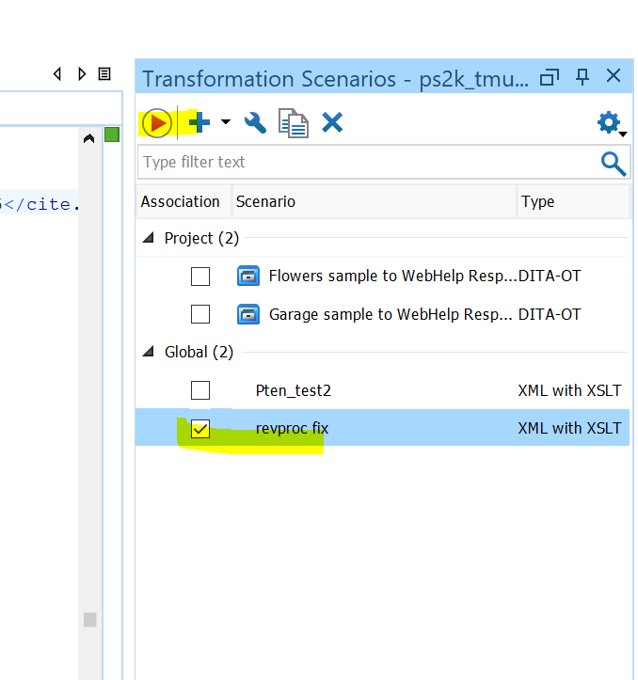

Then the Red arrow botton:

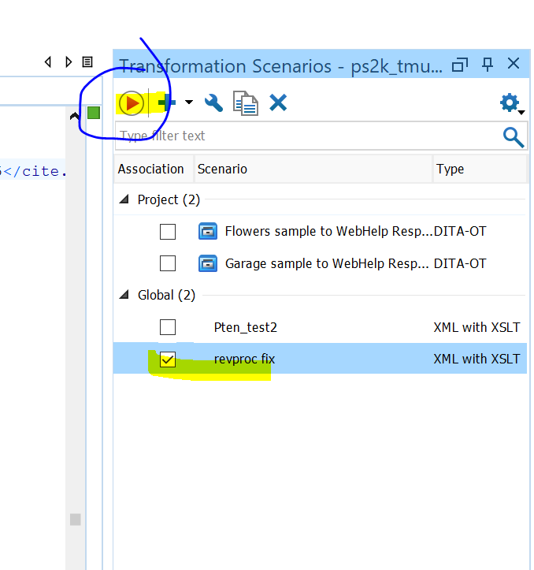

Search for 2024- to make sure the changes are made:

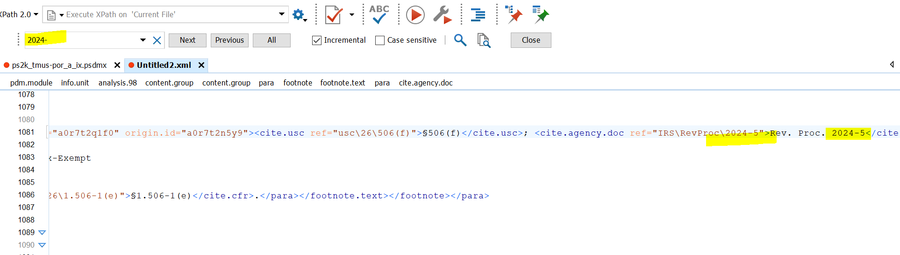

Control A to Select all then Copy the text to original file

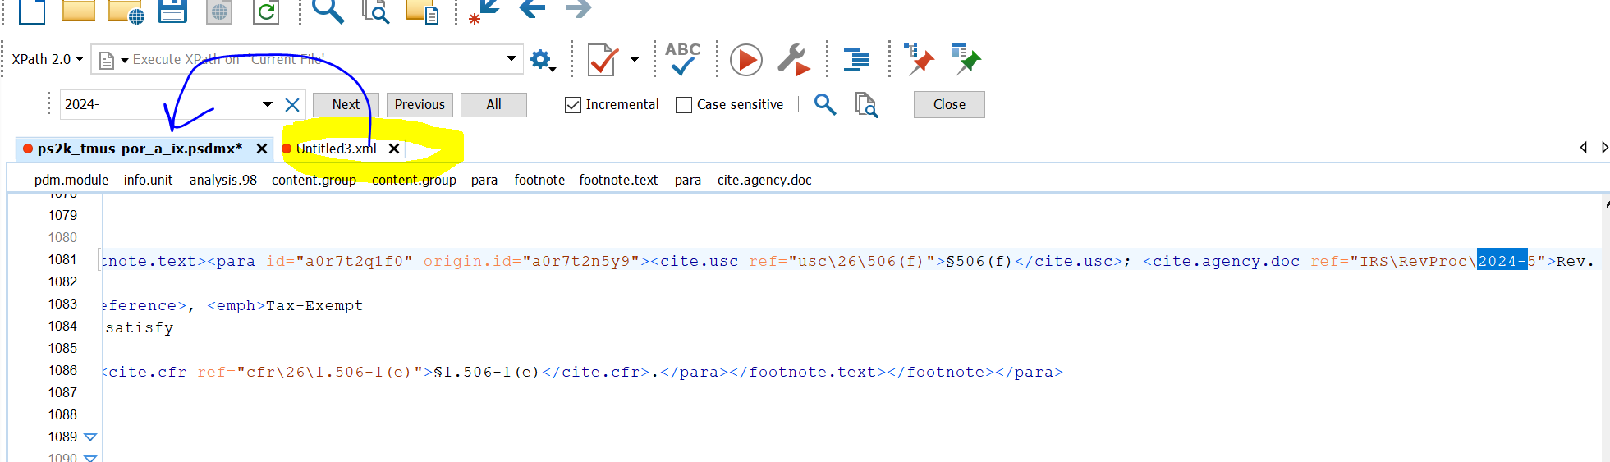

X out of the file then a dialogue box will show click on save

