ATTACHING TICKETS TO CONFLUENCE PAGE TRACKER

Click on Edit
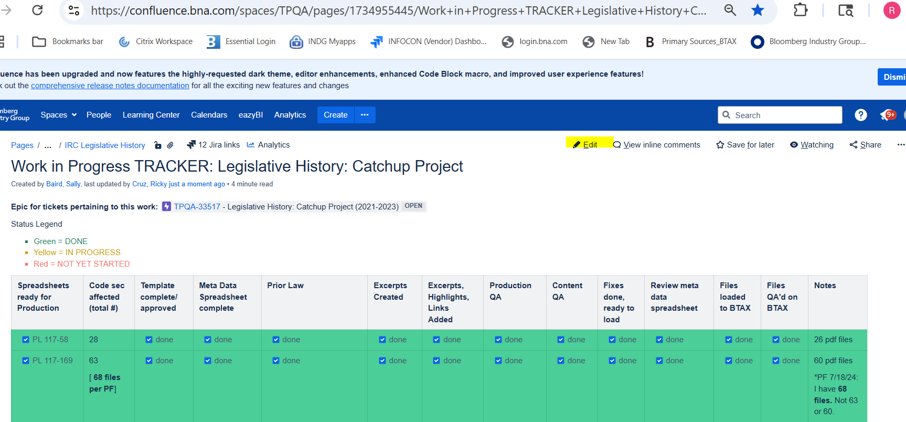

Click on the + sign
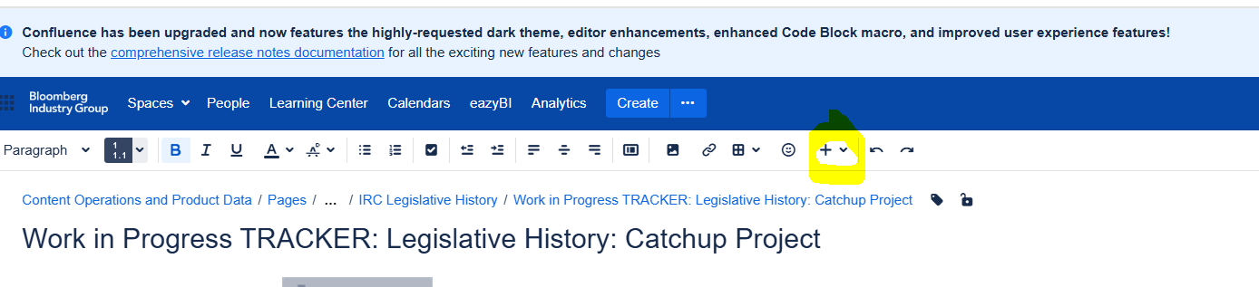

Put cursor on where you want it to be attached
then

Click on Jira Issue Filter
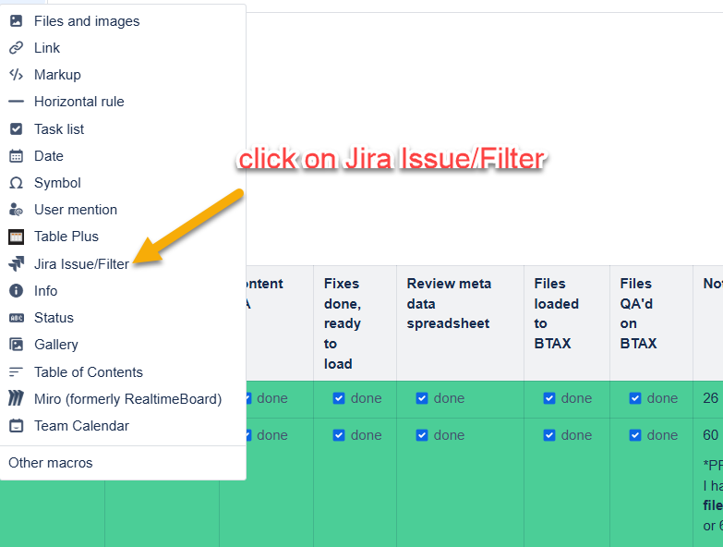

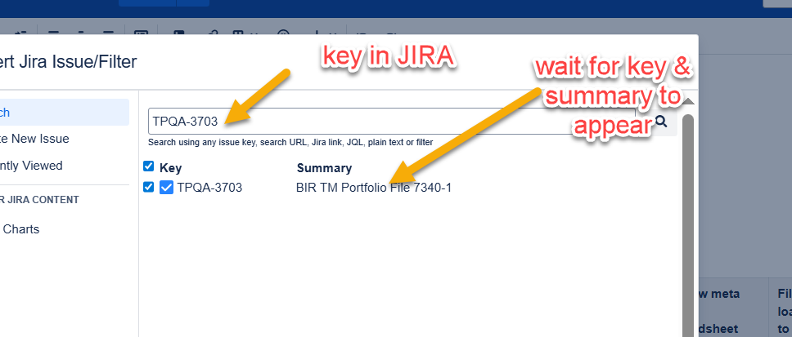
Then click on insert

