Sept 1-5
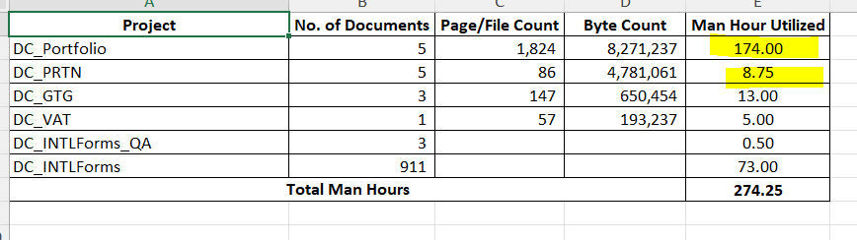
Sept. 8-12
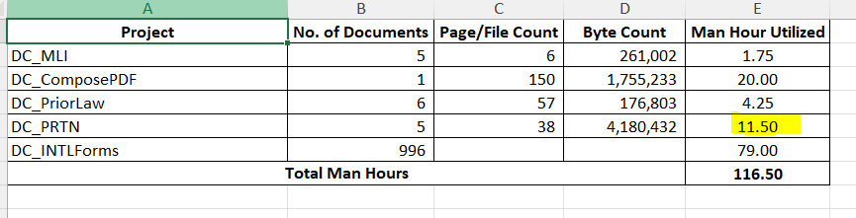

Sept.15-19

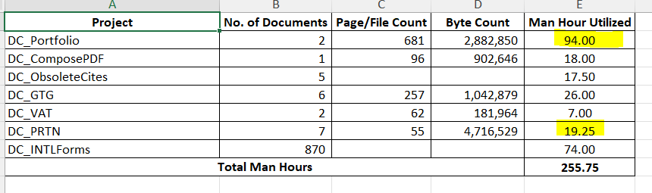

Sept. 22-26

