<table frame="all" colsep="1" rowsep="1"> <tgroup cols="1" frame="all"> <colspec colnum="1" colname="c1" colwidth="94*" colsep="1" rowsep="1"/> <thead> <row> <entry align="center"> <p justify="c"><bb.bookmark name="Madagascar"/><emph face="b">Madagascar</emph></p> </entry> </row> </thead> <tbody> <row> <entry align="center"> <p justify="c"><emph face="b">Country-by-Country Report</emph></p> </entry> </row> <row> <entry> <p>There are no OECD CbC reporting requirements in Madagascar.</p> </entry> </row> <row> <entry align="center"> <p justify="c"><emph face="b">Master File</emph></p> </entry> </row> <row> <entry> <p><emph face="bi">Effective Date:</emph> Tax years ending on or after December 31, 2020.</p> <p><emph face="bi">Scope:</emph> Taxpayers with cross-border financial or commercial intercompany transactions, regardless of amount.</p> <p><emph face="bi">Language:</emph> One of the official languages (i.e., French or Malagasy).</p> <p><emph face="bi">Deadline for Submission:</emph> Filed electronically at the same time as the income statement and the corporate income tax return (e.g., by May 15th of the following year for calendar year-end taxpayers or by November 15th for June 30th year-end taxpayers or by the 15th day of the fourth month following other year-ends). However, the due dates for the 2020 and 2021 financial years are postponed to a later date to be determined by the tax administration (once training sessions are complete).</p> <p><emph face="bi">Maintenance:</emph> Documentation must be maintained for 10 years.</p> <p><emph face="bi">Penalties:</emph> Failure to produce transfer pricing documentation may result in penalties of AR 10,000,000.</p> </entry> </row> <row> <entry align="center"> <p justify="c"><emph face="b">Local File</emph></p> </entry> </row> <row> <entry> <p><emph face="bi">Effective Date:</emph> Tax years ending on or after December 31, 2020.</p> <p><emph face="bi">Scope:</emph> Taxpayers with cross-border financial or commercial intercompany transactions, regardless of amount.</p> <p><emph face="bi">Language:</emph> One of the official languages (i.e., French or Malagasy).</p> <p><emph face="bi">Deadline for Submission:</emph> Filed electronically at the same time as the income statement and the corporate income tax return (e.g., by May 15th of the following year for calendar year-end taxpayers or by November 15th for June 30th year-end taxpayers or by the 15th day of the fourth month following other year-ends). However, the due dates for the 2020 and 2021 financial years are postponed to a later date to be determined by the tax administration (once training sessions are complete).</p> <p><emph face="bi">Maintenance:</emph> Documentation must be maintained for 10 years.</p> <p><emph face="bi">Penalties:</emph> Failure to produce transfer pricing documentation may result in penalties of AR 10,000,000.</p> </entry> </row> </tbody> </tgroup> </table>

Convert the attached test file (Jordan_test) to xml format using information from the source file (Latvia_test_1_use) and completed xml file (Latvia_XML_use)

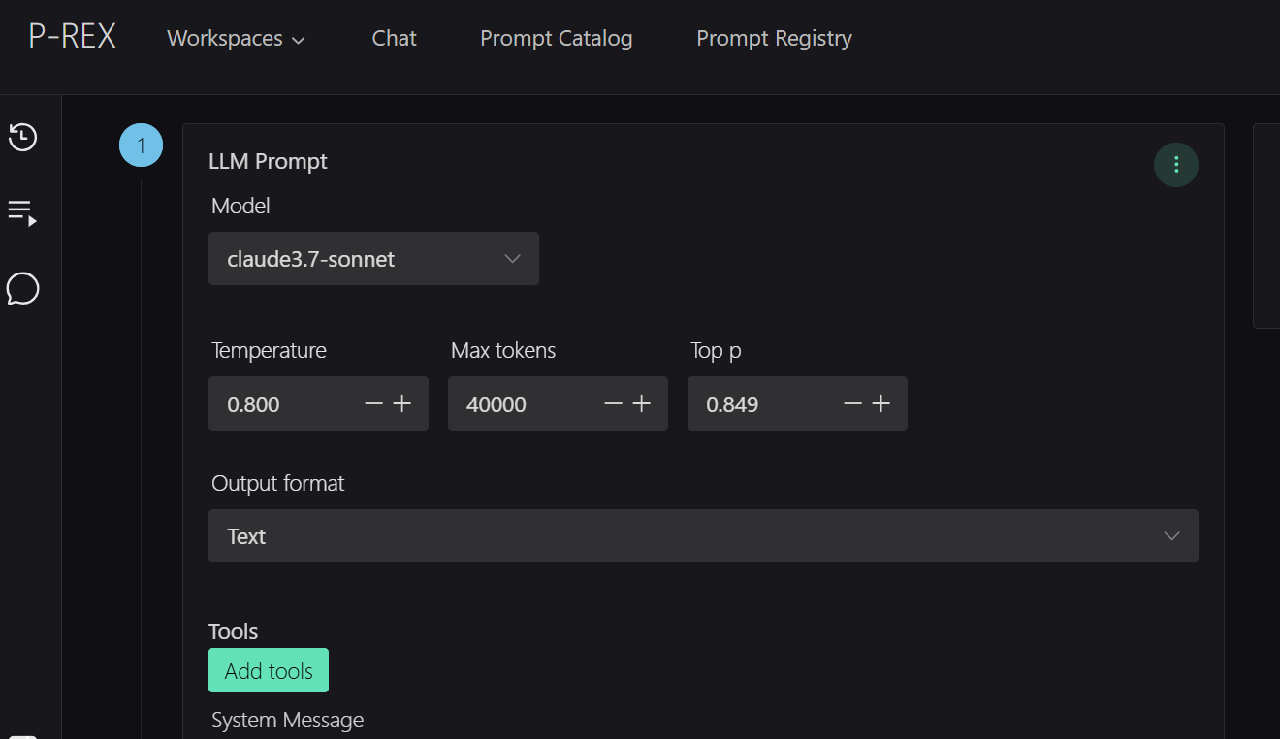

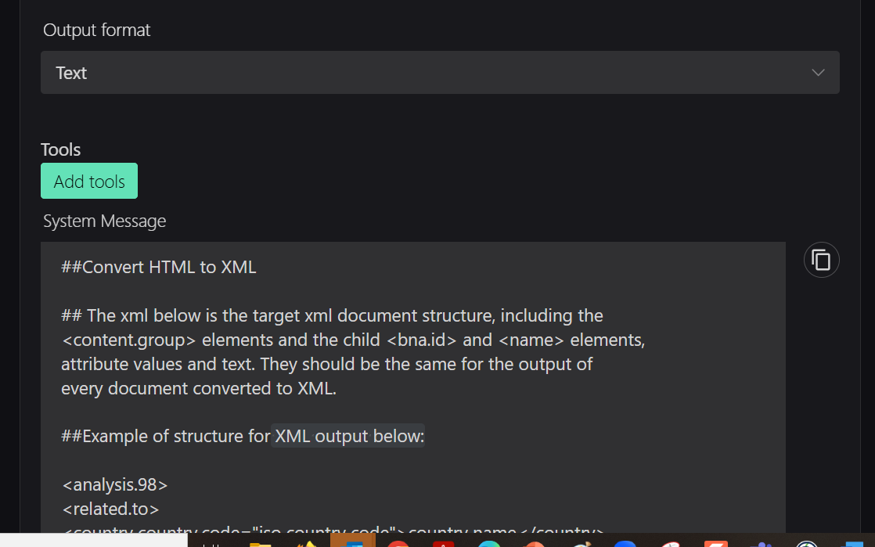

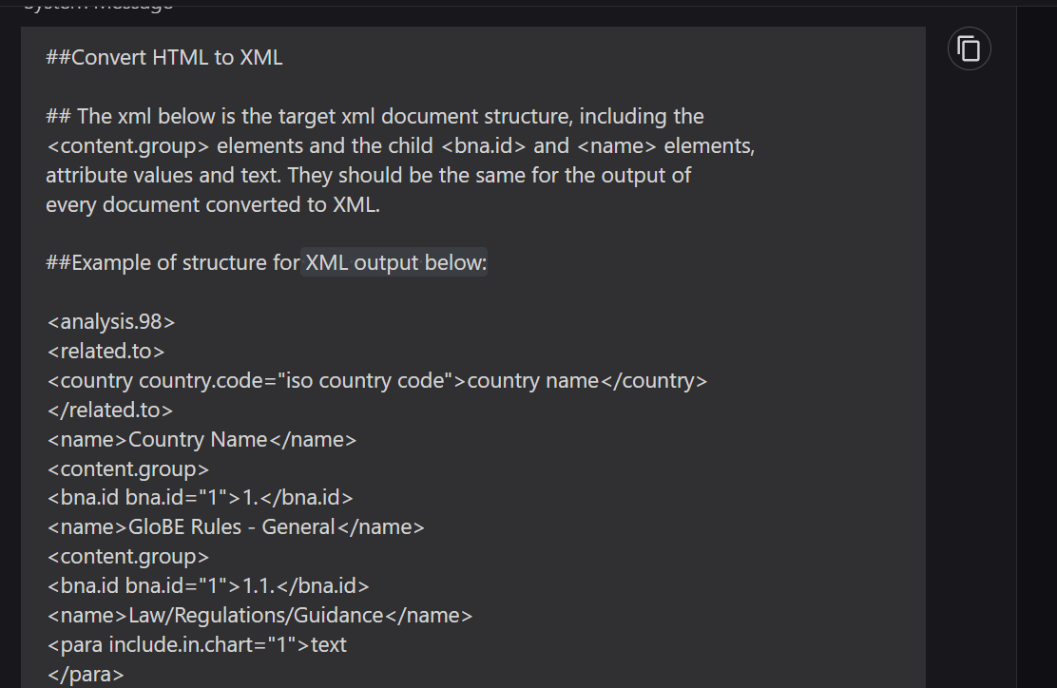

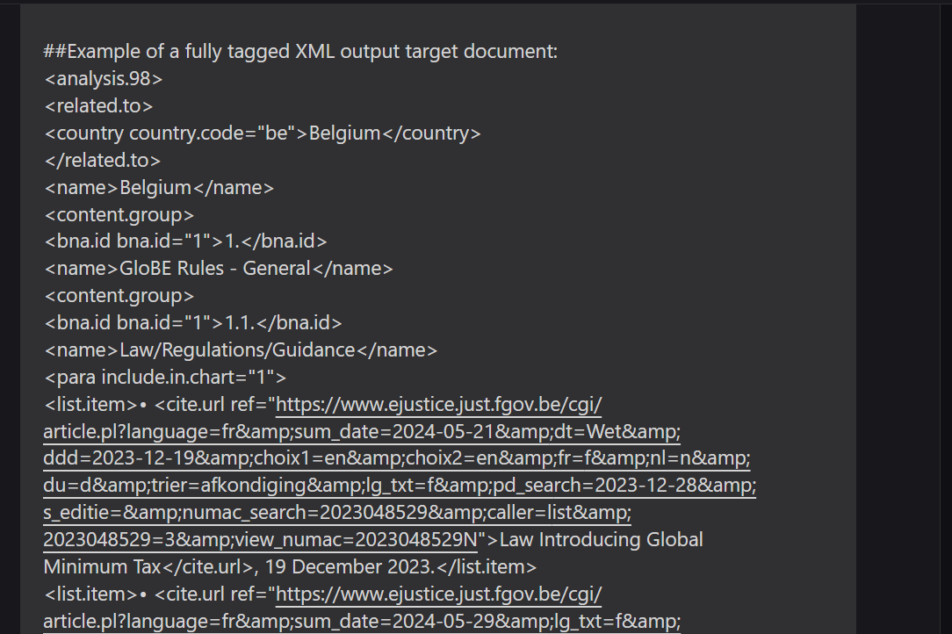

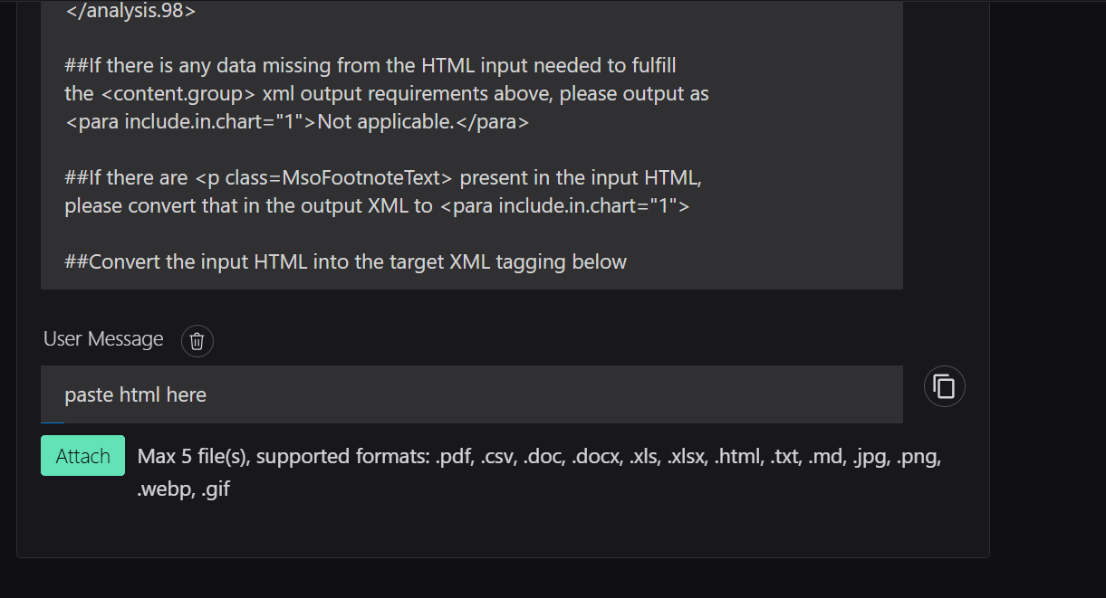

User Message: Please convert the attached file Jordan_jpg into XML format. Ensure that you create appropriate tags for each section, subsection, and individual piece of information. Maintain the hierarchical structure of the content and use attributes where necessary to provide additional context. As reference use the attached document Latvia_test_1_use.jpg as the source file and the sample xml tagging to below:

Create XML tags that reflect the structure and content of the text. Use descriptive tag names and nest elements appropriately. Include any relevant attributes to provide additional information or context. The resulting XML should be well-formed and accurately represent the original content. The Output should contain the table tagging mentioned above. You can send the output in parts if the document is too long. Indicate how many parts you used.

ONLY ADD THIS ROW WHEN A SIMILAR PARAGRAPH APPEARS IN THE PDF FILE TO BE PROCESSED: <row> <entry> <p><emph>For more detailed guidance, please see the Country Portfolio: </emph> <cite.url ref="https://www.bloomberglaw.com/product/tax/document/XPV2BU18#section(1"><emph>Malaysia, Intercompany Pricing, Other Transfer Pricing Provisions, Transfer Pricing Documentation</emph></cite.url>. </p> </entry> </row>

Note: ONLY ADD THIS ROW WHEN A SIMILAR PARAGRAPH APPEARS IN THE PDF FILE TO BE PROCESSED:
<row>
<entry>
<p><emph>For more detailed guidance, please see the Country Portfolio: </emph> <cite.url ref="https://www.bloomberglaw.com/product/tax/document/XPV2BU18#section(1"><emph>Malaysia, Intercompany Pricing, Other Transfer Pricing Provisions, Transfer Pricing Documentation</emph></cite.url>. </p>
</entry>
</row>

