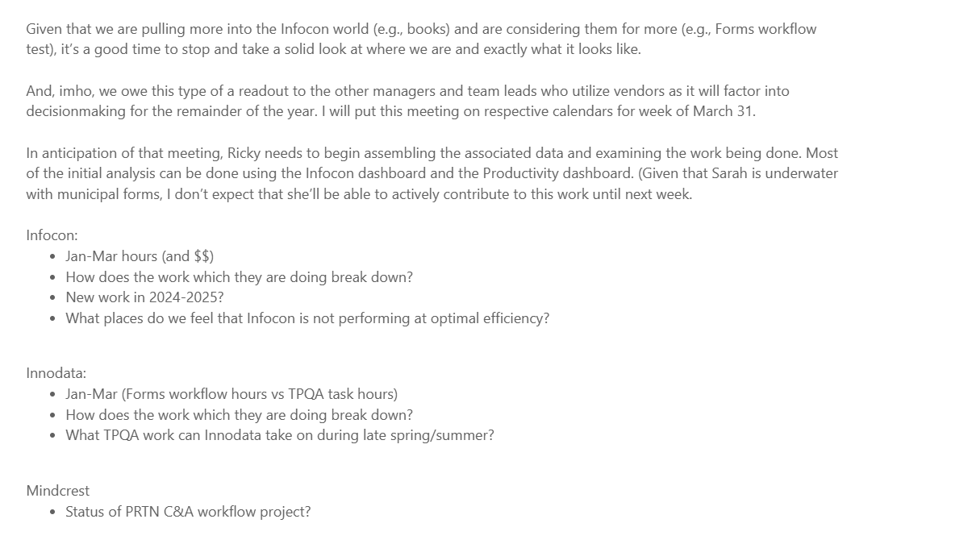

- Infocon Man hrs as of March 1

TODATE
DOCUMENTS | MAN HRS | Project
15 | 58.00 | DC_GTG
4922 | 529.00 | DC_INTNLForms
1 | 0.50 | DC_MLI
4 | 114.00 | DC_Pdf Compose
2 | 9.00 | DC_Pdf Compose (Corrections)
5 | 16.50 | DC_PL
26 | 1254.75 | DC_Portfolio
11 | 139.00 | DC_PROP_REG
36 | 224.50 | DC_PRTN
4 | 110.00 | DC_TaxBook
10 | 66.75 | DC_TD_CFR
7 | 40.00 | DC_VATN
1 | 32.75 | DC_BLAWBooks
4 | 42.00 | DC_ObsoleteCites
1 | 1.75 | DC_Leg_Hist
35 | 346.50 | DC_PTEN

Total as of March 1, 2025
5084 - Documents
-- 2985.00 Man hrs

New Work for 2025
BLAW Books -FLSA
International Forms QA

Infocon Workflows that needs to improve-
- Portfolio Compose pdfs

Innodata
Forms Workflow

Additional Work
STF- Download pdfs
Resume VAT/GTG

Status of Mindcrest Workflow
JIRA Access is done
Dashboard creation is ongoing
JIRA walkthrough with Mindcrest Analysts to be scheduled

