TAX LEGISLATION (House Bill, Senate Bill, & Act Language), COMMITTEE REPORTS, and Conference Agreements

I. OVERVIEW
a. Paula monitors legislative developments and alerts the appropriate personnel when key actions occur, such as passage by the House or Senate, committee reporting, conference agreements, presidential signature, or assignment of a Public Law (PL) number.
b. Through JIRA, Paula submits requests to create new files for newly introduced legislation. She also initiates requests when legislation needs to be reclassified from "Proposed" to "Enacted" status, or when a Public Law number is assigned.
c. Ricky creates the legislative file based on the details provided in the JIRA ticket. For large documents, he may include a temporary link to the PDF from congress.gov, jct.gov, or a BTAX public source until the file is converted. Ricky submits a separate ticket for the Vendor to handle large file processing (including text conversion and tagging). Once the completed documents are received from the Vendor, the PDF is replaced with the XML version and reposted to BTAX.

II. FULL TEXT LEGISLATIVE DOCUMENTS:
We add to BTAX full text of House and Senate Bill language after it has passed the House or Senate (sometimes earlier if it’s a bill of interest). We add full text of House, Senate, JCT, and Conference committee reports as they are released (after we have added the bill language). We add full text of Act language once Congress has passed it (before it is signed by the President). Not every legislation will have committee reports. There are also times when the House Bill language, Senate bill language and Act language will be the same because there are no amendments as it moves through the legislative process. If the legislation has not been enacted (signed into law), it will appear on BTAX under the Proposed heading for that Congress. Once it has been enacted, Paula through JIRA requests that it be moved from the Proposed to the Enacted heading.
For new legislation, a new document needs to be created in BWIP (Service: leg-ref) under the appropriate Congress number (e.g., 117th,118th, currently 119 –119th Congress (2025-2026 )). The name should be the bill number (e.g., H4240 or S0391). If the bill number is less than 4 digits, add zeros before the number to make it a 4 digit number.
File names for the language, committee report, etc. files start with the Congress number, a colon, bill number, hyphen, 2 digit number indicating sort order, and description of content. Examples: 115:h4240-20_HouseBill, 115:h4240-02_ActLang.

HOUSE BILL LANGUAGE
- Template files with the necessary tagging are in legtemplates-tmprod. Copy the template to your Q and name the file as HXXXX-yy_HouseLang, substituting the Bill number for the Xs and using the instructions for the “-yy” in the unit.code.
[If needed: The required tags are: info.unit; unit.start; annotated.source; name; legislative history; struc.level; p.]
- In the copy of the template file, change the attributes of the unit.start tag as follows:

<pdm.module>
<info.unit>
<unit.start class.code="119" class.name="NAME" pdm.name="House_Lang" service.code="leg-ref" subclass.code="hxxxx" subclass.name="" unit.code="hxxxx-20" unit.name="House Bill Language"/>
<annotated.source>
<name>House Engrossed H.R. ___, [Bill Name]</name>
<legislative.history>
<related.to>
<tax.legislative.document legislative.category="Proposed" legislative.resource="Source Documents"/>
</related.to>
<p>Full <cite.url>text</cite.url> of the House engrossed
[Bill Number], [Bill name], passed [Date].</p>
<struc.level1>
<name>SECTION 1.</name>
</struc.level1>
<p><p/>
<struc.level1>
<name>TITLE I—</name>
</struc.level1>
<struc.level2>
<name>SEC. __.</name>
</struc.level2>
<p> </p>
</legislative.history>
</annotated.source>
</info.unit>
</pdm.module>

Class.code – 3 digit number representing the Congress number (currently 119 for 2025 and 2026)
Class.name – name of legislation. You can usually find this in the first Section of the Bill language.
Subclass code – the bill number – e.g., h4240 or h0021 [add 0s before the bill number so that the number is always a 4-digit number].
Unit.code – bill number with document designation. House bill language files are always in the 20s (-20, -21). The number appearing after the hyphen determines the sort order. The unit code includes the subclass code, a hyphen and the 2-digit number (e.g., h1155-20).
- Inside the name tag should be descriptive words such as “House Engrossed”, the bill number and name, and the date the House took action. [You can usually find the date that is passed at the end of the Bill]. Example: House Engrossed, Recovery of Stolen Checks Act (H.R. 1155), passed March 31, 2025.

- Where to find text of the Bill language
- If the bill language is long and cannot be added to product quickly, add a link to a pdf version. Sample of linking to a pdf file below:

<pdm.module>
<info.unit>
<unit.start class.code="119" class.name="119th Congress (2025-2026)" copyright.owner="The Bureau of National Affairs, Inc." pdm.name="House_Lang" service.code="leg-ref" subclass.code="h1155" subclass.name="Recovery of Stolen Checks Act (H.R. 1155)" unit.code="h1155-20" unit.name="House Bill Language"/>
<annotated.source>
<name>House Engrossed, Recovery of Stolen Checks Act (H.R. 1155), passed March 31, 2025</name>
<legislative.history day="31" month="03" year="2025">
<related.to>
<tax.legislative.document legislative.category="Proposed" legislative.resource="Source Documents"/>
</related.to>
<p>Full <cite.url ref="https://www.congress.gov/119/bills/hr1155/BILLS-119hr1155rfs.pdf">text</cite.url> of the House Engrossed, Recovery of Stolen Checks Act (H.R. 1155), passed March 31, 2025.</p>
</legislative.history>
</annotated.source>
</info.unit>
</pdm.module>

After publishing this on product, you will need to convert the pdf to text as noted in either b or c, below.

- You will need to go to Congress.gov. In the search box, type h and the bill number. Example: h1155. After you get the search result, click on HRXXXX, which will bring you to the website for that Bill. Click on the Text tab. You want to choose the House version you were asked to add, e.g., House Engrossed version (if this is not available then choose Reported House version), House Introduced version, etc. Click on XML\HTML or TXT for the file type (If you pick PDF as the version, you will need to remove extraneous text when you copy the text).

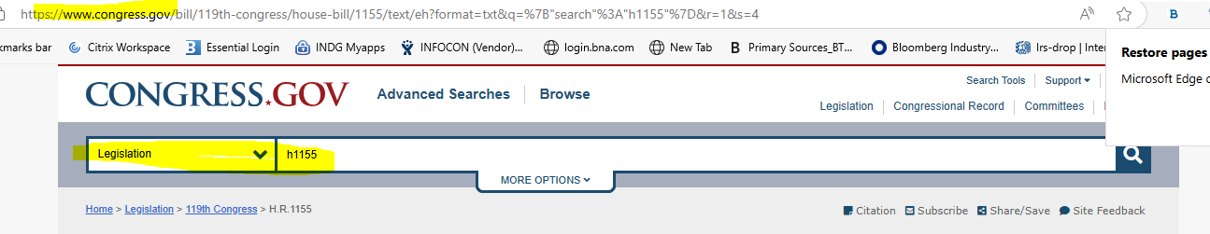
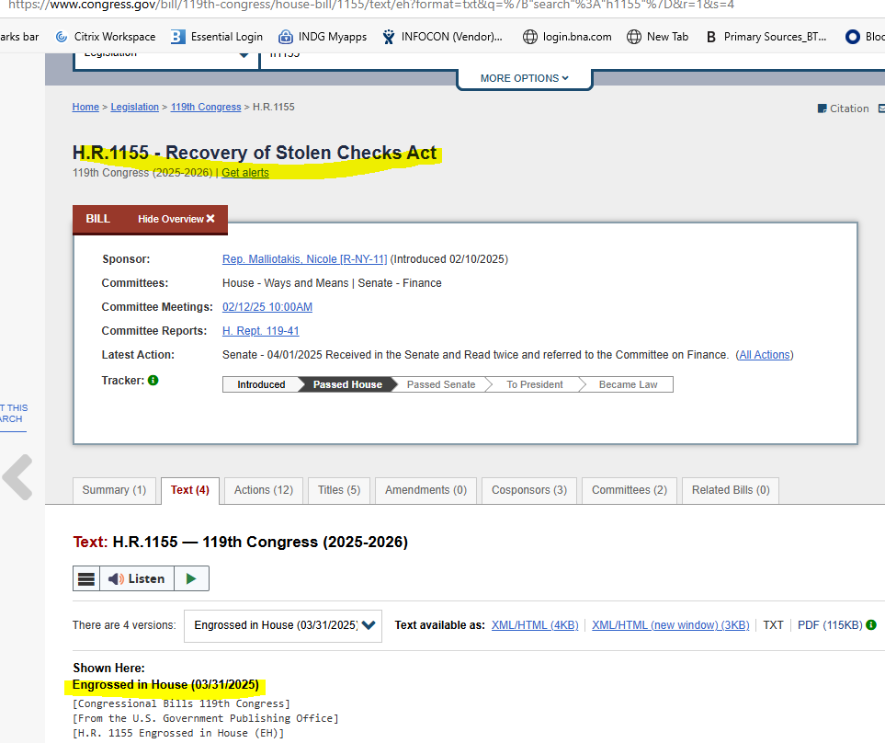

If the document is short, copy the text from Congress.gov to your BWIP file and tag appropriately (see below); otherwise send it through the gateway for conversion.

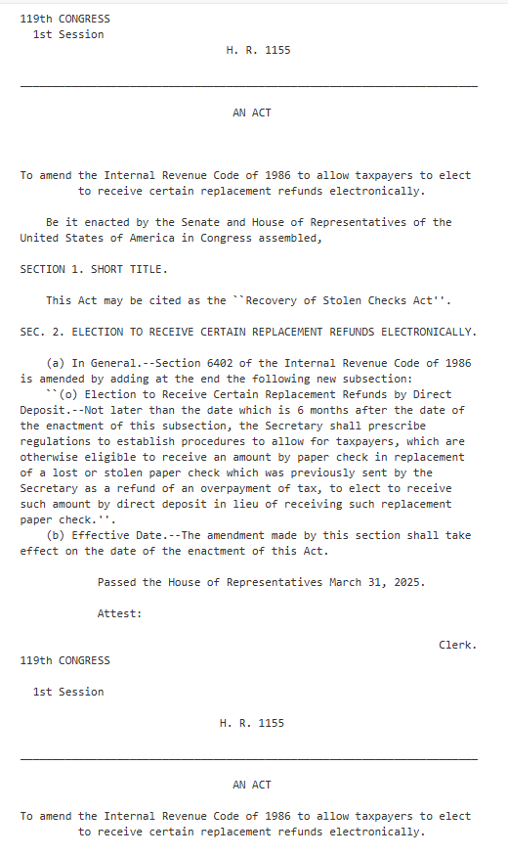

SENATE BILL LANGUAGE

- ACT LANGUAGE

- COMMITTEE REPORTS

