Partial VAT/GTG Conversion Using the Email Gateway

- Open file in Word and replace Manual Linebreak with Paragraph Character

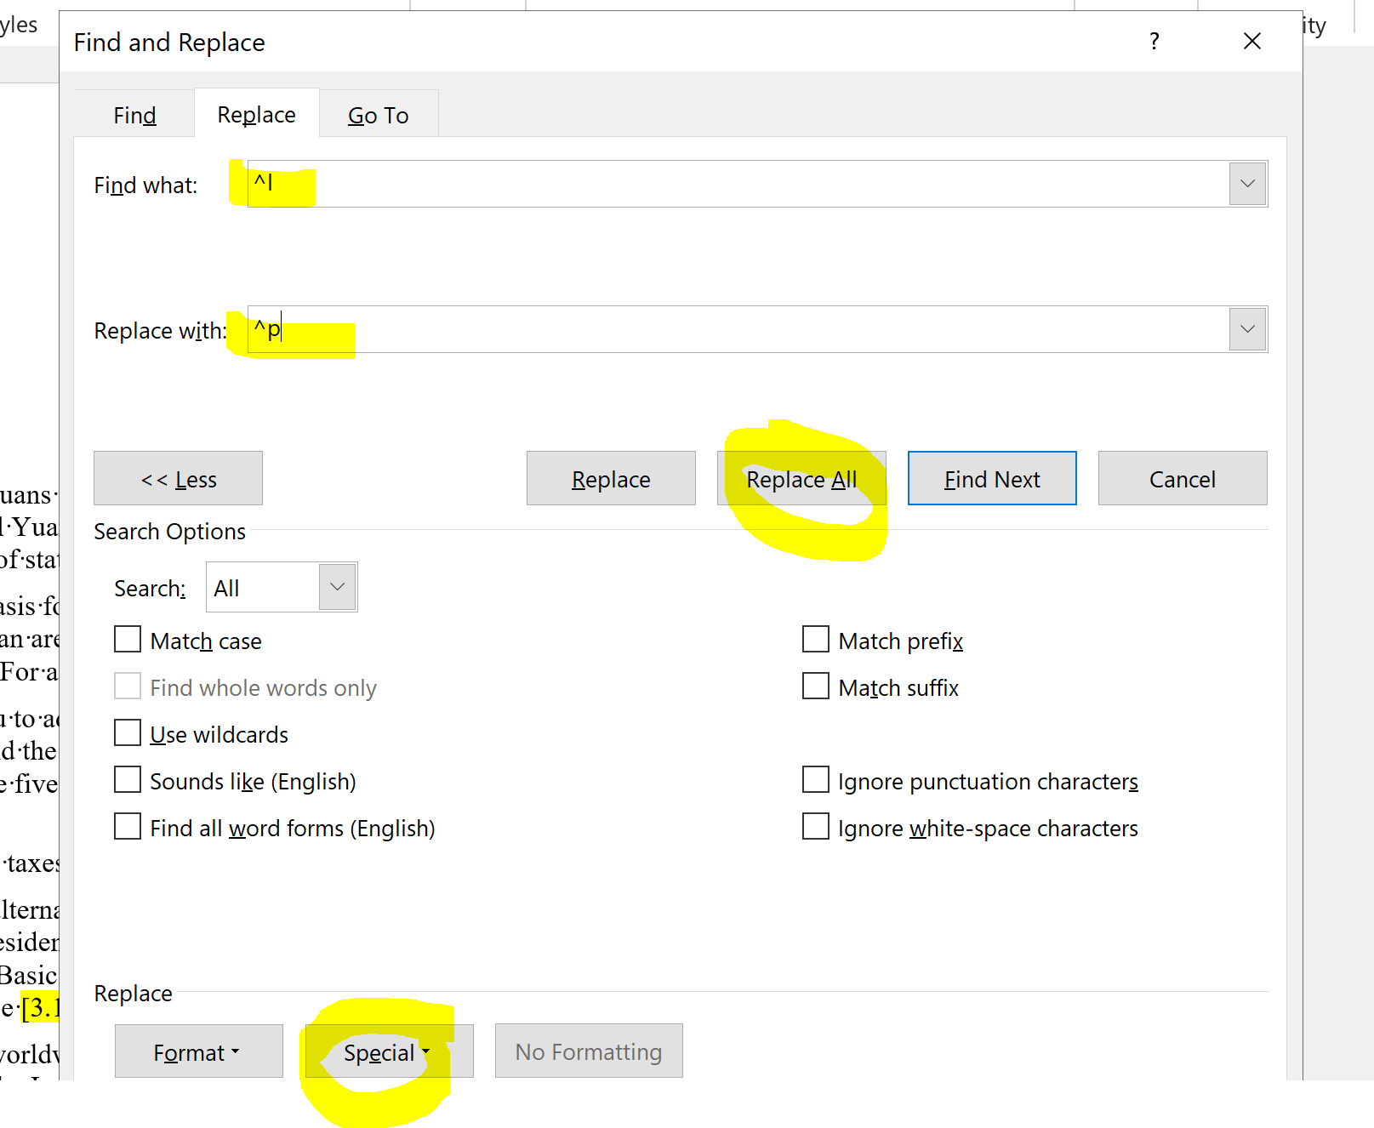

File will look like this originally:
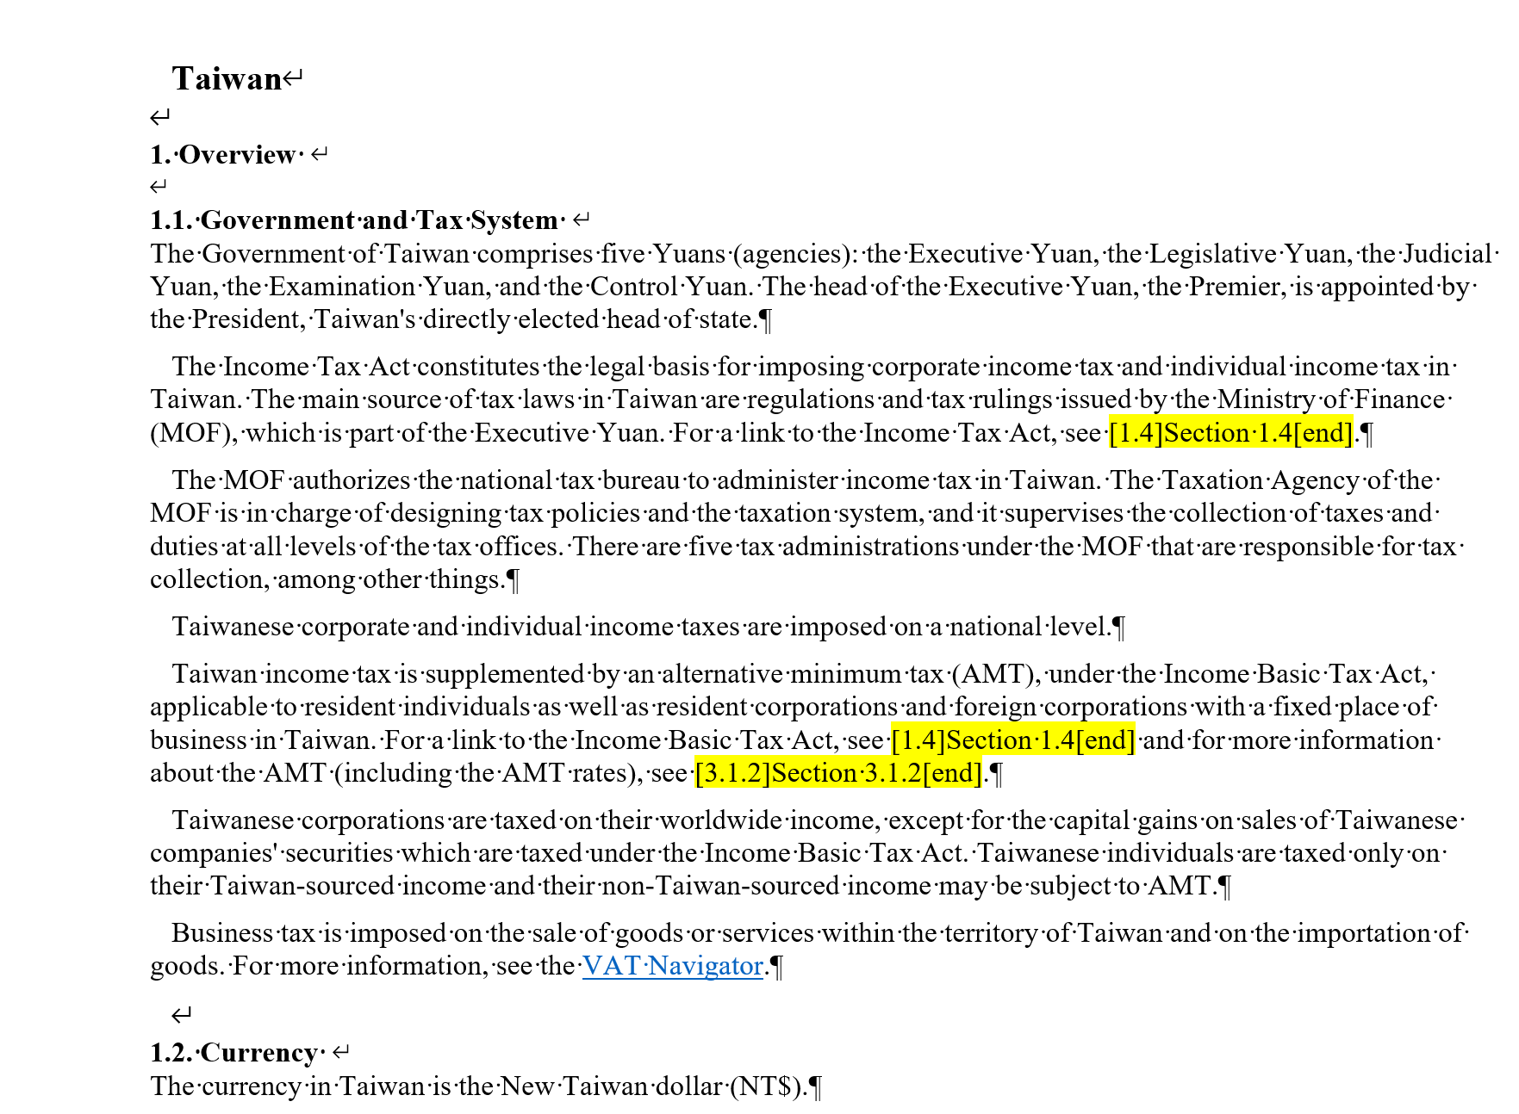

To this:

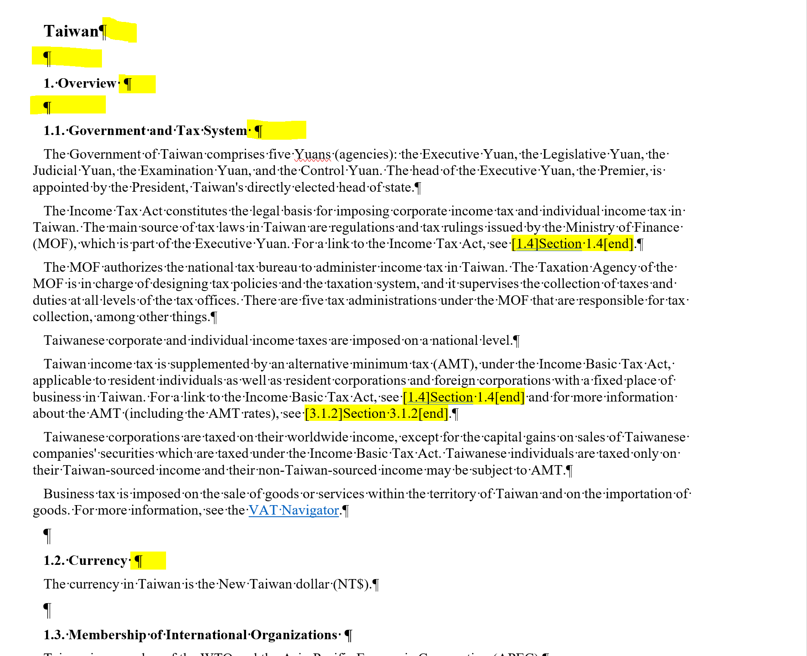

- Replace the Bullets with ###$$$ : 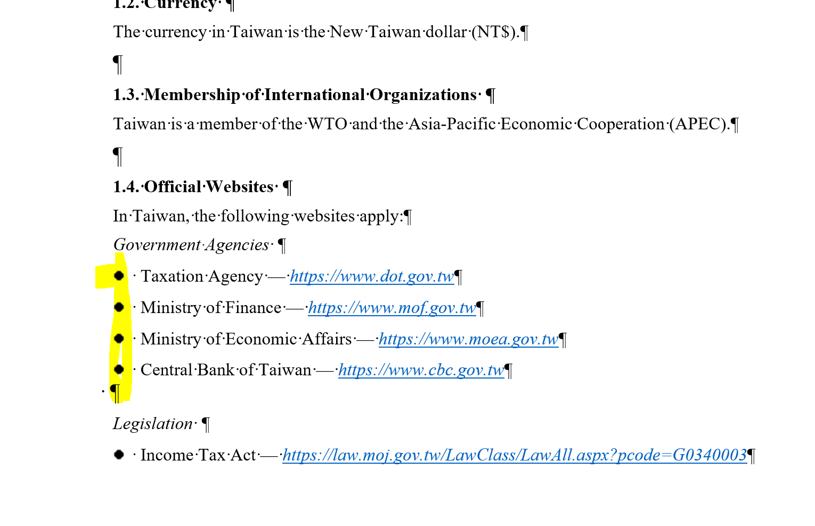
Use Control F to bring up the Find menu

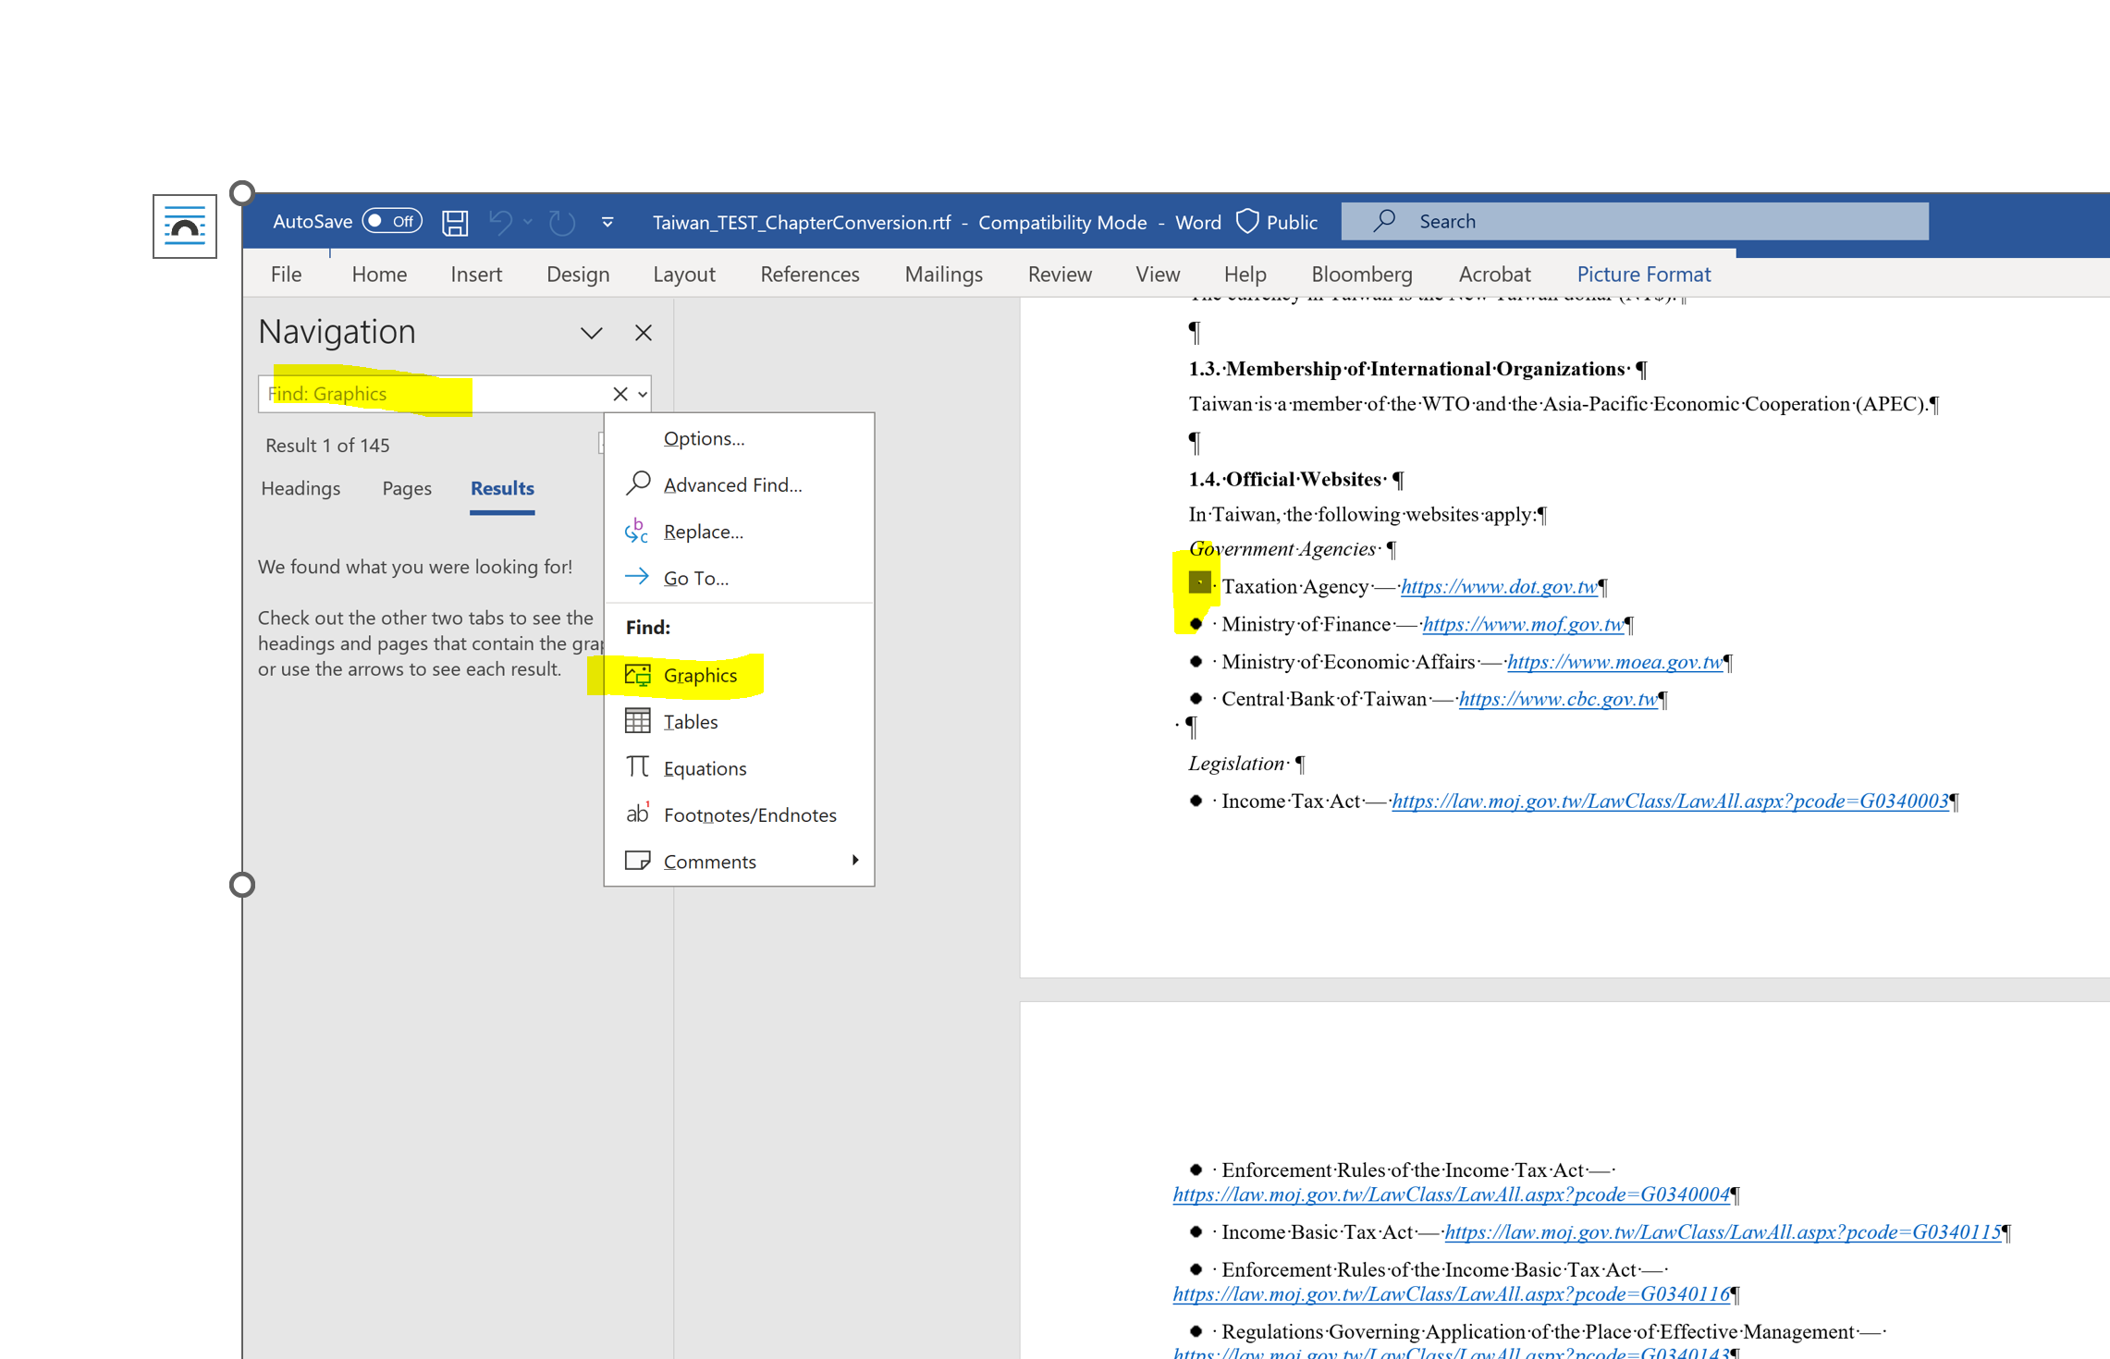

Then click on Home>Replace then type ###$$$ on the Replace with line and retain the ^g on the Find what line (the “^g “was generated when the search for graphics was executed.

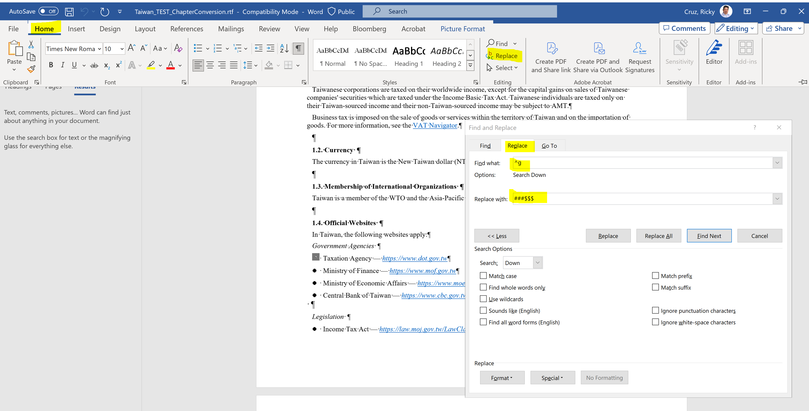

Then click on replace all and the document will look like what is shown below:

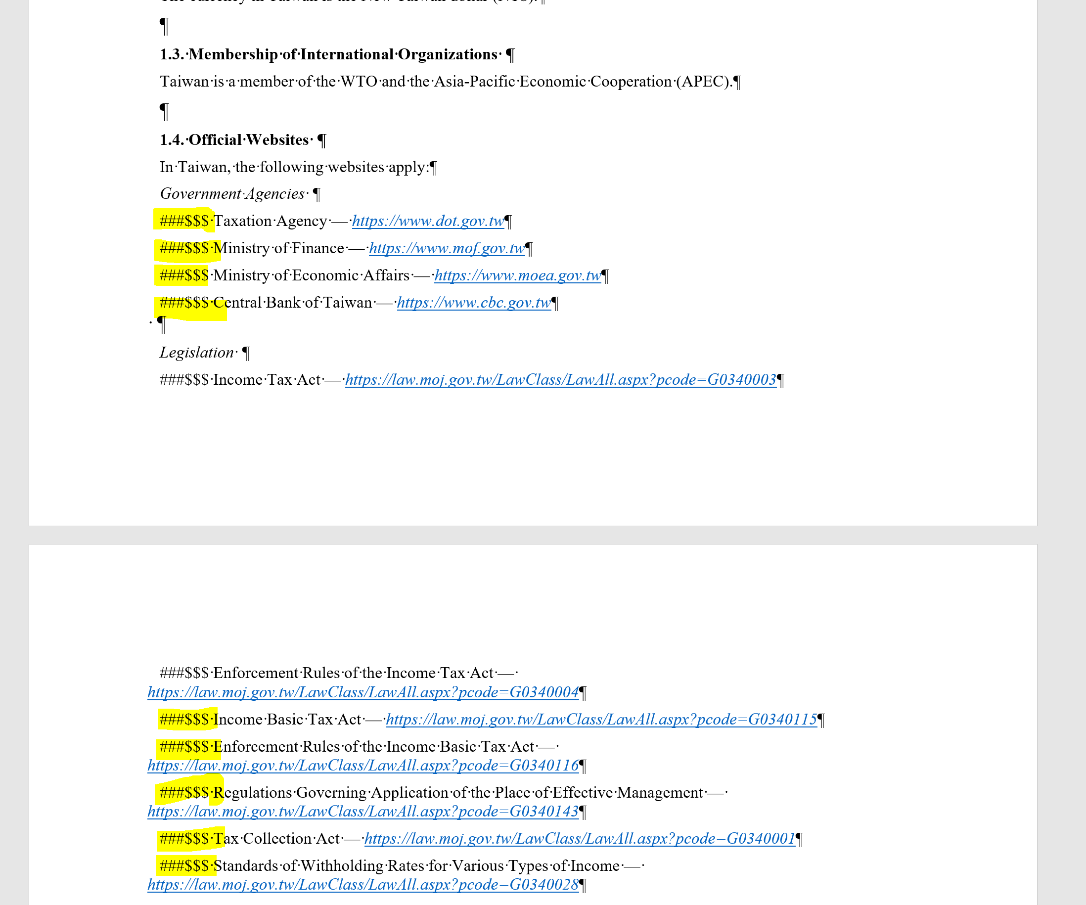

After the replacement save the document as an RTF File:

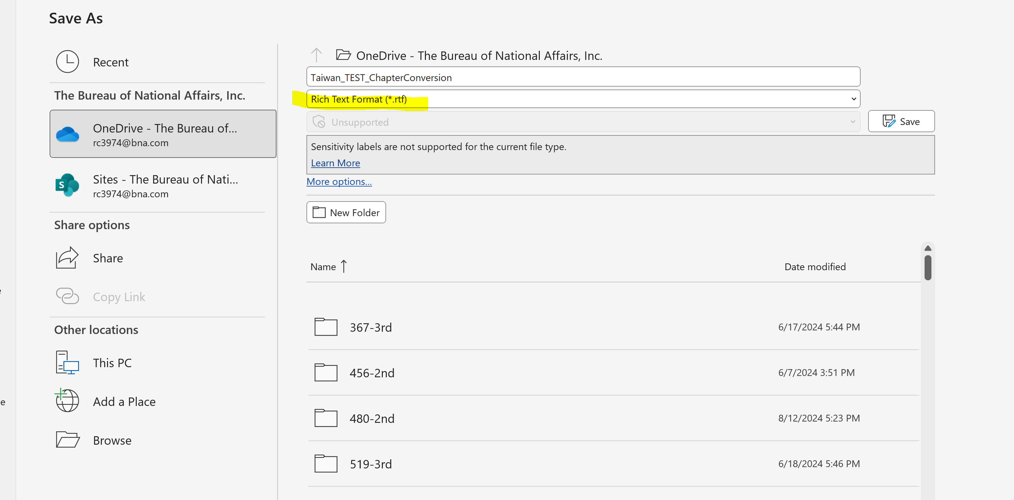

Using the Email Gateway send the file to BWIP

- Create Message following the sample below:
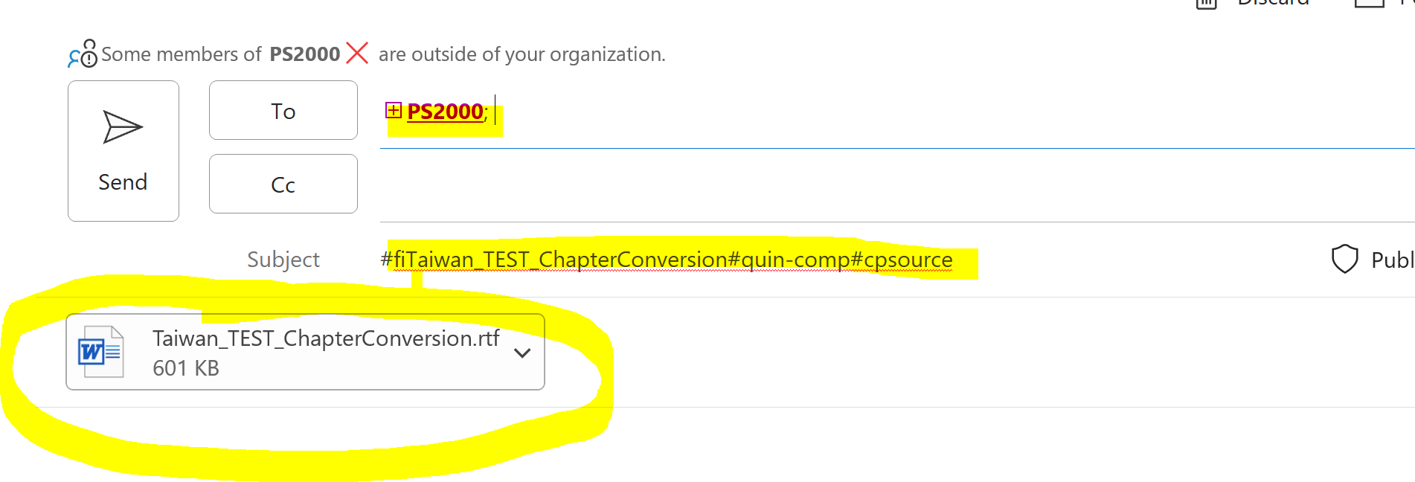
- Message should be addressed to: PS2000
- On the Subject line type: #fiFILENAME#quin-innodata#cpsource
Note: There should be no spaces on the filename. Underscore can be used instead of spaces. A blank space within the filename will cause the transmission to fail.
You can either send the file to the in-comp or in-innodata queue.

- Attach the RTF file then click on send.

In BWIP locate the Actions drop down menu and select Plain Text Edit
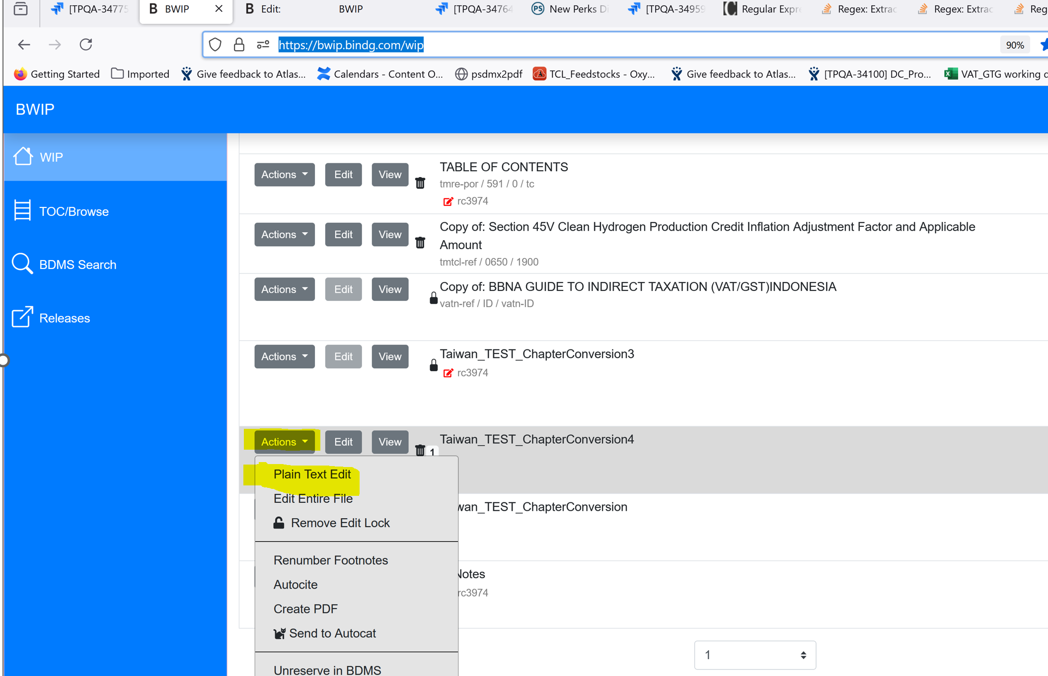

This will open the file with the basic p, emph, & footnote tagging as shown below:

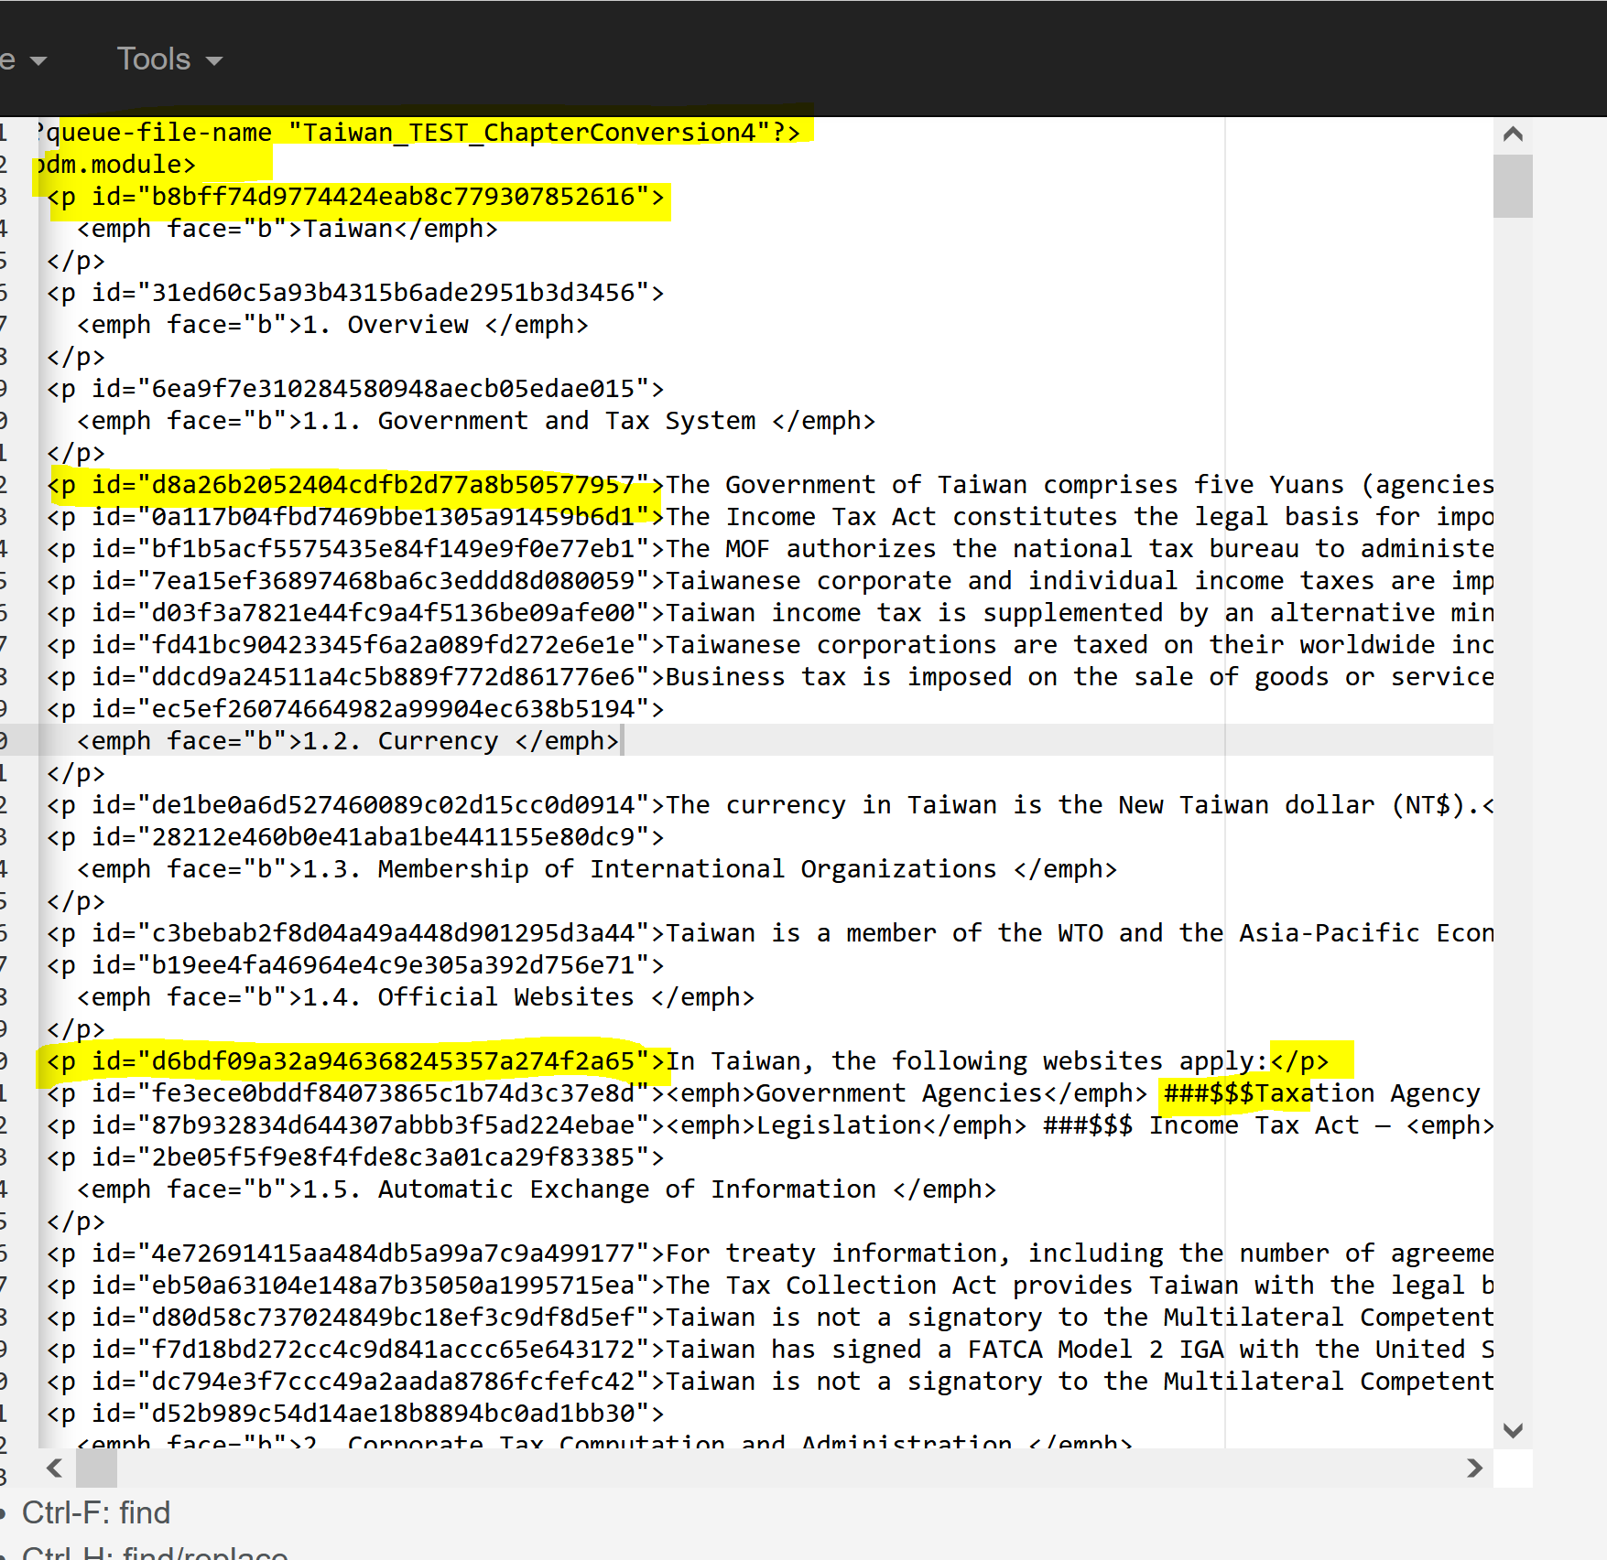

Press Control H to Find and Replace and key the characters below, this will change the <p tags with ID numbers to <para include.in.chart=”1”>

Note: It is important to click on the Regular Expression Tab [.*] for the search to work.

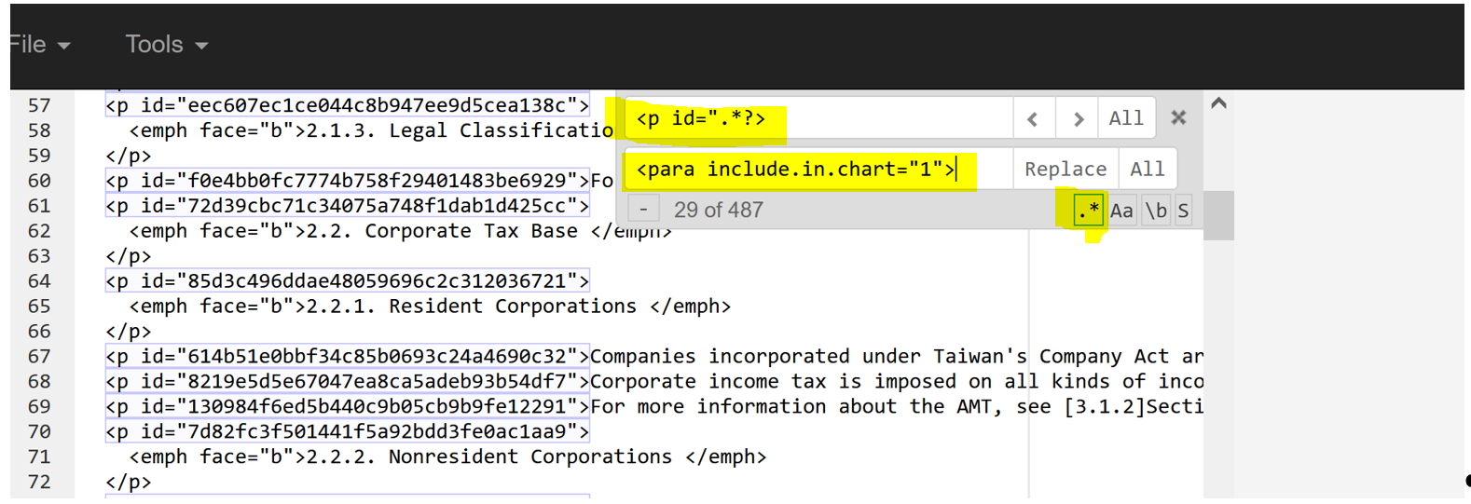

After the initial search and replace the file will have <para include.in.chart=”1”> tags for each line and paragraph and the ###$$$
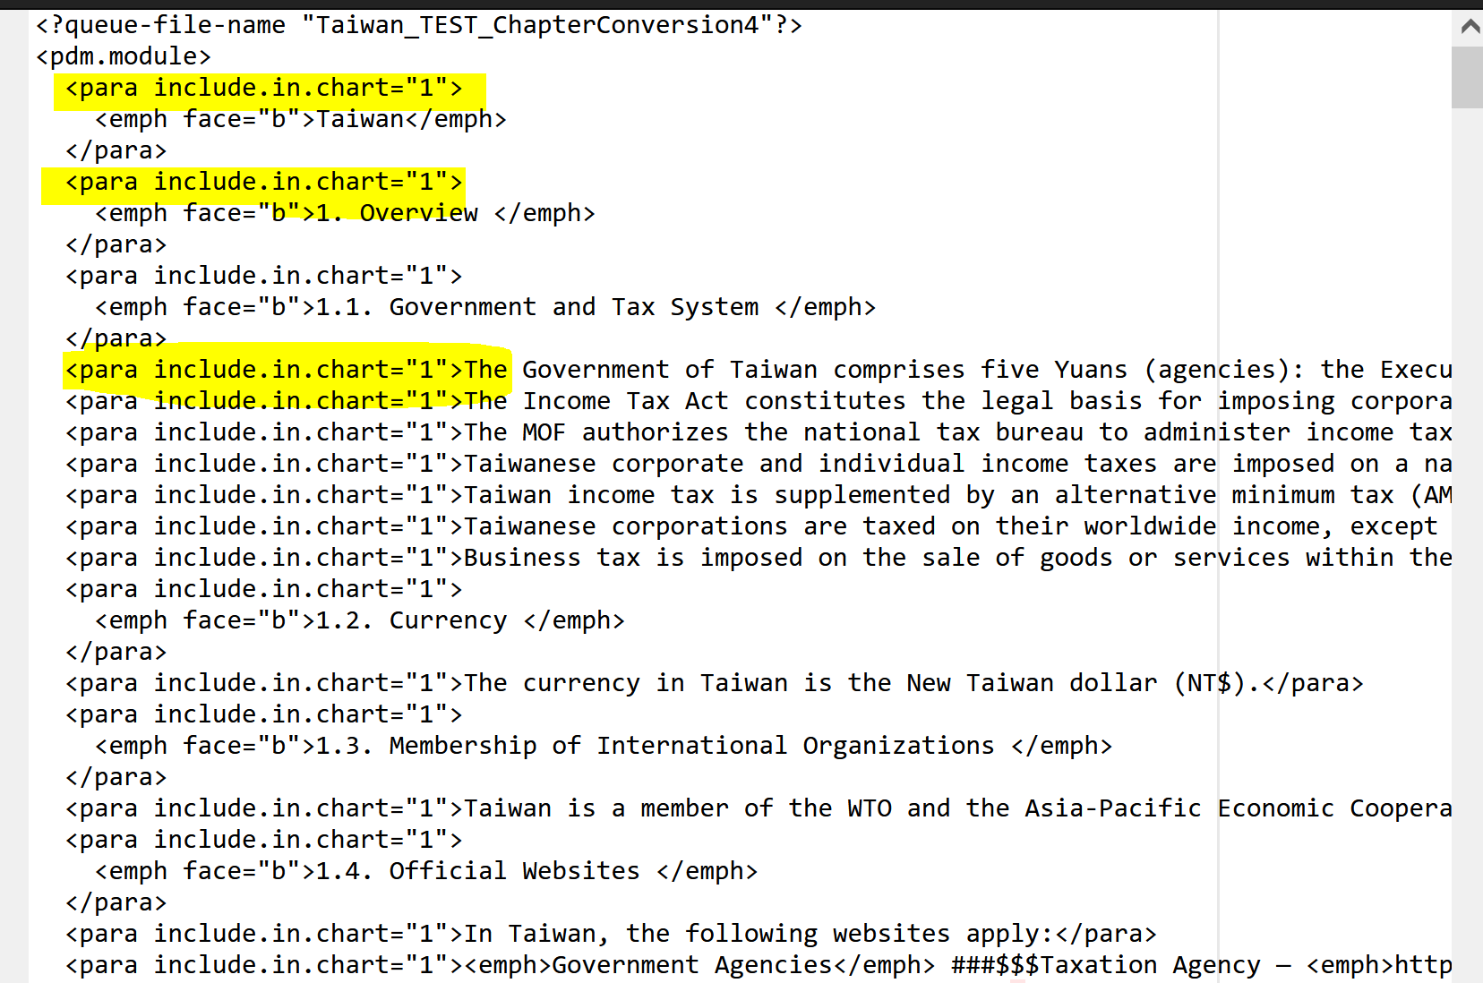

Next step will be replacing the ###$$$ with </list.item>list.item>• <hang/>

Note: For this search and replace there is no need to activate the Regular Expression Tab.
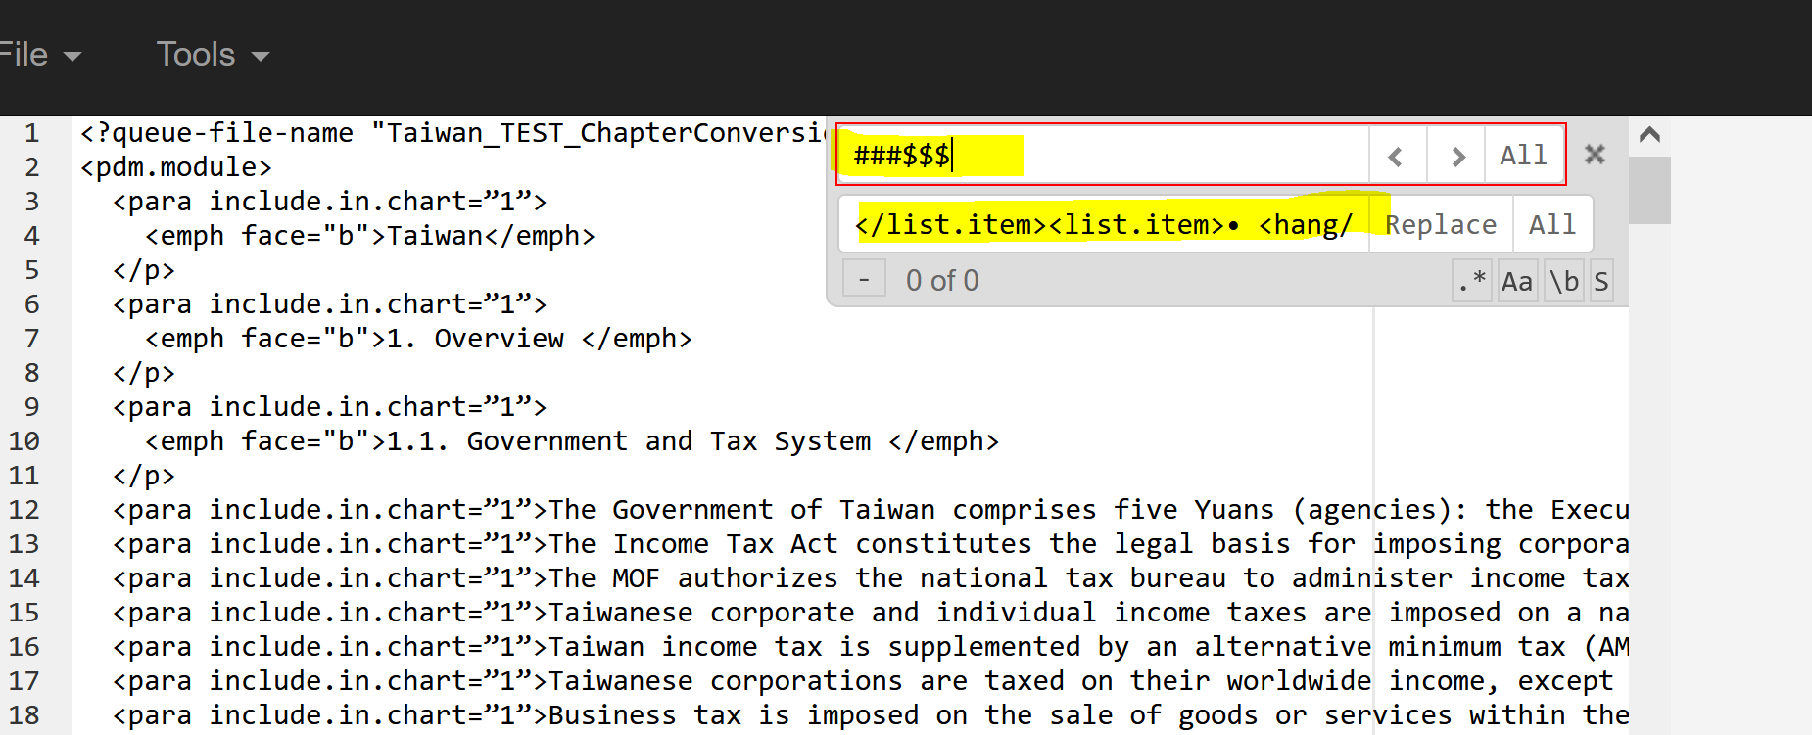

After the replacement the document this will appear as shown below:

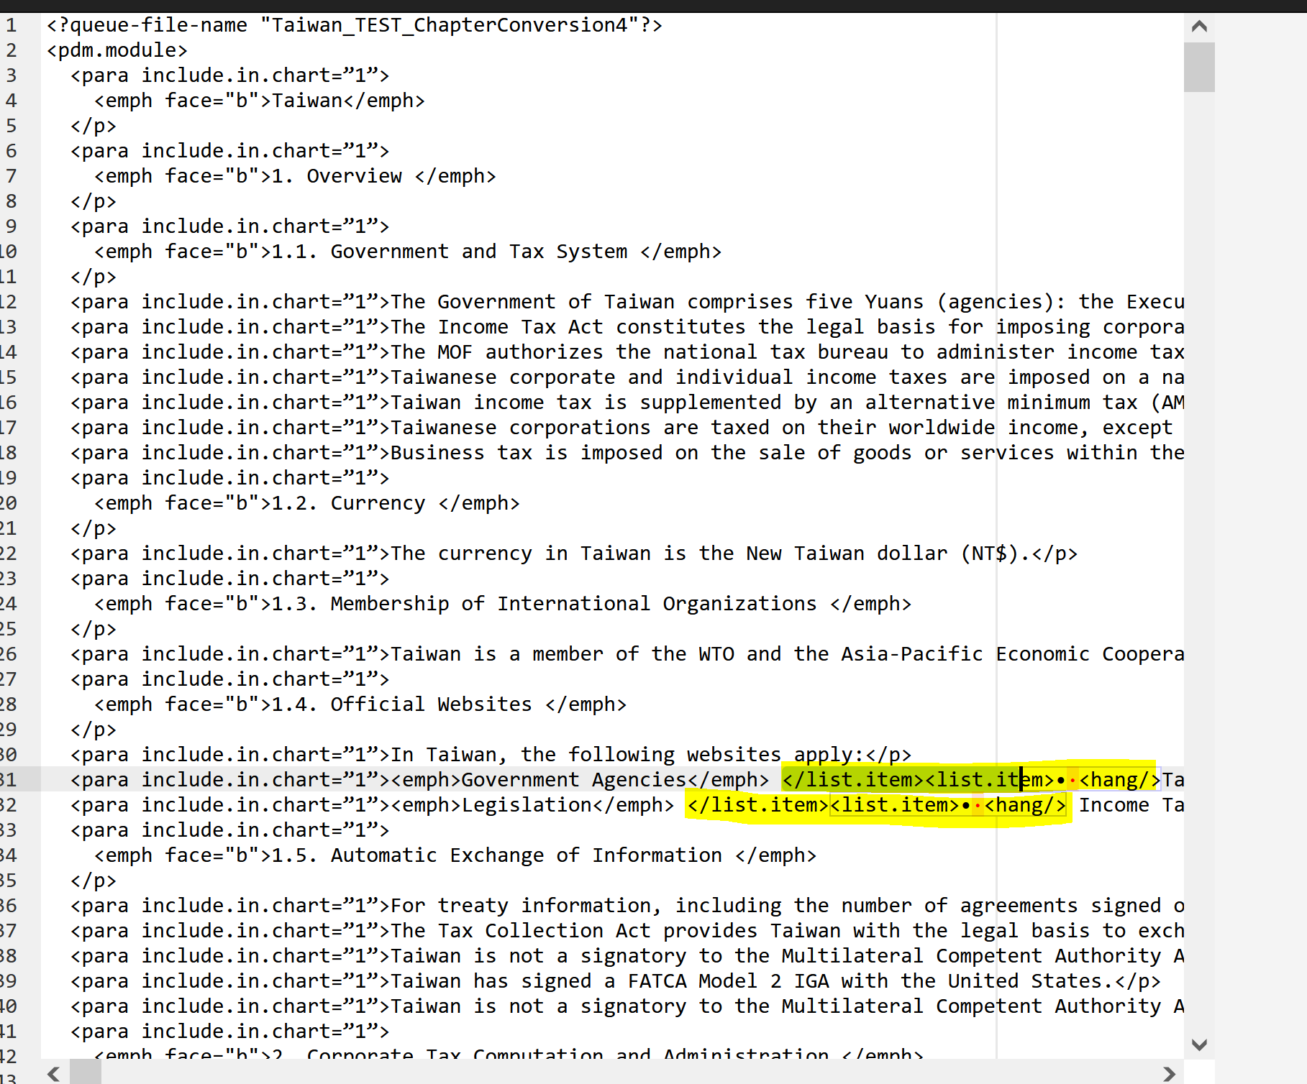

Next step will be replacing the level 2 list items :
Search for <para include.in.chart=”1”>o then replace with <list.item level="2">o <hang/>
Note: include a space after <para include.in.chart=”1”>o when keying in the search box.
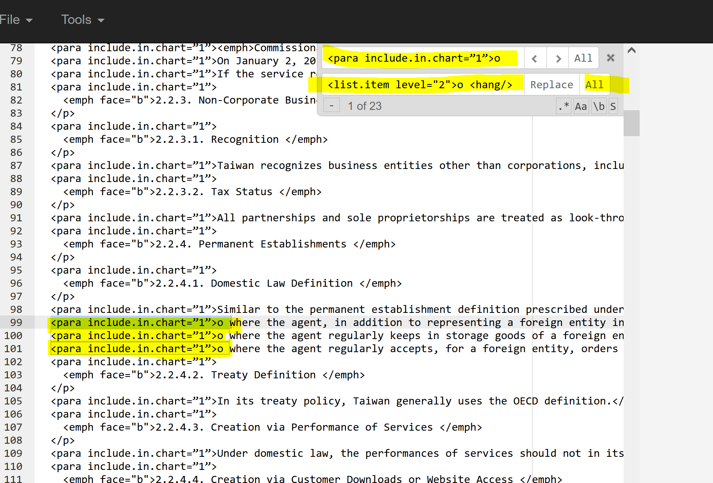

After the replacement text will be as shown below:

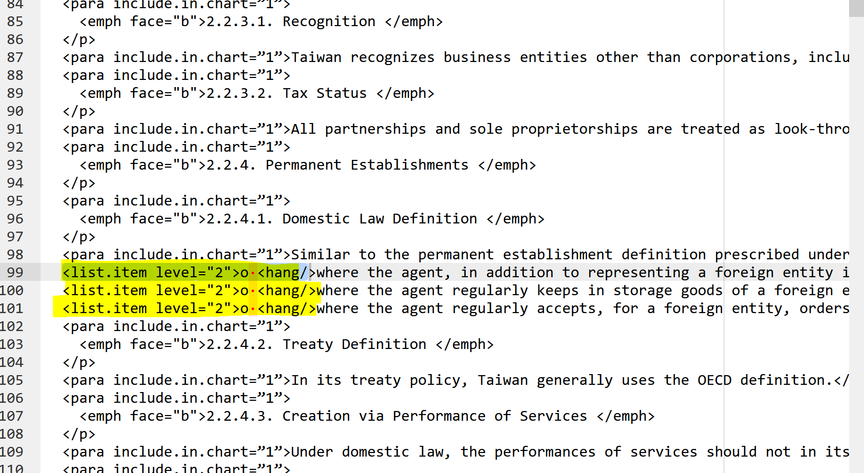

Then we need to
1.Delete the first occurrence of </list.item> and
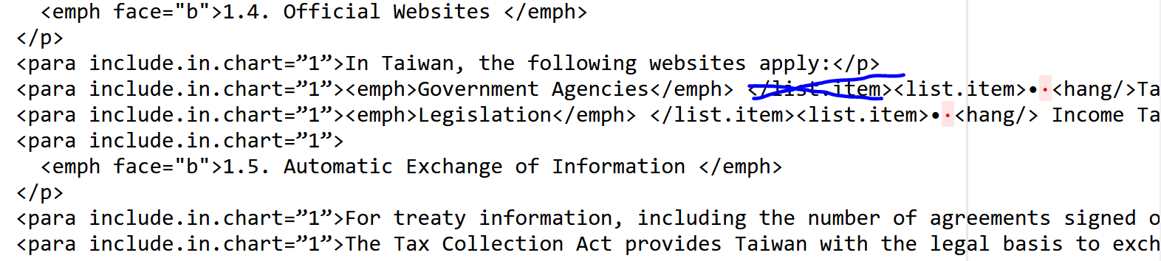
2.Add </list.item> to the last occurrence of <list.item>• <hang/> in a list item group:
Add </list. Item>tag

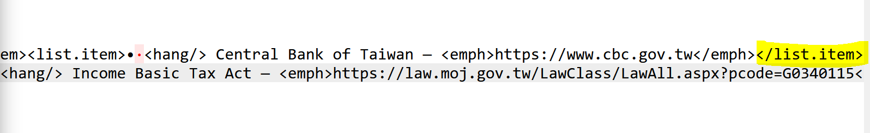
3.Replace </p> with </para> 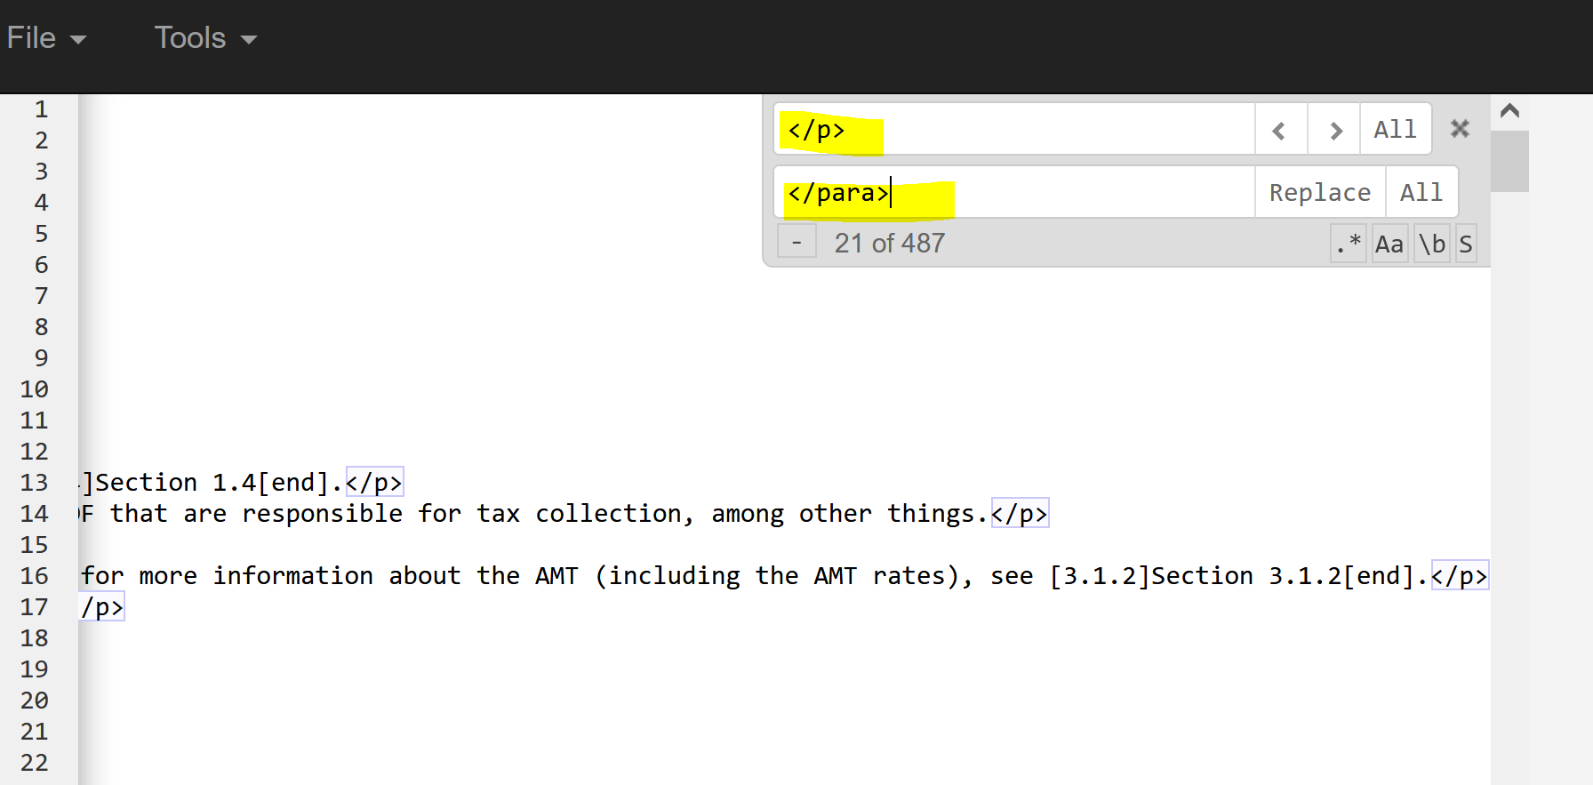

- Replace </para>with </list.item> on text with <list.tem level=”2”> tags:

Note: this should be done individually

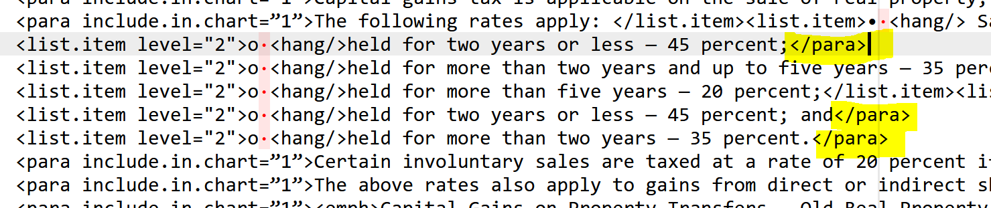

- For Footnotes: Move the footnote number to the space in between the <superior> </superior> tags.

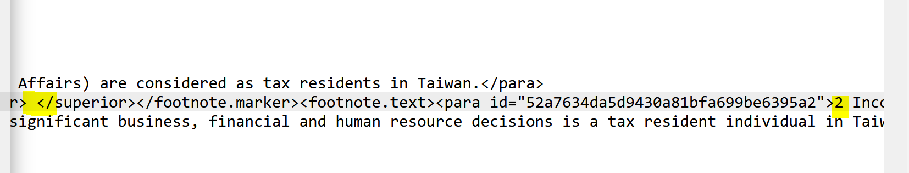
Move footnote number here

To search for footnotes:

Make sure to put your cursor at the top of the file before pressing Contol + F
The search box will also show how many footnotes are in the file.

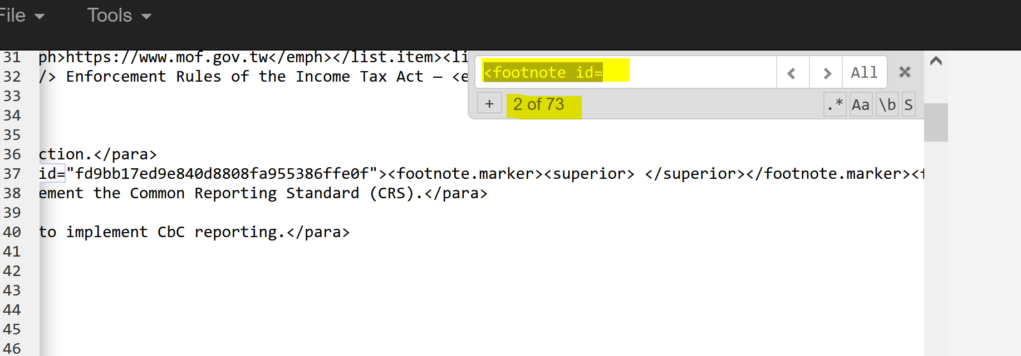

The final step will be putting the info unit tags, content group, bna id, name, cite tags and validating the file. The Parse XML file tool currently doesn’t work in PTE (Plaintext Editor). To Validate you need to save and then Open the file in Oxygen Author mode. If you cannot open the file usually the file is locked.
Also, for the VAT files you don’t need to do a global replacement of the <p> tags with <para include.in. chart=”1”> since not all paragraphs are <para include.in. chart=”1”>.

If you see other patterns you can use PTE for search and replacing text.
e.g., Search for “see [“ and Replace with see <cite.bna.reference ref=”gtgg2\XX\YY”> then you can replace XX & YY with the appropriate country code and section number .

