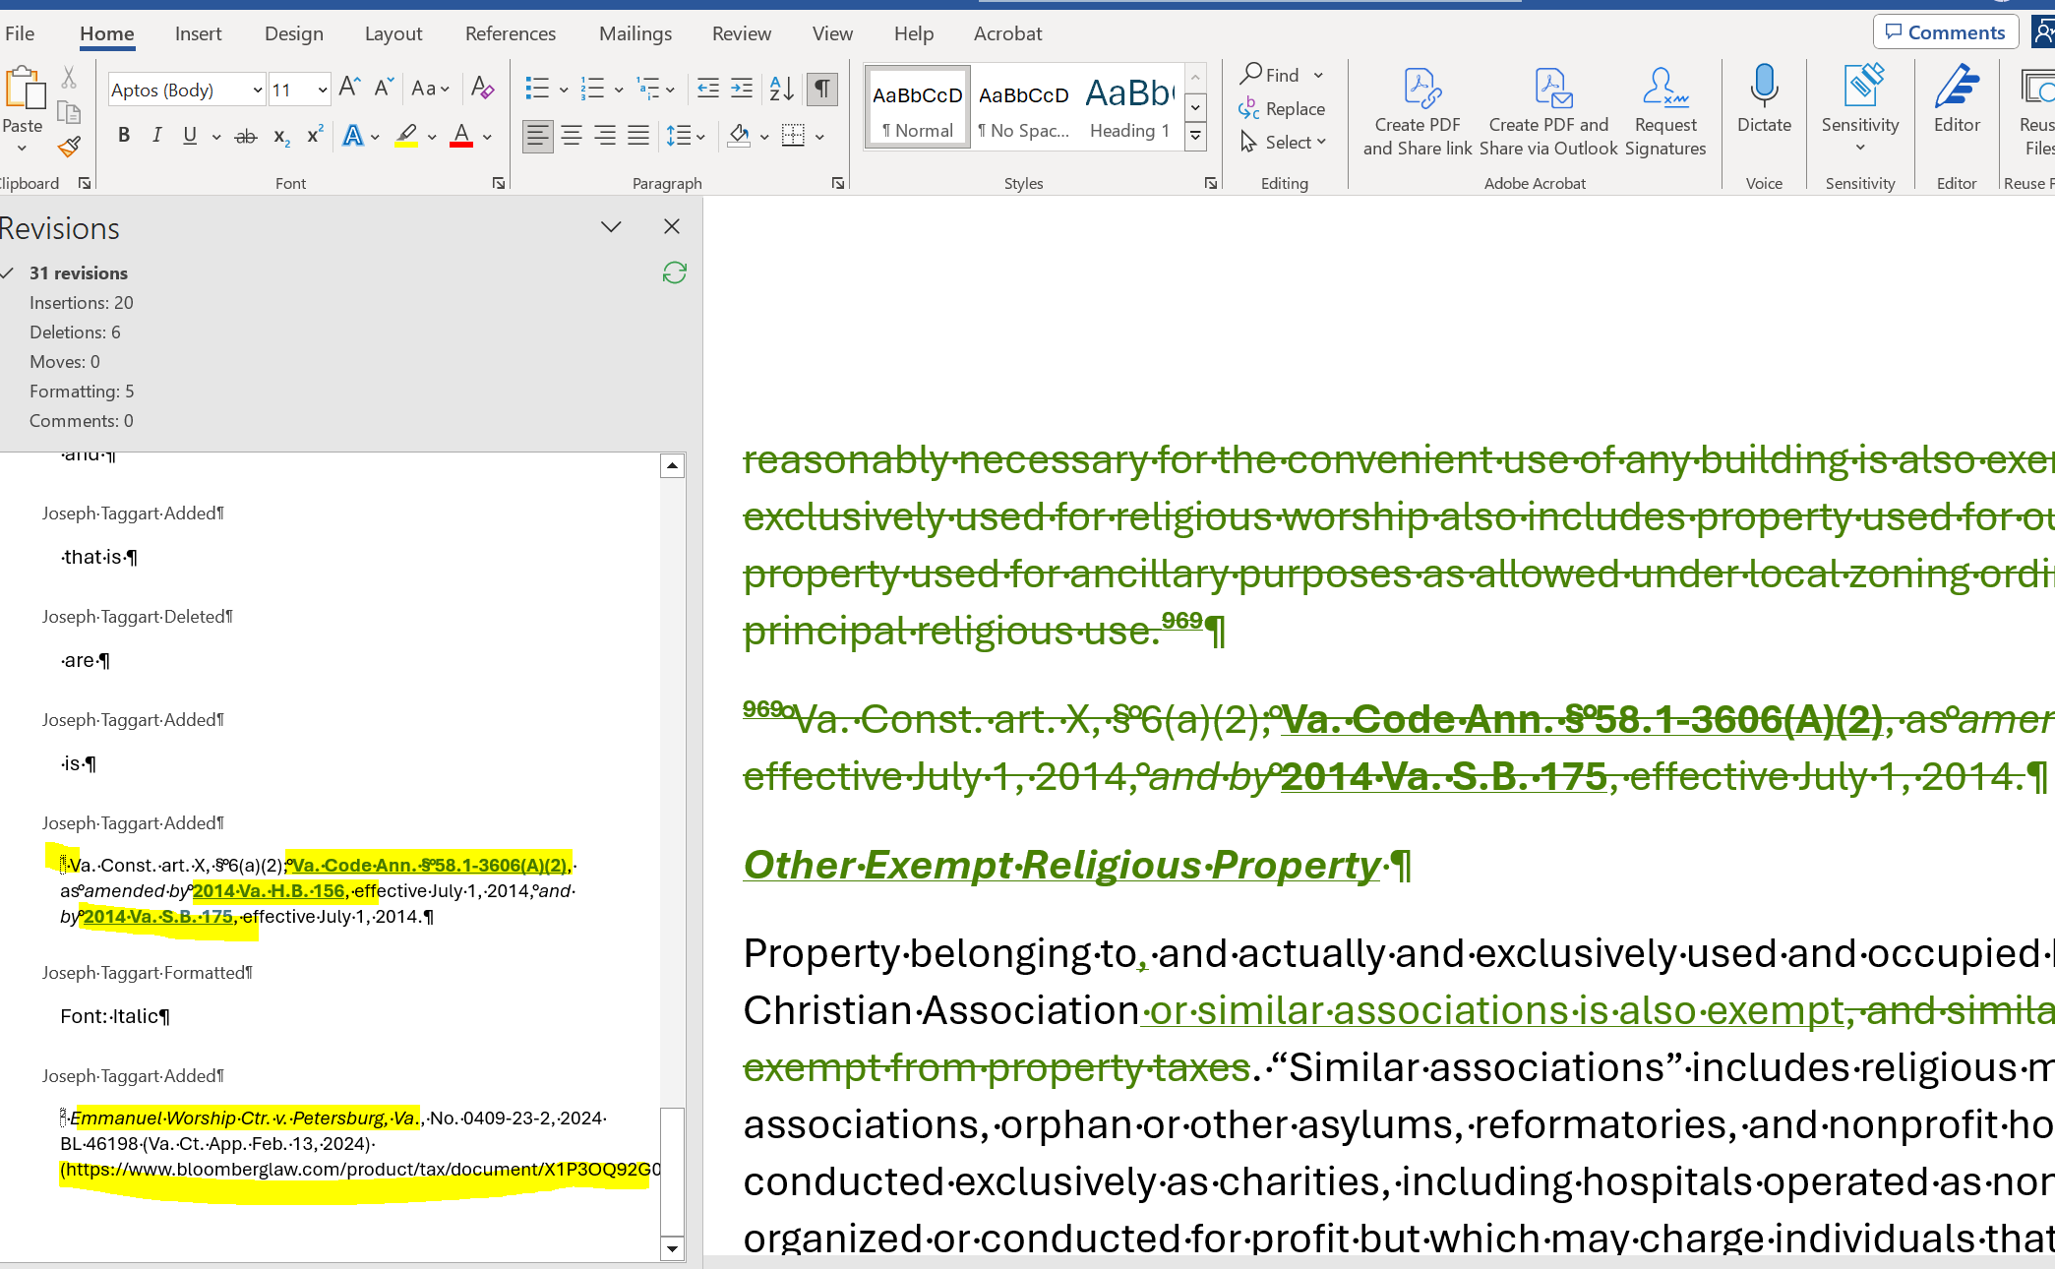
Only paragraphs or sentences in the review pane needs to be searched
URLs needs to be tagged
Words that are in Italics
Words that in Bold count as one instance that needs to be tagged

