PG Tickets with questions:
Title with timeline but there is no title change do we change it
https://jira.bna.com/browse/ECO-249191
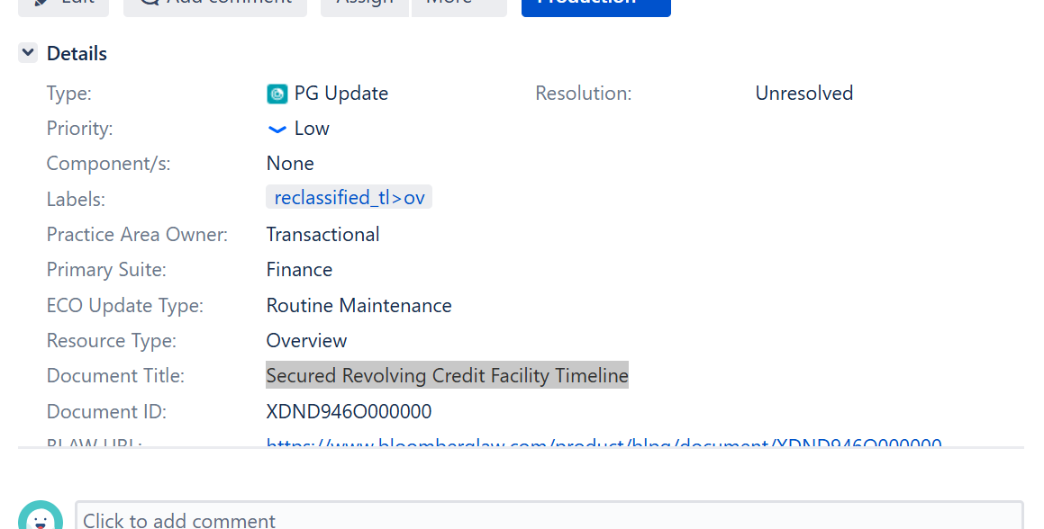

Annotated in the title but there is no title change do we get rid of the (Annotated)
Do we need to change the title in the ex-paywall ticket if it’s different from the Reclassification ticket
https://jira.bna.com/browse/ECO-187202
