Instructions for Generating a TPS Comparison Table using P-REX

- Login to P-REX
- 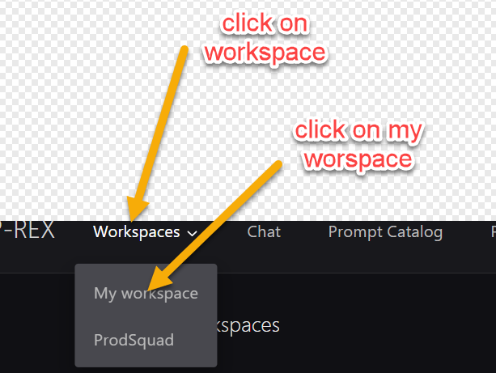

- 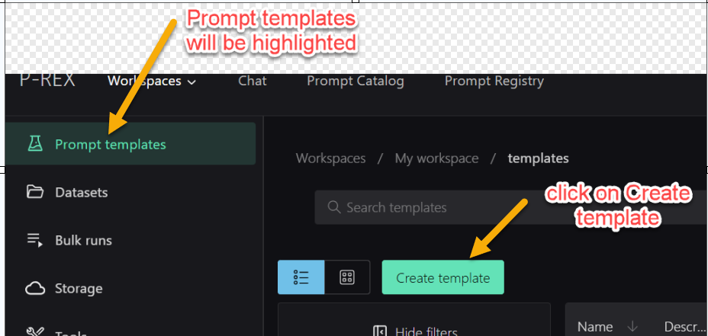

- 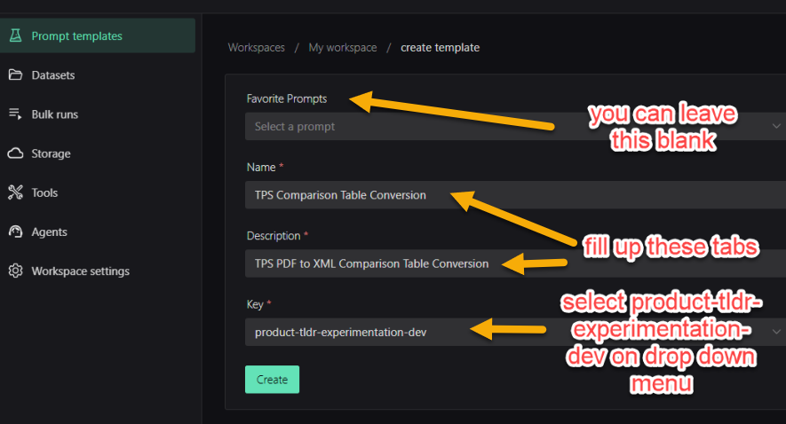

- 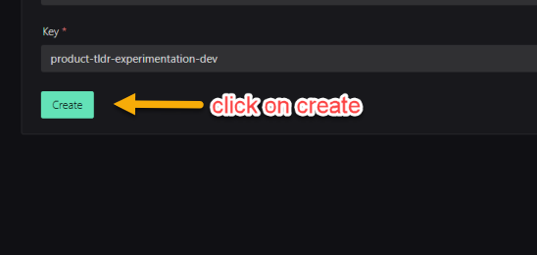
- This will bring up this view:
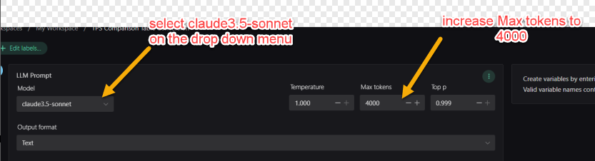

- Paste the text below on the System Message tab:

