PRTN UPDATE WORKFLOW

OVERVIEW
- TPQA receives TAXD JIRA ticket containing the word file to be updated from State Analyst.
- TPQA creates ticket for Infocon/Vendor and attaches the word file for updating. Updates are done in BWIP.
- TPQA creates own ticket to which hours worked on the project and other instructions are recorded.
- Infocon processes the file and informs TPQA when completed.
- TPQA verifies the edits and renumbers the footnotes and releases the file in BWIP
- TPQA then notifies Analyst that it is ready for final review in product/BTAX.

Infocon/Innodata PRTN Update/Data Entry Instructions

Receive JIRA Ticket containing Word file.
Instruction in JIRA ticket gives the location
“Attached is the WORD file for the (insert state) file that is in the PRTN-TMPROD for editing in WebQ
Please acknowledge receipt of ticket.
Please return the completed file by (insert date: Ex.: Thursday, June 13; I usually give them 1 week). Please also provide the hours spent on the project in the COMMENT section.”

In the word files are instructions marked that consist of :
- the locations information in the navigator;
- text to be inserted into the section, including new footnotes;
- text to be deleted from the section
You will need to tag citations, code law, regulations, legislation and administrative documents that are added in paragraphs and footnotes.
Tags have to be in the correct style. Finding a similar item in the file- you can then modify the attribute to match the requested information.
Example:
The file is asking for Utah Code Ann. § 57-2-1234, just modify the information and tag to match the correct information asked for in the red-lined word file.

When tagging Cases requested in the red-lined word file; example:
Shi v. McGeever, No. 23-2868, 2024 BL 115785 (3d Cir. April 4, 2024) (https://www.bloomberglaw.com/product/tax/document/X1CH6TAG0000N)
If you copy the X1CH6TAG0000N Go to your action bar to INSERT- Insert Cite Case Partial.
Place the copied document id in the box and select GET CITE DATA; the system will pull all the proper case information. Select OK in it will put the data in the area your cursor is on.
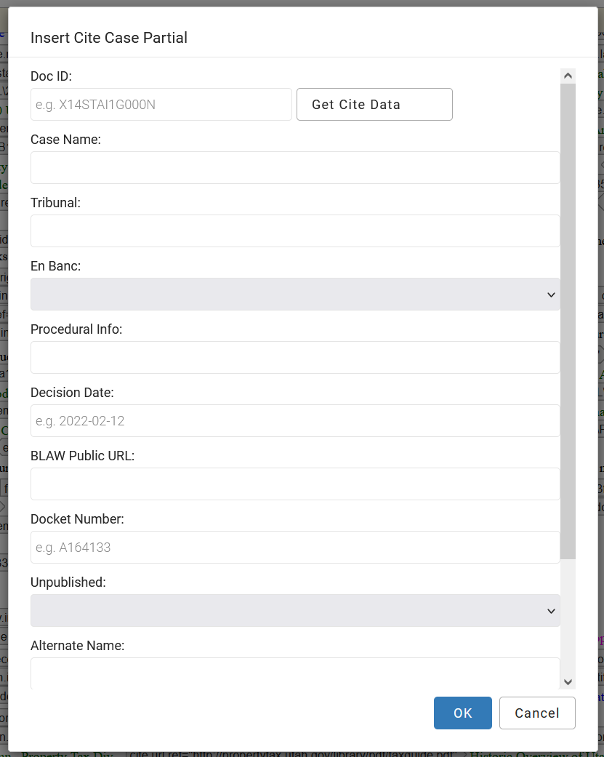
TIP
Look though your document. The tagged (code, regs, legislation, cases, etc.) information is placed in numerous places in the navigator, you can copy and paste tagged information
Do not renumber footnotes. They will be renumbered in office after review.

