857(a)(1): REIT Minimum Distribution Requirement

Link: https://www.bloomberglaw.com/product/tax/document/XAAEI5UO000000
Footnote: None needed (already exists)
Placement: 742.V.A., beneath n.699 (see yellow highlight)
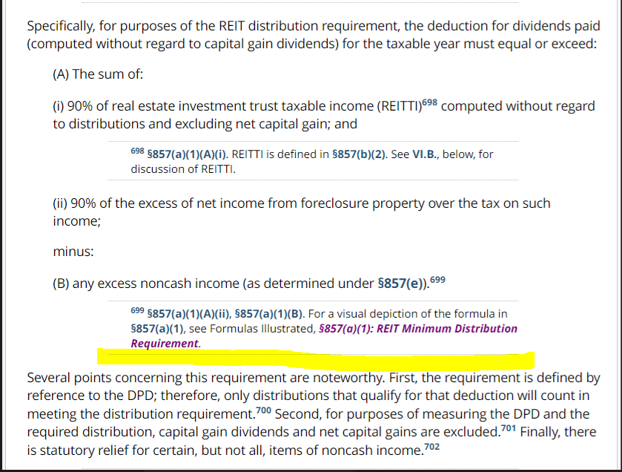

172(a)(2): Net Operating Losses Post-2020 Deduction

Link: https://www.bloomberglaw.com/product/tax/document/X8N82QCG000000
Footnote: None needed (already exists)
Placement: 539.VI.A., below n.1491 (see yellow highlight)
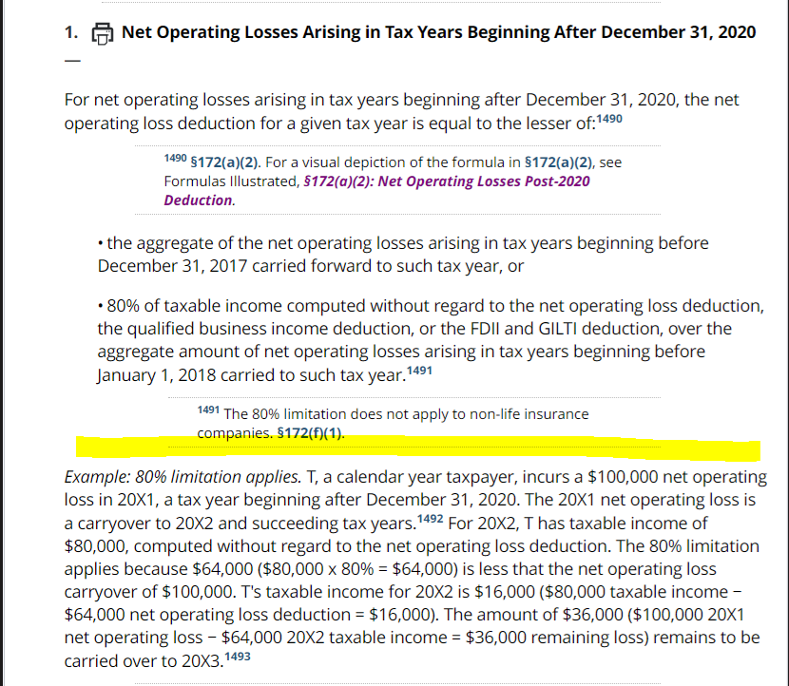

358(a)(1): Basis to Distributees

Link: https://www.bloomberglaw.com/product/tax/document/X9OSBJGK000000
Footnote: None needed (already exists)
Placement: 758.VII.B., beneath n.869 (see yellow highlight)
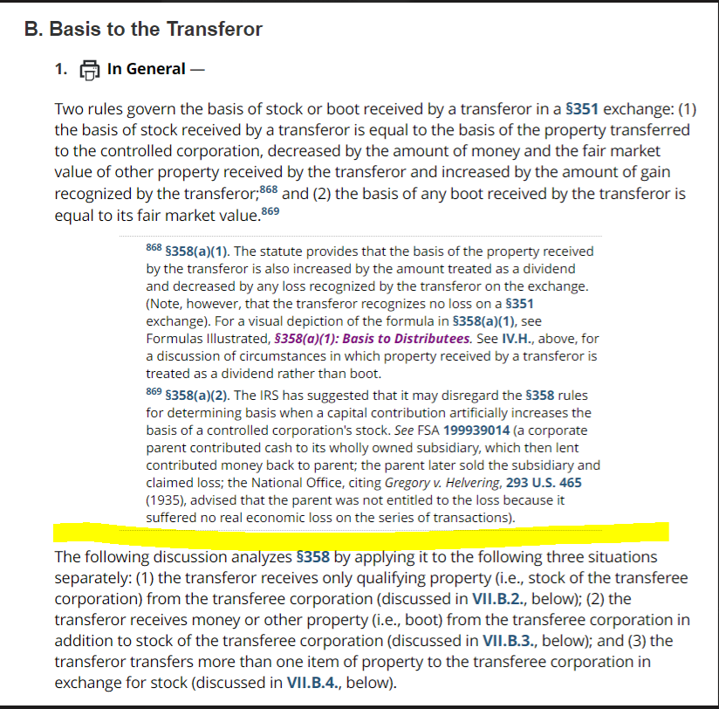

163(j)(4)(C): Excess Taxable Income

536.V.E.
The image here already exists but the footnote needs to be updated because it doesn't come up when searching "Formulas Illustrated" (because "Formula" is singular) also it's not in the style that we do footnotes.

Notes for TPQA:
Delete highlighted "To download this Formula Illustrated, click here."
Add new n.1558.1 at the end of highlighted paragraph. Text should say: "For a visual depiction of the formula in §163(j)(4)(C), see Formulas Illustrated, §163(j)(4)(C): Excess Taxable Income"
Italicized text should link to this page: https://www.bloomberglaw.com/product/tax/document/XFRAAOIC000000
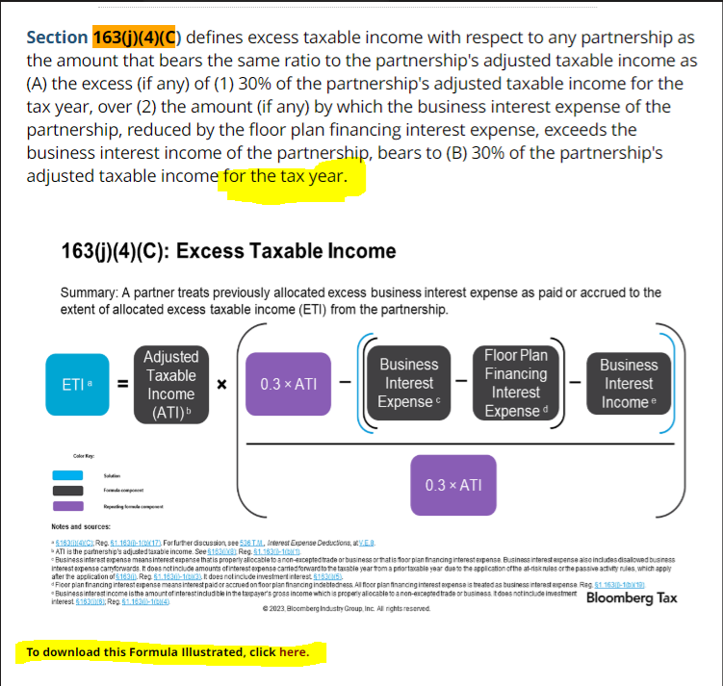

199A(a): Qualified Business Income Deduction
Footnote: 537.II.A., add at the end of existing n.37; text should say: "For a visual depiction of the formula in §199A(a), see Formulas Illustrated, §199A(a): Qualified Business Income Deduction." and the italicized text should link to this page: https://www.bloomberglaw.com/product/tax/document/XBCF9CFC000000
Placement of Image: 537.II.A., beneath n.37 (see yellow highlight)
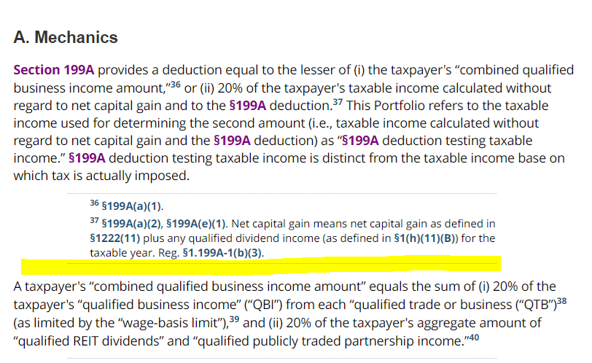

199A(b): Combined Qualified Business Income Amount and Phase-in
Footnote: 537.II.A., add at the end of existing n.40; text should say: "For a visual depiction of the formula in §199A(b), see Formulas Illustrated, §199A(b): Combined Qualified Business Income Amount and Phase-in." Italicized text should link to this page: https://www.bloomberglaw.com/product/tax/document/X8QTGOS0000000
Placement of Image: 537.II.A, beneath n.40 (see yellow highlight) -- should only be the first slide included rather than all seven slides
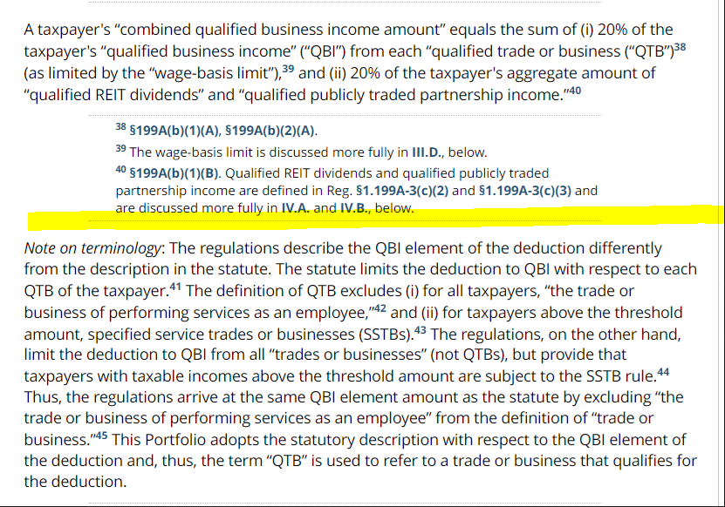

250: Deduction for FDII and GILTI
Footnote: 6200.XII.C., add at the end of existing n.1931 and n.1933
Text for n.1931 should say: "For a visual depiction of the formula in §250(a), see Formulas Illustrated, §250: Deduction for FDII and GILTI." Italicized text should link to https://www.bloomberglaw.com/product/tax/document/XBOSRP7O000000.
Text for n.1933 should say: "For a visual depiction of the formula in §250(b), see Formulas Illustrated, §250: Deduction for FDII and GILTI." Italicized text should link to https://www.bloomberglaw.com/product/tax/document/XBOSRP7O000000.
Placement of Images: 6200.XII.C., first slide should go beneath n.1932 (see yellow highlight on following page); second slide should go beneath paragraph with n.1937 (see yellow highlight on following page)
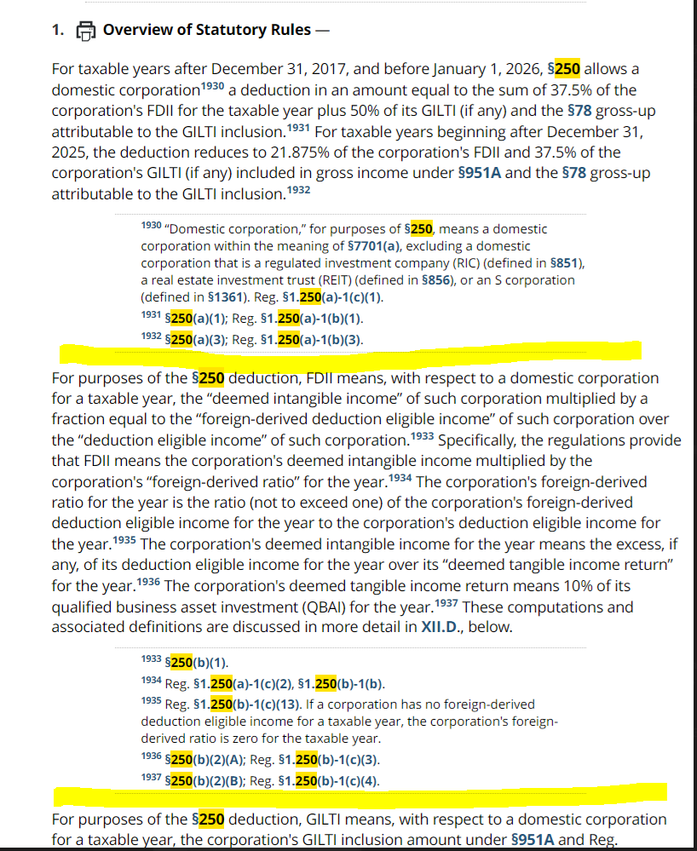

530(c): Coverdell ESA Contribution Limit
Footnote: 518.IV.D., add at the end of existing n.325. Text should say: "For a visual depiction of the formula in §530(c), see Formulas Illustrated, §530(c): Reduction of Coverdell ESA Contribution Limit." Italicized text should link to https://www.bloomberglaw.com/product/tax/document/X63I8ATK000000
Placement of Image: 518.IV.D., after paragraph with n.325
Extra Notes: Delete the highlighted text below (starting with "For single taxpayers" and ending with "$30,000]" because this is repetitive of the image we're adding.
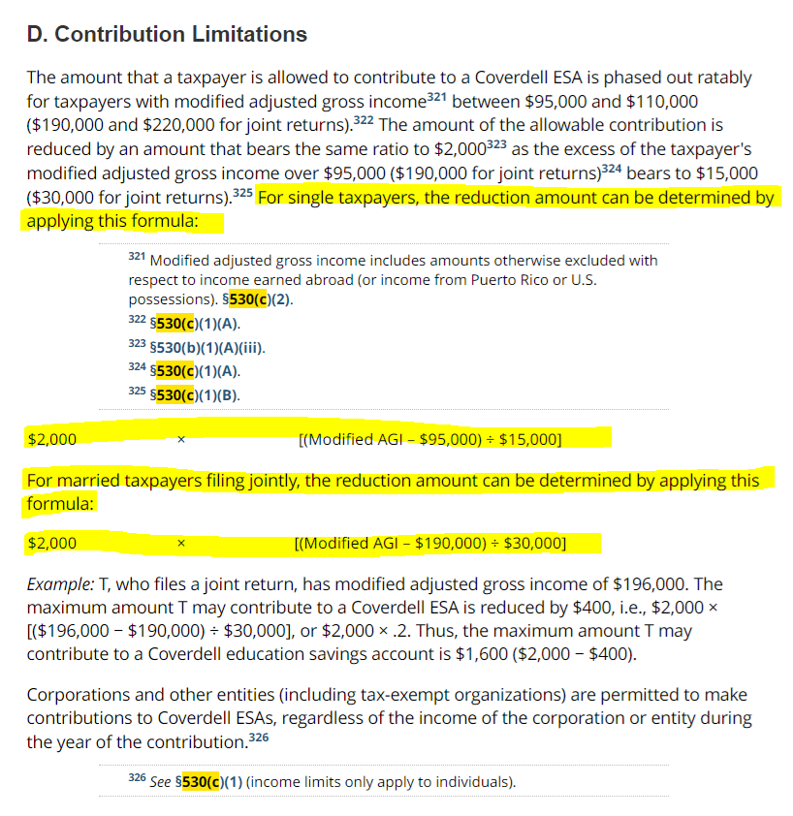
951A: Global Intangible Low-Taxed Income
Footnote: 6215.III.A. Add new n.245.1 at the end of highlighted paragraph. Text should say: "For a visual depiction of the formula in §951A, see Formulas Illustrated, §951A: Global Intangible Low-Taxed Income." Italicized text should link to https://www.bloomberglaw.com/product/tax/document/XEPN47B8000000
Placement of Image: 6215.III.A., bottom of page (see highlight)

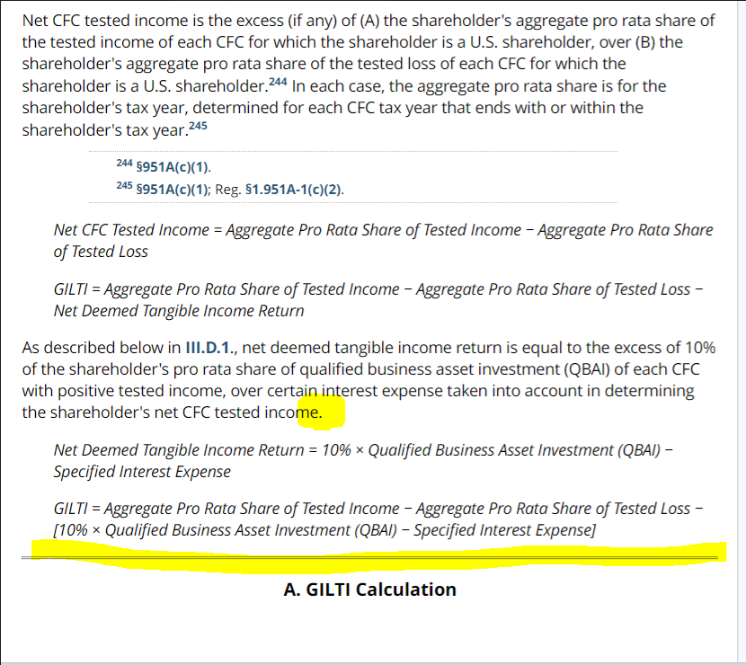

4501: Stock Buyback Excise Tax
Footnote: 767.XI.G., add to end of existing n.903.1. Text should say: "For a visual depiction of the formula in §4501, see Formulas Illustrated, §4501: Stock Buyback Excise Tax." Italicized text should link to: https://www.bloomberglaw.com/product/tax/document/XD0T3ELK000000
Placement of Image: 767.XI.G., beneath n.903.3 (see yellow highlight)
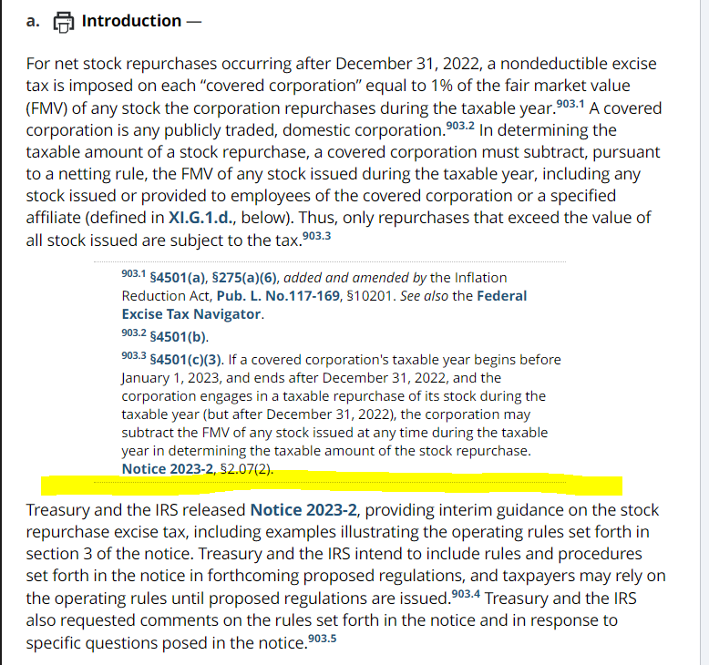

4501(e)(2): Retirement Contributions Stock Buyback Tax
Footnote: 767.XI.G., add to end of existing n.903.33. Text should say: "For a visual depiction of the formula in §4501(e)(2) and Notice 2023-2, §3.07(3), see Formulas Illustrated, §4501(e)(2): Retirement Contributions Stock Buyback Tax." Italicized text should link to https://www.bloomberglaw.com/product/tax/document/X1PO42SS000000
Placement of Images: 767.XI.G., both slides should appear after n.903.34 (see yellow highlight)
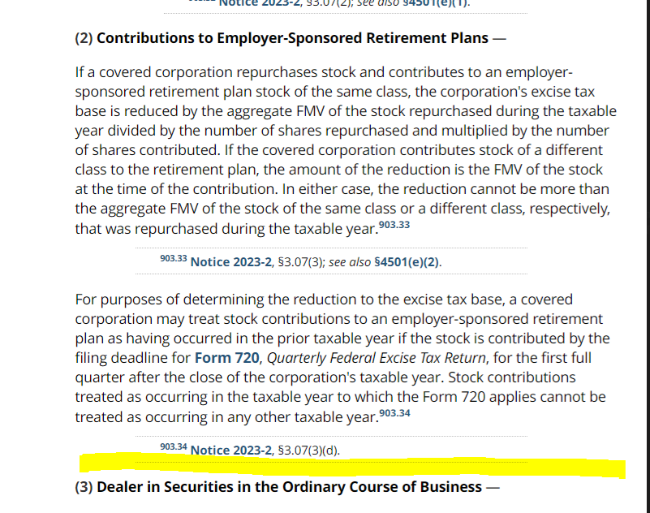

4661: Superfund Tax
Link: https://www.bloomberglaw.com/product/tax/document/XAC25ONO000000
Footnote: None needed (already exists).
Placement of Image: Federal Excise Tax Navigator, 7.7.3. (https://www.bloomberglaw.com/product/tax/document/XQO6K318#section(7)_0), after n.1214 (see yellow highlight)

