Dear Marybeth, Joseph, and Mark,
I hope this message finds you well.
I’m writing to follow up on our previous emails regarding the request for working hours for Mindcrest employees who works on the Property Tax Navigator. As of today, We have not yet received the information, and we are at a point where this data is essential for moving forward with resource allocation and compliance.
Please let me know if there are any issues or clarifications needed to complete this request. If the information is already in progress, a quick update on the expected timeline would be greatly appreciated.
Given the time sensitivity, I’d appreciate your response by September 12 Friday, so we can proceed without further delays.
Thank you in advance for your attention to this matter, and I look forward to your reply.
Best regards,

Email to:
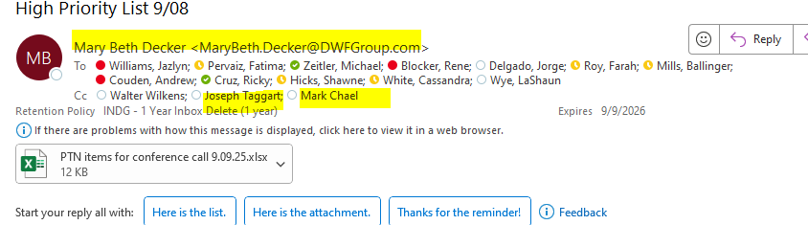

And cc: Jazlyn Williams, Andrew Couden, Sally and Walter Mindcrest boss).

