CODE SECTION UPDATE
SUMMARY
The Act Section of the Bill shows what changes needs to be made to the affected Code Section
1. Check the Effective date before starting—see if it is a delayed effective date)
Search for Act section in Bill pdf (Act Section is from Bill pdf) MODULE 1
2. After determining the affected code section, checkout the file in BWIP (Code Section is from BWIP) ) MODULE 1
https://bna.sharepoint.com/:p:/r/sites/Pride4_Bna4_Data_TaxAccounting/_layouts/15/Doc.aspx?sourcedoc=%7BE76AEFED-45A8-411F-9391-725153AC0E2E%7D&file=IRC%20Training%20Module%201%20Oct%205%202023.pptx&action=edit&mobileredirect=true

3. Add History Source cite MODULE 2
https://bna.sharepoint.com/:p:/r/sites/Pride4_Bna4_Data_TaxAccounting/_layouts/15/Doc.aspx?sourcedoc=%7B6216B887-EE11-4242-9555-B7633EA7C7A8%7D&file=IRC%20Training%20Module%202%20Oct%2012%2C%202023.pptx&action=edit&mobileredirect=true

4. Add Background Note: Effective Date ) MODULE 3
https://bna.sharepoint.com/:p:/r/sites/Pride4_Bna4_Data_TaxAccounting/_layouts/15/Doc.aspx?sourcedoc=%7BFDE74C20-6BCA-46A2-AC4C-C0843D5496F1%7D&file=IRC%20Training%20Module%203%20October%2019%2C%202023.pptx&action=edit&mobileredirect=true

5.Add Background Note: Amendment for Code section ) MODULE 4
https://bna.sharepoint.com/:p:/r/sites/Pride4_Bna4_Data_TaxAccounting/_layouts/15/Doc.aspx?sourcedoc=%7BFDE74C20-6BCA-46A2-AC4C-C0843D5496F1%7D&file=IRC%20Training%20Module%203%20October%2019%2C%202023.pptx&action=edit&mobileredirect=true

6.IF REQUIRED: Add Editor’s Notes ) MODULE 5
7. Add Act Language ) MODULE 5
https://bna.sharepoint.com/:p:/r/sites/Pride4_Bna4_Data_TaxAccounting/_layouts/15/Doc.aspx?sourcedoc=%7B4647D08B-EE84-47B8-A234-27E390F5F1CB%7D&file=IRC%20Training%20Module_%205%20Nov%209%2C%202023%20Session%20A.pptx&action=edit&mobileredirect=true

TRAINING INDEX
https://bna.sharepoint.com/:w:/r/sites/Pride4_Bna4_Data_TaxAccounting/_layouts/15/Doc.aspx?sourcedoc=%7BA44D52E7-8E65-48BD-B154-E203BDB8126C%7D&file=IRC%20TRAINING%20INDEX%20Nov%2021%202023.docx&action=default&mobileredirect=true

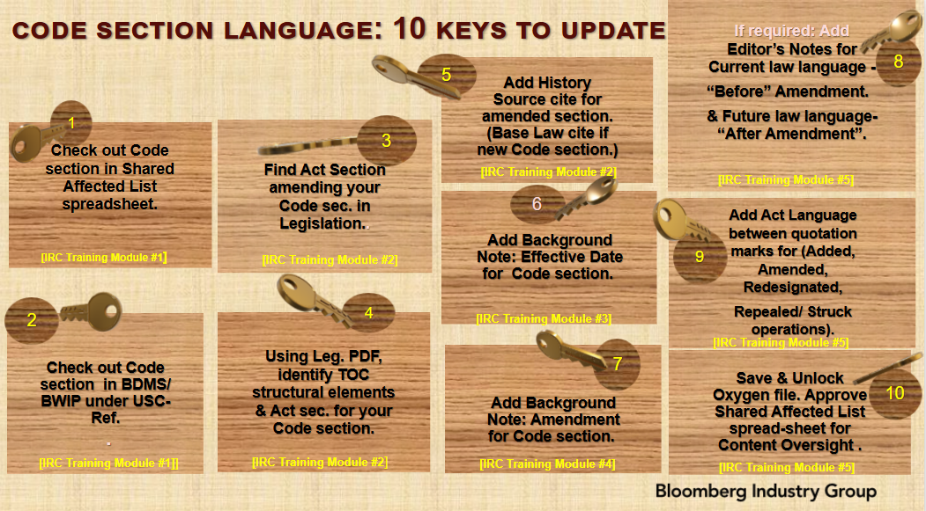

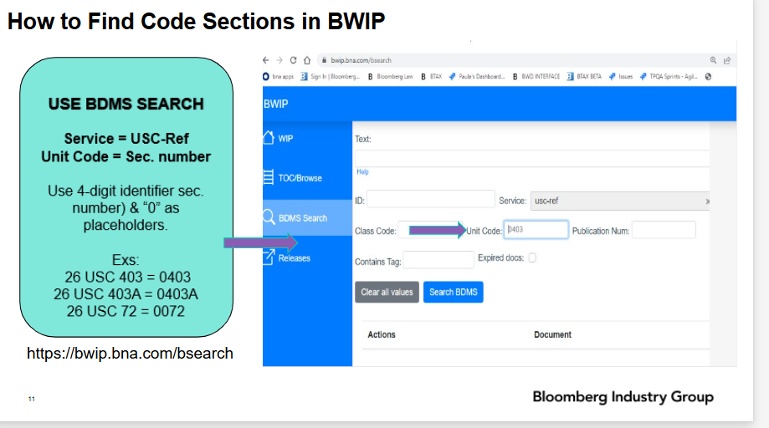

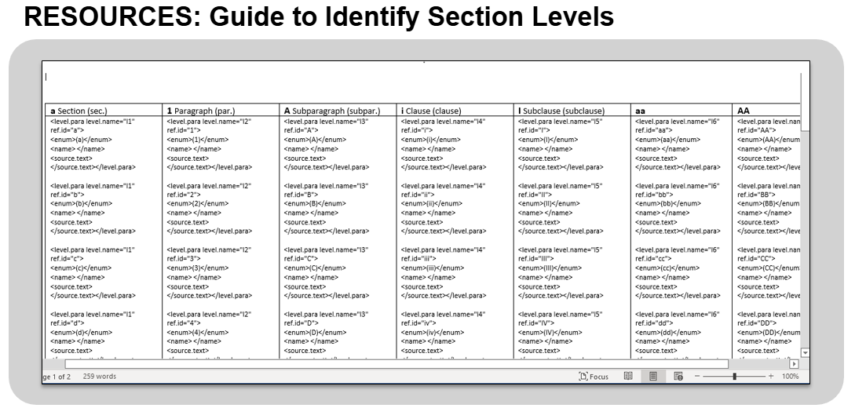

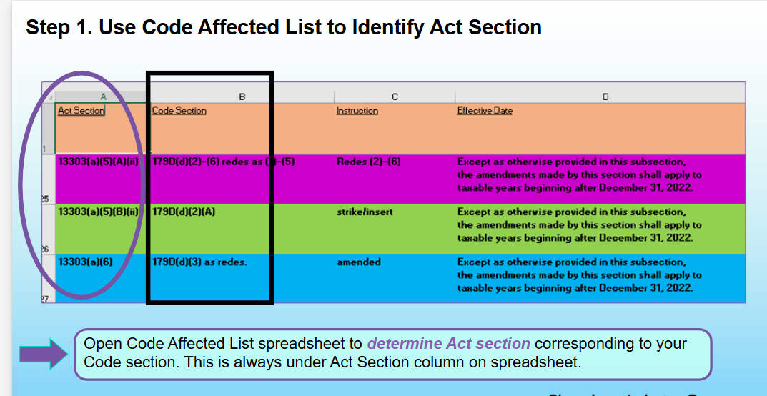

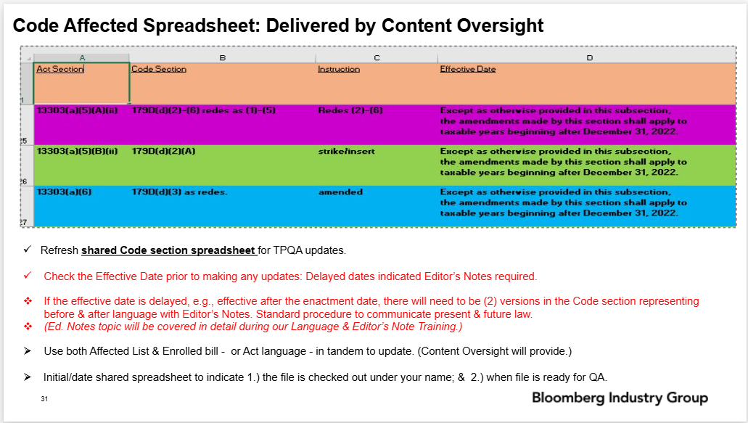

- HISTORY
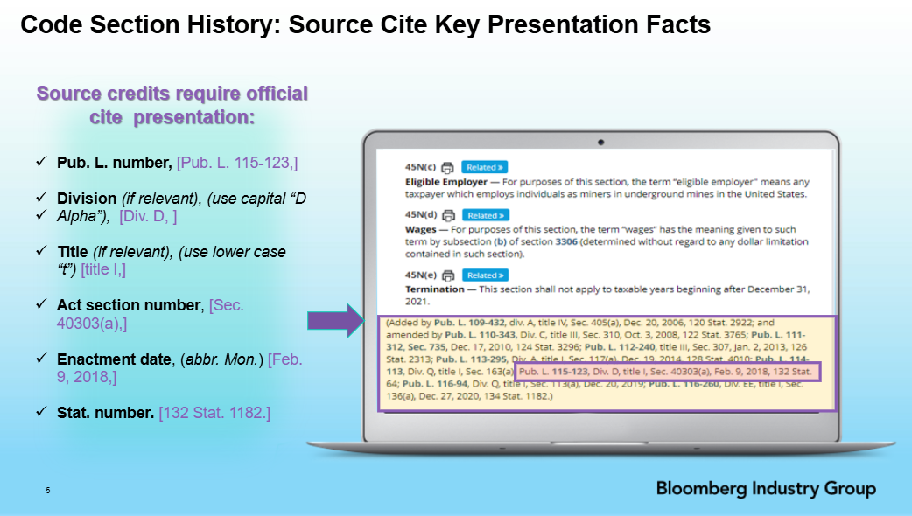

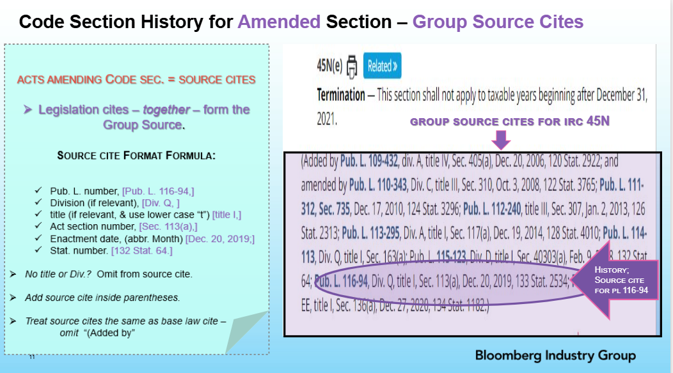

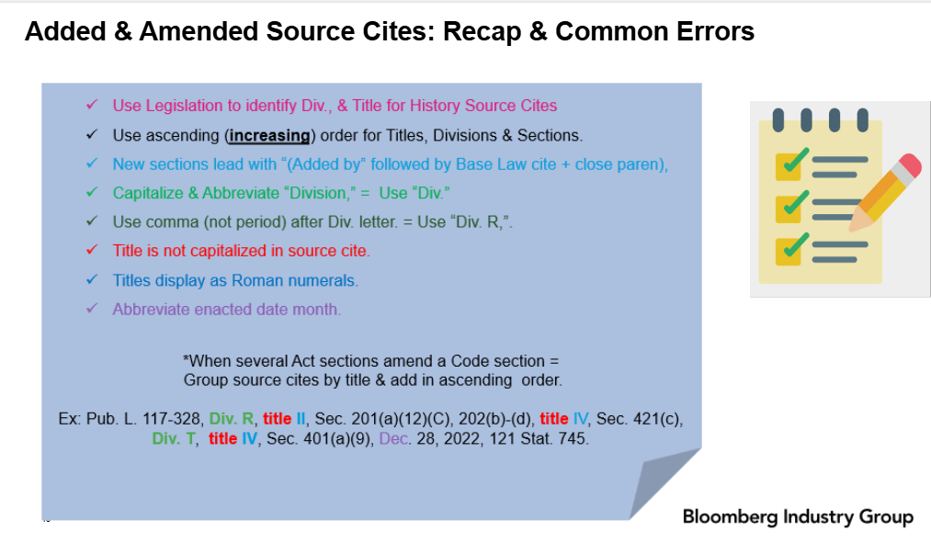

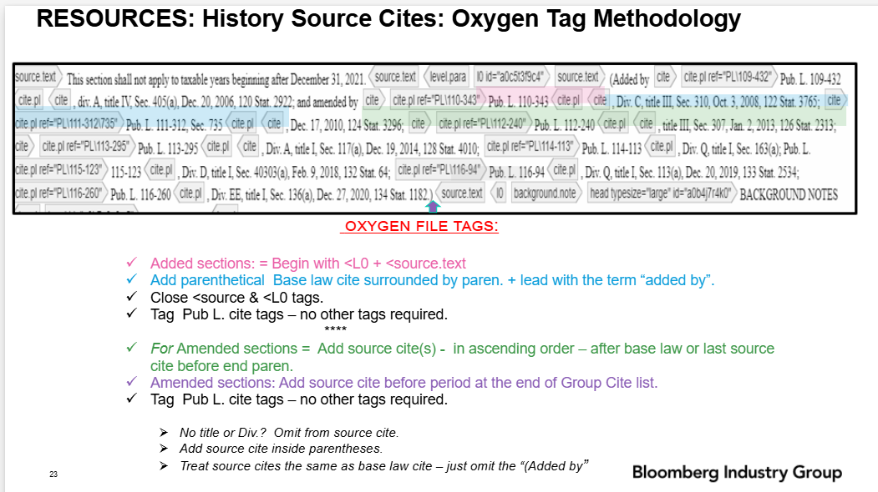

BACKGROUND NOTES
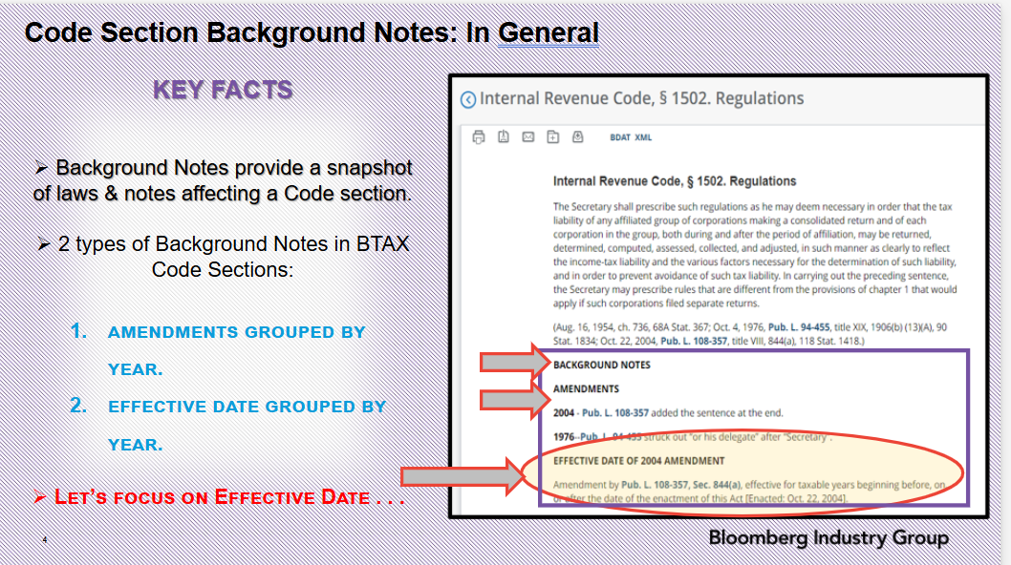

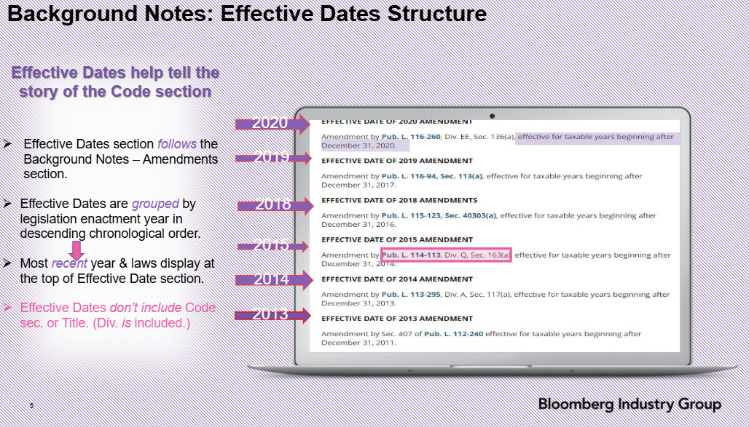

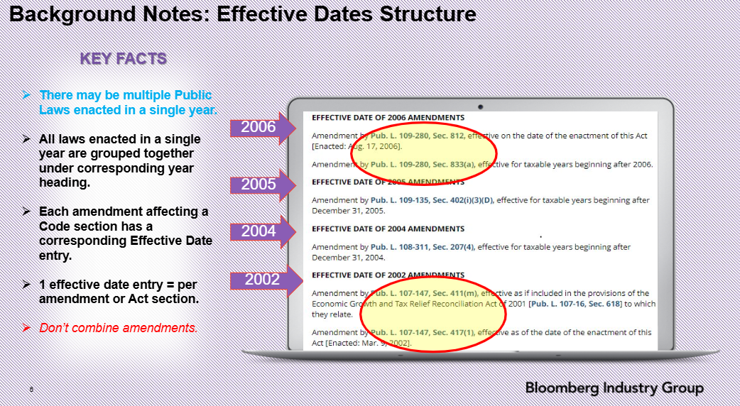

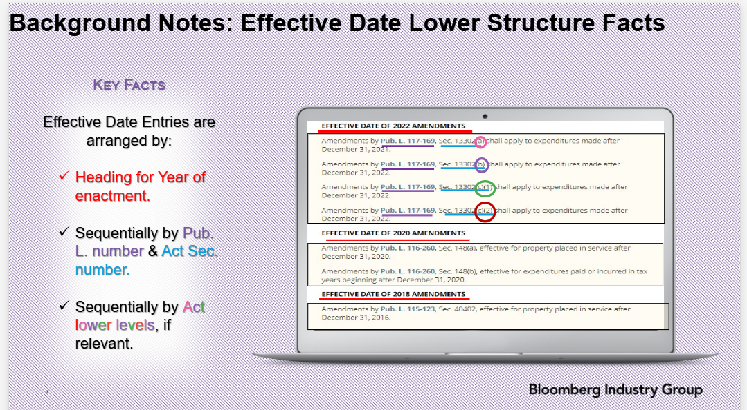

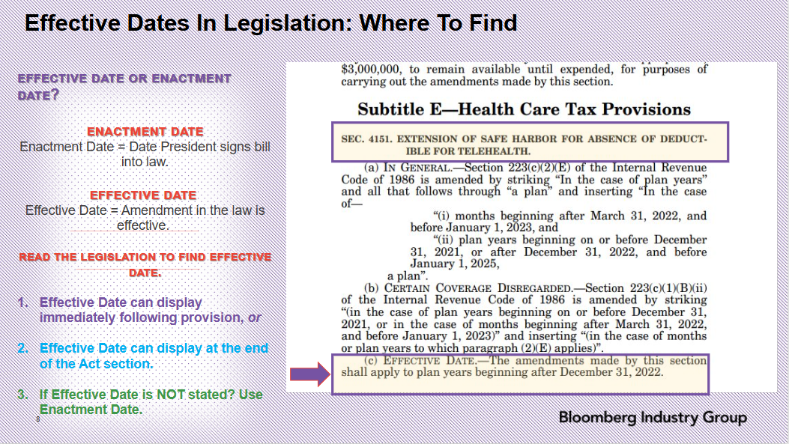

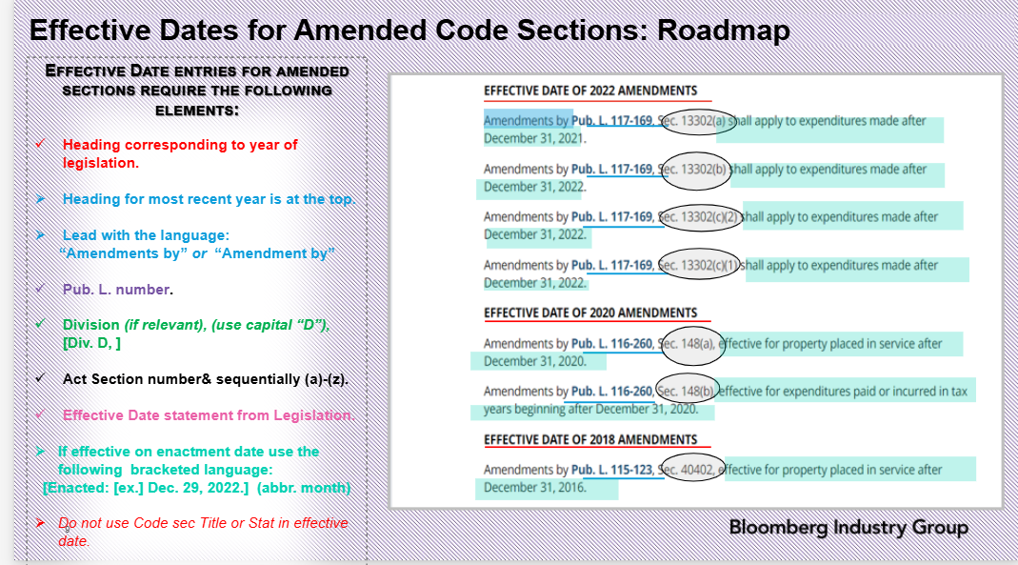

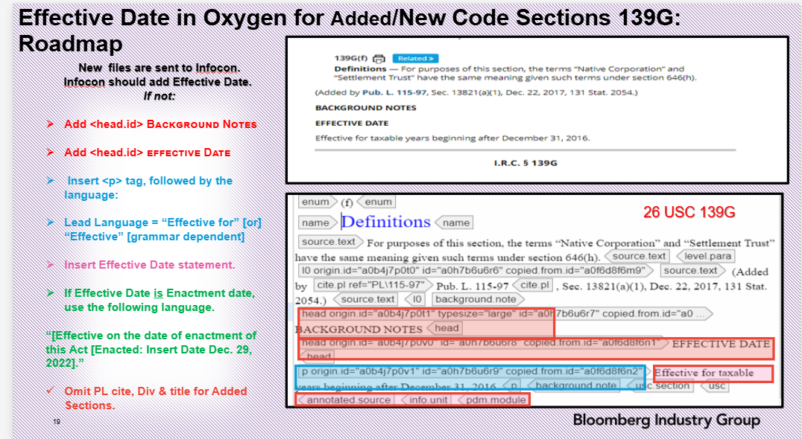

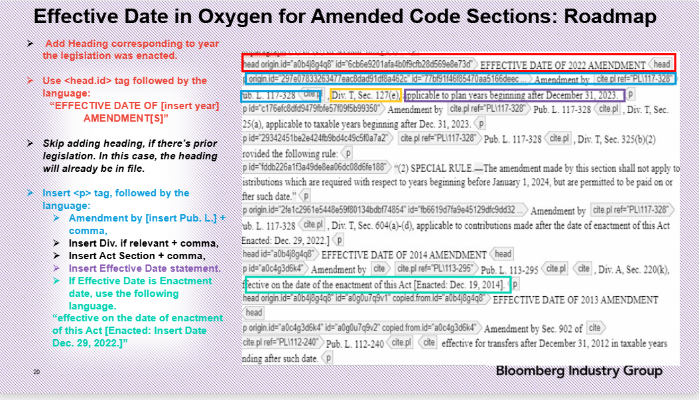

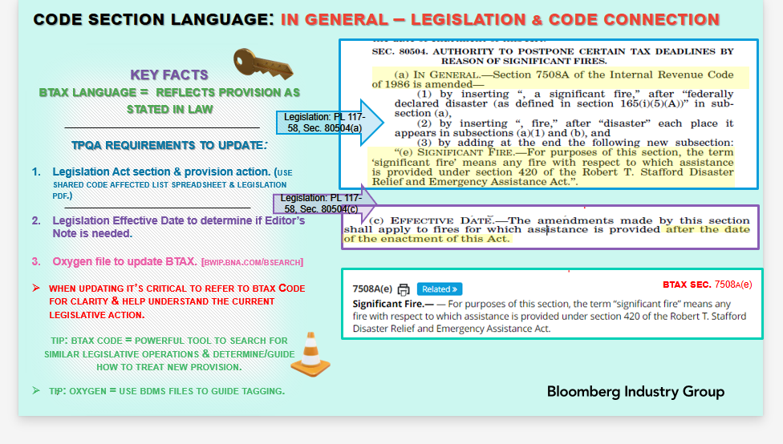
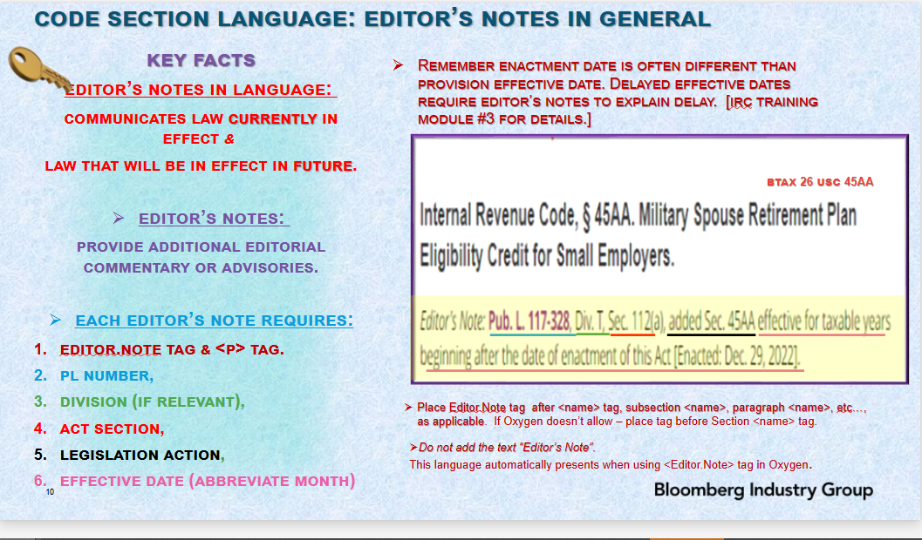
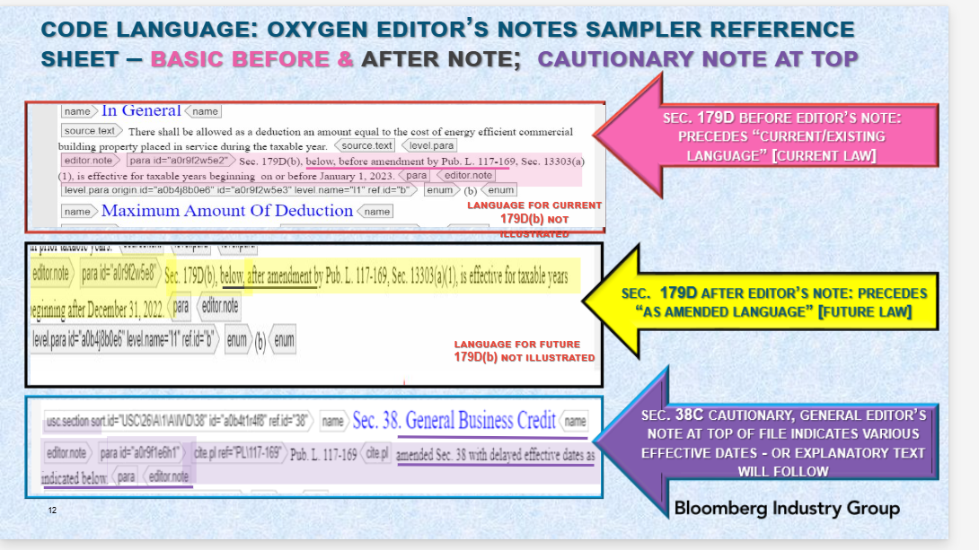
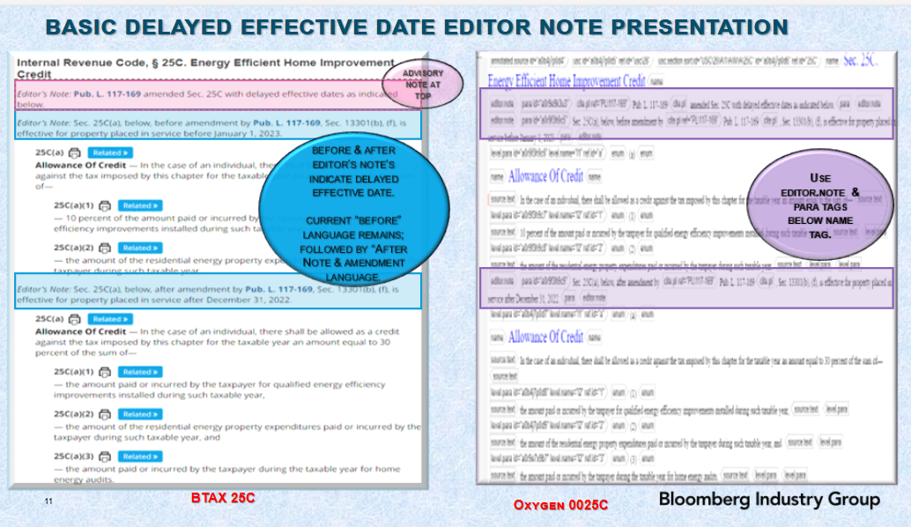

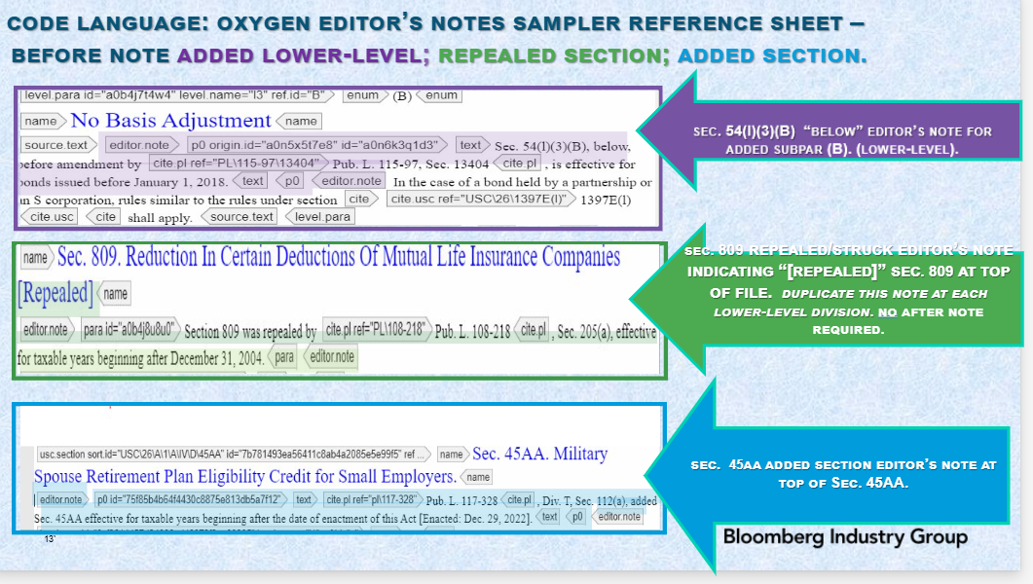

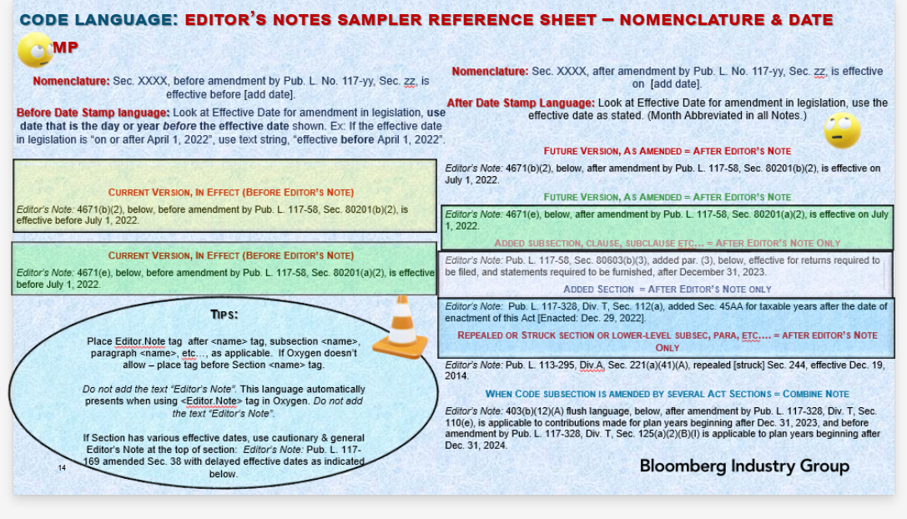

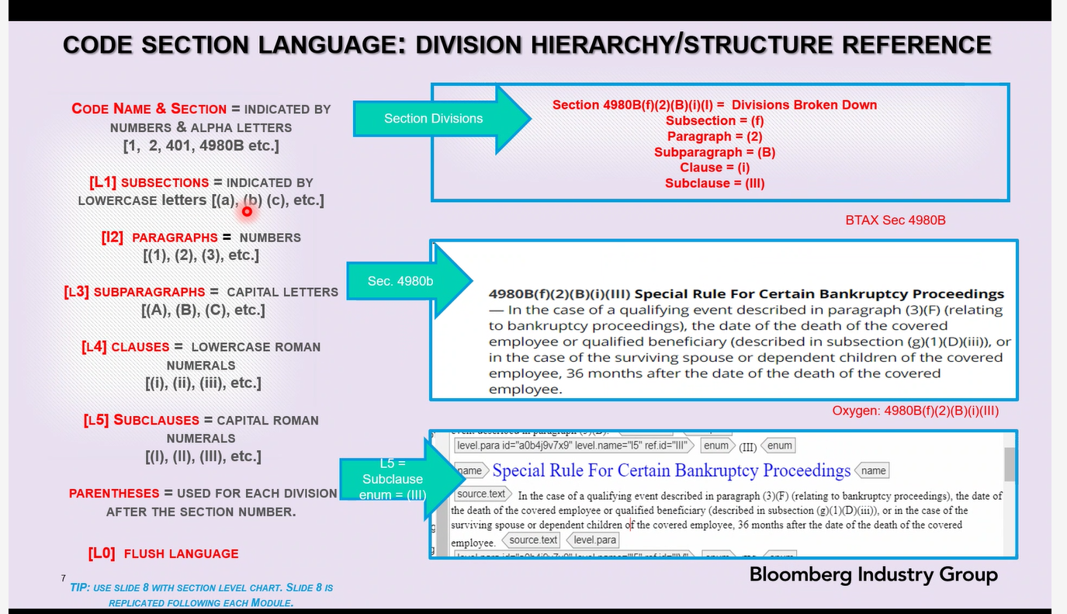

Note: Added/New Code sections don’t have Amendments in the Background Notes.

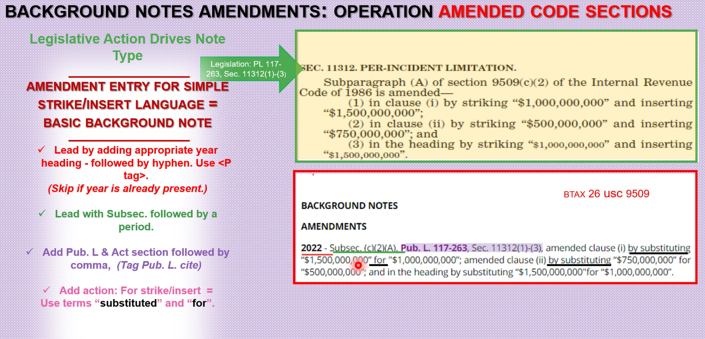

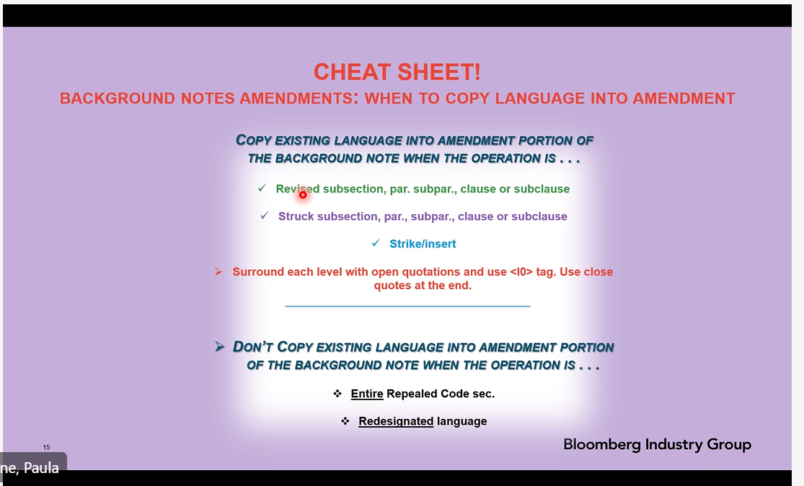

EDITOR’S NOTE SAMPLER
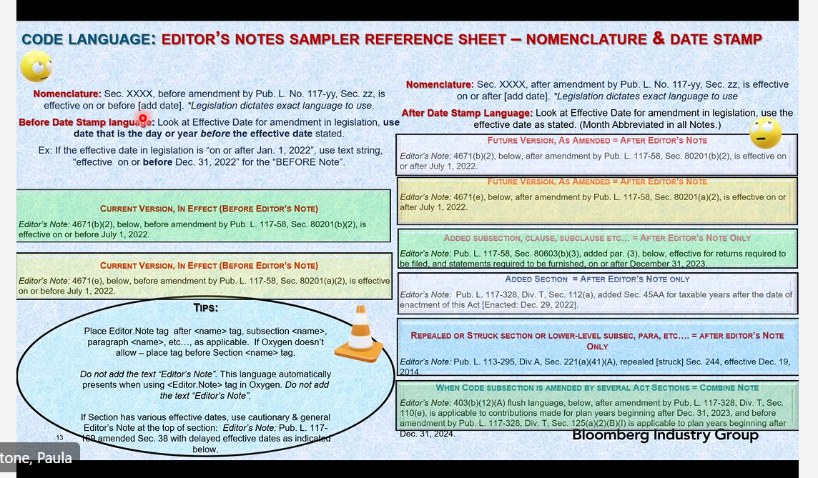

Adding Language to the Code Section Notes
(look at copies for Added, Struck, & Redesignated Code sections)
Note: For added new subsections No Before in Editor’s note since it is new.
Editor’s Note only if the effective date is AFTER the enactment date.(Verify)
EDITOR’S NOTE: Contains Before and After (copy language and edit the After)
For REPEALED – Upper Level no need

For Added no Before Note

For Struck /Removed no After Note
No need to delete the Language yet since it has not happened yet(Only add the Editor’s Note)

