7240-1st

Chapter 1
Quote should be deleted
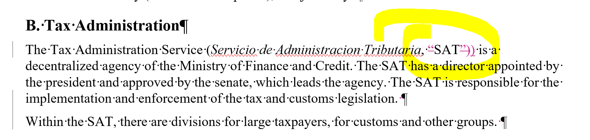

Chapter 2 No Issue

Chapter 3 No Redline Changes on this Chapter

Chapter 4

