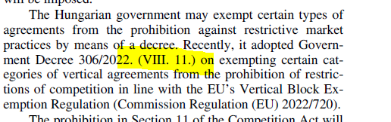
Chapter 2
p.22
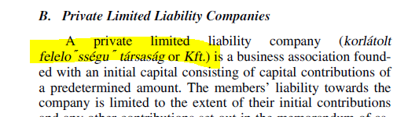

Chapter 3

p.31

?
Chapter 10 _ verify if tag is long quote
p.93& 94

