**Memo**

**Date: November 18, 2022**

**To: MeF Software Vendors**

**From: Montana Department of Revenue**

**Subject: NEW Updates for Passthrough Income Taxes**

The Montana Department of Revenue has updated the schema and business rules for Passthrough Entities. These updates will take effect on November 22, 2022.

If you have already began testing, you will need to resubmit using the updated schema.

Please review the changes below, these changes are also recorded in the change logs for the schema and the business rules on SES.

**Schema Updates for MeF PTE Form**

1. Schema version changed from MontanaBusiness2022V1.0 to MontanaBusiness2022V2.0.

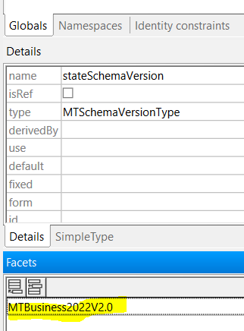

1. FormMTJGI Credit Certificate Number element max length facet changed from 13 to 14. (ReturnState/ReturnDataState/FormMTJGI/JobsGrowthCredit/CreditCertNum).

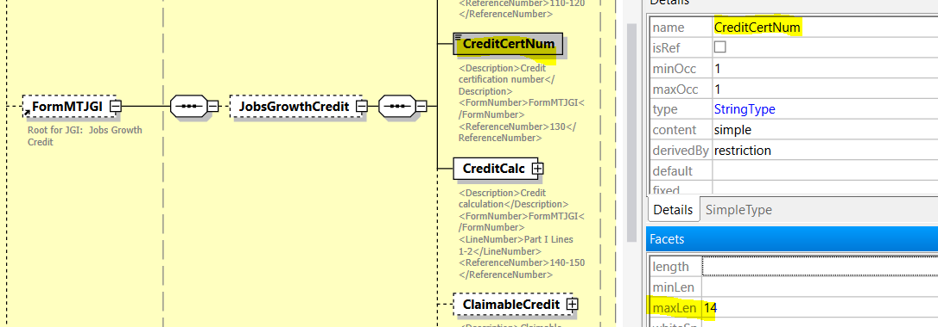

1. PTE Form Line 21b. Change amount value to accept both positive and negative value. Xpath ReturnState/ReturnDataState/FormPTE/PrevUnrptdMTSourceInc amount type changed from USAmountNNType to USAmountType to accept both negative and positive values.

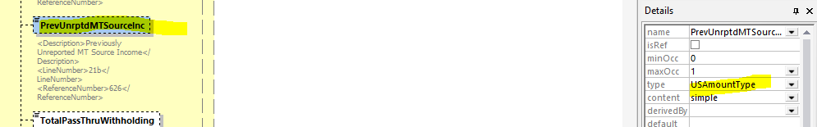

**Reject Code Updates for MEF PTE Form**

Note: These additional reject codes will be added to the PTE Reject Code Spreadsheet uploaded to SES

1. **FormPTE-E9**
   1. IF "Schedule I not required: 100% Montana activity" box is checked AND apportionment figure on page 1 does not equal 100% OR Apportionment Factor is 100% and 100% Montana Activity checkbox is not checked.
2. **FormPTE-E10**
   1. IF "Schedule I not required: 0% Montana activity" box is checked AND apportionment figure on page 1 does not equal 0% OR Apportionment figure is 0% and 0% Montana Activity checkbox is not checked.
3. **FormPTE-E11**
   1. IF the Refund Return checkbox on page 1 is not checked AND page 2, line 33(This is your Refund) is populated OR Refund Return checkbox is checked, and no refund is being claimed.

**Instruction Updates for PTE Form**

1. On Page 5 (which is the 8th page in the PDF due to cover, table of content, and letter) we have removed the text “Include Montana additions and subtractions from the Montana Adjustments Worksheet (Column C, Parts 3 and 4) in the total.”

If you have any questions, please email [dore-services@mt.gov](mailto:dore-services@mt.gov).