**Memo**

**Date: November 18, 2022**

**To: MeF Software Vendors**

**From: Montana Department of Revenue**

**Subject: NEW Updates for Individual Income Taxes**

The Montana Department of Revenue has updated the schema for Individual Income Taxes. These updates will take effect on November 22, 2022.

If you have already began testing, you will need to resubmit using the updated schema.

Please review the changes below, these changes are also recorded in the change logs for the schema.

**Schema Updates for MeF IIT Form**

1. Schema version changed from MontanaIndividual2022V1.0 to MontanaIndividual2022V2.0.
2. The FormMTJGI data element has been changed to allow 14 characters instead of 13.
   1. **DO NOT** include the dashes as part of the certificate number.

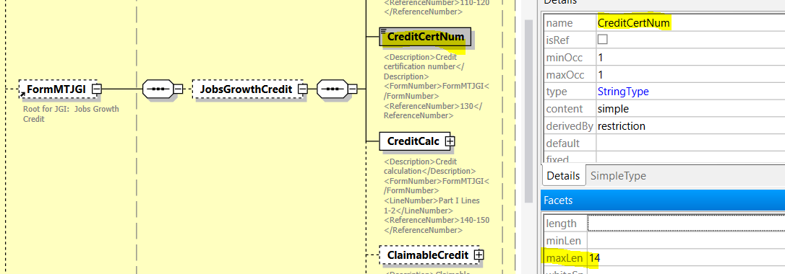

1. The FormMTForm2 Exemption Count, Dependent Count and Exemptions Total child elements have been updated to IntegerNNType from IntergerPosType.
   1. This change will allow a zero to be submitted for each of these elements.
2. The FormMTForm2 Itemized Deduction Schedule data element was misspelled and has been updated.
   1. The correct data element xPath is FormMTForm2/ItemizedDeductions/StateLocalTax/StateAndLocalTaxDeduction.
   2. The previous schema version was StateAndLocalTaxDedcution.
3. The Elderly homeowner/renter credit (Form 2EC) data element enumerations have been updated. The enumeration has been updated to 0.40 from 0.04.
4. The MTefileType MTReturnFilingNonPosType has been updated. This type had a format issue in the camel case of the name, it has been corrected to what is show above.
5. The Spouse child element has been changed from USAmountNegType to USAmountNonPosType.

If you have any questions, please email [dore-services@mt.gov](mailto:dore-services@mt.gov).