**Memo**

**Date: November 18, 2022**

**To: MeF Software Vendors**

**From: Montana Department of Revenue**

**Subject: NEW Updates for Estate Trust Income Taxes**

The Montana Department of Revenue has updated the schema for Estate Trust Income Taxes. These updates will take effect on November 22, 2022.

If you have already began testing, you will need to resubmit using the updated schema.

Please review the changes below, these changes are also recorded in the change logs for the schema.

**Schema Updates for MeF FID Form**

1. Schema version changed from MontanaEstateTrust2022V1.0 to MontanaEstateTrust2022V2.0.
2. The FormMTJGI Credit Certificate Number element max length facet changed from 13 to 14.

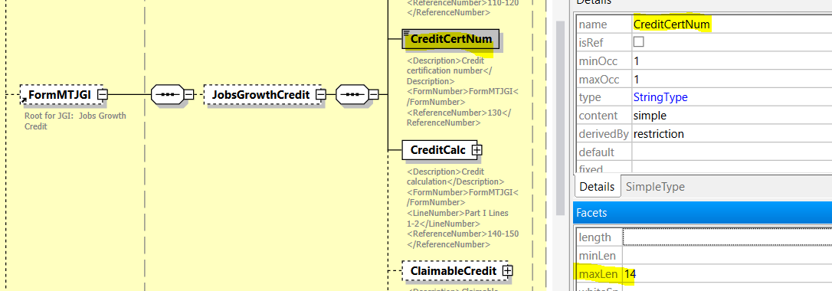

If you have any questions, please email [dore-services@mt.gov](mailto:dore-services@mt.gov).