
2026
Commonwealth of Massachusetts
Department of Revenue

Computer-Generated
Payment Voucher and Extension Forms for
Income, Fiduciary and Corporate Returns
Software Developer’s Guide

(Form PV, Form M-4868, Form M-4768, Form 1-ES, Form 2 PV, Form M-8736, Form 2-ES, Form 355-PV, Form 355S-PV,
Form 355-7004, Form 355-7004 Misc, Form 355-ES, 63 FI-ES, Form M-990T-7004, UBI-ES)

Draft

Table of Contents Page

- – Introduction . . . . . . . . . . . . . . . . . . . . . . . . . . . . . . . . . . . . . . . . . . . . . . . 3
1.1 Miscellaneous Info . . . . . . . . . . . . . . . . . . . . . . . . . . . . . . . . . . . . . ..3
1.2.1 Form-Tax-Voucher –Id Type Matrix . . . . . . . . . . . . ..3
1.2.2 Tax Type, ID Type & Voucher Type table . . . . . . . . . . . ..3
1.3 One-Dimensional (1-D) Barcode layout . . . . . . . . . . . . . . . . . . . . . 4
1.3.3 PO Box Matrix for mailing of forms . . . . . . . . . . . . . . . . . . . . . . .. . . 5
1.4 Two-Dimensional (2-D) Barcode specifications. . . . . . . . . . . . . . . . .6
1.5 Scanline specifications . . . . . . . . . . . . . . . . . 7
1.6 Mailing Locations for Sample Submissions . . . . . . . . . . . . . . . . . . 7
1.7 Other Document References . . . . . . . . . . . . . .. . . . . . .7
1.8 LuhnsMod10 Calculation . . . . . . . . . . . . . . . . . . . . . . . . . . . . . . . . 8

2.0 – Testing Criteria 9
2.1 Vendor requirements for passing certification testing 9
2.2 Text 10
2.3 Optical Mark Fields 10
2.4 Negative Amounts 10
2.5 The Department’s Acceptance Criteria 10
2.6 Massachusetts DOR Contact List 10

- – Income PV / Extension Specifications (Form-PV, M-4868, 1-ES) . . . . . . . 12
3.1 Income PV Example . . . . . . . . . . . . . . . . . . . . . . . . . . . . . . . . . . . . 13
3.2 M-4868 Example . . . . . . . . . . . . . . . . . . . . . . . . . . . . . . . . . . . . . . . 14
3.3 Form 1-ES Example . . . . . . . . . . . . . . . . . . . . . . . . . . . . . . . . . . . . . 15
3.4 Form M-4768 Scanline specifications . . . . . . . . . . .. . . . . . . . . . . . . 13

- – Fiduciary PV Specifications (Form 2 PV, M-8736, 2-ES) . . . . . . . . . . . . . 16
  - Form2 PV Example . . . . . . . . . . . . . . . . . . . . . . . . . . . . . . . . . . . . . . 18
  - M-8736 Example . . . . . . . . . . . . . . . . . . . . . . . . . . . . . . . . . . . . . . . . 19
  - Form 2-ES Example . . . . . . . . . . . . . . . . . . . . . . . . . . . . . . . . . . . . . 20

- – Corporate PV / Extension Specifications . . . . . . . . . . . . . . . . . . . . . . . . . . 21
  - Form 355-PV Example . . . . . . . . . . . . . . . . . . . . . . . . . . . . . . . . . . . 25
  - Form 355-7004 Example . . . . . . . . . . . . . . . . . . . . . . . . . . . . . . . . . 26
  - Form 355-7004 Misc Example . . . . . . . . . . . . . . . . . . . . . . . . . . . . . . 27
  - Form M-990T-7004 Example . . . . . . . . . . . . . . . . . . . . . . . . . . . . . . . 28
  - Form 355-ES Example . . . . . . . . . . . . . . . . . . . . . . . . . . . . . . . . . . . . 29
  - Form 63 FI-ES Example . . . . . . . . . . . . . . . . . . . . . . . . . . . . . . . . . . . 30
  - UBI-ES Example . . . . . . . . . . . . . . . . . . . . . . . . . . . . . . . . . . . . . . . . . 31

6.0 - Document Revisions ………………………………………………………….. 32

Appendix A – 2D layouts ………………………………………………………….. 33
Payment Vouchers ………………………………………………………….. 33
Extensions ………………………………………………………….. 37
Estimates ………………………………………………………….. 42

NOTE:
EXAMPLES on pages 13 to 31 are designed to show placement of data, barcodes and scanline on each coupon. Unless noted otherwise, they may be used as a template for any vendor’s rendering of the coupon. By their nature, they do not change very often. Generally, only the numeric year will be updated annually. Samples found on the DOR web site do not show some items such as barcodes or scanlines.
1.0 Introduction
This document contains the specifications for the various Coupons being generated by Vendors. All the coupons must have a 1D barcode & 2D barcode and be placed as shown in the samples. The scan line format for all the coupons is the same as prior years. The check digit at the end of the scan line should be calculated using the LuhnsMod10 Calculation formula given in section 1.8. Enclosed are the various specifications used to create both a 1-Dimensional & 2-Dimensional barcodes so that DOR will be able to read them.

1.1 Miscellaneous Info
The coupons listed in this document are now Mandatory 2D enabled.
The payment number is an 11-digit number. It can have any value between 1 and 99999999999 but must be fully filled. (e.g.: 1 = 00000000001)
The filing-period will either be a valid date in mmddyy format, or the value “000000”
OCR-A Extended 12 pt font for scanline.
No redacting or masking of data, either printed, 2D encoded or scanline.
Note: Money fields in print and in the 2D barcode must include cents. Printed, include decimal point.
Example 1 Example 2
Money in the body of the document: $1,234.89 $123.00
Money field in the scanline: 0000123489 0000012300
Money field in the 2D barcode: 123489 12300

1.2.1 Form-Tax-Voucher-ID Matrix
Form Type | Tax Type | Voucher Type | ID Type | Period End Year Value
Form1 PV | 053 | 01 or 14 | 005 | Form Year
M-4868 | 053 | 18 | 005 | Form Year
1-ES | 053 | 17 | 005 | Form Year+1
Form2 PV | 049 | 01 or 14 | 004 | Form Year
M-8736 | 049 or 052 | 18 | 004 | Form Year
2-ES | 049 or 052 | 17 | 004 | Form Year+1
355 PV | 014 | 01 or 14 | 004 | Form Year
355 S PV | 014 | 01 or 14 | 004 | Form Year
355-7004 | 014 | 18 | 004 | Form Year
355-7004 Misc | 015, 018, 022, 023, 028, 037 | 18 | 004 | Form Year
M-990T-7004 | 036 | 18 | 004 | Form Year
355-ES | 014, 015, 018, 022, 023, 028, 036, 037 | 17 | 004 | Form Year+1
UBI-ES | 036 | 17 | 004 | Form Year+1
63-FI-ES | 015 | 17 | 004 or 027 | Form Year+1

1.2.2 Voucher Type – Tax Type - ID Type table
Voucher Type |  | Tax Type |  | ID Type
Return Payment | 01 | Club Alcohol Excise | 009 | ITIN | 002
Period Payment | 02 | Corporate Excise | 014 | MA Taxpayer ID | 003
Amended Return Payment | 14 | Financial Institution Excise | 015 | Federal Employer ID | 004
Estimated Payment | 17 | P&C PPO Insurance Excise | 018 | SSN | 005
Extension Payment | 18 | Lottery Annuity Withholding | 021 | Financial Inst Excise Account | 027
 |  | Life Insurance Excise | 022
 |  | Ocean Marine Insurance Tax | 023
 |  | Public Utility Excise | 028
 |  | Sales Tax | 032
 |  | Unrelated Business Income Tax | 036
 |  | Urban Redevelopment Excise | 037
 |  | Withholding Tax | 040
 |  | Estate Tax | 048
 |  | Fiduciary Income Tax | 049
 |  | Partnership Income Tax | 052
 |  | Personal Income Tax | 053
 |  | Multi | 999

1.3.1 One-Dimensional (1-D) Barcode layout
The 1-D barcode of 13 characters plus leading and trailing asterisks is described here.
(The Asterisks are not part of the 1-D value, but part of the Code 39 characteristics).

*1122333445555*
Field | Name | Characters | Value | Miscellaneous
1 | State ID | 2 | “MA”
2 | Voucher | 2 | “PV”
3 | Form ID Code | 3 | See Table for values. | See Table on page 4 for complete list of Form IDs
4 | Page Number | 2 | Page number for the voucher (01 always). | Physical page
5 | Vendor ID | 4 | ID assigned by NACTP to the Form Creator

1.3.2 One-Dimensional (1-D) Barcode specifications

The following are the 1-D parameters:
1) Code 39 symbology
2) Thirteen characters (DO NOT include the start and stop asterisks)
3) 2.5:1 wide narrow ratio
4) Height 0.3 inch
5) Length 2.5 inches.
6) “X” dimension (the narrowest bar and/or space) must be at least 1.5 pts (approximately 20 mils or 3/144 “)
7) Each bar in the barcode must be solid. Streaks in the barcode are unacceptable.
8) A 0.1 inch quiet zone around the barcode must be maintained.

The values for the 1D barcode for the different vouchers are as follows:
Forms | Form ID Code | Note
Form-1PV | 001 | MAPV00101vvvv
Form-2PV | 002 | MAPV00201vvvv
Form M-8736 | 003 | MAPV00301vvvv
Form M-4868 | 004 | MAPV00401vvvv
Form 355PV | 005 | MAPV00501vvvv
Form 355S-PV | 006 | MAPV00601vvvv
Form 355-7004 | 007 | MAPV00701vvvv
Form 1-ES | 008 | MAPV00801vvvv
Form 2-ES | 009 | MAPV00901vvvv
Form 355-ES | 010 | MAPV01001vvvv
Form 355-7004-Misc | 011 | MAPV01101vvvv
Form M-990T-7004 | 012 | MAPV01201vvvv
Form 63 FI-ES | 013 | MAPV01301vvvv
Form UBI-ES | 014 | MAPV01401vvvv
The “vvvv” noted above represents the Vendor Id Code.

Additionally, the following forms have only a 1D barcode (not 2D enabled) with the 1D value beside it in
parenthesis and should be submitted for approval annually. Only one of these forms are required to be submitted for
approval testing.

Form SSR (MAPV71901vvvv) Form M-941 (MAPV72101vvvv)

Form 180 (MAPV72401vvvv) Form M-4768 (MAPV72501vvvv)
Form UBIT-ES (MAPV72201vvvv)

1.3.3 PO Boxes Matrix

Forms | PO Box | ZIP Code | Note
Form-1-PV | 419540 | 02241-9540 | New PO Box for 2022
Form 1-ES | 419540 | 02241-9540
Form M-4868 | 419540 | 02241-9540 | New PO Box for 2022
Form-2-PV | 419544 | 02241-9544 | New PO Box for 2022
Form 2-ES | 419544 | 02241-9544
Form M-8736 | 419544 | 02241-9544 | New PO Box for 2022
Form M-990T-7004 | 419544 | 02241-9544 | New PO Box for 2022
Form UBI-ES | 419544 | 02241-9544
Form 63 FI-ES | 419544 | 02241-9544
Form 63-29A-ES | 419272 | 02241-9272
Form 355-ES | 419272 | 02241-9272
Form 355PV | 419272 | 02241-9272 | e-File Only
Form 355S-PV | 419272 | 02241-9272 | e-File Only
Form 355-7004 | 419272 | 02241-9272 | e-File Only
Form 355-7004-Misc | 419272 | 02241-9272 | e-File Only

Sample address below:

See the following web page for up-to-date mailing information.
https://www.mass.gov/service-details/mailing-addresses-for-massachusetts-tax-forms

Instructions for Estimates are found by following the links below.

https://www.mass.gov/info-details/dor-estimated-tax-payments

https://www.mass.gov/service-details/corporate-excise-tax-estimated-payments

1.4 Two-Dimensional (2-D) Barcode PDF417 Specifications

Encode type | Normal PDF417
DPI | 300 dpi
Pixel shaving | ON
Code word count | Variable
Encryption
Error Correction Level | 4
Mils | 13.1
Data Columns | 13
Module Aspect Ratio | 4:1
Data Rows | Variable
X Dimension | 2
Location | Reserved area top right corner of the forms
Reserved space | 2.5 “ x 1”
Max Characters | 64
Field Delimiter | Carriage Return
End of File Delimiter | “*EOD*”

The software must contain a brief explanation of what a 2-D barcode is and inform taxpayers that any changes made to a document after printing will not be reflected in the 2-D barcode unless they re-print. Handwritten changes on computer-generated documents are not acceptable and will be given lowest priority within the data workflow. Failure to print a new document after any changes will severely impact DOR processing and introduce errors.
- PDF 417 has error detection and correction capabilities. The more error correction is used, the less data can be communicated in the barcode. With respect to data capture, you either get 100% or nothing. Complete barcode read failures are very uncommon. The tax Application Programming Interface (tax API) sets parameters for correction/detection. These parameters should be observed and not altered.
- Based on the experience of previous filing seasons of 2-D barcode use, and due to the low level of deterioration of tax returns (compared to high media-abuse environments) the error correction level in the current market-provided DLL is set to level 4.
- A general rule that can be used to determine if a printer is capable of producing a 2-D barcode is if the printer can produce a graphic such as a tax agency seal or business logo, then the printer should be capable of producing a 2-D barcode that can be scanned.
- Pixel shaving is a technique that produces higher-quality barcodes when printed on lower-quality equipment like inkjet printers. Pixel shaving will result in improved read rates. In the DLL, pixel shaving will always be turned on.
- Increasing the x (horizontal) dimension of the barcode elements will produce the most readable barcodes, especially on low quality ink/bubble jet printers. Whenever possible, software vendors will create a barcode that uses the largest possible x element value for the given space. In the case of the coupons, there is very little available space resulting in a low X Dimension value.
- Users are advised that stretching or scaling the barcode (via copying the paper media or the like) changes its integrity and worsens readability; it should not be employed.
- 2-D barcodes should never be rotated. Rotating a 2-D barcode increases processing difficulty and introduces the risk of errors. Since PDF-417 barcodes are read in both the x (horizontal) and y (vertical) directions on a portrait page, rotating them from their natural position can render the barcode unusable.
- Unless otherwise noted, any line item left unanswered or having a value of zero (blank, no data, nul or 0) should not have a value on the printed page or in the 2D barcode. An inspection of the 2D barcode (raw data) should look something like this, which represents 2 consecutive line items having no data values. <CR><CR><CR>

1.5 Scan line specifications

- The right-most character of the scan line must be exactly 1.5 inches from right edge
- OCR-A font (size 1; 10 characters per inch) must be used for printing the scan line
- There MUST be 0.3 inch clearances above the scan line area
- The baseline of the scan line must be exactly 0.3 inches from the bottom edge of the form
- All forms must be 4.0 inches high and 8.5 inches wide and must print at the bottom of the sheet (portrait setting)

1.6 Sample Submissions mailing locations

10 Samples of each coupon type (in a single pdf file) should be e-mailed to:
anfitformsapproval@dor.state.ma.us

Send in pdf format using data of the vendor’s choosing.

Additionally, please also submit 10 each Form 1-PV, Form M-4868, Form1-ES, Form 2-PV, Form M-8736, Form 2-ES, Form UBI-ES, Form 355-ES, Form 63-FI-ES forms to:
Bank of America,
Coma Lockbox MA5-527-02-07;
ATTN: Amoryll Cooper,
2 Morrissey Blvd.,
Dorchester, MA 02125-3312

Note: Vendors must pass DOR testing for Payment Vouches in order to get final approval for the various 2D testing scenarios. (See the various developers’ guides for more information.)

1.7 Other reference documents

For more information please reference current year versions of:

Part 1 – Corporate Excise Software Developers Guide or
Part 1 – Personal Income Tax Software Developers Guide.

Both documents may be found by visiting State Exchange Server for Massachusetts

See also: Handbook for Reproduction of Department of Revenue Forms

For the list of all forms using a 1D barcode for form identification, please see Appendix B of the “Corporate Excise Software Developers Guide, Part 1”.

For information regarding the e-file mandate and how it may impact coupons, as well as some bulk-file information, please see TIR 16-19. See also updated mandate in TIR 21-9.

To review the various TIRs, please visit the library, sorted by year, at the following page: https://www.mass.gov/lists/dor-technical-information-releases

Generally, we do not issue a TIR when we promulgate a new or amended regulation but we may issue a TIR if there is a law change that may relate to a regulation. Anything we issue can be found online in the legal library. And recent drafts and additions may be found on this page. Vendors should also sign up to receive our email updates. (https://www.mass.gov/service-details/dor-legal-library)

1.8 LuhnsMod10 Calculation

Check Digit fields are calculated according to the following formula:
• Multiply each scan line digit by the weights 1,2,1,2,1 from left to right
• Add all digits of each product to produce the sum
• Divide sum by 10
• If remainder is zero, the check digit is zero.
• If remainder is 1 – 9, subtract remainder from 10 to produce the check digit.

Here is an example scan line:

00100123456789 123115 0000000000 014 010040001 00012345671

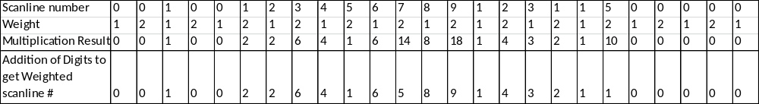

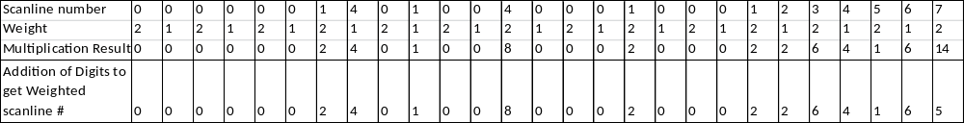

Sum of Weighted values = 99
Divide Sum by 10 = 9 remainder 9

If remainder = 0, the check digit is zero.
If remainder is not zero, subtract remainder from 10 to produce the check digit, therefore for this example,
10 – 9 = 1 (check digit in red above)

2.0 – Testing Criteria

2.1 - Vendor requirements for passing certification testing
DOR does acknowledge that not every vendor can maintain the same level of sophistication in terms of what types of tax scenarios its software can handle. DOR takes a fiduciary responsibility to the taxpayers in certifying a vendor as acceptable. DOR does expect vendors to provide the highest possible quality in the areas of appearance, functionality and accuracy in delivering their product to the marketplace.

See Massachusetts Department of Revenue Publication ‘Handbook for Reproduction of Non-Scannable Department of Revenue Forms’ Section 1.3 for guidance regarding who needs to pass certification testing. To paraphrase: Any company that develops and/or uses substitute Massachusetts Department of Revenue forms MUST get approval from the Department. If the company develops substitute tax forms using its own tax software; develops tax software programs to be used with substitute tax forms developed by another company; or, develops substitute tax forms for other companies to use with their tax software, the company MUST get approval from the Department.
The company must have forms reviewed annually prior to release of the substitute forms. Part of the approval process is for the Payment Voucher to pass DOR testing. The Department has noticed that some customers were submitting returns created by pre-approved, but outdated software. DOR mails those returns back to taxpayers with an explanatory letter.
If a company chooses to release software to their customers (taxpayer or tax practitioner) prior to being approved by the DOR, the company must adhere to the following criterion:
Disable printing of returns created using unapproved software.
A watermark with the text of “DRAFT FORM: THIS WILL NOT BE PROCESSED” or “DRAFT FORM: DO NOT FILE” must be printed across all pages of the coupon(s).
The watermark must be printed in black only. The watermark must be at least tall enough to encompass two printed lines. The watermark must be located such that the taxpayer name and address are obliterated. For coupons where there is no name and address area, the vendor may place the watermark anyplace common sense would dictate. The consumer must not have a way to shut off the watermark feature.
The software must prohibit returns created with unapproved software from being filed electronically.
Once approved, a software patch should remove any watermarks and filing prohibitions.

Vendors are encouraged to submit test samples early to avoid approval delays. DOR will make every effort to review and approve forms within 10 days of receipt. See contact list for where to submit test forms.

Forms will be tested for format and readability in the order in which they are received by the Department. DOR only approves the appearance of the printed substitute form, the 1-D barcode value and the 2-D barcode readability as well as the scanline readability. Certain codes are also verified per specific coupon. DOR does not certify the logic of specific software, or the calculation formulas entered on any forms. DOR does not approve specific equipment or the process used in producing the substitute forms but does require that the substitute forms meet the Department’s standards.

Failure to comply with these requirements WILL cause returns to misread and reject as errors in processing. DOR will capture vendor data and monitor processing results. Specifically, the Department will track readability of coupons with respect to field read rates, as well as tracking 2-D barcode read problems.
Each page has a unique 1-D barcode that the imaging software uses to identify the page in the event that the 2-D barcode cannot be read.

2.2 - Text
Vendors may limit descriptions for captions and lines required by the official coupons to one print line on the substitute form or schedule by using abbreviations and contractions and by omitting articles and prepositions. The substitute schedule must retain sufficient key words, however, to permit ready identification of the caption, line or item. See Massachusetts Department of Revenue Publication ‘Handbook for Reproduction of Non-Scannable Department of Revenue Forms’ Section 3 for more information.

2.3 – Optical Mark Fields
A single upper case “X” must be used to indicate a response in an optical mark field.
No underlining or enclosing of optical mark fields.
One blank character space must immediately precede and follow an optical mark field.
If a field is not applicable, it must be left blank.

2.4 – Negative Amounts and Prohibited characters
Negative amounts or losses must be preceded by a minus sign (“-“) of the left most digit.
Use of parentheses or “X” boxes is not acceptable.
Language regarding the use of “X” boxes must not be printed on the substitute forms.
Do not include “<” or “>” in any field; text or 2D

2.5 - The Department’s Acceptance Criteria
Can we read the 1-D & 2-D barcodes?
Is there a 2-D barcode on every coupon as required?
Is the 2D barcode data correctly located within the barcode?
Is the 1-D barcode correct on each page?
Are the 1-D and 2-D barcodes correctly sized and located?
The payment voucher must pass DOR testing prior to final approval. The 1D & 2D Barcodes and scanline must be readable and correctly configured.
2D barcodes are mandatory.
Are the various codes used per coupon correct for that coupon?
Are dates and monetary values correctly formatted?
Those vendors providing Massachusetts Personal Income Tax Forms and Schedules must pass ALL (1D, 2D and exact positioning) acceptance requirements.

2.6 - Massachusetts DOR Contact List (questions or guidance)
Non 1D enabled forms are submitted to:
Patrick Ford dorforms@dor.state.ma.us
Brian Mcglone dorforms@dor.state.ma.us
Any forms related questions or issues must be presented to the Forms Developers above.

1D and 2D enabled forms are submitted to, preferably via pdf attached to email:
Trivan Nguyen anfitformsapproval@dor.state.ma.us
Gregg Rothwell anfitformsapproval@dor.state.ma.us
Lily Lee anfitformsapproval@dor.state.ma.us
David Higginbottom anfitformsapproval@dor.state.ma.us
The only method of contact will be via e-mail since we no longer have dedicated office space outside of the home. This was effective 3/16/2020 when Covid-19 closed our offices.

The contacts above cannot offer any help in dealing with specific taxpayer issues.

Follow this link for phone numbers of the various DOR help lines: http://www.mass.gov/?pageID=dorterminal&L=3&L0=Home&L1=Tax+Professionals&L2=Help+%26+Resources&sid=Ador&b=terminalcontent&f=dor_help_direct&csid=Ador

Contact Center 617-887-6367 Contact Center is for tax related questions, policy clarification and any legal questions a software development company may have. Be sure to identify yourself as a software vendor looking for a Subject Matter Expert (SME) for a specific question.

NOTE:
It is imperative that all SCANNABLE tax form samples be sent to the email address mentioned above. All SCANNABLE tax form samples sent to this email address are prioritized and verified in the order of receipt.
A scannable form is any form with a 1D barcode on it.

2.7 - The Department’s TIR 21-9 and some impacted documents

TIR 21-9 speaks to the latest electronic filing mandate. It should be read in full for a better understanding of the details. As part of this change, some forms are only going to be accepted electronically and any published version of those forms are for reference only. Some of the trustee forms are initially included as part of the TIR 21-9.

The following forms fall into this category with others possibly following over time:

Form STS
Form MAB-4
Form ST-9
Form MRT
Form ROC
Form ST-9MP

Until further notice, all coupons designated as 2D enabled in this document must have the 2D barcode included in your test submission in order to get approval. This includes any document called out as e-file only in TIR 21-9 and any subsequent DOR notifications. If a software provider chooses to no longer support a paper version of a coupon, please notify the testing team of your decision.
( anfitformsapproval@dor.state.ma.us )

3.0 Income PV Extension Specifications (Form PV, M-4868, Form 1-ES)

- The right-most character of the scan line must be exactly 1.5 inches from right edge
- OCR-A font (size 1; 10 characters per inch) must be used for printing the scan line
- There MUST be 0.3 inch clearances above the scan line area
- The baseline of the scan line must be exactly 0.3 inches from the bottom edge of the form
- All forms must be 4.0 inches high and 8.5 inches wide and must print at the bottom of the sheet (portrait setting)

Please be sure to cut (detach) the vouchers where indicated (dotted line). DO NOT send in either form via an uncut sheet of paper.
Please note that all the vouchers must contain the appropriate 1D barcode

- Form PV scan line must consist of the following

Scan Line Field # | Scan Line Position | Scan Line Content
(1) | 1-3 | Form Number (always 001)
(2) | 4-14 | Primary Taxpayer’s Social Security Number, <zero filled on left> (e.g. SSN 123-45-6789 would be 00123456789)
 | 15 | Space
(3) | 16-21 | Filing Period MMDDYY (Should be the last day of Filing period e.g. 123117 for December 31 2017. Fiscal filers can put the appropriate period end date e.g. 063017 for June 30 2017)
 | 22 | Space
(4) | 23-32 | Filler, all zeros (always 0000000000)
 | 33 | Space
(5) | 34-36 | Tax Type (always 053)
 | 37 | Space
(6) | 38-39 | Voucher Type: (Original Return = 01, Amended Return = 14)
(7) | 40-42 | ID Type (always 005 for SSN)
(8) | 43-46 | 4-digit NACTP Vendor Code
 | 47 | Space
(9) | 48-57 | Amount Enclosed <zero filled on left> (e.g. $12,345.67 would be 0001234567)
(10) | 58 | Check Digit Luhns Mod10 calculation of previous characters excluding spaces (See LuhnsMod10 Calculation section for breakdown)

- M-4868 scan line must consist of the following

Scan Line Field # | Scan Line Position | Scan Line Content
(1) | 1-3 | Form Number (always 001)
(2) | 4-14 | Primary Taxpayer’s Social Security Number, <zero filled on left> (e.g. SSN 123-45-6789 would be 00123456789)
 | 15 | Space
(3) | 16-21 | Filing Period MMDDYY (Should be the last day of Filing period e.g. 123117 for December 31 2017. Fiscal filers can put the appropriate period end date e.g. 063017 for June 30 2017)
 | 22 | Space
(4) | 23-32 | Filler, all zeros (always 0000000000)
 | 33 | Space
(5) | 34-36 | Tax Type (always 053)
 | 37 | Space
(6) | 38-39 | Voucher Type (always 18)
(7) | 40-42 | ID Type (always 005 for SSN)
(8) | 43-46 | 4-digit NACTP Vendor Code
 | 47 | Space
(9) | 48-57 | Amount Enclosed <zero filled on left> (e.g. $12,345.67 would be 0001234567)
(10) | 58 | Check Digit Luhns Mod10 calculation of previous characters excluding spaces (See LuhnsMod10 Calculation section for breakdown)

- Form 1-ES scan line must consist of the following

Scan Line Field # | Scan Line Position | Scan Line Content
(1) | 1-3 | Form Number (always 001)
(2) | 4-14 | Primary Taxpayer’s Social Security Number, <zero filled on left> (e.g. SSN 123-45-6789 would be 00123456789)
 | 15 | Space
(3) | 16-21 | Filing Period MMDDYY (Should be the last day of Filing period e.g. 123118 for December 31 2018. Fiscal filers can put the appropriate period end date e.g. 063018 for June 30 2018)
 | 22 | Space
(4) | 23-32 | Filler, all zeros (always 0000000000)
 | 33 | Space
(5) | 34-36 | Tax Type (always 053)
 | 37 | Space
(6) | 38-39 | Voucher Type (always 17)
(7) | 40-42 | ID Type (always 005 for SSN)
(8) | 43-46 | 4-digit NACTP Vendor Code
 | 47 | Space
(9) | 48-57 | Amount Enclosed <zero filled on left> (e.g. $12,345.67 would be 0001234567)
(10) | 58 | Check Digit Luhns Mod10 calculation of previous characters excluding spaces (See LuhnsMod10 Calculation section for breakdown)

- Form M-4768 scan line must consist of the following

Scan Line Field # | Scan Line Position | Scan Line Content
(1) | 1-3 | Form Number (always 001)
(2) | 4-14 | Primary Taxpayer’s Social Security Number, <zero filled on left> (e.g. SSN 123-45-6789 would be 00123456789)
 | 15 | Space
(3) | 16-21 | Date of Death. MMDDYY
 | 22 | Space
(4) | 23-32 | Filler, all zeros (always 0000000000)
 | 33 | Space
(5) | 34-36 | Tax Type (always 048)
 | 37 | Space
(6) | 38-39 | Voucher Type (always 18)
(7) | 40-42 | ID Type (always 005 for SSN)
(8) | 43-46 | 4-digit NACTP Vendor Code
 | 47 | Space
(9) | 48-57 | Amount Enclosed <zero filled on left> (e.g. $12,345.67 would be 0001234567)
(10) | 58 | Check Digit Luhns Mod10 calculation of previous characters excluding spaces (See LuhnsMod10 Calculation section for breakdown)

3.1 Income PV Example

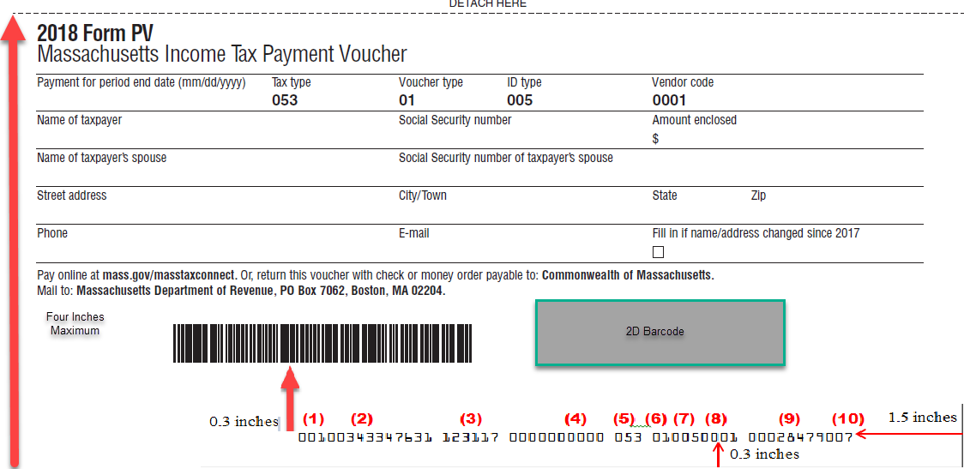

3.2 M-4868 Example

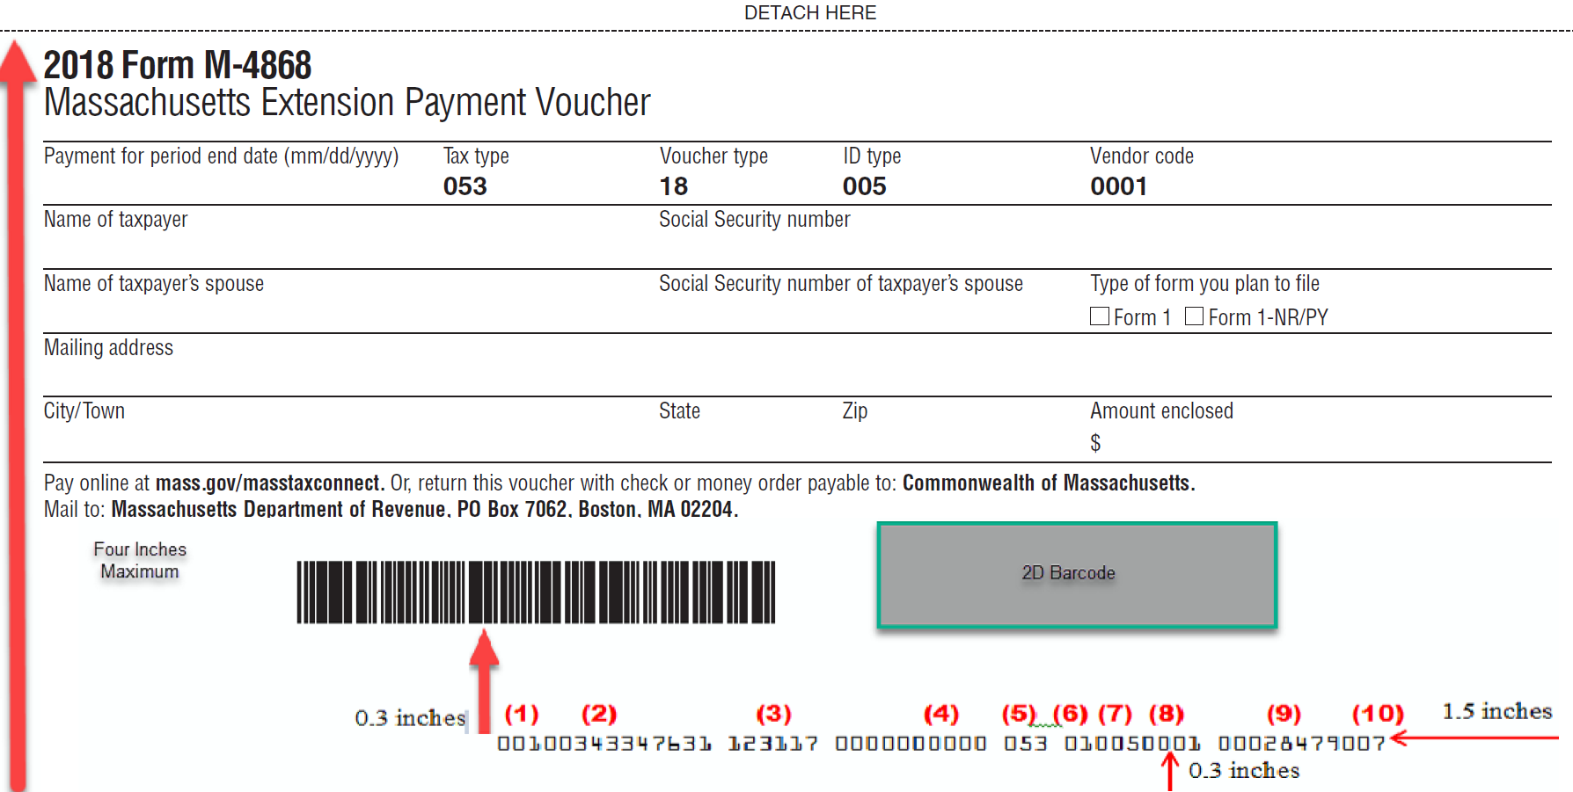

3.3 Form 1-ES example
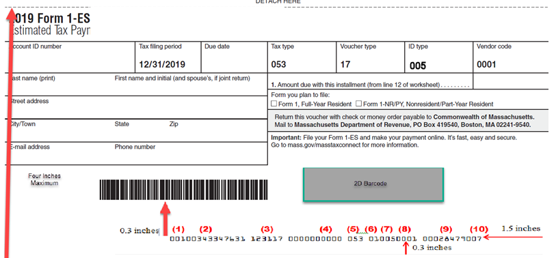

4.0 Fiduciary PV Specifications (Form 2 PV, M-8736, Form 2-ES)

- The right-most character of the scan line must be exactly 1.5 inches from right edge
- OCR-A font (size 1; 10 characters per inch) must be used for printing the scan line
- There MUST be 0.3 inch clearances above the scan line area
- The baseline of the scan line must be exactly 0.3 inches from the bottom edge of the form
- All forms must be 4.0 inches high and 8.5 inches wide and must print at the bottom of the sheet (portrait setting)

Please be sure to cut (detach) the vouchers where indicated (dotted line). DO NOT send in either form via an uncut sheet of paper.
Please note that all the vouchers must contain the appropriate 1D barcode

- Form 2-PV scan lines must consist of the following:

Scan Line Field # | Scan Line Position | Scan Line Content
(1) | 1-3 | Form Number (always 001)
(2) | 4-14 | Federal Identification Number, <zero filled on left> (e.g. 12-3456789 would be 00123456789)
 | 15 | Space
(3) | 16-21 | Filing Period MMDDYY (Should be the last day of Filing period e.g. 123117 for December 31 2017. Fiscal filers can put the appropriate period end date e.g. 063017 for June 30 2017)
 | 22 | Space
(4) | 23-32 | Filler, all zeros (always 0000000000)
 | 33 | Space
(5) | 34-36 | Tax Type (always 049)
 | 37 | Space
(6) | 38-39 | Voucher Type: (Original Return = 01, Amended Return = 14)
(7) | 40-42 | ID Type (always 004 for FEIN)
(8) | 43-46 | 4-digit NACTP Vendor Code
 | 47 | Space
(9) | 48-57 | Amount Enclosed <zero filled on left> (e.g. $12,345.67 would be 0001234567)
(10) | 58 | Check Digit Luhns Mod10 calculation of previous characters excluding spaces (See LuhnsMod10 Calculation section for breakdown)

- M-8736 scan lines must consist of the following:

Scan Line Field # | Scan Line Position | Scan Line Content
(1) | 1-3 | Form Number (always 001)
(2) | 4-14 | Federal Identification Number , <zero filled on left> (e.g. 12-3456789 would be 00123456789)
 | 15 | Space
(3) | 16-21 | Filing Period MMDDYY (Should be the last day of Filing period e.g. 123116 for December 31 2016. Fiscal filers can put the appropriate period end date e.g. 063016 for June 30 2016)
 | 22 | Space
(4) | 23-32 | Filler, all zeros (always 0000000000)
 | 33 | Space
(5) | 34-36 | Tax Type 049 – Fiduciary
 | 37 | Space
(6) | 38-39 | Voucher Type (always 18)
(7) | 40-42 | ID Type (always 004 for FEIN)
(8) | 43-46 | 4-digit NACTP Vendor Code
 | 47 | Space
(9) | 48-57 | Amount Enclosed <zero filled on left> (e.g. $12,345.67 would be 0001234567)
(10) | 58 | Check Digit Luhns Mod10 calculation of previous characters excluding spaces (See LuhnsMod10 Calculation section for breakdown)

- Form 2-ES scan lines must consist of the following:

Scan Line Field # | Scan Line Position | Scan Line Content
(1) | 1-3 | Form Number (always 001)
(2) | 4-14 | Federal Identification Number , <zero filled on left> (e.g. 12-3456789 would be 00123456789)
 | 15 | Space
(3) | 16-21 | Filing Period MMDDYY (Should be the last day of Filing period e.g. 123118 for December 31 2018. Fiscal filers can put the appropriate period end date e.g. 063018 for June 30 2018)
 | 22 | Space
(4) | 23-32 | Filler, all zeros (always 0000000000)
 | 33 | Space
(5) | 34-36 | Tax Type 049 – Fiduciary
 | 37 | Space
(6) | 38-39 | Voucher Type (always 17)
(7) | 40-42 | ID Type (always 004 for FEIN)
(8) | 43-46 | 4-digit NACTP Vendor Code
 | 47 | Space
(9) | 48-57 | Amount Enclosed <zero filled on left> (e.g. $12,345.67 would be 0001234567)
(10) | 58 | Check Digit Luhns Mod10 calculation of previous characters excluding spaces (See LuhnsMod10 Calculation section for breakdown)

4.1 Form2 PV example

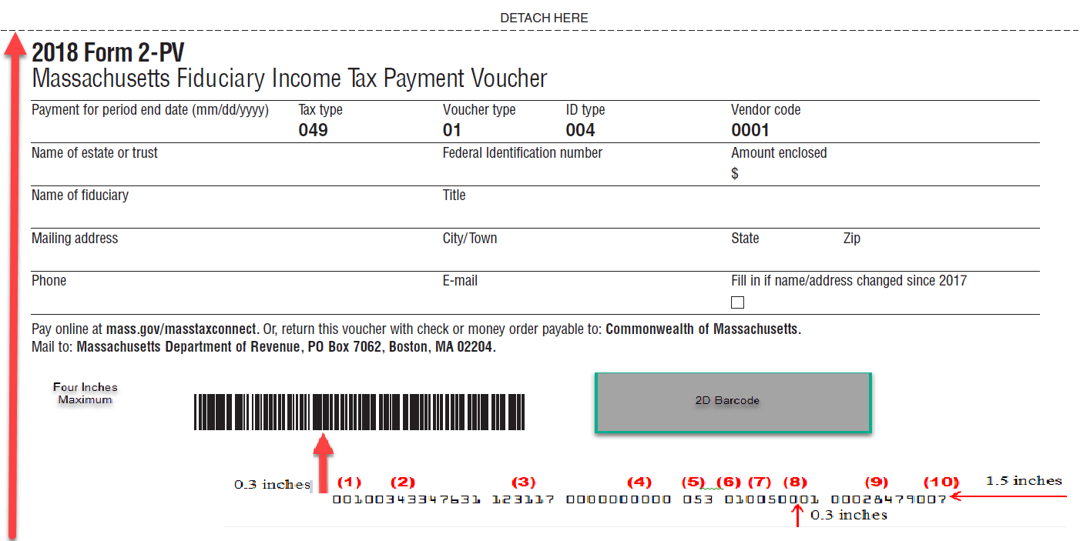

4.2 M-8736 example

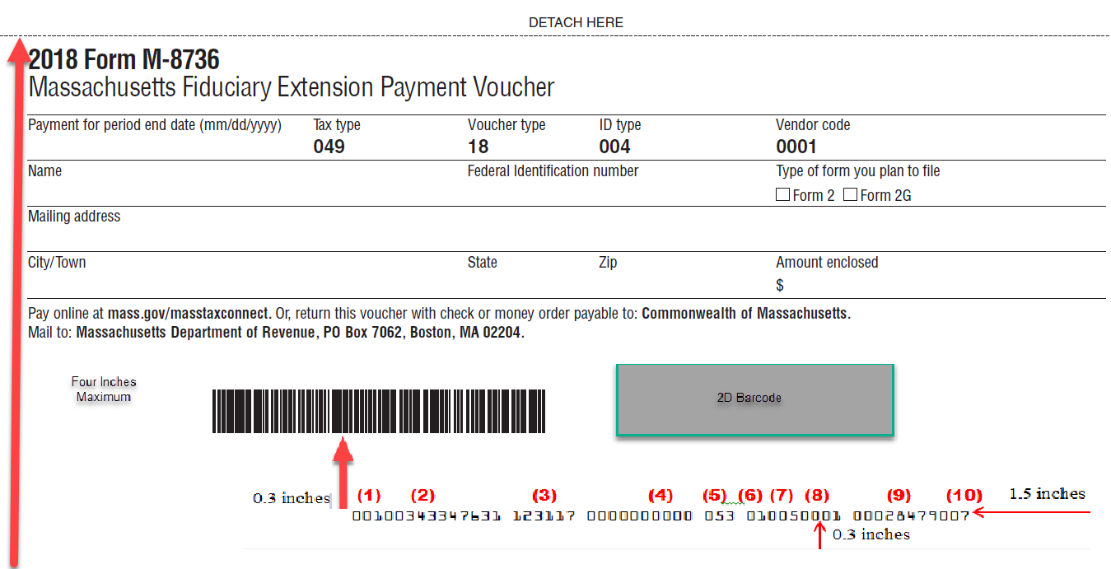

4.3Form 2-ES example

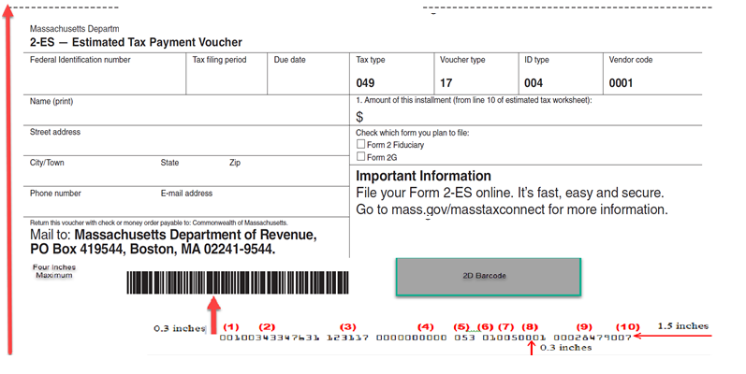

5.0 Corporate PV / Extension Specifications (Form 355-PV, 355S-PV, Form 355-7004, Form 355-7004 Misc, Form M-990-T 7004, Form 355-ES, 63 FI-ES, UBI-ES)

- The right-most character of the scan line must be exactly 1.5 inches from right edge
- OCR-A font (size 1; 10 characters per inch) must be used for printing the scan line
- There MUST be 0.3 inch clearances above the scan line area
- The baseline of the scan line must be exactly 0.3 inches from the bottom edge of the form
- All forms must be 4.0 inches high and 8.5 inches wide and must print at the bottom of the sheet (portrait setting)

Please be sure to cut (detach) the vouchers where indicated (dotted line). DO NOT send in either form via an uncut sheet of paper.
Please note that all the vouchers must contain the appropriate 1D barcode

- Forms 355-PV and 355S-PV scan lines must consist of the following
Scan Line Field # | Scan Line Position | Scan Line Content
(1) | 1-3 | Form Number (always 001)
(2) | 4-14 | FEIN, <zero filled on left> (e.g. FEIN 12-3456789 would be 00123456789)
 | 15 | Space
(3) | 16-21 | Filing Period MMDDYY (Should be the last day of Filing period e.g. 093017 for September 30 2017)
 | 22 | Space
(4) | 23-32 | Filler, all zeros (always 0000000000)
 | 33 | Space
(5) | 34-36 | Tax Type (always 014)
 | 37 | Space
(6) | 38-39 | Voucher Type: (Original Return = 01, Amended Return = 14)
(7) | 40-42 | ID Type (always 004 for FEIN)
(8) | 43-46 | 4-digit NACTP Vendor Code
 | 47 | Space
(9) | 48-57 | Amount Enclosed <zero filled on left> (e.g. $12,345.67 would be 0001234567)
(10) | 58 | Check Digit Luhns Mod10 calculation of previous characters excluding spaces (See LuhnsMod10 Calculation section for breakdown)

- Form 355-7004 scan line must consist of the following
Scan Line Field # | Scan Line Position | Scan Line Content
(1) | 1-3 | Form Number (always 001)
(2) | 4-14 | FEIN, <zero filled on left> (e.g. FEIN 12-3456789 would be 00123456789)
 | 15 | Space
(3) | 16-21 | Filing Period MMDDYY (Should be the last day of Filing period e.g. 093017 for September 30 2017)
 | 22 | Space
(4) | 23-32 | Filler, all zeros (always 0000000000)
 | 33 | Space
(5) | 34-36 | Tax Type (always 014)
 | 37 | Space
(6) | 38-39 | Voucher Type (always 18)
(7) | 40-42 | ID Type (always 004 for FEIN)
(8) | 43-46 | 4-digit NACTP Vendor Code, if applicable
 | 47 | Space
(9) | 48-57 | Amount Enclosed <zero filled on left> (e.g. $12,345.67 would be 0001234567)
(10) | 58 | Check Digit Luhns Mod10 calculation of previous characters excluding spaces (See LuhnsMod10 Calculation section for breakdown)

NOTE:

- Return Payments and/or Extensions requests/payments for Form 355-U filers must be made electronically (see TIR 09-18).

- Form 355-7004 Misc scan line must consist of the following
Scan Line Field # | Scan Line Position | Scan Line Content
(1) | 1-3 | Form Number (always 001)
(2) | 4-14 | FEIN, <zero filled on left> (e.g. FEIN 12-3456789 would be 00123456789)
 | 15 | Space
(3) | 16-21 | Filing Period MMDDYY (Should be the last day of Filing period e.g. 093017 for September 30 2017)
 | 22 | Space
(4) | 23-32 | Filler, all zeros (always 0000000000)
 | 33 | Space
(5) | 34-36 | Tax Type (Should be according to the Form from the table below)
  Account Type | Form | Tax Type Code
  (LIE) Life Insurance | 63-20P | 022
  (INE) P&C - PPO Insurance | 63-23P | 018
  (MIT) Ocean Marine Insurance | 63-29A | 023
  (FIE) Financial Institution | 63-FI | 015
  (URE) Urban Redevelopment | 121A | 037
  (PUE) Public Utility Excise | P.S.1 | 028
 | 37 | Space
(6) | 38-39 | Voucher Type (always 18)
(7) | 40-42 | ID Type (always 004 for FEIN)
(8) | 43-46 | 4-digit NACTP Vendor Code, if applicable
 | 47 | Space
(9) | 48-57 | Amount Enclosed <zero filled on left> (e.g. $12,345.67 would be 0001234567)
(10) | 58 | Check Digit Luhns Mod10 calculation of previous characters excluding spaces (See LuhnsMod10 Calculation section for breakdown)

- Form M-990T-7004 scan line must consist of the following
Scan Line Field # | Scan Line Position | Scan Line Content
(1) | 1-3 | Form Number (always 001)
(2) | 4-14 | FEIN, <zero filled on left> (e.g. FEIN 12-3456789 would be 00123456789)
 | 15 | Space
(3) | 16-21 | Filing Period MMDDYY (Should be the last day of Filing period e.g. 093017 for September 30 2017)
 | 22 | Space
(4) | 23-32 | Filler, all zeros (always 0000000000)
 | 33 | Space
(5) | 34-36 | Tax Type (always 036)
 | 37 | Space
(6) | 38-39 | Voucher Type (always 18)
(7) | 40-42 | ID Type (always 004 for FEIN)
(8) | 43-46 | 4-digit NACTP Vendor Code, if applicable
 | 47 | Space
(9) | 48-57 | Amount Enclosed <zero filled on left> (e.g. $12,345.67 would be 0001234567)
(10) | 58 | Check Digit Luhns Mod10 calculation of previous characters excluding spaces (See LuhnsMod10 Calculation section for breakdown)

- Form 355-ES scan line must consist of the following
Scan Line Field # | Scan Line Position | Scan Line Content
(1) | 1-3 | Form Number (always 001)
(2) | 4-14 | FEIN or Account ID, <zero filled on left> (e.g. FEIN 12-3456789 would be 00123456789)
 | 15 | Space
(3) | 16-21 | Filing Period MMDDYY (Should be the last day of Filing period e.g. 093018 for September 30 2018)
 | 22 | Space
(4) | 23-32 | Filler, all zeros (always 0000000000)
 | 33 | Space
(5) | 34-36 | Tax Type – 014 if Corporation will be filing 355 or 355S tax return. It will depend on the Account Type being filed for Miscellaneous as shown in table below
  Account Type | Form | Tax Type Code
  (COR) Corporate Excise | 355/  355S | 014
  (LIE) Life Insurance | 63-20P | 022
  (INE) P&C - PPO Insurance | 63-23P | 018
  (MIT) Ocean Marine Insurance | 63-29A | 023
  (URE) Urban Redevelopment | 121A | 037
  (PUE) Public Utility Excise | P.S.1 | 028
 | 37 | Space
(6) | 38-39 | Voucher Type (always 17)
(7) | 40-42 | ID Type:  004 when FEIN is entered.  026 when Account ID is entered
(8) | 43-46 | 4-digit NACTP Vendor Code, if applicable
 | 47 | Space
(9) | 48-57 | Amount Enclosed <zero filled on left> (e.g. $12,345.67 would be 0001234567)
(10) | 58 | Check Digit Luhns Mod10 calculation of previous characters excluding spaces (See LuhnsMod10 Calculation section for breakdown)

- Form 63 FI-ES scan line must consist of the following
Scan Line Field # | Scan Line Position | Scan Line Content
(1) | 1-3 | Form Number (always 001)
(2) | 4-14 | FEIN or Account ID, <zero filled on left> (e.g. FEIN 12-3456789 would be 00123456789)
 | 15 | Space
(3) | 16-21 | Filing Period MMDDYY (Should be the last day of Filing period e.g. 093018 for September 30 2018)
 | 22 | Space
(4) | 23-32 | Filler, all zeros (always 0000000000)
 | 33 | Space
(5) | 34-36 | Tax Type – 015
 | 37 | Space
(6) | 38-39 | Voucher Type (always 17)
(7) | 40-42 | ID Type :  004 when FEIN is entered  027 when Account ID is entered
(8) | 43-46 | 4-digit NACTP Vendor Code, if applicable
 | 47 | Space
(9) | 48-57 | Amount Enclosed <zero filled on left> (e.g. $12,345.67 would be 0001234567)
(10) | 58 | Check Digit Luhns Mod10 calculation of previous characters excluding spaces (See LuhnsMod10 Calculation section for breakdown)

- UBI-ES scan line must consist of the following
Scan Line Field # | Scan Line Position | Scan Line Content
(1) | 1-3 | Form Number (always 001)
(2) | 4-14 | FEIN, <zero filled on left> (e.g. FEIN 12-3456789 would be 00123456789)
 | 15 | Space
(3) | 16-21 | Filing Period MMDDYY (Should be the last day of Filing period e.g. 093018 for September 30 2018)
 | 22 | Space
(4) | 23-32 | Filler, all zeros (always 0000000000)
 | 33 | Space
(5) | 34-36 | Tax Type – 036
 | 37 | Space
(6) | 38-39 | Voucher Type (always 17)
(7) | 40-42 | ID Type (always 004 for FEIN)
(8) | 43-46 | 4-digit NACTP Vendor Code, if applicable
 | 47 | Space
(9) | 48-57 | Amount Enclosed <zero filled on left> (e.g. $12,345.67 would be 0001234567)
(10) | 58 | Check Digit Luhns Mod10 calculation of previous characters excluding spaces (See LuhnsMod10 Calculation section for breakdown)

5.1 Form 355 PV Example

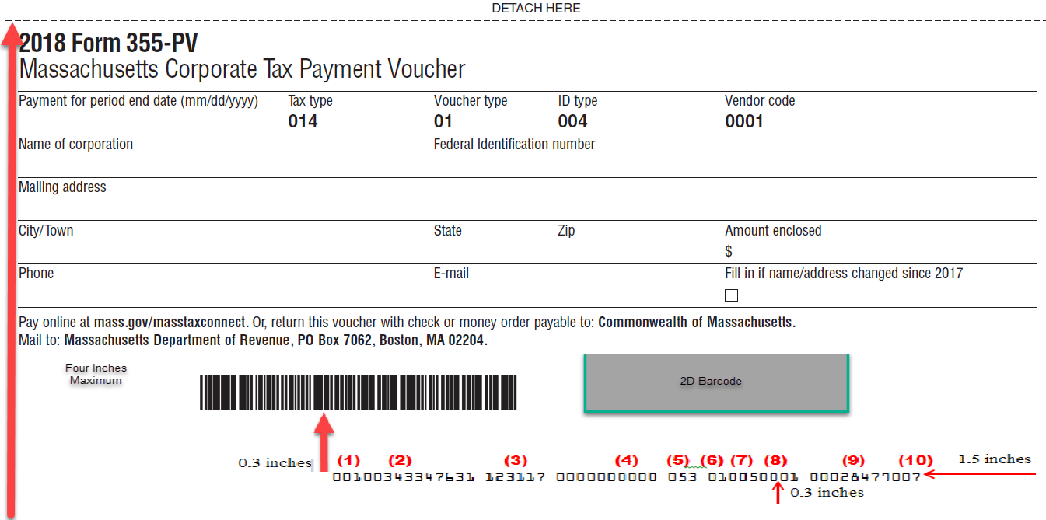

5.1 Form 355S PV Example
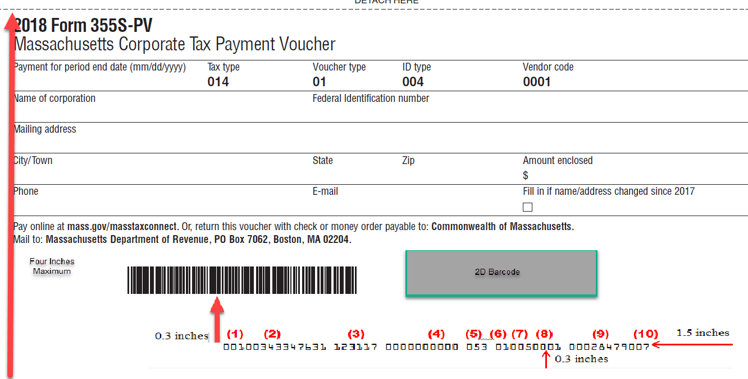

5.2 Form 355-7004 Example

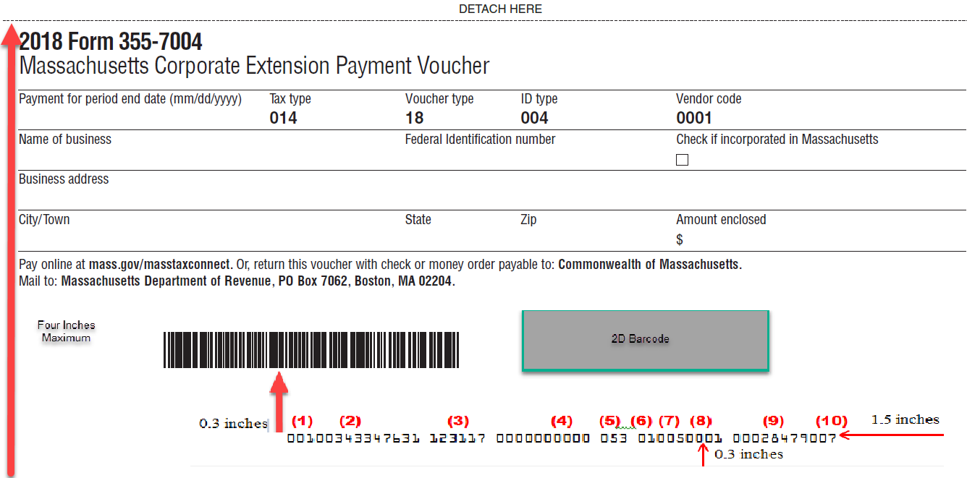
5.3 Form 355-7004 Misc Example

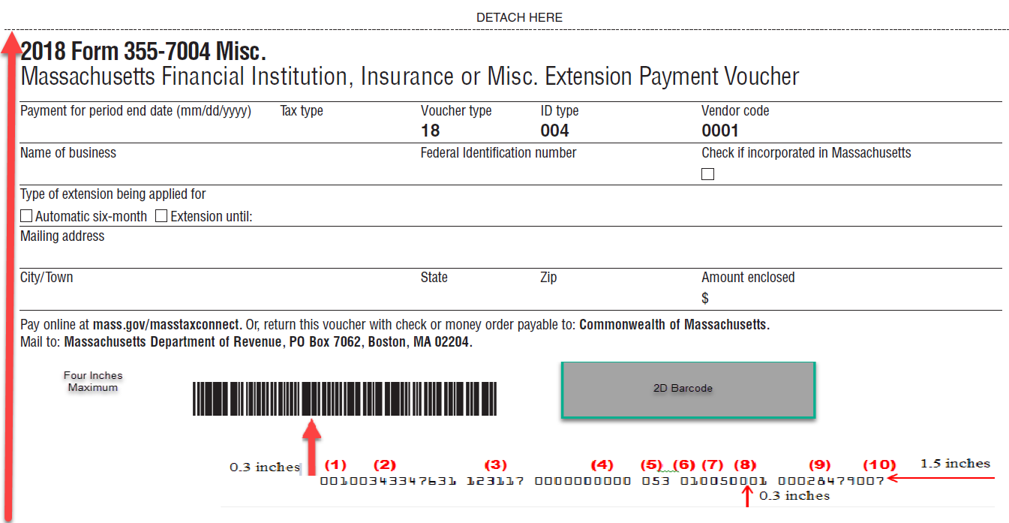
(1) (2) (3) (4) (5) (6) (7) (8) (9) (10)
123 Main Street
12/31/2017 015
ABC Corporation 123456789
Any Town MA 01111-1111 12,345.67
4 inches maximum
00100123456789 123117 0000000000 015 180040001 00012345677
1.5 inches
0.3 inches

5.4 Form M-990T-7004 Example

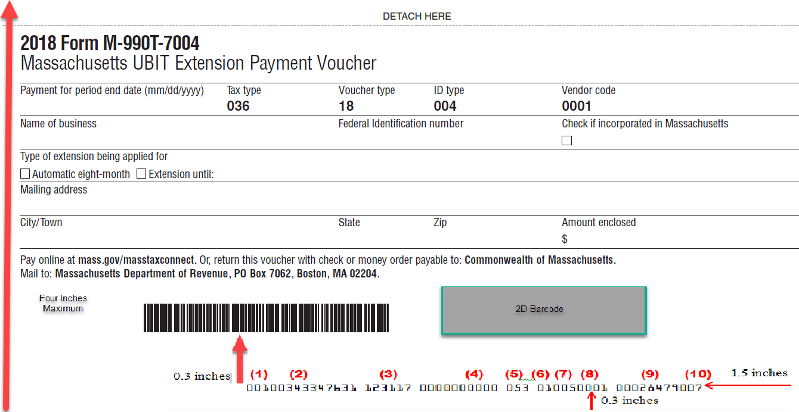

5.5 Form 355-ES Example

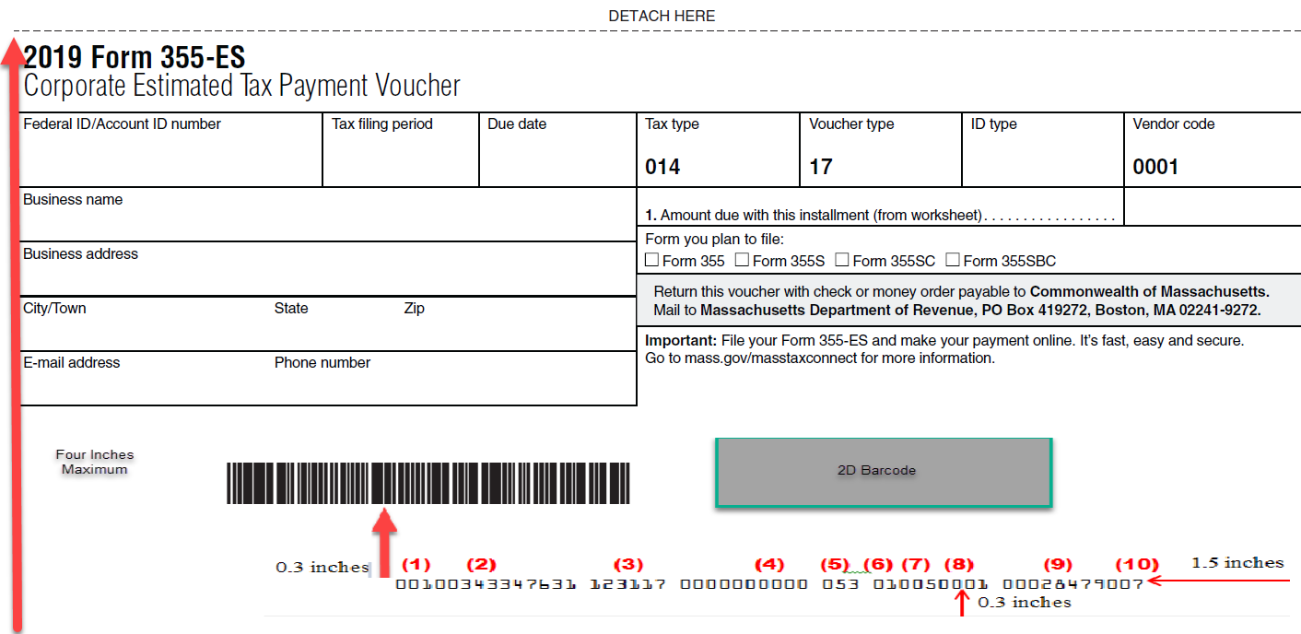

5.6 63 FI-ES Example

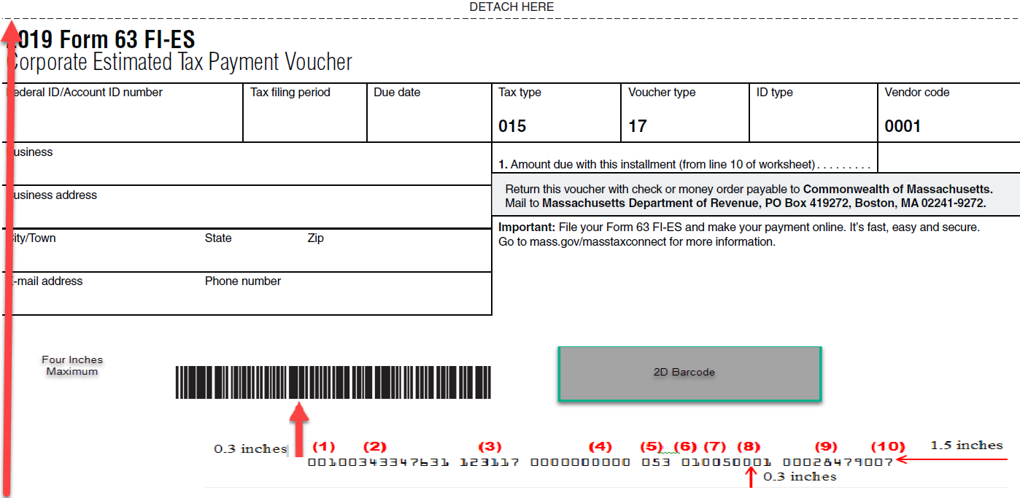

5.7 UBI-ES Example

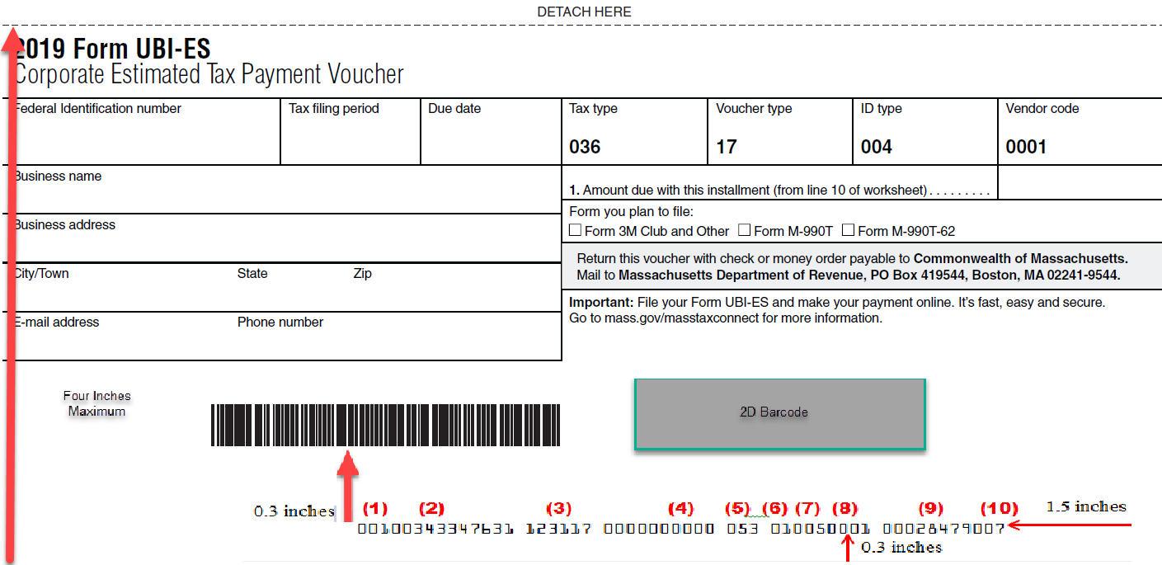

6.0 Document Revisions

This page is included to track changes between published revisions of this document.

Number | Date | Revision
2025-1.0 | 2/28/25 | Performed Annual Updates

Appendix A

Form 1 PV Layout
2-D |  | Data | Size in | Req’d |  |  | Location on
Field No | FIELD NAME | Type | Bytes | Field | VALUE | NOTES | The Form
1 | HEADER_VER_NUMBR | Alpha | 2 | Y | T1 | FTA STANDARD
2 | VENDOR_CDE | Alpha | 4 | Y |  | Vendor creating 2D barcode
3 | SOFTWARE_VERS | Alpha | 2 | Y |  | Vendor provided
4 | STATE_CDE | Alpha | 2 | Y | MA
5 | FORM_YR_NUM | Alpha | 2 | Y | PV
6 | FORM_CDE | Alpha | 3 | Y | 001
7 | PAGE_NUM | Alpha | 1 | Y | 1 | Page number
 | Line Item Data
8 | FORM_NUMBER |  | 3 | Y | 001
9 | TAXPAYER ID | TP Id | 11 | Y |  | If 9 digit, left fill 00 | Second row
10 | PERIOD | Date | 6 | Y |  | mmddyy | Top row, left
11 | PAYMENT RECV |  | 6 |  | 000000 | To match scanline
12 | FILL |  | 4 |  | 0000 | To match scanline
13 | TAX_TYPE | Number | 3 | Y | 053 |  | Top row
14 | VOUCHER TYPE | Number | 2 | Y | 01/14 |  | Top row
15 | ID TYPE | Number | 3 | Y | 005 |  | Top row
16 | VENDOR | Alpha | 4 | Y
17 | AMOUNT DUE | Money | As need | Y |  | Up to 10 bytes | Fifth row, right
18 | CHECK_DIGIT | Number | 1 | Y
19 | END_OF_FILE | Alpha | 5 | Y | *EOD* | FTA Standard

Money fields in print and in the 2D barcode must include cents. Printed, include decimal point.
There is a half inch of white space between the top of the scanline and the bottom of the 1D & 2D barcodes.

Form 2 PV Layout
2-D |  | Data | Size in | Req’d |  |  | Location on
Field No | FIELD NAME | Type | Bytes | Field | VALUE | NOTES | The Form
1 | HEADER_VER_NUMBR | Alpha | 2 | Y | T1 | FTA STANDARD
2 | VENDOR_CDE | Alpha | 4 | Y |  | Vendor creating 2D barcode
3 | SOFTWARE_VERS | Alpha | 2 | Y |  | Vendor provided
4 | STATE_CDE | Alpha | 2 | Y | MA
5 | FORM_YR_NUM | Alpha | 2 | Y | PV
6 | FORM_CDE | Alpha | 3 | Y | 002
7 | PAGE_NUM | Alpha | 1 | Y | 1 | Page number
 | Line Item Data
8 | FORM_NUMBER |  | 3 | Y | 001
9 | TAXPAYER ID | TP Id | 11 | Y |  | If 9 digit, left fill 00 | Second row
10 | PERIOD | Date | 6 | Y |  | mmddyy | Top row, left
11 | PAYMENT RECV |  | 6 |  | 000000 | To match scanline
12 | FILL |  | 4 |  | 0000 | To match scanline
13 | TAX_TYPE | Number | 3 | Y | 049 |  | Top row
14 | VOUCHER TYPE | Number | 2 | Y | 01/14 |  | Top row
15 | ID TYPE | Number | 3 | Y | 004 |  | Top row
16 | VENDOR | Alpha | 4 | Y
17 | AMOUNT DUE | Money | As need | Y |  | Up to 10 bytes | Fifth row, right
18 | CHECK_DIGIT | Number | 1 | Y
19 | END_OF_FILE | Alpha | 5 | Y | *EOD* | FTA Standard

Money fields in print and in the 2D barcode must include cents. Printed, include decimal point.
There is a half inch of white space between the top of the scanline and the bottom of the 1D & 2D barcodes.

Form 355 PV Layout
2-D |  | Data | Size in | Req’d |  |  | Location on
Field No | FIELD NAME | Type | Bytes | Field | VALUE | NOTES | The Form
1 | HEADER_VER_NUMBR | Alpha | 2 | Y | T1 | FTA STANDARD
2 | VENDOR_CDE | Alpha | 4 | Y |  | Vendor creating 2D barcode
3 | SOFTWARE_VERS | Alpha | 2 | Y |  | Vendor provided
4 | STATE_CDE | Alpha | 2 | Y | MA
5 | FORM_YR_NUM | Alpha | 2 | Y | PV
6 | FORM_CDE | Alpha | 3 | Y | 005
7 | PAGE_NUM | Alpha | 1 | Y | 1 | Page number
 | Line Item Data
8 | FORM_NUMBER |  | 3 | Y | 001
9 | TAXPAYER ID | TP Id | 11 | Y |  | If 9 digit, left fill 00 | Second row
10 | PERIOD | Date | 6 | Y |  | mmddyy | Top row, left
11 | PAYMENT RECV |  | 6 |  | 000000 | To match scanline
12 | FILL |  | 4 |  | 0000 | To match scanline
13 | TAX_TYPE | Number | 3 | Y | 014 |  | Top row
14 | VOUCHER TYPE | Number | 2 | Y | 01/14 |  | Top row
15 | ID TYPE | Number | 3 | Y | 004 |  | Top row
16 | VENDOR | Alpha | 4 | Y
17 | AMOUNT DUE | Money | As need | Y |  | Up to 10 bytes | Fifth row, right
18 | CHECK_DIGIT | Number | 1 | Y
19 | END_OF_FILE | Alpha | 5 | Y | *EOD* | FTA Standard

Money fields in print and in the 2D barcode must include cents. Printed, include decimal point.
There is a half inch of white space between the top of the scanline and the bottom of the 1D & 2D barcodes.

Form 355-S PV Layout
2-D |  | Data | Size in | Req’d |  |  | Location on
Field No | FIELD NAME | Type | Bytes | Field | VALUE | NOTES | The Form
1 | HEADER_VER_NUMBR | Alpha | 2 | Y | T1 | FTA STANDARD
2 | VENDOR_CDE | Alpha | 4 | Y |  | Vendor creating 2D barcode
3 | SOFTWARE_VERS | Alpha | 2 | Y |  | Vendor provided
4 | STATE_CDE | Alpha | 2 | Y | MA
5 | FORM_YR_NUM | Alpha | 2 | Y | PV
6 | FORM_CDE | Alpha | 3 | Y | 006
7 | PAGE_NUM | Alpha | 1 | Y | 1 | Page number
 | Line Item Data
8 | FORM_NUMBER |  | 3 | Y | 001
9 | TAXPAYER ID | TP Id | 11 | Y |  | If 9 digit, left fill 00 | Second row
10 | PERIOD | Date | 6 | Y |  | mmddyy | Top row, left
11 | PAYMENT RECV |  | 6 |  | 000000 | To match scanline
12 | FILL |  | 4 |  | 0000 | To match scanline
13 | TAX_TYPE | Number | 3 | Y | 014 |  | Top row
14 | VOUCHER TYPE | Number | 2 | Y | 01/14 |  | Top row
15 | ID TYPE | Number | 3 | Y | 004 |  | Top row
16 | VENDOR | Alpha | 4 | Y
17 | AMOUNT DUE | Money | As need | Y |  | Up to 10 bytes | Fifth row, right
18 | CHECK_DIGIT | Number | 1 | Y
19 | END_OF_FILE | Alpha | 5 | Y | *EOD* | FTA Standard

Money fields in print and in the 2D barcode must include cents. Printed, include decimal point.
There is a half inch of white space between the top of the scanline and the bottom of the 1D & 2D barcodes.

Form M-4868 Extension Layout
2-D |  | Data | Size in | Req’d |  |  | Location on
Field No | FIELD NAME | Type | Bytes | Field | VALUE | NOTES | The Form
1 | HEADER_VER_NUMBR | Alpha | 2 | Y | T1 | FTA STANDARD
2 | VENDOR_CDE | Alpha | 4 | Y |  | Vendor creating 2D barcode
3 | SOFTWARE_VERS | Alpha | 2 | Y |  | Vendor provided
4 | STATE_CDE | Alpha | 2 | Y | MA
5 | FORM_YR_NUM | Alpha | 2 | Y | PV
6 | FORM_CDE | Alpha | 3 | Y | 004
7 | PAGE_NUM | Alpha | 1 | Y | 1 | Page number
 | Line Item Data
8 | FORM_NUMBER |  | 3 | Y | 001
9 | TAXPAYER ID | TP Id | 11 | Y |  | If 9 digit, left fill 00 | Second row
10 | PERIOD | Date | 6 | Y |  | mmddyy | Top row, left
11 | PAYMENT RECV |  | 6 |  | 000000 | To match scanline
12 | FILL |  | 4 |  | 0000 | To match scanline
13 | TAX_TYPE | Number | 3 | Y | 053 |  | Top row
14 | VOUCHER TYPE | Number | 2 | Y | 18 |  | Top row
15 | ID TYPE | Number | 3 | Y | 005 |  | Top row
16 | VENDOR | Alpha | 4 | Y
17 | AMOUNT DUE | Money | As need | Y |  | Up to 10 bytes | Fifth row, right
18 | CHECK_DIGIT | Number | 1 | Y
19 | END_OF_FILE | Alpha | 5 | Y | *EOD* | FTA Standard

Money fields in print and in the 2D barcode must include cents. Printed, include decimal point.
There is a half inch of white space between the top of the scanline and the bottom of the 1D & 2D barcodes.

Form M-8736 Extension Layout
2-D |  | Data | Size in | Req’d |  |  | Location on
Field No | FIELD NAME | Type | Bytes | Field | VALUE | NOTES | The Form
1 | HEADER_VER_NUMBR | Alpha | 2 | Y | T1 | FTA STANDARD
2 | VENDOR_CDE | Alpha | 4 | Y |  | Vendor creating 2D barcode
3 | SOFTWARE_VERS | Alpha | 2 | Y |  | Vendor provided
4 | STATE_CDE | Alpha | 2 | Y | MA
5 | FORM_YR_NUM | Alpha | 2 | Y | PV
6 | FORM_CDE | Alpha | 3 | Y | 003
7 | PAGE_NUM | Alpha | 1 | Y | 1 | Page number
 | Line Item Data
8 | FORM_NUMBER |  | 3 | Y | 001
9 | TAXPAYER ID | TP Id | 11 | Y |  | If 9 digit, left fill 00 | Second row
10 | PERIOD | Date | 6 | Y |  | mmddyy | Top row, left
11 | PAYMENT RECV |  | 6 |  | 000000 | To match scanline
12 | FILL |  | 4 |  | 0000 | To match scanline
13 | TAX_TYPE | Number | 3 | Y | 049/052 |  | Top row
14 | VOUCHER TYPE | Number | 2 | Y | 18 |  | Top row
15 | ID TYPE | Number | 3 | Y | 004 |  | Top row
16 | VENDOR | Alpha | 4 | Y
17 | AMOUNT DUE | Money | As need | Y |  | Up to 10 bytes | Fifth row, right
18 | CHECK_DIGIT | Number | 1 | Y
19 | END_OF_FILE | Alpha | 5 | Y | *EOD* | FTA Standard

Money fields in print and in the 2D barcode must include cents. Printed, include decimal point.
There is a half inch of white space between the top of the scanline and the bottom of the 1D & 2D barcodes.

Form 355-7004 Extension Layout
2-D |  | Data | Size in | Req’d |  |  | Location on
Field No | FIELD NAME | Type | Bytes | Field | VALUE | NOTES | The Form
1 | HEADER_VER_NUMBR | Alpha | 2 | Y | T1 | FTA STANDARD
2 | VENDOR_CDE | Alpha | 4 | Y |  | Vendor creating 2D barcode
3 | SOFTWARE_VERS | Alpha | 2 | Y |  | Vendor provided
4 | STATE_CDE | Alpha | 2 | Y | MA
5 | FORM_YR_NUM | Alpha | 2 | Y | PV
6 | FORM_CDE | Alpha | 3 | Y | 007
7 | PAGE_NUM | Alpha | 1 | Y | 1 | Page number
 | Line Item Data
8 | FORM_NUMBER |  | 3 | Y | 001
9 | TAXPAYER ID | TP Id | 11 | Y |  | If 9 digit, left fill 00 | Second row
10 | PERIOD | Date | 6 | Y |  | mmddyy | Top row, left
11 | PAYMENT RECV |  | 6 |  | 000000 | To match scanline
12 | FILL |  | 4 |  | 0000 | To match scanline
13 | TAX_TYPE | Number | 3 | Y | 014 |  | Top row
14 | VOUCHER TYPE | Number | 2 | Y | 18 |  | Top row
15 | ID TYPE | Number | 3 | Y | 004 |  | Top row
16 | VENDOR | Alpha | 4 | Y
17 | AMOUNT DUE | Money | As need | Y |  | Up to 10 bytes | Fifth row, right
18 | CHECK_DIGIT | Number | 1 | Y
19 | END_OF_FILE | Alpha | 5 | Y | *EOD* | FTA Standard

Money fields in print and in the 2D barcode must include cents. Printed, include decimal point.
There is a half inch of white space between the top of the scanline and the bottom of the 1D & 2D barcodes.

Form 355-7004 Misc. Extension Layout
2-D |  | Data | Size in | Req’d |  |  | Location on
Field No | FIELD NAME | Type | Bytes | Field | VALUE | NOTES | The Form
1 | HEADER_VER_NUMBR | Alpha | 2 | Y | T1 | FTA STANDARD
2 | VENDOR_CDE | Alpha | 4 | Y |  | Vendor creating 2D barcode
3 | SOFTWARE_VERS | Alpha | 2 | Y |  | Vendor provided
4 | STATE_CDE | Alpha | 2 | Y | MA
5 | FORM_YR_NUM | Alpha | 2 | Y | PV
6 | FORM_CDE | Alpha | 3 | Y | 011
7 | PAGE_NUM | Alpha | 1 | Y | 1 | Page number
 | Line Item Data
8 | FORM_NUMBER |  | 3 | Y | 001
9 | TAXPAYER ID | TP Id | 11 | Y |  | If 9 digit, left fill 00 | Second row
10 | PERIOD | Date | 6 | Y |  | mmddyy | Top row, left
11 | PAYMENT RECV |  | 6 |  | 000000 | To match scanline
12 | FILL |  | 4 |  | 0000 | To match scanline
13 | TAX_TYPE | Number | 3 | Y | * |  | Top row
14 | VOUCHER TYPE | Number | 2 | Y | 18 |  | Top row
15 | ID TYPE | Number | 3 | Y | 004 |  | Top row
16 | VENDOR | Alpha | 4 | Y
17 | AMOUNT DUE | Money | As need | Y |  | Up to 10 bytes | Fifth row, right
18 | CHECK_DIGIT | Number | 1 | Y
19 | END_OF_FILE | Alpha | 5 | Y | *EOD* | FTA Standard

- Field 13 acceptable values: 015, 018, 022, 023, 028, 037

Money fields in print and in the 2D barcode must include cents. Printed, include decimal point.
There is a half inch of white space between the top of the scanline and the bottom of the 1D & 2D barcodes.

Form M-990T-7004 Extension Layout
2-D |  | Data | Size in | Req’d |  |  | Location on
Field No | FIELD NAME | Type | Bytes | Field | VALUE | NOTES | The Form
1 | HEADER_VER_NUMBR | Alpha | 2 | Y | T1 | FTA STANDARD
2 | VENDOR_CDE | Alpha | 4 | Y |  | Vendor creating 2D barcode
3 | SOFTWARE_VERS | Alpha | 2 | Y |  | Vendor provided
4 | STATE_CDE | Alpha | 2 | Y | MA
5 | FORM_YR_NUM | Alpha | 2 | Y | PV
6 | FORM_CDE | Alpha | 3 | Y | 012
7 | PAGE_NUM | Alpha | 1 | Y | 1 | Page number
 | Line Item Data
8 | FORM_NUMBER |  | 3 | Y | 001
9 | TAXPAYER ID | TP Id | 11 | Y |  | If 9 digit, left fill 00 | Second row
10 | PERIOD | Date | 6 | Y |  | mmddyy | Top row, left
11 | PAYMENT RECV |  | 6 |  | 000000 | To match scanline
12 | FILL |  | 4 |  | 0000 | To match scanline
13 | TAX_TYPE | Number | 3 | Y | 036 |  | Top row
14 | VOUCHER TYPE | Number | 2 | Y | 18 |  | Top row
15 | ID TYPE | Number | 3 | Y | 004 |  | Top row
16 | VENDOR | Alpha | 4 | Y
17 | AMOUNT DUE | Money | As need | Y |  | Up to 10 bytes | Fifth row, right
18 | CHECK_DIGIT | Number | 1 | Y
19 | END_OF_FILE | Alpha | 5 | Y | *EOD* | FTA Standard

Money fields in print and in the 2D barcode must include cents. Printed, include decimal point.
There is a half inch of white space between the top of the scanline and the bottom of the 1D & 2D barcodes.

Form 1 ES Layout
2-D |  | Data | Size in | Req’d |  |  | Location on
Field No | FIELD NAME | Type | Bytes | Field | VALUE | NOTES | The Form
1 | HEADER_VER_NUMBR | Alpha | 2 | Y | T1 | FTA STANDARD
2 | VENDOR_CDE | Alpha | 4 | Y |  | Vendor creating 2D barcode
3 | SOFTWARE_VERS | Alpha | 2 | Y |  | Vendor provided
4 | STATE_CDE | Alpha | 2 | Y | MA
5 | FORM_YR_NUM | Alpha | 2 | Y | PV
6 | FORM_CDE | Alpha | 3 | Y | 008
7 | PAGE_NUM | Alpha | 1 | Y | 1 | Page number
 | Line Item Data
8 | FORM_NUMBER |  | 3 | Y | 001
9 | TAXPAYER ID | TP Id | 11 | Y |  | If 9 digit, left fill 00 | Second row
10 | PERIOD | Date | 6 | Y |  | mmddyy | Top row, left
11 | PAYMENT RECV |  | 6 |  | 000000 | To match scanline
12 | FILL |  | 4 |  | 0000 | To match scanline
13 | TAX_TYPE | Number | 3 | Y | 053 |  | Top row
14 | VOUCHER TYPE | Number | 2 | Y | 17 |  | Top row
15 | ID TYPE | Number | 3 | Y | 005 |  | Top row
16 | VENDOR | Alpha | 4 | Y
17 | AMOUNT DUE | Money | As need | Y |  | Up to 10 bytes | Fifth row, right
18 | CHECK_DIGIT | Number | 1 | Y
19 | END_OF_FILE | Alpha | 5 | Y | *EOD* | FTA Standard

Money fields in print and in the 2D barcode must include cents. Printed, include decimal point.
There is a half inch of white space between the top of the scanline and the bottom of the 1D & 2D barcodes.

Form 2 ES Layout
2-D |  | Data | Size in | Req’d |  |  | Location on
Field No | FIELD NAME | Type | Bytes | Field | VALUE | NOTES | The Form
1 | HEADER_VER_NUMBR | Alpha | 2 | Y | T1 | FTA STANDARD
2 | VENDOR_CDE | Alpha | 4 | Y |  | Vendor creating 2D barcode
3 | SOFTWARE_VERS | Alpha | 2 | Y |  | Vendor provided
4 | STATE_CDE | Alpha | 2 | Y | MA
5 | FORM_YR_NUM | Alpha | 2 | Y | PV
6 | FORM_CDE | Alpha | 3 | Y | 009
7 | PAGE_NUM | Alpha | 1 | Y | 1 | Page number
 | Line Item Data
8 | FORM_NUMBER |  | 3 | Y | 001
9 | TAXPAYER ID | TP Id | 11 | Y |  | If 9 digit, left fill 00 | Second row
10 | PERIOD | Date | 6 | Y |  | mmddyy | Top row, left
11 | PAYMENT RECV |  | 6 |  | 000000 | To match scanline
12 | FILL |  | 4 |  | 0000 | To match scanline
13 | TAX_TYPE | Number | 3 | Y | 049/052 |  | Top row
14 | VOUCHER TYPE | Number | 2 | Y | 17 |  | Top row
15 | ID TYPE | Number | 3 | Y | 004 |  | Top row
16 | VENDOR | Alpha | 4 | Y
17 | AMOUNT DUE | Money | As need | Y |  | Up to 10 bytes | Fifth row, right
18 | CHECK_DIGIT | Number | 1 | Y
19 | END_OF_FILE | Alpha | 5 | Y | *EOD* | FTA Standard

Money fields in print and in the 2D barcode must include cents. Printed, include decimal point.
There is a half inch of white space between the top of the scanline and the bottom of the 1D & 2D barcodes.

Form 355 ES Layout
2-D |  | Data | Size in | Req’d |  |  | Location on
Field No | FIELD NAME | Type | Bytes | Field | VALUE | NOTES | The Form
1 | HEADER_VER_NUMBR | Alpha | 2 | Y | T1 | FTA STANDARD
2 | VENDOR_CDE | Alpha | 4 | Y |  | Vendor creating 2D barcode
3 | SOFTWARE_VERS | Alpha | 2 | Y |  | Vendor provided
4 | STATE_CDE | Alpha | 2 | Y | MA
5 | FORM_YR_NUM | Alpha | 2 | Y | PV
6 | FORM_CDE | Alpha | 3 | Y | 010
7 | PAGE_NUM | Alpha | 1 | Y | 1 | Page number
 | Line Item Data
8 | FORM_NUMBER |  | 3 | Y | 001
9 | TAXPAYER ID | TP Id | 11 | Y |  | If 9 digit, left fill 00 | Second row
10 | PERIOD | Date | 6 | Y |  | mmddyy | Top row, left
11 | PAYMENT RECV |  | 6 |  | 000000 | To match scanline
12 | FILL |  | 4 |  | 0000 | To match scanline
13 | TAX_TYPE | Number | 3 | Y | * |  | Top row
14 | VOUCHER TYPE | Number | 2 | Y | 17 |  | Top row
15 | ID TYPE | Number | 3 | Y | 004 |  | Top row
16 | VENDOR | Alpha | 4 | Y
17 | AMOUNT DUE | Money | As need | Y |  | Up to 10 bytes | Fifth row, right
18 | CHECK_DIGIT | Number | 1 | Y
19 | END_OF_FILE | Alpha | 5 | Y | *EOD* | FTA Standard

- Field 13 acceptable values: 014, 015, 018, 022, 023, 028, 036, 037

Money fields in print and in the 2D barcode must include cents. Printed, include decimal point.
There is a half inch of white space between the top of the scanline and the bottom of the 1D & 2D barcodes.

Form UBI ES Layout
2-D |  | Data | Size in | Req’d |  |  | Location on
Field No | FIELD NAME | Type | Bytes | Field | VALUE | NOTES | The Form
1 | HEADER_VER_NUMBR | Alpha | 2 | Y | T1 | FTA STANDARD
2 | VENDOR_CDE | Alpha | 4 | Y |  | Vendor creating 2D barcode
3 | SOFTWARE_VERS | Alpha | 2 | Y |  | Vendor provided
4 | STATE_CDE | Alpha | 2 | Y | MA
5 | FORM_YR_NUM | Alpha | 2 | Y | PV
6 | FORM_CDE | Alpha | 3 | Y | 014
7 | PAGE_NUM | Alpha | 1 | Y | 1 | Page number
 | Line Item Data
8 | FORM_NUMBER |  | 3 | Y | 001
9 | TAXPAYER ID | TP Id | 11 | Y |  | If 9 digit, left fill 00 | Second row
10 | PERIOD | Date | 6 | Y |  | mmddyy | Top row, left
11 | PAYMENT RECV |  | 6 |  | 000000 | To match scanline
12 | FILL |  | 4 |  | 0000 | To match scanline
13 | TAX_TYPE | Number | 3 | Y | 036 |  | Top row
14 | VOUCHER TYPE | Number | 2 | Y | 17 |  | Top row
15 | ID TYPE | Number | 3 | Y | 004 |  | Top row
16 | VENDOR | Alpha | 4 | Y
17 | AMOUNT DUE | Money | As need | Y |  | Up to 10 bytes | Fifth row, right
18 | CHECK_DIGIT | Number | 1 | Y
19 | END_OF_FILE | Alpha | 5 | Y | *EOD* | FTA Standard

Money fields in print and in the 2D barcode must include cents. Printed, include decimal point.
There is a half inch of white space between the top of the scanline and the bottom of the 1D & 2D barcodes.

Form 63 FI ES Layout
2-D |  | Data | Size in | Req’d |  |  | Location on
Field No | FIELD NAME | Type | Bytes | Field | VALUE | NOTES | The Form
1 | HEADER_VER_NUMBR | Alpha | 2 | Y | T1 | FTA STANDARD
2 | VENDOR_CDE | Alpha | 4 | Y |  | Vendor creating 2D barcode
3 | SOFTWARE_VERS | Alpha | 2 | Y |  | Vendor provided
4 | STATE_CDE | Alpha | 2 | Y | MA
5 | FORM_YR_NUM | Alpha | 2 | Y | PV
6 | FORM_CDE | Alpha | 3 | Y | 013
7 | PAGE_NUM | Alpha | 1 | Y | 1 | Page number
 | Line Item Data
8 | FORM_NUMBER |  | 3 | Y | 001
9 | TAXPAYER ID | TP Id | 11 | Y |  | If 9 digit, left fill 00 | Second row
10 | PERIOD | Date | 6 | Y |  | mmddyy | Top row, left
11 | PAYMENT RECV |  | 6 |  | 000000 | To match scanline
12 | FILL |  | 4 |  | 0000 | To match scanline
13 | TAX_TYPE | Number | 3 | Y | 015 |  | Top row
14 | VOUCHER TYPE | Number | 2 | Y | 17 |  | Top row
15 | ID TYPE | Number | 3 | Y | 004/027 |  | Top row
16 | VENDOR | Alpha | 4 | Y
17 | AMOUNT DUE | Money | As need | Y |  | Up to 10 bytes | Fifth row, right
18 | CHECK_DIGIT | Number | 1 | Y
19 | END_OF_FILE | Alpha | 5 | Y | *EOD* | FTA Standard

Money fields in print and in the 2D barcode must include cents. Printed, include decimal point.
There is a half inch of white space between the top of the scanline and the bottom of the 1D & 2D barcodes.

Not printer introduced problems for which the vendor has no control
As found on the official Department produced version of the forms

