Update to Specification Document CIT-620-2D on 01/22/2026:
Specification Document R-2210 (12/18/2025) 2-D Barcode Spec Doc & Test Scenarios CIT-620-2D Corporation Income Tax Return Tax Year 2025 Version 3.0
ISSUE: 2D Barcode Specifications Page 44 - Percentage field’s maximum field length was incorrectly listed as 6 for Lines 2 and 3 and has been updated to max field length 5.
BEFORE:
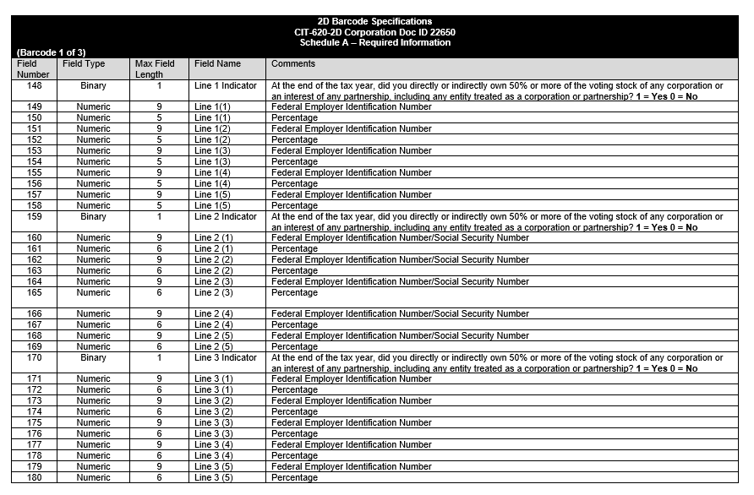
AFTER::
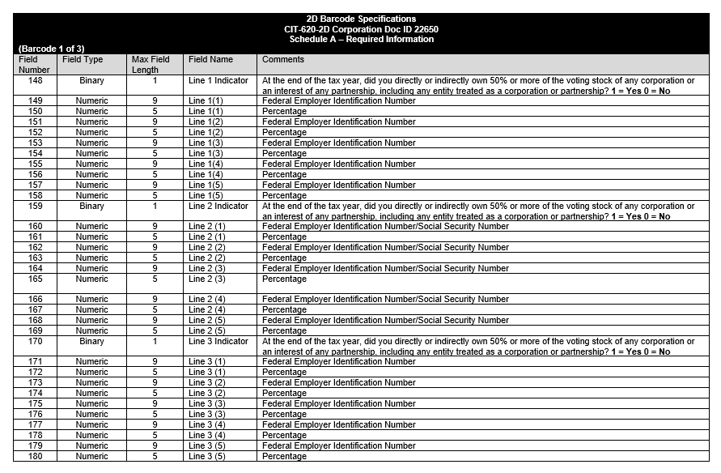
Spec Doc Title Before Update:
Specification Document: R-2210 (12-18-2025) 2-D Barcode Spec Doc & Test Scenarios CIT-620-2D Corporation Income Tax Return Tax Year 2025 Version 3.0
Spec Doc Title After Update:
Specification Document: R-2210 (01/22/2026) 2-D Barcode Spec Doc & Test Scenarios CIT-620-2D Corporation Income Tax Return Tax Year 2025 Version 4.0

