Updates between Versions of the Specifications for the 2D IT-540 return

12/14/2020
- Added Taxpayer’s Telephone Number field in the field placement and 2D barcode (field 24)

12/15/2020
- P4 – Unit Type use postal abbreviations such as APT, STE, FL, RM
- P7 – Nonrefundable Priority 1 Credits - This should be line 6 on the schedule C.
- P9 – Return Line 22 – instructions state to subtract line 22 from line 19 – this should be line 21 minus line 19
- P9 – Return line 31 – instructions state add lines 26 – 31, per the web instructions this should be add lines 25-30, not 26-31.

12/15/2020
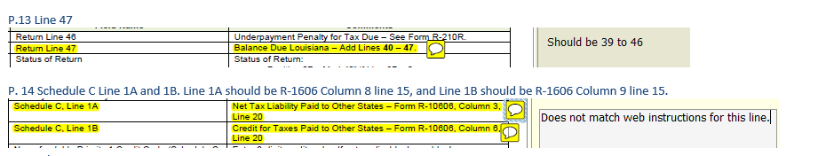

Page 18
Instructions were changed to

Page 20

Page 30 –Field 43 changed to Field 45.

Page 33


Page 35
Page 36

Page 13

12/28/2020
Page 19 and 36
Added fields on Schedule E to include the retirement dates on Schedule E. The changes are highlighted on the specifications.

