Updates to CIFT-620 Specifications

1/14/2021
The 2D Fields were renumbered to correct the issue of two 221 fields.

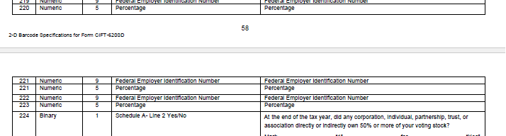

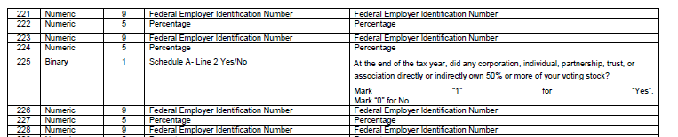

1/19/2021
Page 8- Added Line 11 to Franchise Tax
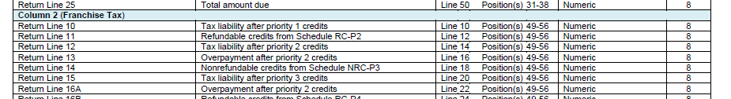

Page 8- Added Line 11 to Franchise Tax
