UPDATES to 2D Corp Specs

12/30/2019
2D Renumbering for Schedules B.C,D,E,F and J. The error in the field numbers was corrected.

Error : Correction:
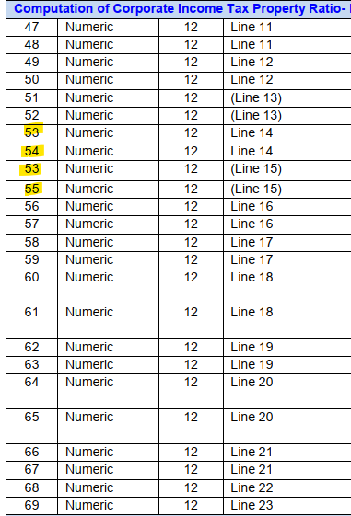
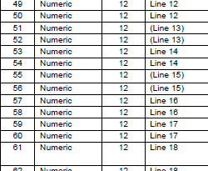
Line 3L was missing from the 2D specs.
Error:
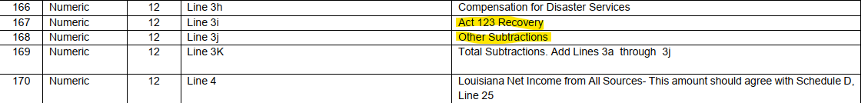
Corrected
