 | Specifications for  Form R-6463 (1/18)
There are no changes to the form or specifications for the 2018 tax year. If you have already received approval on this version (1/17) during the past testing season, you do not need to resubmit for approval.

Size: The size of the detached voucher must be 8-1/2” x 3-5/8” and should be printed at the bottom of an 8-1/2” x 11” sheet.

Document Identification Number: The document identification number for Form R-6463 (1/17) is 1907 and must be printed on Line 62 in Positions 75 through 78 in a Courier 12-point font (10 characters per inch).

Reference Mark: A reference mark must be printed on the voucher and shall consist of:

- A 2-point 1/2" horizontal line, positioned 1/2" from the right edge and 1” from the bottom edge, and
- A 2-point 1/2" vertical line, positioned 1/2" from the right edge of the page and 1/2” from the bottom edge of the page.
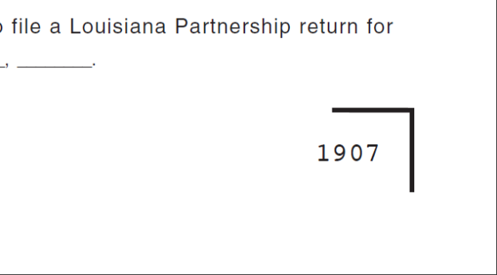
1/2"
1/2"
1"

Barcode: A barcode must be printed on the voucher according to the following specifications:

- The barcode is a “three of nine” type,
- Reads 1907, which is the document identification number,
- Is 1/2" in height, and
- Is located 1/2” from bottom edge and1/2” from left edge.

