ISTC Bulletin 08/12/2025
Good morning,
It was brought to our attention that the Payroll LOI for 2025 had an issue where all boxes are checked when one box is checked here:
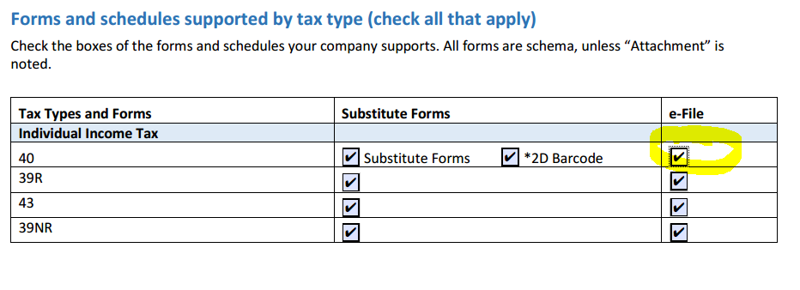
An updated copy of the LOI has been uploaded to SES with this error corrected.
Please don’t hesitate to contact our e-File coordinator, Nico Yingling, at greg.anderson@tax.idaho.gov if you have any questions.
Thank you.

