2025 Bulletin – 12-01-2025 – Schema V2.0 correction
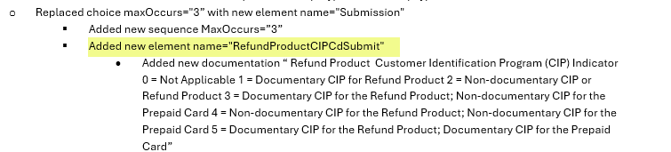
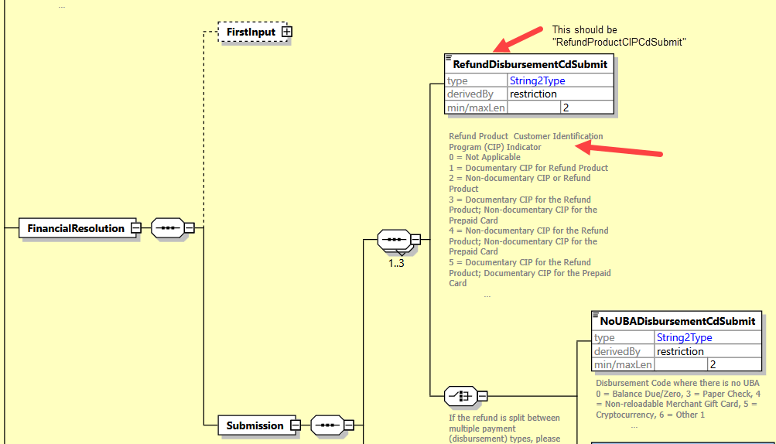

Thanks to Katie Wright of Tax Technologies for reporting this.

