Reasons for Change:
Credits and recapture weren’t being considered in computing ABE and Composite tax paid by the entity. The PTE-12 instructions were changed to accommodate this. There were relevant instructions in other forms that were also updated.
Change Specific to Each Affected Form:
Form 44: The following instructions, page 4, upper-left, contained a duplication of Section I instructions
Was:
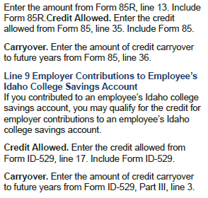
Now:

Form 49R: The following instructions contain an added reference to the K-1 for ABE return type
Was:

Now:
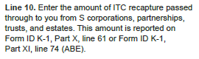
Form 67: The following instructions contain an added reference to the K-1 for ABE return type
Was:
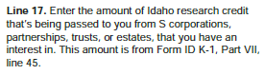
Now:
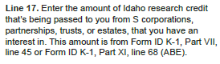
Form 68: The following instructions contain an added reference to the K-1 for ABE return type
Was:
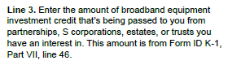
Now:
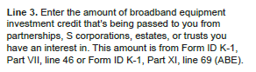
Form 83: The following instructions contain an added reference to the K-1 for ABE return type
Was:
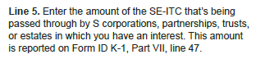
Now:
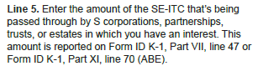
Form 84: The following instructions contain an added reference to the K-1 for ABE return type
Was:
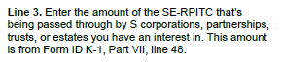
Now:
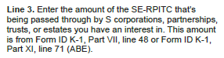
Form 85: The following instructions contain an added reference to the K-1 for ABE return type
Was:
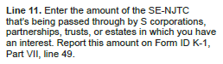
Now:
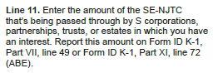
Form ID-529: The following instructions contain an added reference to Form ID K-1
Was:

Now:

Form 68R: The following instructions contain an added reference to the K-1 for ABE return type
Was:

Now:

Form 83R: The following instructions contain an added reference to the K-1 for ABE return type
Was:
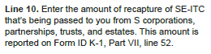
Now:
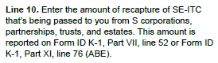
Form 84R: The following instructions contain an added reference to the K-1 for ABE return type
Was:
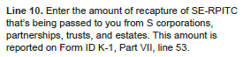
Now:
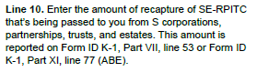

Form 85R: The following instructions contain an added reference to the K-1 for ABE return type
Was:
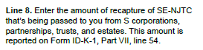
Now:
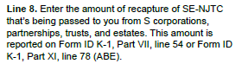
Form 65: The following form line instructions no longer allude to PTE-12
Was:
Now:
Form 41S: The following form line instructions no longer allude to PTE-12
Was:
Now:
Form ID K-1: The following form line instructions and instructions contain an added reference to the K-1, Part XI
Was:




Now:

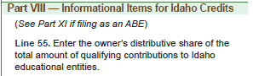


Form PTE-12: The following instructions were changed to include PTE-12 column totals equaling different lines in Forms 41S and 65
Was:
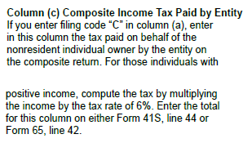
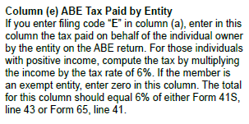
Now:
