Test Plan Change and Important Notes on Forms 41S, 65, and PTE-12:
Regarding Tax and Minimum Tax with Forms 41S and 65:
- We would not expect there to be taxable income, or tax, at the entity level in a Regular return type because income and tax liability flows through to the owner in these cases.
- Minimum tax should only apply (Form 41S) in cases that line 44 (tax) is either blank or the value is less than $20. Minimum tax is used in lieu of tax in these cases. This is true for Regular, Composite, and ABE return types.
What was previously this:
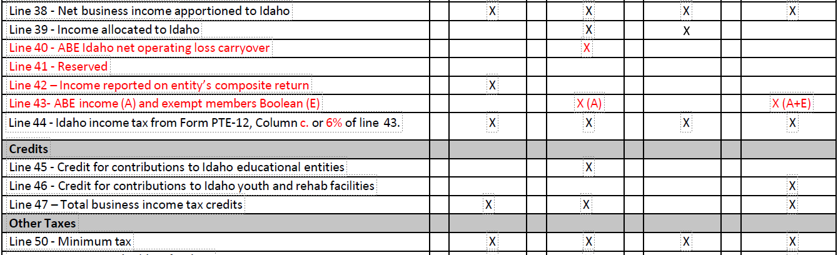

Has become this:
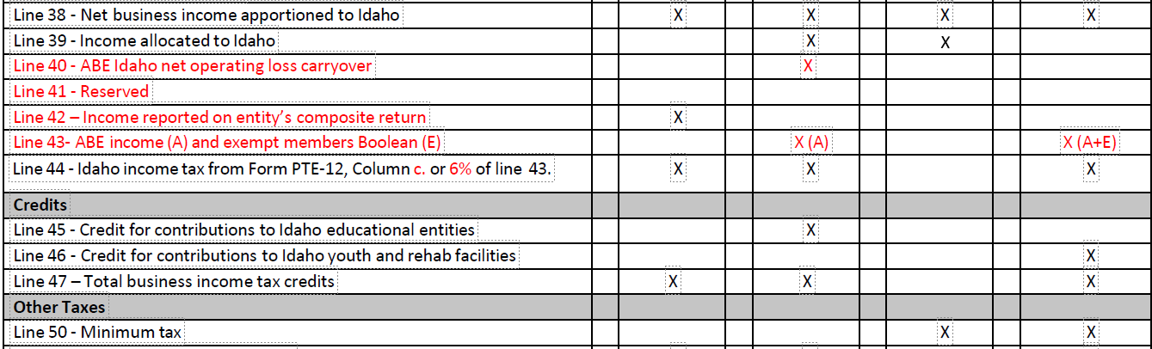

And what was previously this:
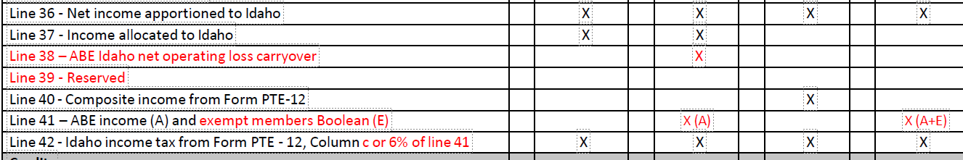
Has become this:
