ISTC Forms Bulletin: TY22
9/21/22:
For our permitted account forms tax partners: We have uploaded the 850, 910, 967, and POA. If you’re supporting these forms, please consider submitting tests for them soon. We require use of the voucher test pack, and test submissions of all forms you’re supporting at once.
For our income tax forms partners: We have uploaded all four of our income tax vouchers for TY22. Please consider making test submissions soon for all that you’re supporting, and we require use of the voucher test pack to make your submissions.
If you submitted an LOI to us, you should be soon receiving an intro letter from your tester. Please specify the name of your tester in the title of your test submissions.
10/26/22:
We have added a new Form 43 to the Forms folder today. The only change present with this new form is in the instructions, Standard Deduction formula, line 5 (multiplication factor values).
Old instruction:
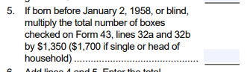
New instruction:
