February 18, 2022
2021 Form 49, Part I, line 2 has received, and is limited to, the following edit. There has been no change to the form instructions:
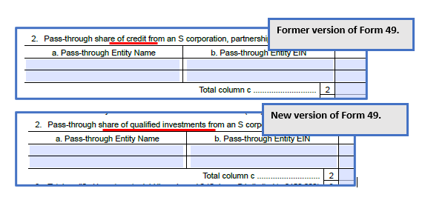
Credit is the computed amount of the Qualified Investments (3% of Qualified Investments), and this computation should occur in pursuant Form 49, Part I, line 6.
Please integrate the new Form 49 substitute document into your TY21 software package. If you have coded per the form instructions, there should be no computation change necessary.

